9

Bridging Industrial Risk Management Deficits in India using a Geo-ICT
Based Tool
Debanjan Bandyopadhyay, Nilanjan Paul, Anandita Sengupta, Cees van Westen
and Anne van der Veen

9.1 INTRODUCTION

Dealing with the issue of industrial risk is a complex task, which requires collective action from a range of actors. A platform for sharing pertinent risk related information and building collaboration between relevant risk factors can be an important contribution in this respect. Such a platform supports decisions on key functional aspects, regulatory support, risk assessment, emergency management, risk informed land use planning and risk communication (Fedra 1998; Neuvel, Scholten et al. 2010). In a number of developed countries, the need for a framework to share risk information between actors like governments, industries and the public has been mandated through policy and regulations which form the basis for risk management initiatives (Walker, Simmons et al., 1999). In order to attain such objectives, regulatory authorities and institutions have established databases that provide information about facilities storing or emitting hazardous chemicals - systems like the Toxic Release Inventory (TRI) of Chemicals and the Major Accident Reporting System (MARS) and the Seveso Plant Information Retrieval System (SPIRS) have been made operational (JRC). Several other tools ranging from commercial software like SAFETI and EFECTS to applications like ARIPAR and ALOHA have been promoted by research and regulatory agencies to provide decision support capabilities to key risk actors (Technica 1984; Pe 2005; Boot, Veld et al. 2006). Understanding that risk has a strong spatial dimension, Geo-ICT modules for risk management have also been integrated with certain tools like XENVIS, IRIMS and HARIA (Contini, Bellezza et al., 2000). In addition, online maps delivered through GIS platforms and integrated with country wide risk data are emerging as a new frontier for sharing risk information at national level, as in the Risicokaart initiative of the Netherlands (Risicokaart ; Moen and Ale 1998; Basta, Neuvel et al. 2007). Nonetheless, very few integrated tools and information systems have been designed to be able to serve the needs of a majority of risk actors in this broad spectrum.
In spite of the Bhopal accident in 1984 and several others which occurred subsequently in different parts of India, significant weaknesses currently prevail in the risk management framework of the country. This is in spite of a rapid rise in the number of major accident hazard (MAH) industries, which are distributed across more than 100 industrial clusters in the country. Though a comprehensive set of regulations have been formulated and responsibilities assigned to several competent authorities, yet the implementation of risk prevention and mitigation measures have been weak. Recently, a study conducted by the National Disaster Management Authority (NDMA), has identified the key gaps in risk management - the findings include lack of accessible information on potential chemical hazards to planners and emergency planning personnel and the administration, absence of harmonized criteria for undertaking risk assessment, no provisions for risk guided land use planning in regulations or the planning framework and the inadequate risk communication to the communities at risk (NDMA 2007). Although, India has witnessed considerable progress in ICT in the last decade, the amount of effective risk information that is available in the public domain and to different actors is negligible. Due to these deficiencies, industrial accidents from hazardous facilities continue to cause considerable loss of human lives and damage to property, as exhibited most recently by the Jaipur accident (MoPNG 2009).
Recently, efforts have been initiated by the government and other stakeholders to improve information availability on industrial risk sources and the hazardous substances they store. The Ministry of Environment and Forests (MoEF) commissioned a project to develop a GIS-based Emergency Planning and Response System (GEPR) for MAH industry clusters in select industrialized States in the Country (Gahlout, Guha et al., 2009). The GEPR was aimed at providing an inventory of hazardous substance storages and displaying consequences of a potential accident in the form of a spatial footprint on a digital map. However, a review of its capabilities point to certain weaknesses - the low resolution of spatial data is not adequate for local emergency response and lack of integration with an intrinsic hazard modelling tool that requires the system to function based on a number of predefined hazard scenarios that may not match with an actual accident scenario. This limits the application of GEPR in emergency situations where rapid hazard simulations matching the scale of the accident are desired. Another novel initiative was taken up by an industry organization through the Environmental Risk Reporting and Information System (ERRIS) project, which encouraged industries to voluntarily report hazard related information to a web-based Risk Reporting Information System (Bandyopadhyay and Paul 2008). The ERRIS was made accessible to selected stakeholders for two industrial clusters in the eastern part of the country. At this time though, there is no integrated ICT solution in India that can reinforce and consolidate risk management activities through better sharing of information and provide guidance for informed decision making to several actors.
This paper makes an effort to demonstrate the capabilities of the Risk Management Information System (RMIS) tool, which has been developed as a follow up of the ERRIS project. Taking into account the present management framework for industrial risks in India, we explore how a system like RMIS can bridge some of the existing gaps with regard to sharing of risk information and using it for informed decision making. Through this paper, we hope to stimulate discussion and debate on the application of information systems to better manage industrial risks in India.

9.2 THE GEO-ICT INTEGRATED SOLUTION: RMIS

The Risk Management Information System (RMIS) is an evolving Geo-ICT based tool which combines in one platform a risk information system, a modelling toolbox and risk oriented planning support capabilities. First developed as a web-based risk information system under the ERRIS project, further research and development based on feedbacks from potential users, has now resulted in a robust and versatile information system and planning support tool that can cater to the requirements of a host of risk management actors including regulators, planners, emergency responders and the community in general.
With the need for drawing and assembling data from diverse sources, the RMIS integrates both spatial and non-spatial data using different data capture mechanisms, assimilates them through a logical data model and makes relevant set of information available through an easy to use, intuitive map based user interface. The conceptual data model that links up data from these sources is presented in Figure 9.1 below.

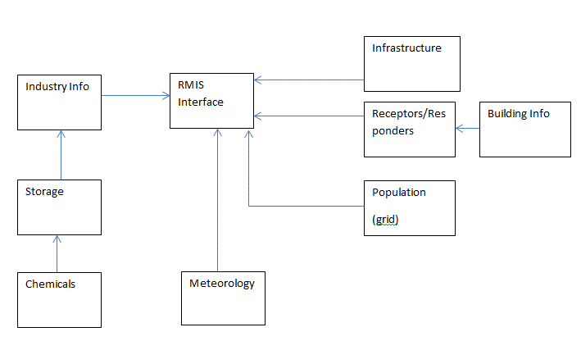

Figure 9.1: RMIS conceptual data model

The RMIS comprises of a web-map based graphical interface which provides the end user with a display of spatial and attributes data on a map along with the option to perform spatial queries. Consequence modelling and risk estimation algorithms for simulating probable damages from a potential accident scenario have been integrated with the RMIS along with live meteorological data feed. The RMIS can be accessed by end-users from remote locations once they connect to the application over the internet/intranet. The distributed web-GIS architecture ensures easy accessibility of hazard information in a spatial context and improves the capability of decision makers, emergency responders and local administration to effectively manage technological accidents originating from hazardous facilities. The RMIS has also been implemented on scalable hardware and software infrastructure so that it remains easily maintainable and can accommodate future innovations in hardware and communication technologies.
As several actors having different set of information needs are expected to use the RMIS for meeting their information requirements, the level of access to information or rights to alter data in several linked databases is provided based on the role a particular user has been assigned by the system administrator through an integrated user access control and role authorization module.

9.3 BRIDGING THE GAPS

9.3.1 Regulatory support

Regulatory mechanisms play an important role in risk management. Several regulatory styles have been practiced by nations, which differ in the way how risk regulations are evolved and implemented. The prevailing approach for regulating risk from hazardous installations is based on a prescriptive ‘Command and Control’ approach (Mohan and Aggarwal 1990) which focused on licensing and monitoring based control of hazardous installations. However, with the occurrence of the Bhopal disaster in early 1980’s, many countries initiated a review of their respective regulatory systems for dealing with industrial risk. The European system made a shift towards a more performance and goal oriented regulatory approach through the Seveso II Directive, which laid considerable stress on risk assessment and management as the guiding principles of risk regulations and ensure that population is not exposed to any undue risk or safety concerns (EC 1996; Wettig and Porter 1998). In the US, a progression has been noted to a more risk-informed approach – a regulatory philosophy, where risk insights are considered together with other factors to establish requirements that better focus licensee and regulatory attention on design and operational issues, prioritized based on their importance to health and safety (Genn 2003). The success of these evolving regulatory approaches depended to a considerable extent on the availability of up to date and valid information on hazards, dangerous substances, and vulnerabilities existing in the surroundings of hazardous installations (Walker, Simmons et al., 1999).
In India, after Union Carbide disaster in Bhopal and followed closely by the Sriram Gas leak incident in Delhi in the 1980s, the provisions relating to industrial safety in the Factories Act was strengthened and legislation specific to prevention and management of accidents arising out of hazardous installations was formulated in the form of the Manufacture, Storage, Import of Hazardous Chemicals Rules (MSIHC), 1989 and subsequently amended in 2000 (MoEF 2000). According to MSIHC Rules, industries storing and handling hazardous chemicals are required to submit a safety report and an Onsite Emergency Plan to the regulatory agencies containing vital industry specific information that would enable the regulators attain swift control of an industrial accident. The Factories Act (GoI 1987) also lays down specific requirements for hazardous industries in terms of laying down adequate safeguards within the installation, preparation of on-site emergency measures and information disclosure about potential accidents to the workers and the public. However, with the prescriptive and authoritative approach being still prevalent, industries appear to be secretive and not unwilling to divulge information on hazards and risks, fearing punitive actions and penalties. As a result, competent authorities often do not have up-to-date information about nature of hazardous chemicals stored, specific amounts and locations of such storages which also leads to inability of crisis management groups and emergency responders to initiate coordinated action and demonstrate a coherent response to managing risk from hazardous installations.
Understanding the requirement for updated information on hazard sources, chemical substance and other risk related data, a need has been felt to make a transition towards more risk-informed regulations enabling transparent sharing and exchange of information between the competent authority and the hazardous facilities, and wherever required with the stakeholders. Using the RMIS, competent authorities can readily access regulatory information and reports for all hazardous industries within a MAH industry cluster along with full understanding of spatial locations of such storages and activities. The presence of consolidated information in a single database can aid in regulatory planning activities - like understanding overall hazard potential in an area. This is illustrated through a search in the RMIS to identify MAH industries which store flammable hazardous chemical of quantity more than 10,000 metric tons, as in Figure 9.2 below.

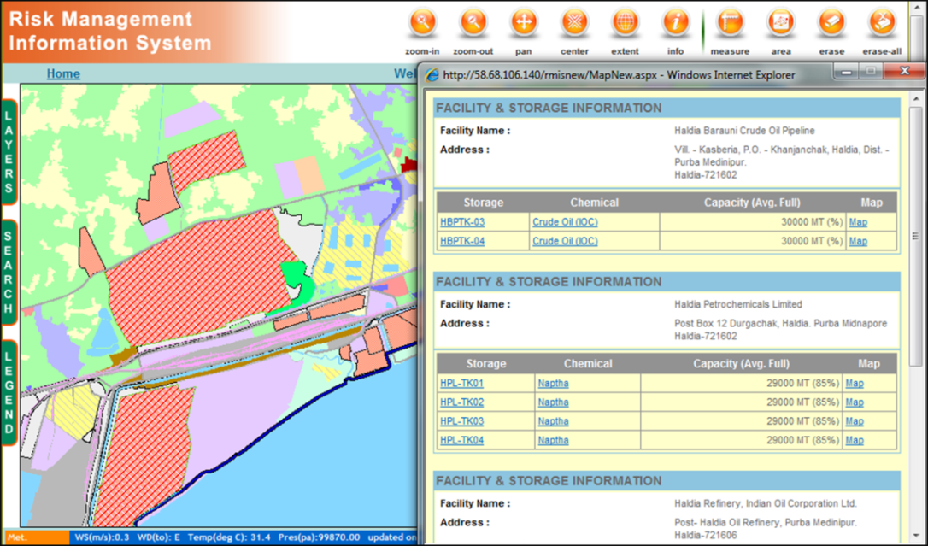

Figure 9.2: Querying RMIS for regulatory planning

9.3.2 Support to tool-based risk assessment

Risk assessment at the industrial facility level, is an important component of the risk management framework which assists decision makers to prioritize safety management within the facility and also take appropriate preventive and mitigation measures to safeguard the community living in the vicinity of such a facility from a potential industrial accident. Risk assessments are data intensive, large number of variables and criteria are often required along with a number of assumptions that need to be made to undertake quantitative or semi-quantitative risk assessments. Taking these complexities into account, many countries have laid down standardized metrics for undertaking such risk assessment. Countries like the Netherlands, UK and USA have laid down detailed guidance for undertaking facility level risk assessments. For example, the coloured books in Netherlands along with the BEVI Guidance lay down methods, set limits on input parameters, specify models to be used and endpoints for hazard calculation (VROM 1997; VROM 1999; RIVM 2004). Applying such a standardized framework would ensure that risks from individual facilities are verifiable, reproducible and comparable and can be used for cumulative risk summation on a common platform.
In India, though basic templates for safety audits and emergency management plans are set in regulations, there is no framework document that delineates the risk philosophy to be followed and neither are there specific guidance’s for undertaking a regulatory risk assessment. As a result, risk assessment is undertaken by hazardous industries based on methodology laid down by different risk consultants. A review of more than 80 cluster level hazard analysis studies undertaken by different consultants, as a part of a MoEF project in 2001, revealed substantial differences in consequence modelling results for similar accidents scenarios involving the same hazardous chemical (ERM 2002). Thus, it is difficult to use such results for drawing up area level risk minimization measures. In response to the need for standardization and harmonization, there is the need for the use of a common tool for risk assessment, which would reduce uncertainty in results and intrinsically standardize risk assessment to a significant extent when such risk assessments are undertaken following standard set of guidance and within specified boundary conditions.
The RMIS can be proposed as a tool similar to the RMP Comp software (USEPA 1999) in the US which is used by industries for standardized mapping and submission of RA results to regulatory authorities. Following the US model, the algorithms underlying such consequence calculations have been intentionally kept simple in the RMIS, so that the data requirements are not very intensive. It is possible to be transparently validated against spreadsheets which are available in public domain (AIChE 2000) ensuring that consequence modelling calculations performed by the tool are traceable. The RMIS has an in-built database of hazardous chemicals, and also a database on hazardous chemical storages in an area and can accept feed from an online meteorological station, providing data on aspects like average wind speeds and resultant vector for predominant wind direction thus automating the calculation process, considerably. Moreover, as the system is integrated with a geo-database, the results can be visualized on a referenced geographical frame and also tied up to vulnerability data.

9.3.3 Guidance to land-use planners

The accidents in hazardous facilities in Bhopal and Mexico highlighted the need for adopting controls through which separation can be maintained between such sites, residential areas and settlements using land use planning instruments. In some densely populated countries of the West like the Netherlands and UK, land use planning measures based on assessment of risk had been put into practice since 1960’s and these aspects were further reinforced when the Article 12 of the Seveso II Directive in Europe made it obligatory for government of Member States to adopt provisions for land use planning controls when new installations are authorized or when further urbanization occurs in the vicinity of hazardous installations (EC 1996). The responsibility of drawing up such land use controls measures were accorded to the competent authorities in each of the EU Member States and several approaches have been adopted for this purpose (Christou and Mattarelli 2000). In a country like the Netherlands or UK, where risk consciousness is considered to be high, an external safety policy guides the risk informed land use planning framework taking into account national level criteria for acceptable risk in terms of two measures: Individual Risk (IR), the Societal Risk (SR) representing the expectation value of the number of people killed per year. These criteria are to be followed by the local planning authorities through restrictions in the development and land use plan (Ale 2001), and several existing tools like ARIPAR and SAFETI can assist in this process through calculation, analysis and visualization of results on a GIS based interface (Spadoni, Contini et al. 2003).
In India, land use planning is applicable to urban planning areas which are demarcated based on regulatory provisions laid down by the state level Town and Country Planning Acts. The consideration of industrial risk issues into land use planning has seldom occurred because of lack of appreciation of these aspects amongst the planning community. Site assessment and EIAs are required to be undertaken for new hazardous industries as per provisions of Factories Act and EIA Notification. In practice, however, seldom are alternative site options considered from the risk point of view for setting up an industry; instead the focus is to plan on a site where land is made available by the government or can be attained through purchase. As a result, the risk levels in areas housing a cluster of hazardous industries are quite alarming, and any accident can result in significant damage to life and property.
The RMIS now integrates a risk mapping module with the expectation that criteria for risk informed land use planning will soon be formulated to guide further development of new hazardous industries. Using this module in RMIS, the user can calculate two measures of risk – Individual Risk and Societal Risk and helps the planner to visualize it on a map of the concerned area. Individual Risk indicates the cumulative risk to a person from a combination of hazardous facilities in an area while Societal Risk is represented by Potential Loss of Life (PLL) to population over the planning area under consideration. The individual risk levels, with predefined acceptance criteria, can assist planners to understand the implications of setting up a new industry in the planning area by studying the escalation of risk that may be caused by the facility and residential areas which may be affected as result. The PLL can facilitate the consideration of alternatives for stabilization of risk levels through the adoption of preventive measures like restriction on further construction of residential houses in a particular area, which already shows high societal risk levels. Figure 9.3 below portrays RMIS in functioning in the risk mapping mode with PLL levels displayed for five different risk scenarios.

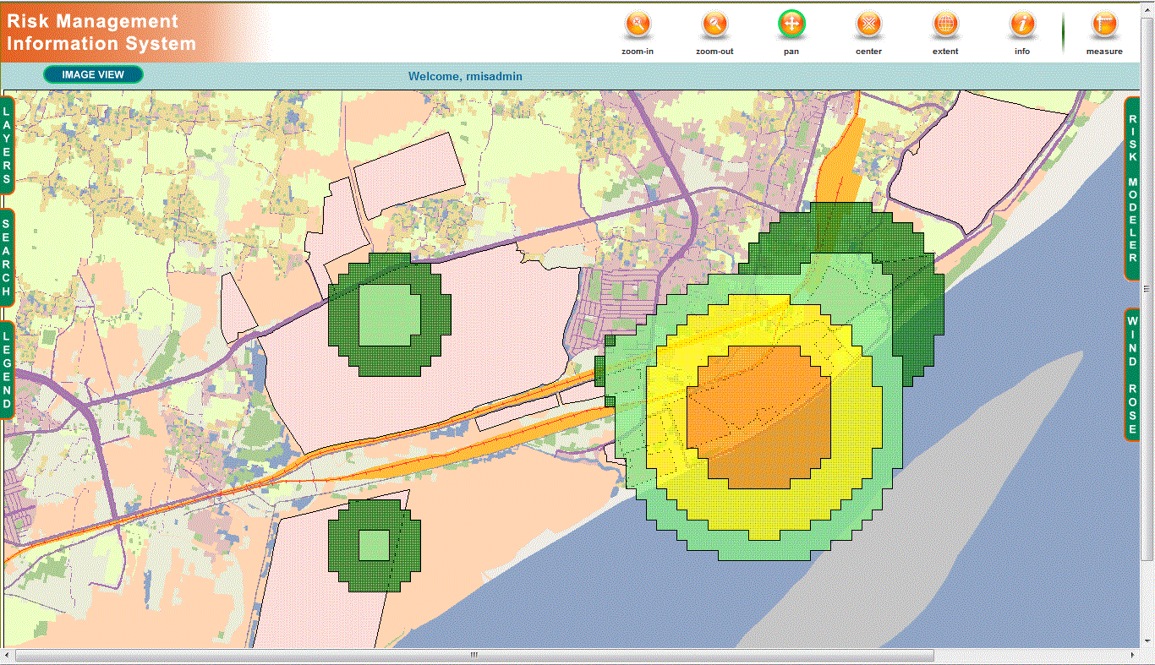

Figure 9.3: RMIS showing individual risk from number of reference scenarios

9.3.4 Enabling emergency response

With the rapid advances made in the field of ICT, there is recognition that having access to updated and time critical information is the key to effectively manage an emergency arising out of an industrial accident. Recent emergencies and emergency response exercises, however, have highlighted deficiencies in emergency management with information not reaching the right organizations and people at the right time, resulting in unnecessary loss of life and property (Kevany 2003) thus constraining effective mitigation, preparation, response and recovery.
At present, the practice of emergency management in India is still on the path to attaining maturity. The EPPRCA Rules envisage a four-tier crisis management system in the country – involving the Central Crisis Group, the State Crisis Group, the District Crisis Group and the Local Crisis Group to manage emergencies arising out of industrial operations. However, in actual terms, these groups are not functional in many industrial towns. In those where they function, they are often handicapped by the lack of sharing of information or its availability in the right form, and the coordination between different agencies and emergency responders is often weak. Discussions with administration and response personnel reveal that one of the key aspects that prevent efficient emergency management is the lack of updated and valid information available in the paper based on-site emergency management plans. Also, no computerized tool presently exists which can provide assistance to emergency responders to help tackle an emergency situation within short time, rather than reviewing a report to extract information which is often too time consuming.

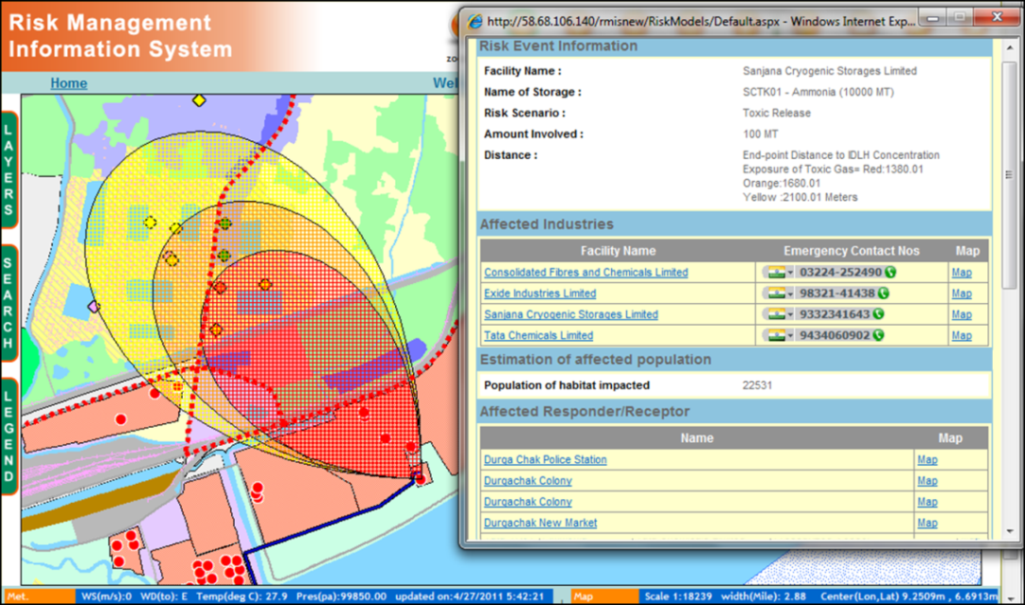

Figure 9.4: RMIS functional view in emergency response mode

The RMIS is designed to assist emergency responders in devising response strategies and initiate appropriate preventive and mitigation actions. Once information about a certain accident, including identity of the storage involved and the amount of chemical likely to be involved, is conveyed to the local emergency centre, response personnel could initiate the hazard modeller module of the RMIS. The Consequence Modeller is designed to capture updated information from the data available in the databases and real time information on wind speed and wind direction from the plugged in automatic weather station. It is also guided by intrinsic rule-based expert system, through which the user can generate a spatial footprint to a certain endpoint in terms of toxic gas concentration, radiation or overpressure level, originating from the source point of the hazard, and aligned with the wind direction in the case atmospheric dispersion is involved, visualized on an automated GIS map on the screen of the system. The system also queries for relevant information on vulnerabilities underlying the footprint and brings up in a pop up window, information on the estimated number of people likely to be affected, susceptible receptors like schools hospitals in the area, other industrial hazards where cascading effects can occur and transportation infrastructure which may be severed by the impacts. To assist in better visualization, the linear infrastructures affected are highlighted in ‘red’ for the responders to take note. Figure 9.4 presents how RMIS displays the footprint of a toxic gas release scenario and the information it brings up and shows to the emergency responder to assist in emergency management.

9.3.5 Information to communities

There has been growing recognition that communities should be involved, educated and made aware of industrial risk and how best to deal with it in the event of an accident. Acknowledging the societal concerns about risk arising from hazardous facilities and with the objective of helping communities to better cope with the consequences arising from a potential industrial accident in the neighbourhood, several countries have framed or included provisions in risk regulation whereby the role of the public and information sharing with regards to hazards have been clearly laid down. The Seveso Directive II (EC 1996) in Europe not only acknowledges the need for access to risk related information like the Safety reports, but also requires hazardous industries and competent authorities to involve in meaningful consultations during offsite emergency planning and land use planning decisions. In the US, the Emergency Planning and Community Right to Know Act (Congress 1986) establishes requirements for the government and the industries to report information on hazardous and toxic chemicals.
In India, learning lessons from the Bhopal disaster, regulation formulated to attain better control on industrial hazards recognized the right of the public in knowing information to improve their capacity to cope with impacts of possible accidents. Rule 15 of the MISHC Rules prescribes that facility managers should provide information to the public on the nature of the major accident hazard that can originate from a facility and the safety measures, including “do’s and don’ts” which should be adopted by the public in such a situation (MoEF 2000). This is supplemented by Section 13 of the Rules on Emergency Planning, Preparedness and Response for Chemical Accidents (EPPRCA) titled “Information to the Public” which require the Local Crisis Group to assist the MAH installations in an industrial pocket to take appropriate steps to inform persons likely to be affected by a chemical accident (MoEF 1996). Section 41B of The Factories Act, 1949 as amended in 1987 also mandates compulsory disclosure of information by the occupier hazardous facility with regard to storage, transportation and handling of hazardous substances to the workers and general public living in the vicinity of hazardous facilities (GoI 1987). The Right to Information Act, 2005 also reinforces the right of citizens to seek information regarding hazardous substances and its effects. However, in practice, it has been seen that industries are seldom willing to share such information, primarily considering that it will give rise to public anxiety and will be detrimental to corporate image and reputation.
The RMIS, through a restricted access system, is in a position to make available minimum set of information to the public through the internet. This updated information can also be used in preparing information booklets and other paper guidance documents to educate the community on various precautionary and safeguard measures to be taken up by local communities who are exposed to industrial risk. Such information may include basic data on type of hazardous substances and a summary of the MSDS sheet in an easily understandable format, with visualization of the hazard source location being aided through a map based interface. It is expected that such active dissemination of information on hazards would lead to gradual improvement in safety culture and knowledge thereby improving the coping capacity of the community to respond to potential industrial accidents.

9.4 CONCLUSION

The RMIS can provide a host of benefits to different risk factors including regulators, administrators, emergency responders, planners and has the potential to be an ICT tool of choice for improving risk management in India. Not only can it provide valid and up-to-date information about risk sources, substances, vulnerabilities and local meteorology integrated from diverse sources, but also its decision and planning support functions enable informed decisions, making risk management more effective. The application is available through an interactive thin-client interface and provides visualization of risk on a spatial dimension, supported by wizard assisted analytical functionalities, helpful not only to experts in industrial risk assessment but also to administrators and decision makers trained on using the system through a focused capacity building exercise. Being developed on a distributed architecture, it is expected that the RMIS can play a vital role in facilitating dialogue and help in developing a shared understanding of chemical risk leading to the formulation of feasible risk reduction strategies and management plans. Trials of RMIS undertaken with various stakeholders in the Haldia region of West Bengal, demonstrate that the system can adapt to situational and operation requirements for risk information and decision support in India. Overall, the development and implementation of RMIS would be in line with the Disaster Management Policy defined by the Government of India which emphasizes on management of knowledge and information to build better coordination between different government agencies and other actors who play a role in disaster prevention and management. Presently, the RMIS is an evolving platform - further research and development is on-going to improve functionalities and capabilities of the system. They range from making the interface more user friendly to improving the system architecture for meeting the needs and requirements from multiple users located at several locations, building operational redundancy and improving communication bandwidth.

References

AIChE (2000). Guidelines for Chemical Process Quantitative Risk Analysis. (2nd Edition). Center for Chemical Process Safety.
Ale B.J.M. (2001). Risk Assessment Practices in The Netherlands. Safety Science 40(1- 4) 105-126.
Bandyopadhyay D., and Paul N. (2008). A GIS Based Framework for Managing Industrial Risks in India. Municipalika. Making Cities Work. Mumbai, India.
Basta C., Neuvel, J.M.M., Zlatanova S., and Ale B. (2007). Risk-maps informing Land-Use Planning Processes: A survey on the Netherlands and the United Kingdom recent developments. Journal of Hazardous Materials 145(1-2) 241-249.
Boot F.H., Veld H.V., and Kootstra F. (2006). Riskcurves: A Comprehensive Program Package for Performing a Quantitative Risk Assessment. AIChE Spring National Meeting Orlando.
Christou M. D., and Mattarelli M. (2000). Land-use planning in the vicinity of chemical sites: Risk-informed decision making at a local community level. Journal of Hazardous Materials 78(1-3) 191-222.
Congress U. (1986). Emergency Planning and Community Right-to-Know Act. Title 42, Chapter 116.
Contini S., Bellezza F., Christou M.D., and Kirchsteiger C. (2000). The use of geographic information systems in major accident risk assessment and management. Journal of Hazardous Materials 78(1-3) 223-245.
European Commission (1996). Seveso II - Council Directive 96/82/EC on the Control of Major-accident Hazards Involving Dangerous Substances.
ERM (2002). Review of Hazard Analysis Report and Preparation of Vulnerability Map of India.
Fedra K. (1998). Integrated risk assessment and management: overview and state of the art. Journal of Hazardous Materials 61(1-3) 5-22.
Gahlout S.S. (2009). GIS and Online Emergency Planning and Information Reporting System for Chemical Accidents in India. Paper presented at Second India Disaster Management Congress, New Delhi.
Genn S. (2003). Safety goals in ‘risk-informed, performance-based’ regulation. Reliability Engineering & amp; System Safety 80(2) p 163-172.
Government of India (1987). The Factories Act, 1948,as amended by the Factories (Amendment) Act, 1987.
JRC. MARS and SPIRS. Retrieved on 16.09.2011, from: http://mahb.jrc.it/index.php?id=39.
Kevany M.J. (2003). GIS in the World Trade Center attack--trial by fire. Computers, Environment and Urban Systems 27(6) 571-583.
Kirchsteiger C. (2002). Towards harmonising risk-informed decision making: the ARAMIS and compass projects. Journal of Loss Prevention in the Process Industries 15(3) 199-203.
MoEF (1996). Rules on Emergency Planning, Preparedness and Response for Chemical Accidents.
MoEF (2000). S.O.57(E): Manufacture, Storage and Import of Hazardous Chemical (Amendment) Rules.
Moen J.E.T., and Ale B.J.M. (1998). Risk maps and communication. Journal of Hazardous Materials 61(1-3) 271-278.
Mohan R. and Aggarwal V. (1990). Commands and controls: Planning for indian industrial development, 1951–1990. Journal of Comparative Economics 14(4) 681-712.
MoPNG (2009). IOC Fire Accident Investigation Report.
NDMA (2007). National Disaster Management Guidelines, National Disaster Management Authority, Govt. of India.
Jeroen M., Neuvel M., Scholten H.J., and Brink A. van den (2012). From Spatial Data to Synchronised Actions: The Network-centric Organisation of Spatial Decision Support for Risk and Emergency Management. Applied Spatial Analysis and Policy 5 (1), 51-72
NRC (2007). Successful Response Starts with a Map: Improving Geospatial Support for Disaster Management. Washington DC, National Research Council.
Pe C.S P.S.M.D. (2005). Computer aids. Lees' Loss Prevention in the Process Industries (Third Edition). Burlington, Butterworth-Heinemann (1-5).
Risicokaart Retrieved from http://risicokaart.nl/. on 26.08.2011
RIVM (2004). External Safety Establishments Regulations (BEVI).
SNDR (2002). A National Hazards Information Strategy : Reducing Disaster Losses Through Better Information. National Science and Technology Council.
Spadoni G., S. Contini et al. (2003). The New Version of ARIPAR and the Benefits Given in Assessing and Managing Major Risks in Industrialised Areas. Process Safety and Environmental Protection 81(1) 19-30.
Technica (1984). The SAFETI Package. London, Technica Ltd.
USEPA (1999). Risk Management Program Guidance for Offsite Consequence Analysis.
Vrom M.O. (1997). CPR14E - Methods for the calculation of physical effects due to the release of hazardous materials (liquids and gases), Yellow Book. C. J. H. van den Bosch and R. A. P. M. Weterings. Den Haag.
Vrom M.O. (1999). CPR14E - Guidelines for Quantitative Risk Assessment. Purple Book. Den Haag.
Walkera G., Simmonsb P., Irwinc A., and Wynneb B. (1999). Risk communication, public participation and the Seveso II directive. Journal of Hazardous Materials 65(1-2) 179-190.
Wettig J., and Porter S. (1998). Seveso Directive: Background, contents and requirements. Industrial Safety Series. M. D. C. Christian Kirchsteiger and A. P. Georgios, Elsevier (6) 27-68.

