Exercise 7b. Analysis of costs & benefits of risk reduction scenarios.

Expected time: 3 hours
Data: data from subdirectory: RiskCity_exercises/exercise07b/answers
Objectives: After calculating the expected losses for the different return periods, and the average annual risk, we would now like to analyze the various options that the municipality has to mitigate the risk, using a basic cost/benefit analysis.

In the previous exercise we have calculated annual losses in monetary values (for direct losses to buildings and contents only). These were made for flooding, seismic, landslides and technological hazards scenarios occurring at different time intervals. The table below gives a summary of these values. These will be the basis for the cost-benefit analysis in this chapter.

Return Period | Annual Probability | Flooding | Seismic | Landslides | Technological
 |  | Direct monetary building losses in € .10 ⁶
5 | 0.2 | 19.34
10 | 0.1 | 34.4
15 | 0.0667 |  | 8.493
25 | 0.04 | 100
35 | 0.0286 |  | 85.85
50 | 0.02 | 199 | 231.0 | 0.1519 | 44.96
60 | 0.0167 |  | 338.3
100 | 0.01 | 510 |  | 2.016
200 | 0.005 |  |  | 16.49
300 | 0.0033 |  |  | 33.99
400 | 0.0025 |  |  | 61.93
500 | 0.002 |  |  |  | 249.3

- Open Excel and create in a worksheet the same setup as above.
- Plot the risk curves
- What can you conclude on the individual hazard types? Which one would cause the highest losses?

The municipality of RiskCity has made a study and the report came up with the following possibilities for risk reduction. The following table shows a number of possible risk reduction measures, including also a very general indication of the costs that these measures would take. In the following section we will evaluate some of these in more detail.

 | Measure | Estimated risk affect
Flooding | Evacuation of buildings in flood hazard zone with 10 year return period | Reduces risk in the 10 year RP flood zone by 100 %
Flooding | Flood retention basin | Reduces the probability of flooding per zone by 1 RP.
Seismic | Seismic retrofitting | Reduces losses by 40 percent,
Landslides | Evacuation of highest hazard zones | Reduces risk in these zones by 100 %
Landslides | Slope stabilization measures | Reduces risk by 90 percent
Technological | Relocation of chemical industry | Reduces risk by 100 percent

In the coming sections we will first evaluate the options for flood risk reduction. We will first look at the scenarios, define how they will reduce the risk, then calculate the investments of risk reduction measures and finally make a cost benefit analysis.
There are of course many also many other risk reduction measures possible. You can broadly subdivide these in Structural and Non-structural measures. Structural risk reduction measures involve engineering measures and construction of hazard-resistant and protective structures and infrastructure. They can be quantified in monetary values. Non- structural risk reduction measures involve components related to land use zoning, early warning, awareness raising, disaster preparedness etc.

Flood risk reduction:
Two scenarios are mentioned for flood risk reduction:
- Scenario I involves the removal of housing in the 10-year Return Period flood zone (i.e. including the 2-year and the 5-year floodplain). The buildings should be demolished, new terrain should be bought, and new buildings have to be constructed in other hazard free zones, infrastructure should be constructed, and the 10 year RP flood zone is converted into green areas (park areas with recreational facilities). A strict supervision is made to avoid that these areas are invaded illegally by squatters. This requires the set-up of a vigilance group which involves costs over a larger period. The risk in the area that was formerly threatened by a 10 year Return Period flood will be reduced to 0, as a consequence of this risk reduction measure. The expected losses for the flood scenarios with return periods higher than 25 years will be basically the same. However, these will become also lower, because the losses for the 25 year event should be reduced from this.
- Scenario II involves the construction of an upstream storage lake. This basin is constructed in the upstream area of the city, and would not involve the removal of houses from the study area. However, the river channel should be made adequate and some engineering works have to be carried out to some of the bridges in the area. The flood retention basin and drainage also needs regular maintenance. The retention basin will reduce the flood losses. It will retain the discharge for 2 and 5 years, and reduce the risk to 0. For the other return periods the damage will reduce: the losses of a 10 year RP will be those of a 5 year RP flood in the original situation; those of a 25 year RP will be those of a 10 year RP etc.

In order to do a cost-benefit analysis of the various risk reduction measures we need to compare the present average annual risk with the future average annual risk of the two scenario’s , to define the amount of risk reduction. In the table below the flood losses are indicated for the current situation.

- Make an estimation of the reduction in flood losses based on the description of the scenarios given above, and fill in the values in the table below.

Flood recurrence in years. | Flood Losses (without mitigation.)  ( in € .10 ⁶⁾ | Mitigation Scenario I Flood Losses  ( in € .10 ⁶⁾ | Mitigation Scenario II Flood Losses  ( in € .10 ⁶⁾
2 | 0 | 0 | 0
5 | 19.3 | 0 | 0
10 | 34.4 | 0 | 19.3
25 | 100 | 100 | 34.4
50 | 199 | 199 | 100
100 | 510 | 510 | 199
200 | 1134 | 1134 | 510

Calculating total annual risk from a risk curve
The first step in the cost-benefit analysis is to calculate the total annual risk for the present situation and the reduction in total annual risk given the various risk reduction scenarios. The total annual risk is the total area under the risk curve, of which the X-axis display losses (in monetary values) and the Y-axis displays the annual probability of occurrence. The points in the curve represent the losses associated with the return periods for which an analysis was done (e.g. the return periods listed in the table above). There are two “graphical” methods to calculate the total area under the curve. We will first briefly look at those.

Method 1: Triangles and rectangles method
The area under the curve is divided into trangles, which connect the straight lines between two points in the curve and have X-axis difference as difference between the losses of the two scenarios. Y-axis of the triangles is the difference in probability between two scenarios. The remaining part under the curve is then filled up with rectangles, as illustrated in the graph and table below.

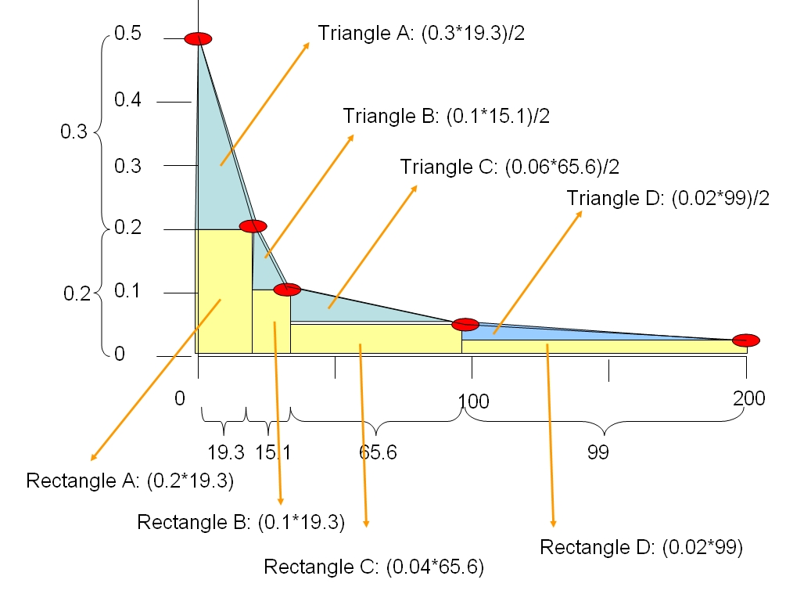
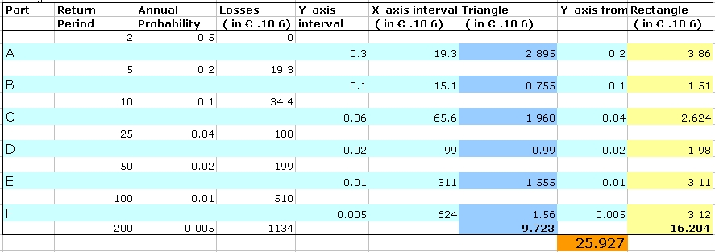
This is the annual risk, taking the sum of the triangles and squares in the graph
Method 2: Simplified rectangles method.
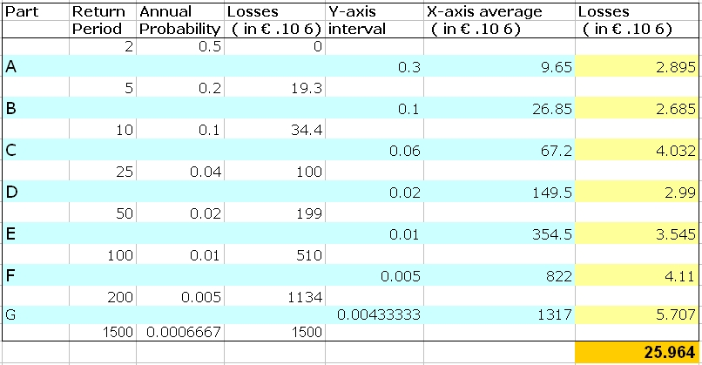
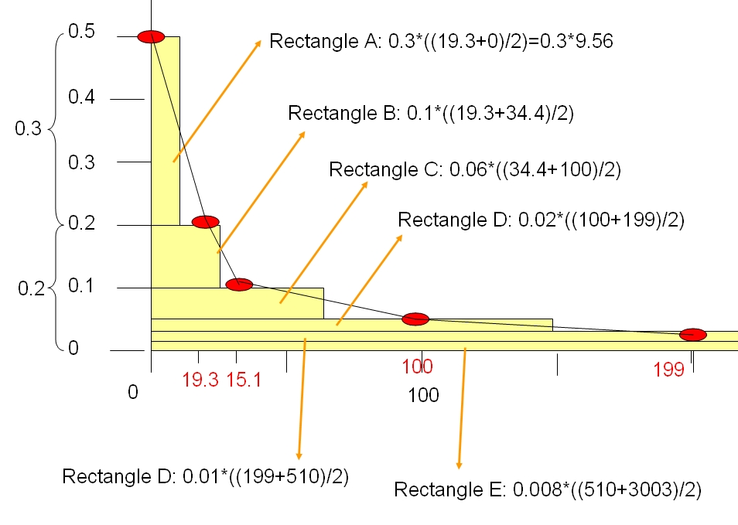
In this method we simplify the graph into a number of rectangles, which have as Y-axis the difference between two successive scenarios, and as X-axis the average losses between two successive loss events. See graph and Excel table below

Now that we know two method we can start calculating them in Excel

- Open Excel and create in a worksheet the same setup as indicated in the first method. Calculate the total annual losses
- Then in the same workbook, make another worksheet and calculate the annual losses using the second method.

Since there is a large variation in probabilities and losses the graph doesn’t show very nice. You might like to change the range of the X-axis and reduce it a bit more.
Now that we have calculated the annual loss for the existing situation, we can also now evaluate the reduction in total annual losses for the two scenarios.

- Calculate in Excel in the same way the average annual risk for Scenario I and Scenario II ( see earlier table with the losses for the two scenarios for the various return periods that you filled in yourself)
- Calculate the amount of risk reduction, comparing Scenario 1 and Scenario 2 with the original average annual risk. Fill in the table below.

 | Average annual risk  ( in € .10 ⁶⁾ | Annual risk reduction  ( in € .10 ⁶)
Present situation
Scenario 1

Scenario 2

- Plot the three risk curves in one graph in Excel

We have now calculated the benefit, which is equal to the amount of risk reduction.

Calculating the investment costs
After calculating how much the risk reduction is on an annual basis for the two different scenarios, we can now evaluate the benefits. The benefit is equal to the amount of risk reduction.
However, the two risk reduction scenarios also involve certain costs. The next table indicates the investment costs for implementing the two scenarios.

 | Specific activities | How to calculate | Standard values | Values
Scenario 1 | Buy the land of the privately owned buildings in the flood zone | Nr of building * standard land prince | Standard land price per building = 15000 | A
Scenario 1 | Demolition of buildings in flood zones with RP of 2,5 and 10 years | Nr of buildings * standard demolition costs | Standard demolition costs = 1000/building | B
Scenario 1 | Acquisition of new land | Nr of buildings * standard costs for land per building | Standard costs for land per building = 10000 | C
Scenario 1 | Construction of new buildings for people removed from flood zones | Nr of buildings * replacement costs | Average Replacement costs = 50,000 / building | D
Scenario 1 | Construction of infrastructure for people removed from flood zones | Nr of buildings * standard infrastructure costs | Standard infrastructure costs = 250 / building | E
Scenario 1 | Adaptation of the zones where the buildings are | Area in hectares * standard adaption costs / hectare | Standard adaptation costs / m² = 20 | F
Scenario 2 | Construction of the flood retention basin | Estimated costs by contractor | 10,000,000 | 25,000,000
Scenario 2 | Adaptation of the river bed | Estimated costs by contractor | 10,000,000 | 25,000,000
Scenario 2 | Adaptation of the bridges | Estimated costs by contractor | 5,000,000 | 25,000,000

For scenario 2 the costs of the investments for the risk reduction strategy are relatively simple. The mitigation works involve engineering works, which are calculated by a contractor and which amount at 25,000,000. However, for scenario 1, which involves the removal of a number of buildings in the highest flood hazard zones, we would still need to calculate the individual components.
IF you are not directly interested in calculating the investment costs for the removal of buildings and adaptation of the terrain you can skip this part of the exercise and move to the next part.

To calculate the A to D component costs from the table above, you need to know first the number of buildings in the flood zone of 10 years return period. For the component E you need to know the area of the 10 year flood zone.

- You can find the number of buildings that are located in the flood zones with a return period of 10 year by crossing the raster maps Flood_10_year with the map Building_map
- You can find the area of the flood zone of 10 years by rasterizing the map Flood_10_year and then calculate the histogram.

- Write the values in the table below and calculate the costs for the various components of Scenario 1.
- Calculate the total investment of scenario 1.

Scenario 1 | Nr of buildings | Area of 10_year flood zone | Standard costs  in € | Costs  ( in € .10 ⁶)
A
B
C
D
E
F
Total investments

IMPORTANT:
We are considering only the economic aspects of executing Scenario 1. There are many more socio-economic aspects: the communities living in these areas will not be just willing to move out of these places. They have historic ties with the place where they live, they depend on the location where they live for their livelihood, etc. etc. These intangible aspects should also be taken into account apart from the purely economic ones.

For advanced ILWIS users:

For experienced ILWIS users: Calculating the number of destroyed buildings.
- The number of buildings that was calculated has an error: it includes also the buildings that were already destroyed by the disaster in 1998. Find a way to exclude those buildings. Tip: use the land use type Vac_damaged to mask out the buildings that are no longer there.
- The buildings that are in the 10 year flood zone are not only residential buildings. They have various land use types. You might like to improve the calculation of the demolition and reconstruction costs by differentiating building costs based on different land use types.
- The area of the flood hazard zone with a 10 year return period also includes the current river. Find a way to exclude the area of the current river.

Cost benefit analysis

After calculating the risk reduction (benefit) and the investment costs of the two flood scenarios we can now continue to evaluate the cost/benefits. The following table indicates the costs of the two scenarios.

 | Costs: investment cost for the scenario | Benefits: Annual risk reduction
Scenario 1 | 50,000,000 | 6,612,000
Scenario 2 | 25,000,000 | 16.189,500

Maintenance cost and operational costs
Each of the two scenarios will also require long term investments.
- Scenario 1 requires the set-up of a municipal organization that controls the illegal spread of housing in highly hazardous areas. It will require staff, office and equipment costs, which will rise over time depending on the increases of salary and inflation. The annual costs are estimated to be 250.000. We consider that these costs will increase with 5 % each year.
- Scenario 2 also requires maintenance and operation costs. The flood retention basin contains a basin in which sediments are deposited. Annually the sediments from this basin have to be removed using heavy equipment. Also the drainage works needs regular repair. The costs for maintenance are considered to be 500.000 per year. We consider that these costs will increase with 5 % each year. See table below.

Investment period
The investments for both scenarios are not done within one single year. They are spread out over a larger number of years, because normally not all activities can be carried out in the same year.
- It is quite difficult to remove existing buildings. The municipality would like to buy the land of private owners, but they will resist, and there will be many lawsuits that might take a lot of time. Therefore we consider that the entire relocation of all building might take as much as 10 years. The investment costs are therefore spread out over this period.
- The construction of the engineering works for scenario 2 will take less time. Still it is considered that the costs are spread over a period of 3 years.
The benefits will start in the year that the investments are finished. For scenario 1 this is in year 11 and for scenario 2 it is in year 4.

Project lifetime.
The lifetime of the scenario 2 is considered to be 40 year. After that the structure will have deteriorated and it needs to be rebuilt. For the relocation scenario it is more difficult to speak about a life time, but we will also keep the same period of 40 years.
Each project has a certain life time, during which the investments of the projects should be paid off. The flood retention basin is constructed to exist for at least 40 years. Of course this life time is not very applicable to the scenario I: evacuation of houses from the high flood risk zone.

Table: Costs of the Flood Risk Reduction Scenario’s (costs in € .10 ⁶).

Year | Investments Cost  Scenario I_F  ( in € .10 ⁶) | Operational costs municipal squatter control  ( in € .10 ⁶) | Investments Cost  Scenario II_F  ( in € .10 ⁶) | O&M costs  Year Scenario II  ( in € .10 ⁶)
1 | 10 % of 50=5 | 0.250 | 33 % of 25 | 0
2 | 10 % of 50=5 | 0.250 + 5% | 33 % of 25 | 0
3 | 10 % of 50=5 | 0.263+ 5% | 33 % of 25 | 0
4 | 10 % of 50=5 | 0.276+ 5% | 0 | 0.5
5 | 10 % of 50=5 | 0.289+ 5% | 0 | 0.500+ 5%
6 | 10 % of 50=5 | 0.304+ 5% | 0 | 0.525+ 5%
7 | 10 % of 50=5 | 0.319+ 5% | 0 | 0.551+ 5%
8 | 10 % of 50=5 | 0.335+ 5% | 0 | 0.579+ 5%
9 | 10 % of 50=5 | 0.352+ 5% | 0 | 0.608+ 5%
10 | 10 % of 50=5 | 0.369+ 5% | 0 | 0.638+ 5%
11 | 0 | 0.388+ 5% | 0 | 0.670+ 5%
12 -40 | 0 | Etc.. | 0 | Etc.

We are now going to put the avoided risk per year in a table as well as the cost and we will calculate the benefits over the 40 years period.

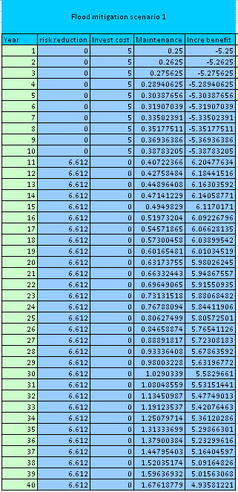
- Create in Excel a new table: called Flood Mitigation Scenario I (see figure left).
- Column 1: Years ( starting with 1 up to 40 year)
- Column 2: Risk Reduction (i.e. Risk avoided, or Benefit)
- Column 3: Invest cost for the risk reduction scenario.
- Column 5: Maintenance
- Column 4: Incremental Benefits
- Enter the values and calculate the incremental benefit over the 40 years period.

Net Present Value
We need to take into account that the same amount of money in the future will be less valuable today. We will need therefore to calculate the so-called net present value (NPV).

The Net Present Value (NPV) calculates the net present value of an investment by using a discount rate and a series of future payments (negative values) and income (positive values).
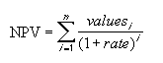
Rate: is the rate of discount over the length of one period
Value 1 value 2 … are the “arguments” representing the payments and income.
NPV = the discounted benefits and costs at a given discount rate.
An example is given below:
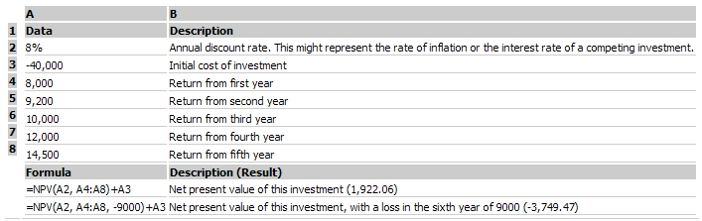

- In the Excel worksheet to the right of the table call a cell NPV ( Net Present Value) ;
- In the cell next to it insert the name Interest rate (which is the same as discount rate) and enter the value of: 10 %.
- In Excel: Click in your “NPV” cell and Insert Function; select Financial Functions.
- Select: NPV
- The Function Arguments Box opens ( see figure below);
- Select for Interest Rate 10%
- For value 1: select the whole column down all the incremental benefits; starting at year 1 up to year 40.
- Click OK

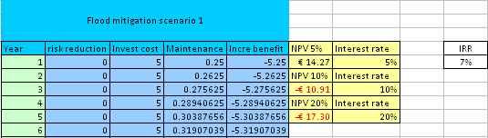

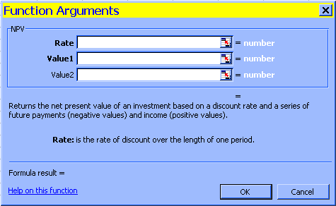
- Repeat the NPV calculation, but now with a discount rate / interest rate of 5 and 20 %

Question:

- Is the NPV still positive?
- What do you expect of the value of the Internal Rate of Return?

Internal Rate of Return
Now we are going to calculate the Internal rate of return. The Internal Rate of Return is the discount rate/interest rate at which the NPV=0

- In Excel: Click Insert Function and select Financial Functions.
- Select: IRR
- The Function Arguments Box opens;
- Read the HELP file
- For values: select the whole column down all the incremental benefits; starting at year 1 up to year 40.
- Click OK.

Other flood scenario
Now we will compare the NPV and IRR values for the various flood risk reduction scenarios.

- Repeat the procedures for Flood Mitigation Scenario 2. Fill in the results in the table below.
- Remember that Flood Mitigation Scenario II has also Operation & Maintenance costs that have to be subtracted as well from the benefits, in order to calculate the incremental benefits. .

Flood Risk Reduction Scenario | NPV at 5 % interest rate | NPV at 10 % interest rate | NPV at 20 % interest rate | IRR
Mitigation Scenario I | €14.27 | - €10.91 | - €17.30 | 7 %
Mitigation Scenario II | €195.80 | €91.16 | €27.32 | 42%

Question:
Which Mitigation Scenario would you advice the Municipality?

