Answer: Analysis of costs & benefits of risk reduction scenarios.

From the graph below you can see that the hazard types that could cause more losses, are the seismic and the flooding.

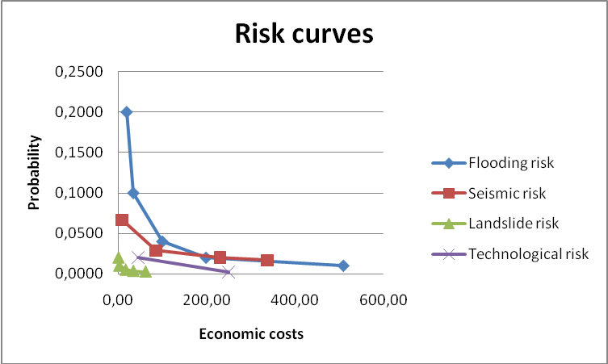

11.1 Flood risk reduction:

According to the following table we are going to evaluate the annual risk for the 2 scenario previewed for the mitigation of the risk. We used the first of the graphic methods explained on the text (triangles and rectangles).

Flood recurrence in years. | Flood Losses (without mitigation.) | Mitigation Scenario I Flood Losses | Mitigation Scenario II Flood Losses
Flood recurrence in years. | ( in € .10 ⁶⁾ | ( in € .10 ⁶⁾ | ( in € .10 ⁶⁾
2 | 0 | 0 | 0
5 | 19,3 | 0 | 0
10 | 34,4 | 0 | 19,3
25 | 100 | 65,6 | 34,4
50 | 199 | 164,6 | 100
100 | 510 | 475,6 | 199
200 | 1134 | 1099,6 | 510
Scenario I
Method 1: SCENARIO 1
Part | Return period | Annual Probabiliy | Losses (in € .10E6) | Y - axis interval (in € .10E6) | X - axis interval (in € .10E6) | triangle (in € .10E6) | Y - axis probability | rectangle
 | 2 | 0,5 | 0
A |  |  |  | 0,3 | 0 | 0 | 0,2 | 0
 | 5 | 0,2 | 0
B |  |  |  | 0,1 | 0 | 0 | 0,1 | 0
 | 10 | 0,1 | 0
C |  |  |  | 0,06 | 65,6 | 1,968 | 0,04 | 2,624
 | 25 | 0,04 | 65,6
D |  |  |  | 0,02 | 99 | 0,99 | 0,02 | 1,98
 | 50 | 0,02 | 164,6
E |  |  |  | 0,01 | 311 | 1,555 | 0,01 | 3,11
 | 100 | 0,01 | 475,6
F |  |  |  | 0,005 | 624 | 1,56 | 0,005 | 3,12
 | 200 | 0,005 | 1099,6 |  |  | 6,073 |  | 10,834
 |  |  |  |  |  |  | 16,907

Scenario II

Method 1: SCENARIO 2
Part | Return period | Annual Probabiliy | Losses (in € .10E6) | Y - axis interval (in € .10E6) | X - axis interval (in € .10E6) | triangle (in € .10E6) | Y - axis probability | rectangle
 | 2 | 0,5 | 0
A |  |  |  | 0,3 | 0 | 0 | 0,2 | 0
 | 5 | 0,2 | 0
B |  |  |  | 0,1 | 19,3 | 0,965 | 0,1 | 1,93
 | 10 | 0,1 | 19,3
C |  |  |  | 0,06 | 15,1 | 0,453 | 0,04 | 0,604
 | 25 | 0,04 | 34,4
D |  |  |  | 0,02 | 65,6 | 0,656 | 0,02 | 1,312
 | 50 | 0,02 | 100
E |  |  |  | 0,01 | 99 | 0,495 | 0,01 | 0,99
 | 100 | 0,01 | 199
F |  |  |  | 0,005 | 311 | 0,7775 | 0,005 | 1,555
 | 200 | 0,005 | 510 |  |  | 3,3465 |  | 6,391
 |  |  |  |  |  |  | 9,7375
 | Average annual risk  ( in € .10 6) | Annual risk reduction  ( in € .10 6)
Present situation | 25.927 | 0
Scenario 1 | 16.907 | 9.02
Scenario 2 | 9.7375 | 16.1895

The graph below compare the risk curve on the case without any mitigation project, with the evacuation of buildings in flood hazard zone with 10 year return period (Scenario 1), and the construction of a Flood retention basin (Scenario 2).

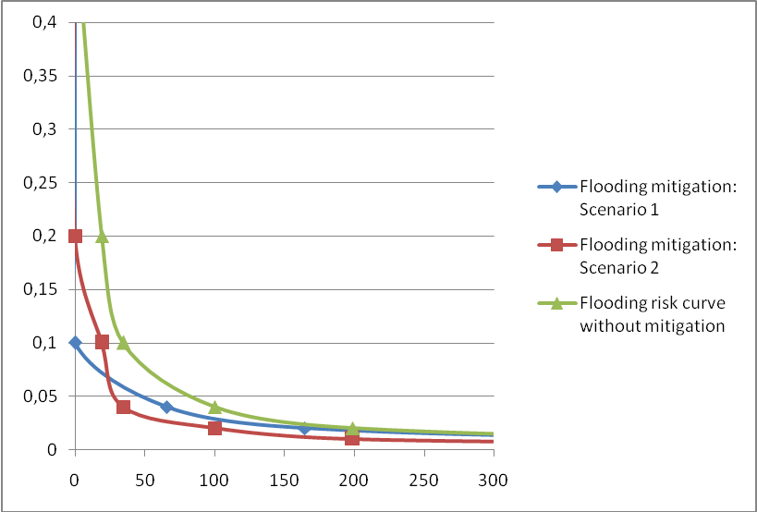

In order to have a better understanding of what it means, on the graph below are represented the curve without any mitigation plan and the curve with the project of the scenario 1. The risk reduction is the difference between the area under curve of the flood risk without any mitigation plan and the area under curve after the application of a mitigation plan.

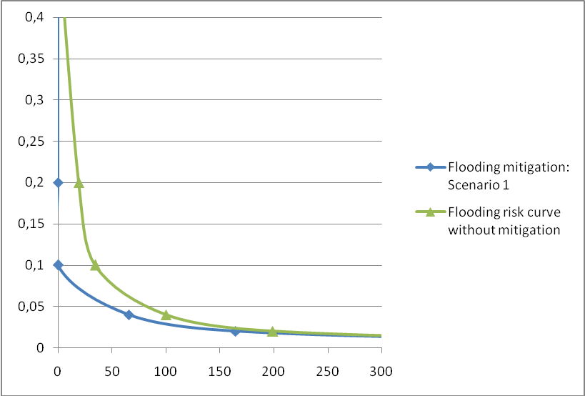
Risk reduction applying the mitigation scenario 1
Average annual risk after the scenario 1 of mitigation

Calculating the investment costs
- Cross the Flood_10_year with the map Building_map and call the output table Flood10_buildings.
- Open the table building_map and join with the table Flood10_buildings. Read in the column Flood_10_year. Call the output column Flooding_10.
- In the table building_map type the formula:
Building_10_flooded = iff(Flooding_10="RP 10 YEAR",1,0)
- Now you can read the sum values, with the statistic pane active, under the column Building_10_flooded. This is the number of buildings affected.

Scenario 1 | Nr of buildings | Area of flood zone | Standard costs  in € | Costs  ( in € .10 6)
A | 490 |  | 15000 | 7.350
B | 490 |  | 1000 | 0.490
C | 490 |  | 10000 | 4.900
D | 490 |  | 50000 | 24.500
E | 490 |  | 1000 | 0.4900
F |  | 645539 | 20 | 12.912
Total investments |  |  |  | 50.641

For advanced ILWIS users:
For experienced ILWIS users: Mask out the buildings destroyed after the disaster on the 1998

- Open the table building_map and type the following formulas:
Actual_buildings:=iff(Pred_landuse="vac_damaged",1,0)
And then:
Actual_buildings_in_10years:=iff((Building_10_flooded=1)and(Actual_buildings=1),1,0)
- Now you can read the correct number of buildings affected by a floods of 10 years of return period (422 buildings). See the image below.

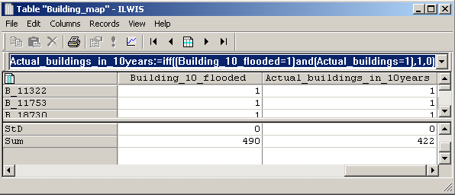

For advanced ILWIS users:

We are going now to consider for every landuse type a different values of demolition and reconstruction of the buildings. Create your own table with your estimation or use the following.

For experienced ILWIS users: Considering different cost of demolition and reconstruction

- Create your own table with your estimation or use the following values.

 | Com_business | Com_hotel | Com_market | Com_shop | Ind_hazardous | Ind_industries | Ind_warehouse
Cost of demolition per building | 800 | 1500 | 400 | 700 | 2500 | 2000 | 1200
Cost of reconstruction per building | 40000 | 80000 | 30000 | 40000 | 120000 | 100000 | 80000

 | Ins_fire | Ins_hospital | Ins_office | Ins_police | Ins_school | Pub_cemetery | Pub_cultural
Cost of demolition per building | 1200 | 1800 | 1100 | 1200 | 1000 | Building not possible  1000 | 800
Cost of reconstruction per building | 60000 | 100000 | 55000 | 60000 | 50000 | Building not possible  50000 | 40000

 | Pub_electricity | Pub_religious | Rec_flat_area | Rec_park | Rec_stadium | Res_large | Res_mod_single
Cost of demolition per building | 500 | 1100 | Building not possible  1000 | Building not possible  1000 | 1500 | 1200 | 1000
Cost of reconstruction per building | 30000 | 55000 | Building not possible  50000 | Building not possible  50000 | 700000 | 60000 | 50000

 | Res_multi | Res_small_single | Res_squatter | River | Vac_car | Vac_construction
Cost of demolition per building | 1300 | 900 | 400 | Building not possible  1000 | Building not possible  1000 | Building not possible  1000
Cost of reconstruction per building | 80000 | 40000 | 20000 | Building not possible  50000 | Building not possible  50000 | Building not possible  50000
Note: You could do it with the SMCE tool (Spacial MultiCriteria Evaluation).

 | Vac_damaged | Vac_shrubs
Cost of demolition per building | Building not possible (the buildings have to be masked) | Building not possible  1000
Cost of reconstruction per building | Building not possible (the buildings have to be masked) | Building not possible  50000

Note: For some landuse class is not possible have buildings. Despite that, some buildings, because of some pixels, have been classified in dome of this classes. For this buildings we will use a standard value.

Note: we are using a value of reconstruction and demolition for building. In order to have a more accurate estimation it could be done per floorspace, but this make more complicate the exercise.

We are going to don’t consider the buildings destroyed after the events on the 1998. In fact we will use the buildings values evaluated on the previous exercise.

- Open the table building map, go to columns, aggregate, and select the column Actual_buildings_in_10years. Group by pred_landuse. Use the sum function and call the output column buildings_affected_per_class.
- Read the values and fill the table below, creating a table in an excel file.

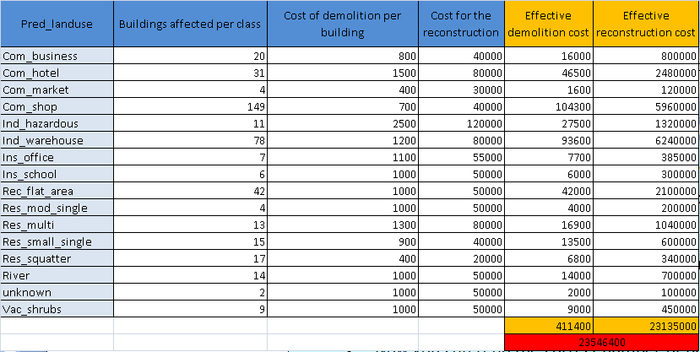

For advanced ILWIS users:

We want to exclude the area of the river from the area flooded by the events of 10 years of return period.
For experienced ILWIS users: exclude the area of the river from the area flooded
- From the raster map mapping_units create an attribute map of the column pred_landuse. Call it landuse.
- Type the following formula:
Flood10:=iff(Flood_10_year="RP 10 year",1,0)
iff(isundef(landuse),0,iff((landuse="river"),1,0))only_flood10:=Flood10-river
Area_flooded:=iff(only_flood10=0,?,only_flood10)


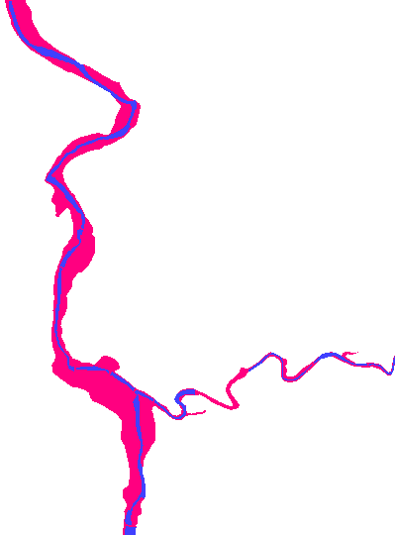

Cost benefit analysis

 | Costs: investment cost for the scenario | Benefits: Annual risk reduction
Scenario 1 | 50,000,000 | 8,762,000
Scenario 2 | 25,000,000 | 16.189,500

After the evaluation in excel of the incremental benefit, you can evaluate the NPV. Check your results with the table below.
As you can see with a discount of 5%, the NPV became positive.
We aspect a IRR lower than 10%.
NPV 10% | Interest rate
-€ 3,10 | 10%
NPV 5% | Interest rate
€ 34,56 | 5%
NPV 20% | Interest rate
-€ 15,58 | 20%
IRR
9%

Now we are going to evaluate the incremental benefit for the second scenario, and then the NPV and the IRR. Check the values below.

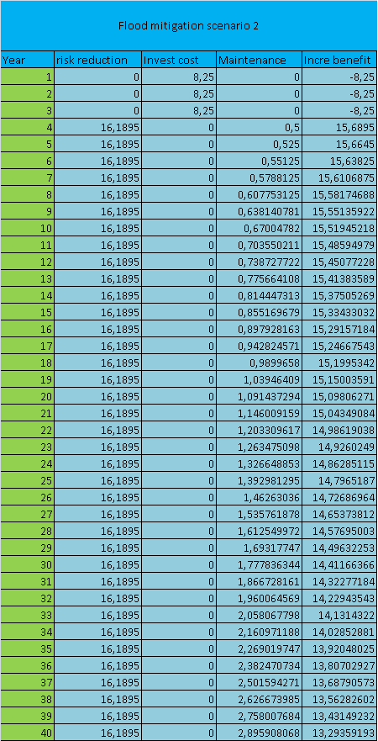

NPV 10% | Interest rate
€ 91,37 | 10%
NPV 5% | Interest rate
€ 196,02 | 5%
NPV 20% | Interest rate
€ 27,50 | 20%

IRR
43%

According to the IRR of the two mitigation plan, we will suggest to the municipality, the second scenario, that have the highest IRR value.

11.2 Seismic risk reduction:

Calculate the annual risk as following.
Method 1: Earthquake
Part | Return period | Annual Probabiliy | Losses (in € .10E6) | Y - axis interval (in € .10E6) | X - axis interval (in € .10E6) | triangle (in € .10E6) | Y - axis probability | rectangle
 | 2 | 0,5 | 0
A |  |  |  | 0,3 | 3 | 0,45 | 0,2 | 0,6
 | 5 | 0,2 | 3
B |  |  |  | 0,133333 | 5,493 | 0,3662 | 0,066667 | 0,3662
 | 15 | 0,066667 | 8,493
C |  |  |  | 0,038095 | 77,357 | 1,473467 | 0,028571 | 2,2102
 | 35 | 0,028571 | 85,85
D |  |  |  | 0,008571 | 145,15 | 0,622071 | 0,02 | 2,903
 | 50 | 0,02 | 231
E |  |  |  | 0,003333 | 107,3 | 0,178833 | 0,016667 | 1,788333
 | 60 | 0,016667 | 338,3
F |  |  |  | 0,011667 | 4661,7 | 27,19325 | 0,005 | 23,3085
 | 200 | 0,005 | 5000 |  |  | 30,28382 |  | 31,17623
 |  |  |  |  |  |  | 61,46005

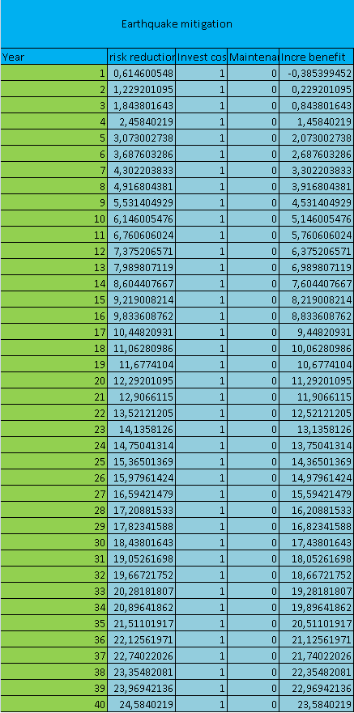
NPV 10% | Interest rate
€ 134,47 | 5%
NPV 5% | Interest rate
€ 50,90 | 10%
NPV 20% | Interest rate
€ 13,35 | 20%

IRR
43%

The annual risk reduction of 1% due to the retrofitting of 100 buildings per year, is of course a major simplification. In order to have a realistic cost-benefit analysis we should consider the average cost of the buildings that are going to be substituted, multiply for the number of buildings retrofitted per year and then evaluate again the risk curve, based on the new losses. You have to do that for every year (because every year you are going to reduce the risk), and for every year you should evaluate a risk curve with the new values of losses after the mitigation. Since this procedure will take a lot of time and the results are comparable with the procedure just used on the previous exercise, we hold as reasonable to use the approximation of the risk reduction of 1% of the number of building affectd.

11.3 Landslide and technological risk reduction:

