Exercise 7a: Risk information for emergency preparedness & response.
Expected time: 3 hours
Data: data from subdirectory: RiskCity_exercise/exercise07a/data
Objectives: The aim of this exercise is that you use the risk information that you have generated in the previous exercise for emergency preparedness. We will make a simulation of an emergency that might take place in RiskCity. You work in a team as the geo-information department of the local authority and you have to provide the local authority with the required information to respond to the emergency.

Introduction to the simulation exercise
The Geo-Information department of the municipality of RiskCity is in charge of collecting and handling spatial information that should be used in the emergency preparedness phase in order to provide the decision makers with the adequate information to respond to disasters (Figure 1). You have a GIS database and you will have continuous access to Blackboard and e-mail where you may receive regular situation reports on which you have to react. You will also receive messages from the emergency management group of the municipality of RiskCity, which will request particular types of information.
You have the following tasks:
- Task 1: Planner. The planner reads and interprets the messages that are received regarding the situation. He/she also will receive messages from the emergency managers in RiskCity asking for specific information. The planner should use the available information and plan the tasks that should be carried out by the analyst.
- Task 2: Analyst. The analyst is the person that is mostly involved in the GIS analysis, based on the requests made by the planner. He/she will provide the information to the communicator.
- Task 3: Communicator. The communicator is responsible for preparing small reports with the answers to the questions posed by the emergency managers of RiskCity. It may also be required to provide some map information in the reports. The reports should be mailed to a given e-mail address in time.
In the distance education course you have to play to perform all 3 tasks. In a classroom situation it is possible to divide the tasks and work in groups of 3 people.

ThThe role of supervising staff is twofold during the simulation exercise:
- One of the supervising staff members will evaluate the reports submitted by the groups in real time, and communicate back when the information is missing. Note that the score given each time depends on both the accuracy and the speed of the response.
- Two other supervising staff will be available to provide support during the simulation, by giving hints on how to solve particular GIS problems.

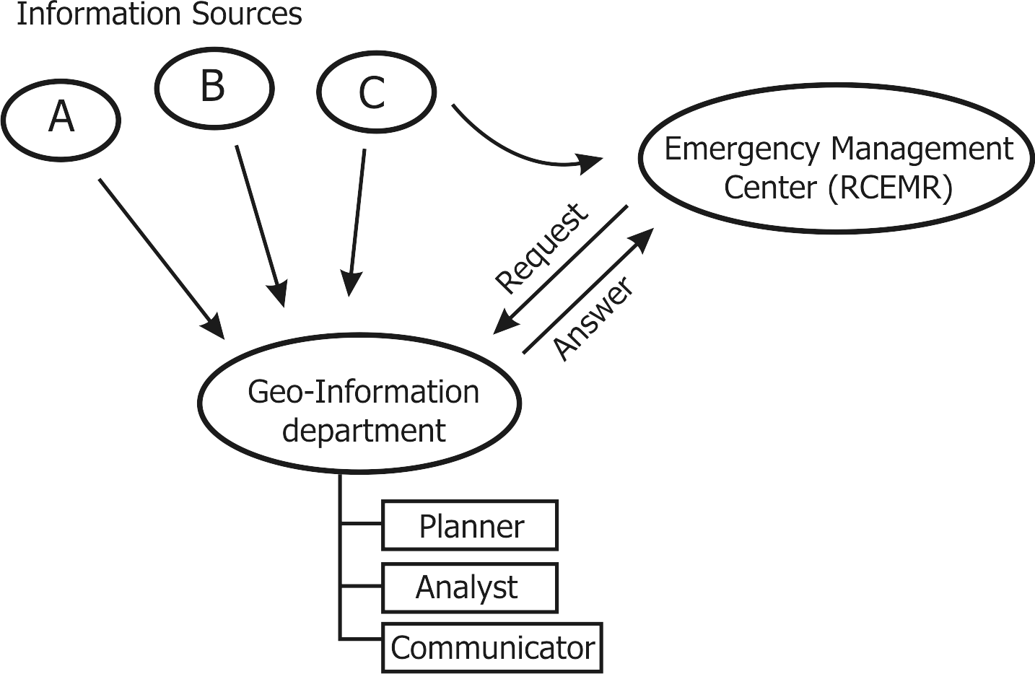
Figure 1. Overview of organisational setup of the RiskCity emergency management.

Input data
This simulation case study uses a large amount of data, related to hazards, elements at risk and expected losses for earthquakes, flooding, landslides and technological hazards. This simulates the real situation where you do not know when and what may happen, and therefore all available information might be useful.
The table below gives a list of the most important data
Name | Type | Meaning
Elements at risk
Mapping_units | Raster | Building blocks of the city. The accompanying table containing general statistical information on the number of buildings and people per building block.
Building_map_1998 | Raster Map | Building map of the city showing the situation after the disaster of 1998. The accompanying table contains information on: the landuse, the number of floors, the floorspace, the building types, and the daytime and nighttime population within the buildings in RiskCity.
Earthquake data
Seismic_risk | Table | Table that links to the map Mapping_units, which containing expected building losses and population losses for earthquakes with intensities ranging from VI to IX (Modified Mercalli Intensity)
Earthquakes_country | Point | Point map of the earthquake catalogue and accompanying table with historical earthquake information.
Flood data
Flood_risk | Table | Table that links to the map Mapping_units, which containing expected building losses and population losses for floods with 5, 10, 25, 50 and 100 year return periods
Flood_05year to Flood_100_year | Polygon | Polygon maps with modelled flood extend of floods with 5, 10, 25, 50 and 100 year return periods
Flood_10y, flood_50y and Flood_100y | Raster | Raster maps with flood depth for floods with 10, 50 and 100 year return periods
Landslide data
Landslide_risk | Table | Table that links to the map Mapping_units, which containing buildings and population located in high, moderate and low landslide hazard zones
Landslide_susceptibility | Raster | Raster map of the landslide susceptibility
Landslide_ID | Polygon map | Landslide inventory map with a table containing relevant landslide information.
Technological risk data
Technological_risk |  | Table that links to the map Mapping_units, which containing buildings and population located in zones close to the main hazardous industry.
Main_industry | Point | Point map with location of the main industrial site in RiskCity.
Other data
High_res_image | Raster | High resolution image of the study area.
Country_anaglyph | Raster | Anaglyph map of the entire country.
City_center | Point | Location of RiskCity within the country
Real time data
Rainfall_data |  | Daily rainfall data is given to the participants at regular intervals during the simulation
Situation reports |  | The participants will receive regular updates on the emergency situation.
Information requests |  | The team will receive regular requests from emergency managers related to information they

Preparing for the simulation
In the distance education course everyone could start the simulation exercise at a different time of the day, depending where you are in the World. In order to be able to carry out the exercise, you need to inform the course coordinator at which time exactly (GMT time) you are going to start the simulation exercise. You also have to indicate which e-mail you are going to use for receiving the messages.

- Inform the course coordinator 2 days before at which time (GMT time) you want to start this exercise, and indicate the e-mail address to which the messages related to this exercise will be send.
- The answers to the exercises should be mailed to the following e-mail: DGIM@itc.nl.

In this exercise you will receive e-mails at certain time intervals of Technical organisations related to riskcity (National weather forecasting center, National earthquake center, Geological Survey etc.) with situation reports. You will also receive e-mails from the RiskCity Emergency Management Center (RCEMC) with specific request for information, which you have to provide based on the GIS data available for this exercise. You have to provide the answers by e-mail to DGIM@itc.nl in time. We will evaluate whether you give the right answers and whether you did this in time. The total duration of the simulation is 3 hours.

As you know that there will be an event that might take place during the simulation, but do not know what and when, it might be best to use the time before you receive any message to become further acquainted with the data. The most important dataset is the map of the buildings, called Building_map_1998.

Pixel Information
One of the most important tools for querying information is the Pixel Information window. You can open this and add the most important data layers, and keep this “always on top” during the simulation

- Open the High_res_image and add the segment map Building_map_1998.
- Open Pixel Information, and add the maps: Building_map_1998, Mapping_units, Wards, Landslide_susceptibility, Slopecl and other ones if needed. Select Options, Always on Top
- Keep this window open during the simulation. It will allow you to make rapid consultations of the data.

While you still have time, it is important to identify the main emergency centers. You can find the buildings and number of people related to the fire-brigades, policestations and hospitals.

- Open the domain Landuse and check the names and codes.
- Open the table Building_map_1998 and create a column using the following formula:
Emergency:=iff((landuse="ins_p")or(landuse="ins_f")or(landuse="ins_h"),landuse,?)
- Display the raster map Building_map_1998 with the attribute Emergency that you just made. Overlay the segments of Building_map_1998.
- Check out where the fire stations, hospitals and police stations are.

Be aware that you may receive situation reports and scientific information through email.

Good luck…. And wait for the e-mails

