Exercise 6M. Quantitative multi-hazard risk assessment, using risk curves
Step 1: Checking building loss information for different hazard types.

Page 06M - 4

Q: Display the loss scenarios for flooding (Losses_10y, Losses_50y and Losses 100y). Compare the patterns.

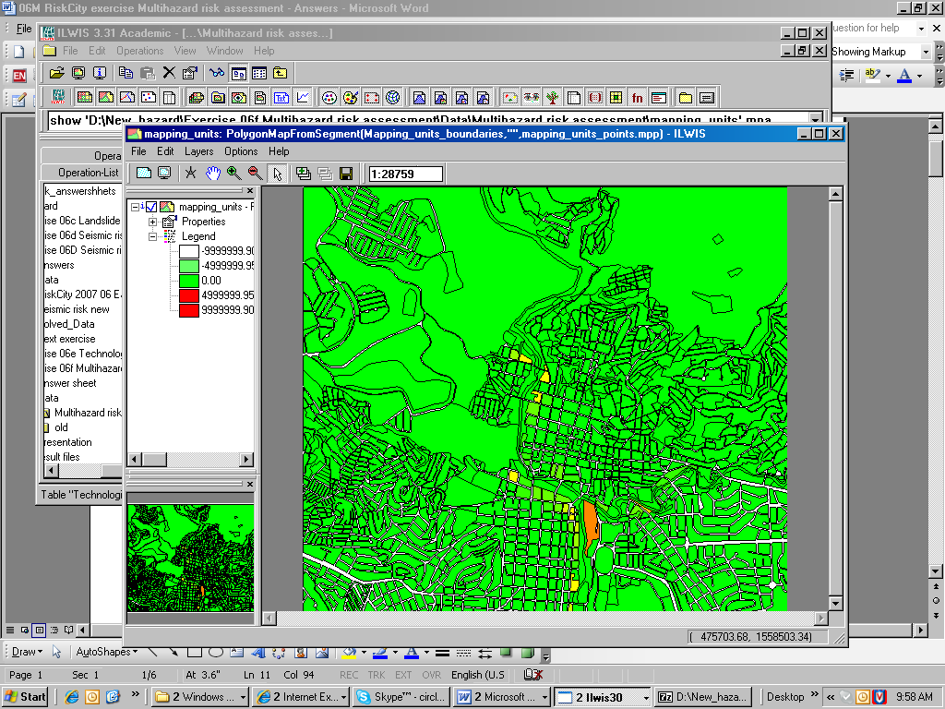
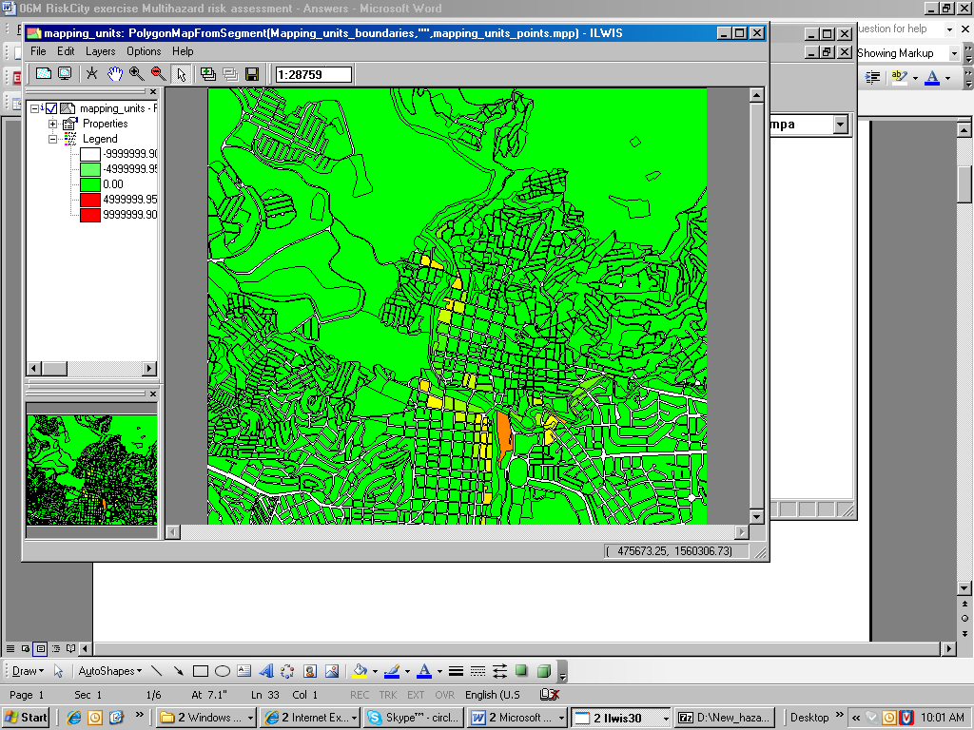
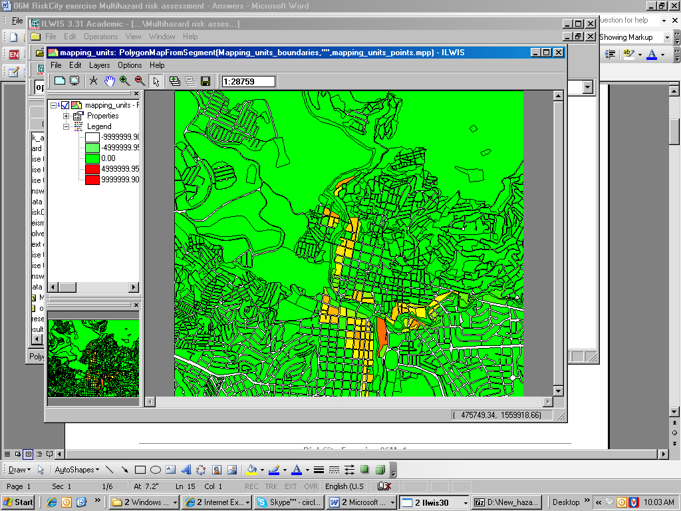
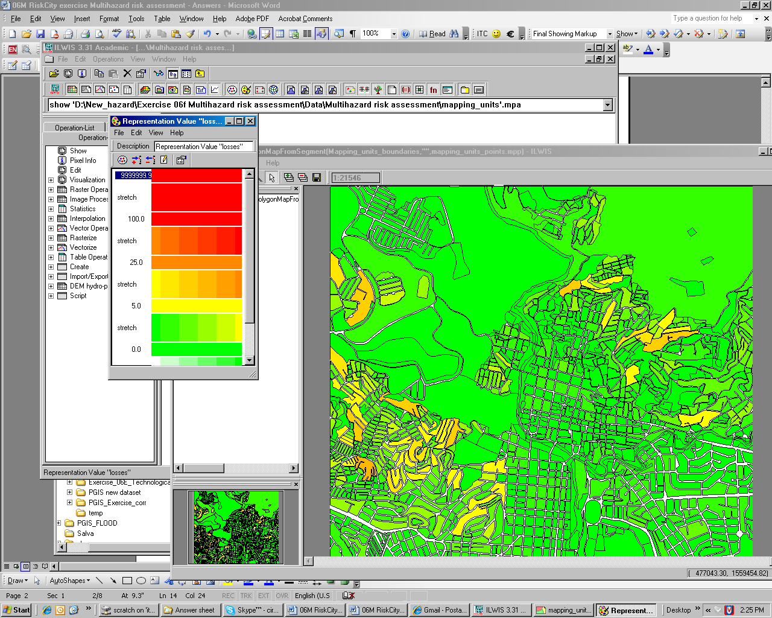
A: The following maps represent losses due to flood events with return periods of 1 into 10, 50, and 100 years.
Flood losses 100years return period

Flood losses 10years return period Flood losses 50years return period
The legend shows the losses in terms of building numbers. All the maps refer to the same legend

The affected areas are located next to the river and their dimensions increase at the increase of the flood event. It is clear how for a 100 years return period flood the damages are higher than a 50 years one. The losses are expressed in building numbers.

Q: Link the map Mapping_units to one of the other tables with building losses and also visualize them using the representation Losses. What can you conclude on the spatial distribution of the building losses throughout the city?

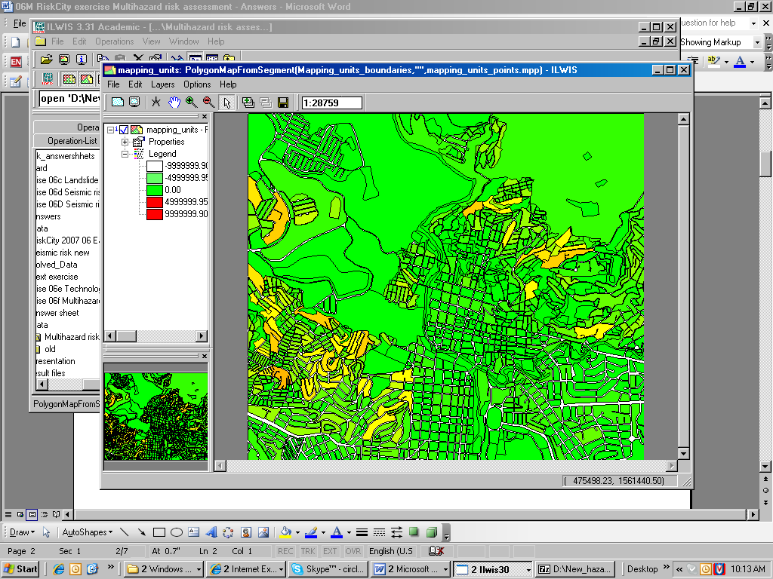
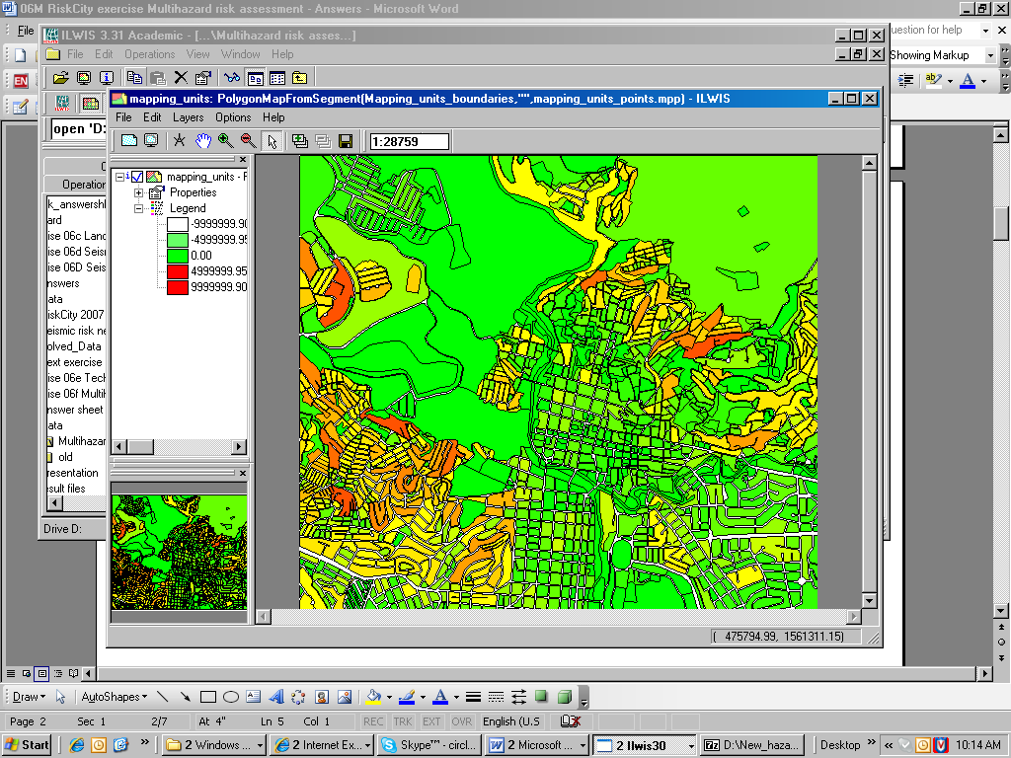
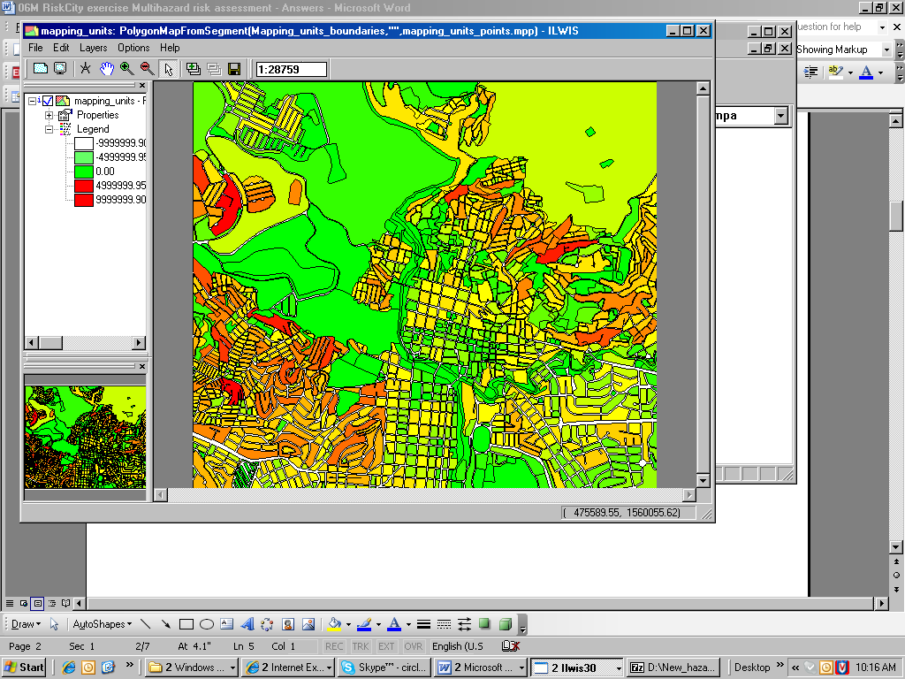
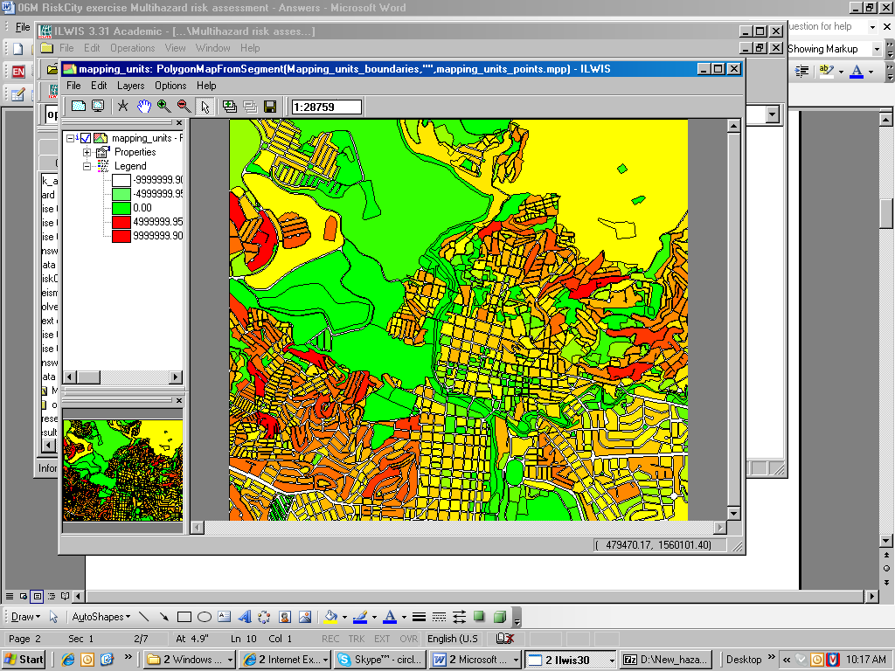
A: the maps below show the losses estimations for the four different scenarios of seismic hazard (expressed in MMI scale).
Seismic losses scenario VI losses Seismic losses scenario VII

Seismic losses scenario VIII losses Seismic losses scenario IX

Here we only show the losses related to two hazards: flood and seismic. Regarding such hazards we can state that the differences regard mainly two aspects: the spatial distribution, and the overall amount of losses. Concerning the spatial distribution, the losses due to floods are concentrated in the flooded areas, while the seismic losses are spread on the entire territory of RiskCity. The flood hazard is limited to the floodable areas close to the river, while the seismic hazard involves homogeneously all the city area (in this case we consider the impact as it has a homogeneous distribution without taking into account different eventual positions of the epicenter or different lithologies or other aspect that can affect the intensity distribution of an earthquake). The scenario VII corresponds to a 100 years return period event: therefore the losses related to this scenario can be directly compared to the losses coming from the 100 return period floods. Already through a visual comparison between the two maps we can easily state that the expected seismic losses are much higher than the flood losses for the same return period.

Q: Why are the building losses indicated in decimals, and not as integers? What could be the reason for that?

A: The risk assessment has been carried out at the building level. For each building a value of losses has been extracted with a range from 0 (no damage) to 1 (building totally damaged/collapsed). The total losses have been calculated by aggregating buildings losses information to the mapping unit: the losses for each mapping unit are the result of the sum of the losses for all the buildings within that particular mapping unit. Therefore the overall losses for each hazard scenario are indicated in decimals.

Page 06M - 5

Q: Answer the following questions and put the answers in the table below.

A:
Question | Answer
Which scenario has the largest building losses? | The highest losses are caused by the earthquake scenario IX (14459.05 buildings)
Compare scenarios with the same return period. Which one is the highest? | The common return period for considered hazards is one into 50 years. Among the different hazards the highest losses belong to the seismic hazard (scenario VI represents a earthquake with a return period of 1/50 years; the losses for that scenario are 1248.77)
Which mapping unit has the highest losses and in which scenario is that? (Hint: sort the table on the column with the highest losses in descending order) | The mapping unit with the highest losses is Nr_219, the details of the losses are showed in the figure below.
How many mapping units have no losses at all?  (Hint: sort the table on the column with the highest losses in ascending order) | 143 mapping units have no losses, due to the fact that no buildings are located within their area.
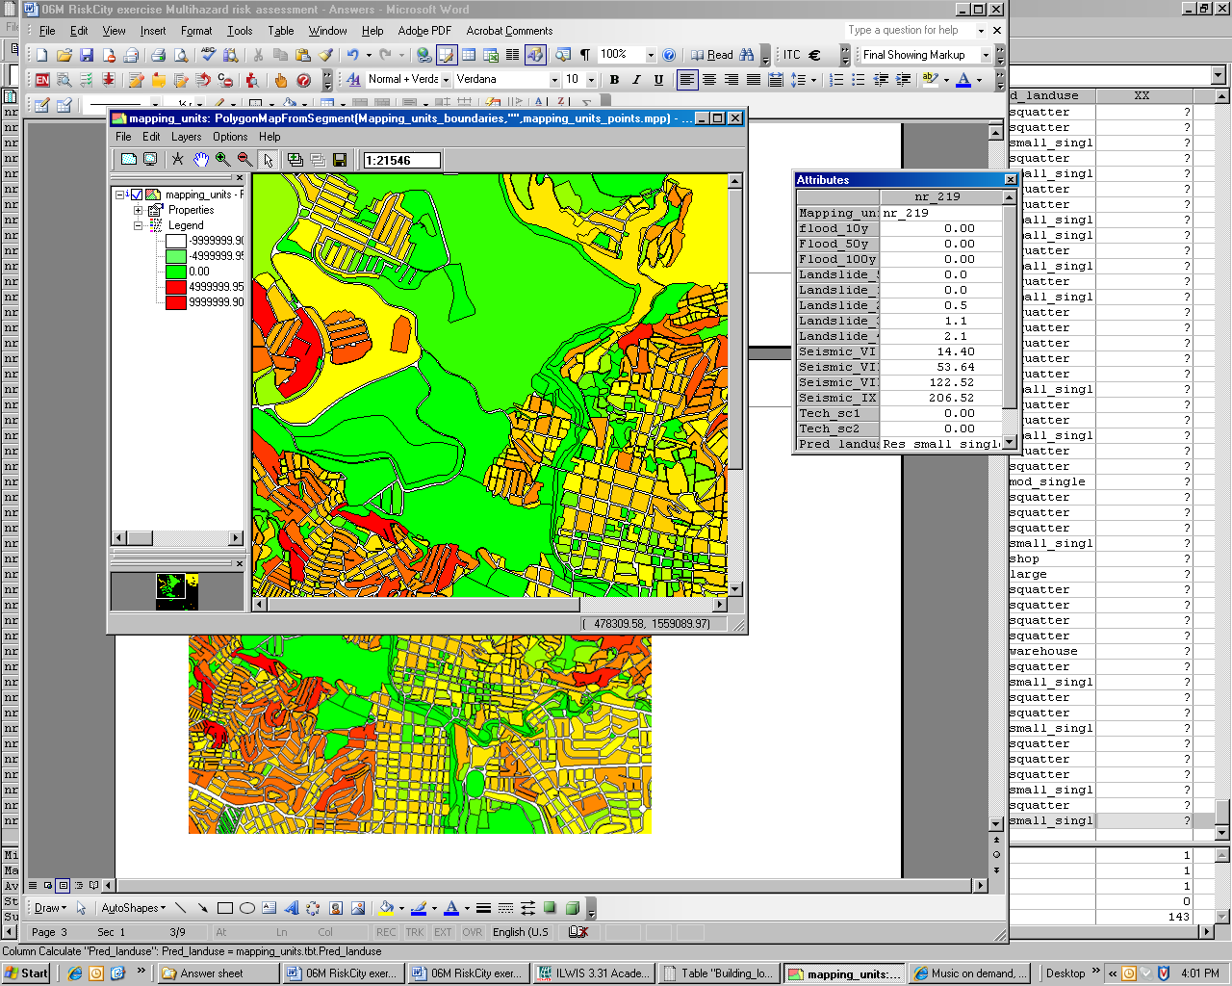
Mapping unit with the highest losses related to the Earthquake scenario IX.

Step 2: Generating risk curves for building losses.

Page 06M - 7

Q: Make 3 risk curves for landslide hazard:
Plot the Return Period on the X-axis and the Building Losses on the Y-axis
Plot the Return Period on the X-axis and the Specific Annualized risk on the Y axis
Plot the Building losses on the X-Axis and the Annual Probability on the Y-Axis.
Compare the three types of graphs. What can you conclude on the usefulness of the different risk curve type?

A1: This graph has the advantage that it is better visible which return periods have the largest contribution to the overall losses; from the graph it is possible to evaluate how the losses increase when the return period increases (look at the difference between the pattern of landslide’s and earthquake’s losses in the graph below).

A2: This graph enhances the contribution to the annual losses of each scenario; we can evaluate from the graph which scenario is the most crucial in the expected annual losses (in the seismic hazard for instance we can see, from this kind of graph, that the most contributing events are the ones with a return period of 100-150 years – see graph below with specific annualized risk).

A3: The risk curve representing the losses versus the annual probability, it can be used directly to calculate the Average Annual Losses (AAL). This is done by calculating the area under the curve (also Guide Book, session 6.5.5).

Q: Now also make these 3 types of curves for the other hazard types, and compare them. What can you conclude?

A1: From the graph it is clear how the expected losses caused by earthquakes are much higher than the other hazards. Concerning the overlapping return periods the flood hazard is the second major cause of losses.

A2: In this graph the specific annual risk is projected in relation to the return period for all the hazard types. The earthquake scenarios with return periods from 100 to 200 years are the most affecting the annual risk. Regarding very short return periods (1 to 10 years), flood events have a very high expected annual risk. Landslides and technological hazards contribute in minor part to annual risk

This graph has the advantage to allow the calculation of the Average Annual Losses (AAL); which is represented by the area under each curve. We cannot have a clear comparison among the different hazards risks because the return periods for each hazard don’t overlap. It is already clear with the data we have that the area under the seismic risk curve is the most contributing to the average annual loss.

