Exercise 06-T. Technological risk assessment - ANSWERS.

The answers follow the same order of the questions in the text.

Page 6E-1

Check the new column; what does the expression produce? What does the code %K stand for?
Hazardous = iff(landuse="Ind_hazardous",%K,?)

The expression produces a column “Hazardous” in which, every time the building has the landuse “Ind_Hazardous”, the “K column” content is stored. The symbol %K refers to the primary column of the table called “K column”; in the table Building_map_1998 it is the first one on the left without name in gray.

Page 6E-2

In RiskCity, there are 50 hazardous buildings. They belong to two building types: 31 buildings in bricks with cement, and 19 ones in reinforced concrete. The most vulnerable type among the two is brick with cement, because less stable and strong than the other.

6E.1 Hazard scenario modeling

Page 6E-3

Endpoint distances for the two scenarios:

Scenario 1: 395m
Scenario 2: 1410m

The most affecting variables are…

6E.2 Evaluating the areas affected

Page 6E-4

Vuln_Accident_1:=(395-Distance_Accident_1)/395
The distance map represents the distance in meters from the source (0m) to the end points (395m) for the first scenario. The equation creates a map with the distance in the reverse order: 395m at the source and 0m at the end points; then the values are normalized in a scale from 0 to 1 by dividing them by the maximum number (395). The map represents the vulnerability values and the lowest value is 0 at the end of the “distance” area.

Page 6E-5

The cross-tables Building_damage_1/2 represent the cross between the map Building_map_1998 and, in turn, the maps Vulnerqability_Accident_1 and _2. The resulting tables show for each building the areas with different vulnerability values. In the figure below, the three lines highlighted in red represent the building B_2910; each row refers to the area of the building (column: Area) with a different vulnerability value (column: Vulnerability_Accident_2). Through the command “Aggregation” and the function “Predominant”, the vulnerability value with the largest area is selected for the entire building (column Vulnerability_Building_2). This is the reason why the two columns slightly differ. The columns Vulnerability_accident1/2 and Vulnerability_building1/2 slightly differ.

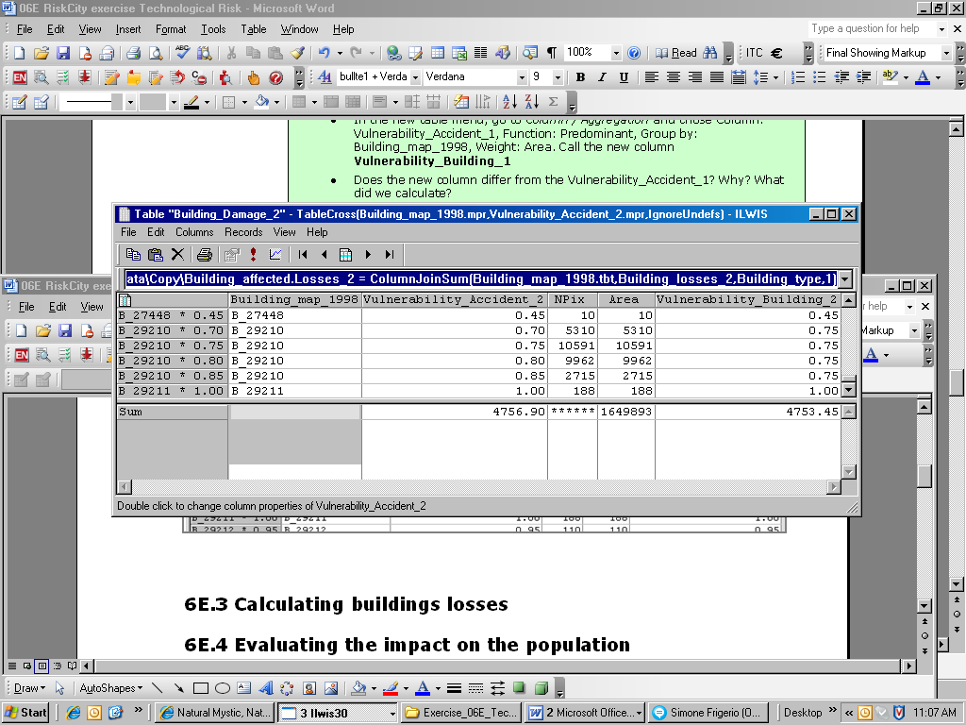

6E.3 Calculating buildings losses

Page 6E-6

From ILWIS Help file:“…A two-dimensional table is used to combine or reclassify two raster maps with a class or ID domain. It defines a value for each possible combination of input classes or IDs. A two-dimensional table consists of rows which represent one domain and of columns which represent another domain. In the two-dimensional table, you have to assign a value, class name or ID to the fields which represent the combination of these domains. When you apply the two-dimensional table on the command line of the Main window, you need two input raster maps which have the domains as used by the two-dimensional table, the output raster map then contains the values, classes or IDs that you entered in the fields of the two-dimensional table...” The two domains used to build the 2D table are the Building_type and the Nr_Floors_class. The 2D table represents a matrix in which the different values are stored for all the combinations between the classes or the identifiers of the two domains; in this case the vulnerability values all the combinations between number of floors and building types. When we apply it in the table Building_map_1998, we create a new column (Vuln_building_type) with the corresponding vulnerability value according to the building type and the number of floors of each building.

Table: Technological Risk
Building Type | Scenario 1 |  | Scenario 2
Building Type | Affected Buildings | Buildings Losses | Affected Buildings | Buildings Losses
Adobe | 12 | 4.8 | 455 | 79.3
Brick with Cement | 324 | 70.8 | 5134 | 1376.6
Brick with Mud | 164 | 44 | 2721 | 667.4
Fieldstone | 0 | 0 | 5 | 0.3
Reinforced Concrete | 227 | 23.6 | 1961 | 414.8
Wood and others | 227 | 23.6 | 1961 | 414.8
Total | 729 | 144.3 | 10646 | 2596.4

6E.4 Evaluating the impact on the population

Page 6E-8

 | Affected Population |  | Evacuated buildings
 | Day-time | Night-time | Nr of buildings | Nr of people
Scenario 1 | 2969 | 675 | 120 | 194
Scenario 2 | 86766 | 43886 | 1775 | 6168

The explosion occurred in densely built-up area; if we carefully check the use of the buildings (Landuse) we can realize that most of them contain commercial activities, shops, warehouses and workshops, offices. This is the reason why the daytime population is much higher than the nighttime population.

