Exercise 6F: Flood Risk Assessment.
Expected time: 3 hours
Data: data from subdirectory: Riskcity exercises/exercise06F/data
Objectives: This exercise will demonstrate how to combine flood depth information, for example generated by a flood model, with building data, such a location, height and construction materials into a flood risk assessment. For three flood scenarios with different return periods (10, 50 and 100 years) the risk will be assessed. At the end of the exercise one should be able to understand and replicate the steps in the procedure.

Riskcity has experienced several severe flood events, which have caused damage. In order to evaluate the flood risk, flood depth maps have been generated with a hydraulic model for different return periods. Because of the limited amount of time, will only consider only three flood scenarios with return periods of 10, 50 and 100 years.

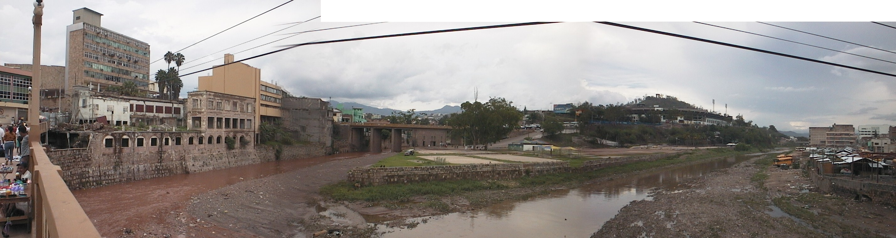
Figure Buildings in the confluence of the two rivers in RiskCity

Name | Type | Meaning
Flood data
Flood_100y, Flood50y, Flood_10y | Raster map | Flood depth maps resulting from flood modeling study for scenarios with 100, 50 and 10 year return period.
Building data
Building_map_1998 | Raster map | Updated map of buildings for the situation after the disaster of 1998. For all buildings information is available on the urban landuse, number of floors, building area, and total floorspace.

PART 1
In this exercise we follow the quantitative risk assessment approach, which tries to quantify the risk according to the risk definition given in chapter 1 of the Guide Book. As explained in chapter 1 this equation has the basic form:

Risk = Hazard * Vulnerability * Amount of elements-at-risk

This equation is not only a conceptual one, but can be actually calculated with spatial data in a GIS to quantify risk from hazards. The way in which the amount of elements-at-risk are characterized (e.g. as number of buildings, number of people, economic value or the area of qualitative classes of importance) also defines the way in which the risk is presented. The hazard component in the equation actually refers to the probability of occurrence of a hazardous phenomenon with a given intensity within a specified period of time (e.g. annual probability). For calculating risk quantitatively using equation 1 the vulnerability is limited to physical vulnerability of the elements-at-risk considered, determined by the intensity of the hazard event and the characteristics of the elements-at-risk (e.g. building type). The equation can be modified in the following way:

R_{S} = P_{T} * P_{L} * V * A

in which:
P_{T} is the temporal (e.g. annual) probability of occurrence of a specific hazard scenario with a given return period in an area;
P_{L} is the locational or spatial probability of occurrence of a specific hazard scenario with a given return period in an area impacting the elements-at-risk;
V is the physical vulnerability, specified as the degree of damage to a specific element-at-risk given the local intensity caused due to the occurrence of the hazard scenario;
A is the quantification of the specific type of element at risk evaluated.

It is important here to indicate that the amount can be quantified in different ways, and that the way the amount is quantified also the risk is quantified. For instance the amount can be given in numbers, such as the number of buildings (the risk is then the number of buildings that might suffer damage), number of people (e.g. injuries/ casualties/affected), the number of pipeline breaks per kilometer network etc. The elements at risk can also be quantified in economic terms. It is then usually expressed as damage.
In order to be able to evaluate these components we need to have spatial information as all components vary spatially, as well as temporally. The temporal probability of occurrence of the hazard scenario (P_{T}) has also a spatial component. For example a flood with a given return period has a certain extension, and spatial variation of intensity. The term (P_{L}) indicating the spatial probability of occurrence and impact. This is not relevant for all types of hazards, and in many cases this probability can be indicated as 1, given a specific hazard scenario (e.g. the area that will be flooded given a return period of 50 years).

- Open the raster map Flood_100y and add the raster map building_map_1998. Make this last map 50% transparent. Open the Pixel-Information window and explore the flooded areas and the water depths at these locations.
- Close the map window.

As you can see large parts of the center of the city are flooded, but also further North you will find buildings that are affected by the water. The water depths may reach up to 8 meters in certain locations!
In the following exercise we will analyse how many buildings are affected in the three flood scenarios.

- Create a flood extent map by typing:
floodextent_010:=ifundef(flood_10y,0,1)
QUESTION 6F1:
What does this statement do?

- Look at the result.
- Cross the map buildings_map_1998 with the map floodextent_010 and create a cross-table building_flooded_010.
- Open the cross-table and add a column with the surface area of the houses. Do this using the join operator in the column menu. The surface area information can be found in the histogram building_map_1998, and add the column “area”, but name it area_building.

QUESTION 6F2:
Why is this newly added column different from the existing column “area”? Are the values different for all rows?

- Calculate the area percentage of the buildings affected by typing:
Perc_affected_010:= iff(floodexent_010=1,area/area_building,0)
- Calculate the number of buildings that are partially affected by the flood by typing:
partially_flooded_010 := iff(perc_affected_010>0,1,0)
- And calculate the number of buildings that are completely flooded:
completely_flooded_010 = iff(perc_affected_010=1,1,0)

QUESTION 6F3:
How many houses are now completely flooded and how many partially? How many buildings are affected in total?

- Repeat this whole procedure for the other two flood maps (from the top of this box)
- Write down the number of buildings affected (total), and plot them in a risk graph See two examples below.

QUESTION 6F4
How is the risk quantified in this assessment?

Two ways to represent a risk curve. Left: Plotting losses against return period. Right: plotting losses against annual probability.

There are several ways to express economic losses. The Probable Maximum Losses (PML) is the largest loss believed to be possible in a defined return period, such as 1 in 100 years, or 1 in 250 years. In the graphs shown above the PML for 1 in 1000 years is 1400. The risk can also be represented as a curve, in which all scenarios are plotted with their return periods or probability and associated losses. Such a risk curve is also called the Loss Exceedance Curve (LEC). The left graph has the advantage that it is better visible which return periods have the largest contribution to losses. The right curve can be used directly to calculate the Average Annual Losses (AAL). This is done by calculating the area under the curve (also Guide Book, session 6.5.5).

We will now add the calculated percentage of buildings affected to the table building_map_1998.

- open the table: Building_map_1998
- Join to this table the table buildings_flooded_010, column perc_affected_010.
- Follow the steps through the join-wizard. Because the building_flooded_010 has more than one record for some buildings so you need to select an aggregation function.
- Select: MAXIMUM.

QUESTION 6F5:
Why are there more than one record for some buildings in the table building_flooded_010;
Why is the function “Maximum” the appropriate choice?

- Repeat this procedure (from the top of this box) for the other two flood scenarios (add columns perc_affected_050 and perc_affected_100 to the table building_map_1998)

PART 2
In the following part of this exercise we will make a link between the building properties (vulnerability of the elements-at-risk) and the characteristics of the hazard (in this case, flood depth). In order to do this we have to prepare the data to be able to make this link; The flood depth maps must be classified (sliced in ILWIS terminology) and the buildings must be characterized in a way that makes sense for flood risk. Based on experience of past flood events there are two major characteristics of buildings that define the vulnerability. These are: construction material and number of floors. We will create a new class based on a combination of these two parameters and we will link these with the classified flood depth maps.

We will classify the three flood depth maps (flood_10y, flood_50y and flood_100y.

- Create a group domain Flooddepth and insert the following class-boundaries:

Upper Boundary | Class Name | Code
0.5 | < 0.5 m | 1
1 | 0.5 – 1.0 m | 2
3 | 1.0 – 3.0 m | 3
6 | 3.0 – 6.0 m | 4
99 | > 6 m | 5

- Slice the three flood depth maps and name the: flood_010_cla, flood_050_cla and flood_100_cla.

Now we prepare the building characteristics. Step 1 is to create a domain with the three main types of building materials:

- Create a class domain building_mat and insert the following three classes:

Class name | Code
Adobe and wood | a
Brick | b
Concrete | c

- Right-click on the domain landuse and select “create table”. Name it building_mat
- Open the table building_mat and add a column building_mat and give it the domain building_mat
- Fill in the table as shown in the figure below.

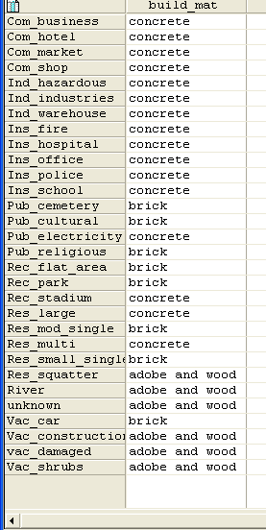

Step 2 is to reclassify the building according to their number of floors. This was already done in the table building_map_1998, but this classification does not suit our purpose. We want to have the houses classified in three classes: 1 floor buildings, 2 floors and n floors. We do this because the floods usually affect the first (ground) floor, sometimes the second floor and only in exceptional cases it reaches the higher floors.

- Create a group domain Nr_floors and insert the following classes:

Upper Boudary | Class name | Code
1.5 | 1 floor | 1
2.5 | 2 floors | 2
99 | >2 floors | n

- Open the table building_map_1998
- In order to reclassify the number of floors type the following in the table command line:

Nr_floors_flood := CLFY(nr_floors,Nr_floors)

- Now we want to add the construction material to the table. We do this using the join option in the column menu.
- Select the table Building_mat, column Building_mat and go through the join-wizard accepting all defaults.

In the following step we will merge the building material with the number of floors so we have characterized the buildings as a function of these two parameters.

- Type the following instruction in the table command line:

Build_type:=code(build_mat)+code(nr_floors_flood)

A new column is added to the table with 9 codes: a1, a2, an, b1, b2, bn, c1, c2 and cn.

QUESTION 6F6:
What do these codes mean?

a1 =

a2 =

an =

b1 =

b2 =

bn =

c1 =

c2 =

cn =

The domain of these codes is “string” (check this!).

- Double-click on the column header and select the option “create domain from strings in column”. Domain name is Build_type
- Close the table.

- Adjust the representation of build_type to the following colour scheme:

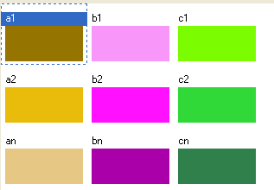

- Create an attribute map build_type from the raster map building_map_1998 (select column build_type) and have a look at the resulting map.

We have now almost all the required data for the flood risk assessment: We have a map with a characterization of the buildings (build_type) and we have three maps for different flood hazard scenarios (flood_010_cla, flood_050_cla and flood_100_cla). The only thing lacking are the vulnerability curves like the ones you created in exercise 5a. In the following, final part of this exercise we will create a 2-dimensional table in which we insert the flood vulnerability curves for each of the 9 buildings types. With this table we will obtain the damage fraction to the buildings caused by the flood.

- Create a new 2-dimensional table. Give it the name flood_vuln; Primary domain = build_type, secondary domain = depth. The value range is: 0 to 1 and precision is 0.01
- Fill in the table as shown in the figure below.
- Close the table

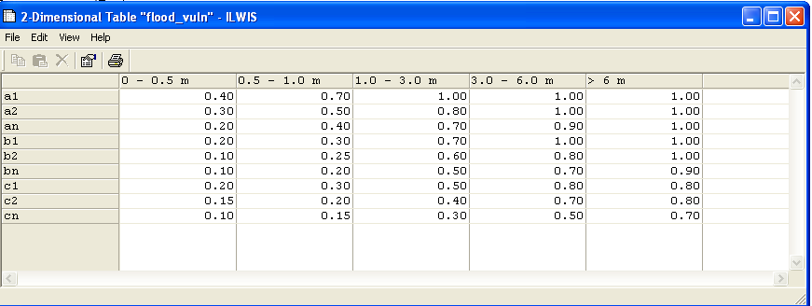

e space
QUESTION 6F7:
The 2 dimensional table represents 9 vulnerability curves. Please draw the 9 curves in this space:

The 2-dimensional table is used to integrate the data from two different maps into one output map. We will compare the depth map with building type map and for each pixel the corresponding output value is read from the table, e.g. build_type = c2 and flood depth = 1.0 – 3.0 m, then the vulnerability value = 0.40.

- To use the 2-dimensional table, type the following statement in the command line of the ILWIS catalogue window:

build_damage_010:=flood_vuln[build_type,flood_010_cla]

Question 6F8:
What does the output map represent? How is the risk expressed in this map?

- Repeat the use of the 2-dimensional table for the other two flood scenarios.

Now the flood risk maps are finished. However, it is useful to be able to represent this map as an attribute map to the map building_map_1998. To do that we first cross the build_damage maps with the building_map_1998 and then we join the resulting table to the table building_map_1998.

- Cross the building_map_1998 with the build_damage_010 map and name the output table: build_1998_damage_010.
- Open the table building_map_1998 and join it with the new table build_1998_damage_010; select column build_damage_010.
- Go through the join-wizard accepting the defaults but at the last window select as aggregation function “maximum” (There are some buildings that fall in two damage classes, and we select the worst case option).

- Repeat this procedure for the other two flood scenarios.

Now the building damage for each flood scenario is added to the building_map_1998 table. If we now would know the value of each building, the total damage of each flood scenario can be calculated and a risk curve can be constructed. This will be done in a later exercise.

To be delivered:
The three build_damage_xxx maps (screen-dumps or exported as bitmaps).

