Exercise 6A. Qualitative risk assessment.
Expected time: 1 hour
Data: data from subdirectory: Riskcity exercise/exercise06a/data
Objectives: This exercise shows you a simple method for qualitative risk assessment, using a matrix to combine qualitative vulnerability and susceptibility classes. We take landslide risk as an example here.

Input data
In this exercise we will use the landslide susceptibility map (Susceptibility) that was generated using statistical method as in exercise 3L. For the elements at risk we will use the mapping units representing the building blocks. The map Landslide_ID is also required in order to change the susceptibility map into a hazard map, with the temporal landslide information.
Name | Type | Meaning
Elements at risk
Mapping_units | Raster | Building blocks of the city
Mapping_units | table | Table containing general statistical information on the number of buildings and people per building block
Landslide data
Landslide_ID | Raster | Points within each of the interpreted landslides with associated attribute table
Landslide_ID | Table | Attribute table with information on the landslides in the area.
Susceptibility | Raster | Landslide susceptibility map made using a statistical method.
Other data
High_res_image | Raster | High resolution image of the study area.
Landuse | Table | Land use classification of the study area

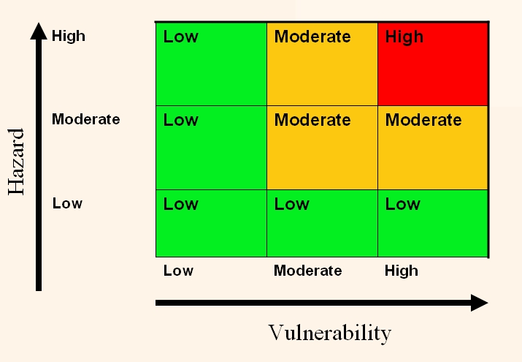
In situations where there is not enough temporal information available to be able to estimate the hazard probability, it is better to use a simple method that combines qualitative hazard and vulnerability maps. The qualitative hazard map is in fact the susceptibility map, and the vulnerability map is showing the number of elements at risk (buildings and population in this case).
The matrix approach is based on the combination shown in the figure.
We will use the landslide susceptibility map, in which the actual landslides have been included as high susceptibility if they are active or as moderate susceptibility if they are old landslides. The landslide susceptibility map is called Susceptibility. We will also use the map Mapping_units and the table linked to that for analyzing the vulnerability.

Making the vulnerability map

- Rasterize the map mapping_units using the georeference Somewhere.
- Open the table Mapping_units and have a look at the various columns
- Open the map Susceptibility and check the contents, also by overlaying the landslides.

As you can see this table contains columns indicating the number of buildings and population per unit. We will use these columns for making a simple subdivision into three vulnerability classes. We will use the number of buildings, and we will use the following, very simple, classification (open for improvement if you like), indicate in the table.
This is of course a large simplification. If more time was available the vulnerability could be better evaluated using Spatial Multi Criteria Evaluation with many more criteria.
 | Number of buildings per unit | Nighttime population
Low vulnerability | < 5 | < 3
Moderate vulnerability | 6 – 25 | 4 -20
High vulnerability | > 25 | > 20

We will here only use the number of building for the Vulnerability matrix, but you can also see the result later if you base it on population.

- Check the class domain Vulnerability,it has three classes (Low_v, Moderate_v, High_v). (If not present; make the class domain.)
- In the table Mapping_units create a column Vuln_buildings, which contains the criteria for the buildings in the table above, using a formula:
Vuln_buildings:=iff(nr_buildings<5,”Low_v”,iff(nr_buildings<25, “Moderate_v”, ”High_v”)) use; doman; Vulnerability
- In the table Mapping_units create a column Vuln_population, using a formula, based on the criteria given in the table above. Design the formula yourself.
- Combine the two types of vulnerability (from vuln_buildings and vuln_population)and determine the highest class in a formula. HINT: use the OR operator in your formula. Design the formula in the table yourself. Name the output column: vulnerability (Use the same domain Vulnerability)
Be careful to use the domain Vulnerability for the column “vulnerability” otherwise you cannot create the attribute map “Vulnerability”.
Is not possible derive an attribute map from a string domain.
Now that you have generated a column Vulnerability, you can simply make an Attribute map of this from the map Mapping_units.

- Create an attribute map using the raster map Mapping_units, and the column Vulnerability.

Combining hazard and vulnerability
The next step is to combine the Vulnerability and the Susceptibility map into a qualitative risk map. We can do this using a so-called two-dimensional table, which looks like the matrix shown in the figure above.
Be careful to make in the window of the 2-dimensional table a new domain Risk, with three classes: High_risk, Moderate_risk, and Low_risk

- Select File, Create, 2 Dimensional Table. Enter the following parameters:
Table name: Qualitative_risk
Primary Domain: Susceptibility
Secondary Domain: Vulnerability
Contents Domain: make a new class domain Risk, and add the classes High_risk, Moderate_risk, and Low_risk.
- On the command line execute following formula:
Qualitative_risk = Qualitative_risk [Susceptibility,Vulnerability]

Have a good look at the resulting qualitative risk map.

- Calculate the percentage of the area with high, moderate and low risk.

Percentage of the area
High landslide risk
Moderate landslide risk
Low landslide risk

For experienced ILWIS users
- For experienced ILWIS users:
Improve the vulnerability map
- This map can be improved by using another classification of the vulnerability components, for example by including also the the urban landuse as criteria in the analysis. Try to do this and see if it improves the result.

- For experienced ILWIS users:
Improve the susceptibility map
- You can also improve the method by using 4 hazard classes, including a very high hazard class that contains the recent landslides. Adapt the matrix so that it includes 4 classes of hazard and vulnerability.

