Answer sheet. Exercise 6a. Qualitative risk assessment

Making the vulnerability map
 | Number of buildings per unit | Nighttime population
Low vulnerability | < 5 | < 3
Moderate vulnerability | 6 – 25 | 4 -20
High vulnerability | > 25 | > 20

- According to the table above, the formula for the population vulnerability is:

Vuln_population:=iff(Nighttime_population<3,"Low_v",iff(Nighttime_population<20,"Moderate_v","High_v"))

- Then the formula for the combined vulnerability, between the vulnerability of the population and the vulnerability of the buildings is:

Vulnerability:=iff((Vuln_buildings="High_v")or(Vuln_population="High_v"),"High_v",iff((Vuln_buildings="Moderate_v")or(Vuln_population="Moderate_v"),"Moderate_v","low_v"))

Use the domain “Vulnerability”.

- The result map is shown below.
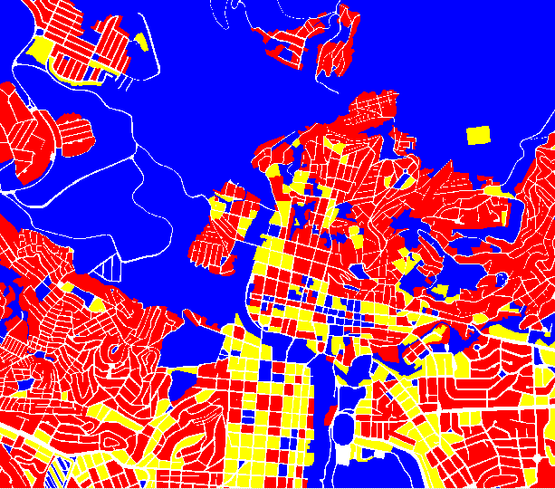
Vulnerability_map

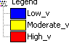

Combining hazard and vulnerability
Creating the two-dimensional table: Make sure to click the create domain button and create the class domain “Risk” with three classes. Note that you can change the order in which they appear by selecting Edit, Manual Sorting in the Domain Editor.

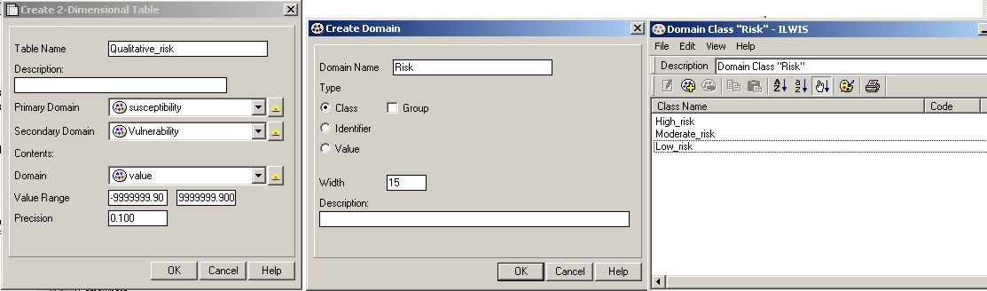

Below are shown the 2-Dimensional Table “Qualitative_risk” and “Qualitative_risk” map.
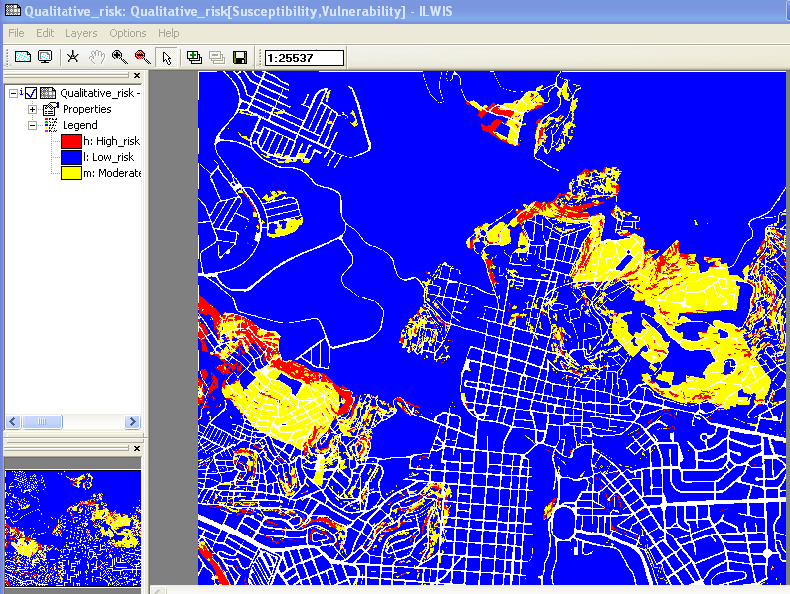
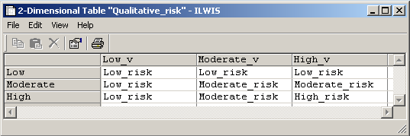

Qualitative_risk 2-D table.

Qualitative_risk map.

We want to know the percentage of the area with high, moderate and low risk.

- Open the catalog of ILWIS, select the Qualitative_risk map, right click, statistics, histogram.
- Read the value from the histogram and fill the table below, then you can calculate the percentage
- See the images below.

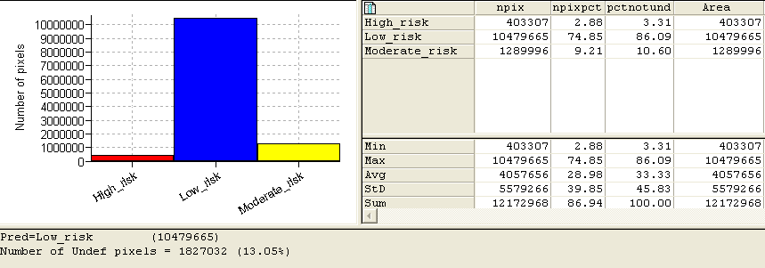
Histogram of Qualitative_risk.
The Area is expressed in number of pixel, but since the pixel size is 1m you can use directly these values as area (expressed in m^2).

 | Area | Percentage of the area | Percentage_area ( excl undef)
High landslide risk | 403307 | 2,88% | 3.31%
Moderate landslide risk | 1289996 | 9.21 | 10.60%
Low landslide risk | 10479665 | 74.85 | 86.09%

From this table we can read that most of the area is classified as “Low_risk”.

Keep in mind that this table has been derived considering the nighttime scenario. This means that the Qualitative_risk map shows the spatial distribution of the risk during the night.

For experienced ILWIS users

Improved vulnerability map

- We are here considering the vulnerability based on the land use classes. The first step is to aggregate the land use classes in 3 classes (Low_v, Moderate_v, High_v). Following is shown our clustering but you can make a different classification if you are not agree.

Low Vulnerability | Moderate Vulnerability | High Vulnerability
Vac_shrubs  Vac_damaged  Vac_construction  Vac_car  River  Rec_park  Rec_flat_area  Pub_cemetery | Res_large  Rec_stadium  Ins_office  Ind_industries  Comm_shop  Comm_market  Comm_hotel  Comm_business  Ind_warehouse  Res_multi  Res_mod_single | Res_squatter  Res_small_single  Ins_school  Pub_electricity  Pub_religious Ins_police  Pub_cultural  Ins_hospital  Ind_hazardous  Ins_fire | High population density  High population density  Vulnerable age group and high density  High change of secondary damage  Important cultural value  Important for law and order and rescue  High population density, important cultural value  Important for the medicals emergency  Possible technological risk – domino effect  Important for the response phase
Clustering of the landuse classes.

- Open the table Landuse and create new column called Vuln_landuse using the domain “vulnerability”. Select the class values according to the table above. Use the domain Vulnerability.

- Open the table mapping_units and join with the column Vuln_landuse from the table Landuse.

- We need now to combine the 3 type of vulnerability (buildings, population and landuse). We are going to assign the maximum value of vulnerability among the 3 type, to the mapping units.
Type the formula:

Total_vulnerablility:=iff((Vuln_buildings="High_v")or(Vuln_population="High_v")or(Vuln_landuse=”High_v”),"High_v",iff((Vuln_buildings="Moderate_v")or(Vuln_population="Moderate_v")or(Vuln_landuse=”Moderate_v”),"Moderate_v","low_v"))

Use the domain Vulnerability.

We need now to check the results and how much is improved the new vulnerability map related to the Vulnerability map based only on the population and number of buildings.
- Create an attribute map from the column “Total_Vulnerability” and call it Total_Vulnerability.
- Display the results.
- Create a histogram from this map (right click on Total_vulnerability, statistic, histogram).
- Create also a histogram of Vulnerability map of the previous exercise (the vulnerability map based on population and buildings).
- Compare the results graphs.
- Open a spreadsheet and compare the results.

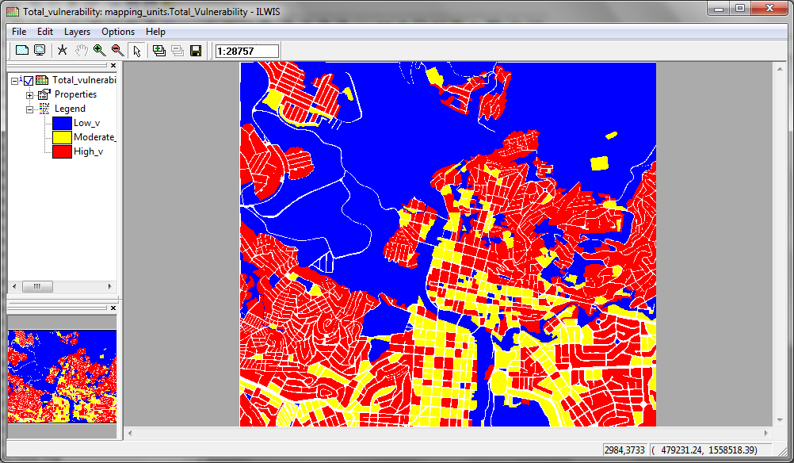
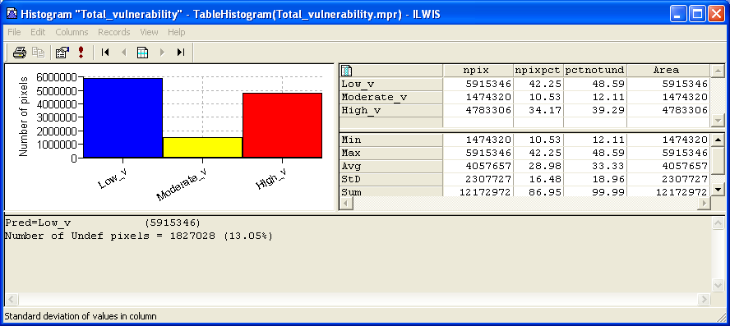

Histogram of Map Total_Vulnerability.
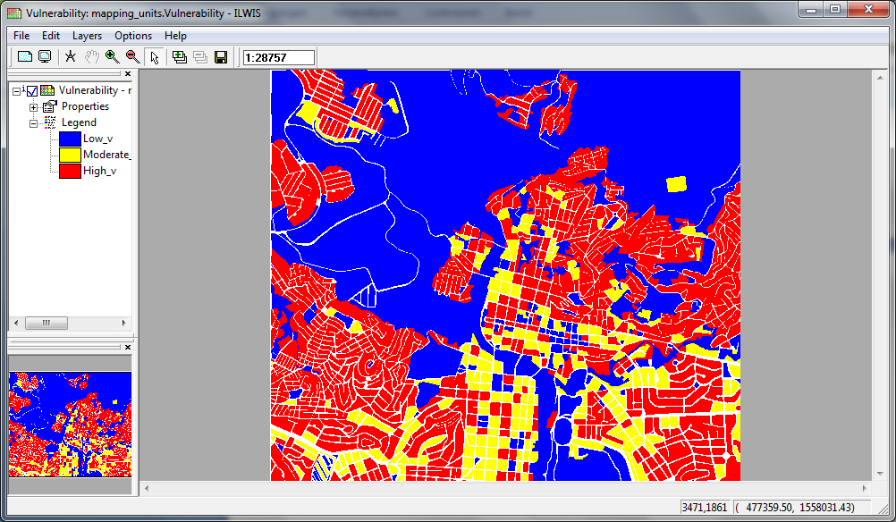

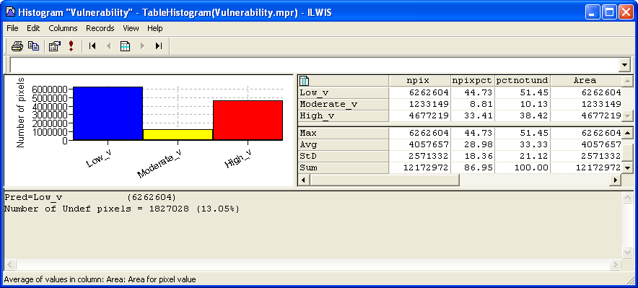

Histogram of Map Vulnerability.

Having a look to the results table is possible affirm that the vulnerability classes are changed only marginally, with an increasing of the high vulnerability. This is obvious because using the “or” operator in the combination of the 3 type of vulnerability, we are assigning the higher value of vulnerability. This it means that the classes where the old values were “Low_v” or “Moderate_v” and in the new field are “High_v” , will be “High_v”, while in the case of new field with a classes of vulnerability lower then the previous vulnerability, the final value will be the same then before.
 | percentage
Vulnerability classes | Vulnerability | Total_Vulnerability | Change
Low_v | 51.45 | 48.59 | -2.86
Moderate_v | 10.13 | 12.11 | 1.98
High_v | 38.42 | 39.29 | 0.87

- For experienced ILWIS users:
Improve the susceptibility map
- Cross the susceptibility_map with the landslide_id.
- Include Undefined. Call the result table and the result map Susceptibility_landslide.
- Join the cross table Susceptibility_landslide with the landslide_id and read in the column activity then type the following formula:

Susceptibility_very_high:=iff(Activity="a","Very_High",susceptibility)
Add the string “Very_high” to the domain “Susceptibility”.

- Create an attribute map using the cross map Susceptibility_landslide and use the column susceptibility_very_high from the Susceptibility_landslide table.
- Show the results.

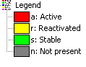
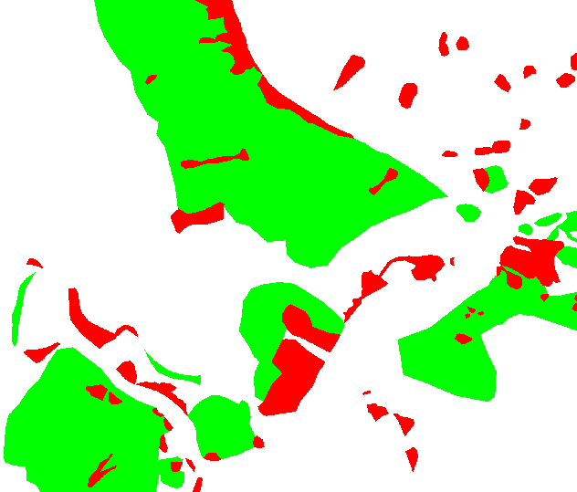
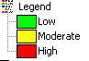
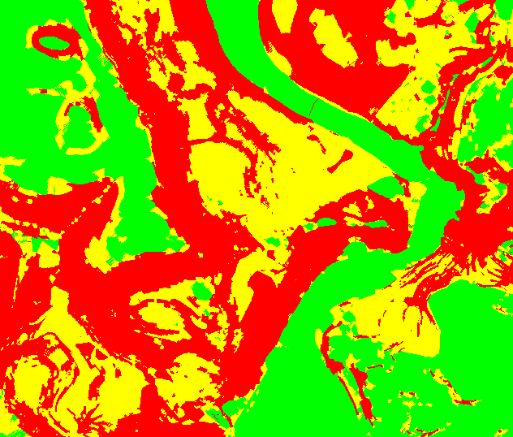
Landslide_id

Susceptibility_map

Cross operation

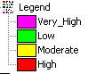
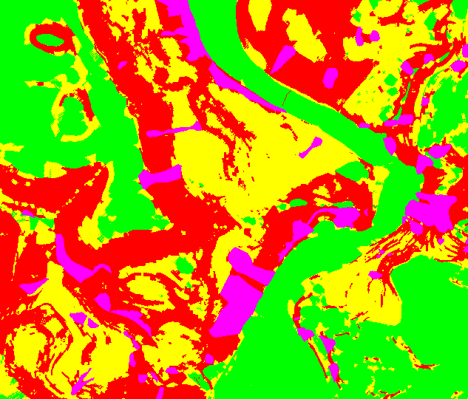
Attribute map
Susceptibility_Very_high

