Exercise 5b. Spatial Multi Criteria Evaluation for vulerability and qualitative risk assessment.
Expected time: 3 hours
Data: data from subdirectory: RiskCity_exercises/exercise05b/data
Objectives: In this exercises you will generate a number of indicators for social vulnerability, based on different administrative units. Also indicator maps of physical vulnerability will be generated, as well as some capacity indicators. The social and physical vulnerability indicators are combined into an overall vulnerability indicator using Spatial Multi Criteria Evaluation.

Introduction

Spatial multi criteria evaluation is a technique that assists stakeholders in decision making with respect to a particular goal (in this case a qualitative risk assessment). It is an ideal tool for transparent group decision making, using spatial criteria, which are combined and weighted with respect to the overall goal. For implementing the analysis in the RiskCity case study, the SMCE module of ILWIS was used (ITC, 2001). The input is a set of maps that are the spatial representation of the criteria, which are grouped, standardized and weighted in a criteria tree. The theoretical background for the multi-criteria evaluation is based on the Analytical Hierarchical Process (AHP) developed by Saaty (1980).
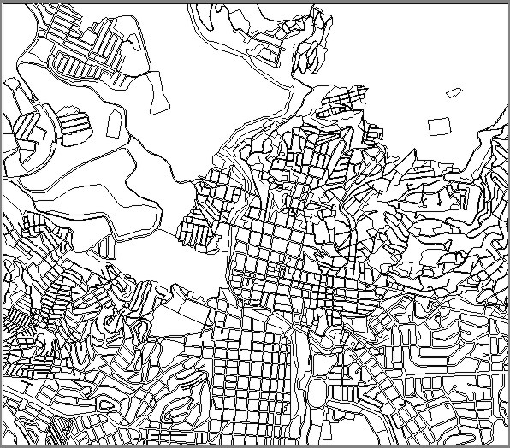
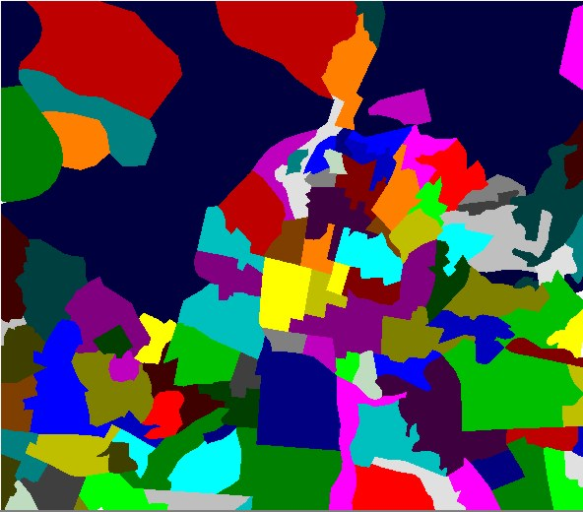
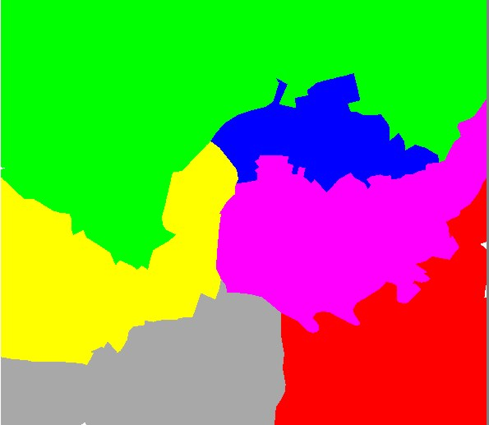
In the analysis a number of steps were followed. First the problem was structured into a main goal (Qualitative risk assessment) and a number of sub-goals. The main sub-goals identified were Social Vulnerability, Population Vulnerability, Physical Vulnerability, and Capacity. An overview of the criteria used for each sub-goal is presented in Figure 4. For each of these sub-goals a number of criteria were defined, which measure their performance. Once this was defined, a criteria tree was created, which represents the hierarchy of the main goal, sub-goals, and criteria. For each of the criteria a link was made with the relevant spatial and attribute information. In the RiskCity case study the vulnerability and capacity criteria are linked to three different spatial levels: mapping units, wards, and districts within the city. As the criteria were in different formats (nominal, ordinal, interval etc.) they were normalized to a range of 0-1. The criteria classes were weighted against each other, then the criteria belonging to the same sub-goal and eventually also the sub-goals themselves were weighted, using either pair wise comparison, or rank ordering methods. Once the standardization and weighting was done, a composite index map was calculated for each sub-goal, and eventually the qualitative risk map was produced, and classified into a number of classes.
The data for this exercise is stored in a number of tables that can be linked to the polygon maps of the three different administrative levels: Mapping_units (the smallest subdivision which are mostly building blocks surrounding by streets), Wards (neighborhoods of the city) and (the whole city is composed of 5 districts).
These three different administrative units also have different attribute information related to it. For example, demographic information from the city is only available at a generalized district level. Unemployment information is available at ward level, whereas information on poverty level and social structure is available even at building block level.
There is also a fourth level, which is the level of individual buildings (map Building_map), however at this level we don’t have any relevant information that can be used as indicators in the Spatial Multi-Criteria Evaluation.

Input data

The following data are used in this exercise.
Name | Type | Meaning
Elements at risk
Mapping_units | Polygon | Building blocks of the city
Mapping_units | table | Table containing general statistical information on the number of buildings and people per building block
Wards | Polygon | Ward of the city
Wards | Table | Table with population information derived from census data for the wards in the city
Districts | Polygon | Districts of the city
Districts | Table
Losses for different types of hazards
Flood_risk_buildings  Seismic_risk_buildings  Technological_risk_buildings  Landslide_risk_buildings | Tables | Tables with the results of the loss estimations for flooding, earthquakes, landslides and technological hazards for buildings. These are the results of the previous exercises
Flood_risk_population  Seismic_risk_population  Technological_risk_population  Landslide_risk_population | Tables | Tables with the results of the loss estimations for flooding, earthquakes, landslides and technological hazards for buildings. These are the results of the previous exercises
Other data
High_res_image | Raster | High resolution image of the study area.
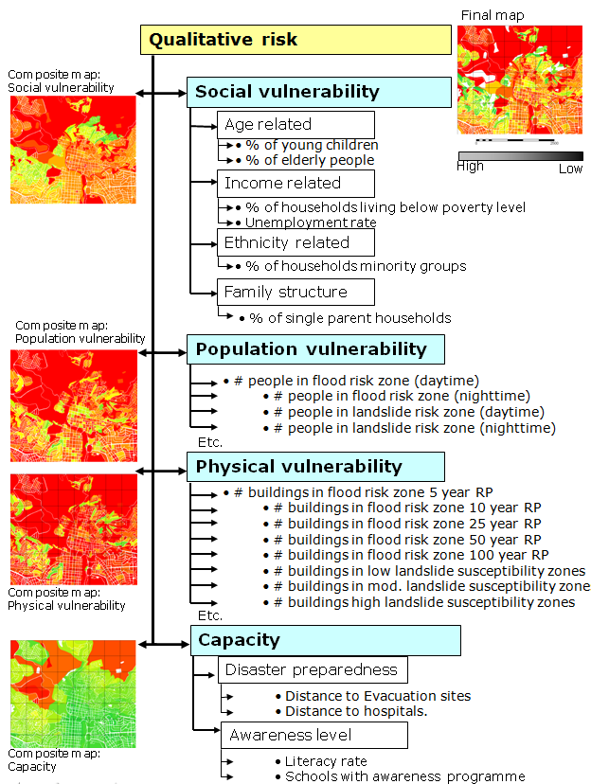

Selecting the indicators and general approach

- Open the map Mapping_units , and add the maps Wards, and Districts. Rasterize these maps; use geo reference Somewhere.
- Use PixelInformation to find out the information from the attributes linked to these maps.
Out of these data we will generate the following four sets of indicators:
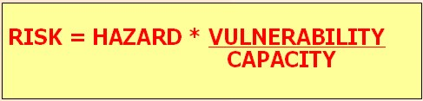
In this exercise we are using the Risk relation as indicated left. We would like to include both vulnerability as well as capacity. Capacity expresses the positive managerial and operational resources and procedures for reducing risk factors
1. Social vulnerability indicators, indicated in table 1, such as:
- Percentage of young children
- Percentage of elderly people
- Population density in daytime
- Population density in nighttime
- Percentage of minority groups
- Percentage of single parent households
- Percentage of households living below poverty level.
- Literacy rate
2. Population vulnerability indicators (indicated in table 2)
- Number of people located in flood hazard zones, with different return periods, and with both a daytime and nighttime scenario
- Number of people located in landslide hazard zones, with different degree of susceptibility to landslides, and with both a daytime and nighttime scenario
- Number of people located in technological hazard zones, with different degree of susceptibility to landslides, and with both a daytime and nighttime scenario
- Number of people located in seismic hazard zones, with different intensities and return periods and with both a daytime and nighttime scenario
3. Physical vulnerability indicators (indicated in table 3)
- Number of buildings located in flood hazard zones, with different return periods
- Number of buildings located in landslide hazard zones, with different degree of susceptibility to landslides
- Number of buildings located in technological hazard zones, with different degree of susceptibility to landslides
- Number of buildings located in seismic hazard zones, with different intensities and return periods
4. Capacity indicators
- Awareness

Table 1: Overview of available data for Social vulnerability assessment
Map | Table | Column | Meaning
Districts | Districts | Age_under_4 | Percentage of young children, of pre-school age
Districts | Districts | Age_4_to_12 | Percentage of children, of primary school age
Districts | Districts | Age_12_18 | Percentage of teenagers, of secondary school age
Districts | Districts | Age_18_24 | Percentage of adolescents, following further education
Districts | Districts | Age_24_65 | Percentage of population in working age
Districts | Districts | Age_over_65 | Percentage of retired people.
Districts | Districts | Minor | Percentage of population coming from minority groups.
Wards | Wards | Nr_buildings | Number of buildings per ward
Wards | Wards | Daytime_population | Daytime population per ward
Wards | Wards | Nighttime_population | Nighttime population per ward
Wards | Wards | Unemployment | Unemployment rate per ward
Wards | Wards | Literacy_rate | Literacy rate per ward
Mapping units | Mapping units | Pred_landuse | Predominant landuse per mapping unit
Mapping units | Mapping units | PerVacant | Percent of mapping units that is vacant and could be used as shelter area, if it has the right landuse
Mapping units | Mapping units | Percent_single_ household | Percentage single household per mapping units
Mapping units | Mapping units | Poverty_level | Percentage of population in mapping unit living below poverty level

Apart from the social vulnerability indicators, we also take into account the population vulnerability indicators, which are given in the table below.

Table 2: Overview of available data for population vulnerability.
Map | Table | Column | Meaning
Table:  Mapping units  Indicator:  Flood risk to people | Flood_risk_population | day_pop_aff_10_year  day_pop_aff_50_year | Number of people affected by a flood with a return period of 10 ans 50 years, during daytime
Table:  Mapping units  Indicator:  Flood risk to people | Flood_risk_population | night_pop_aff_10_year  night_pop_aff_50_year | Number of people affected by a flood with a return period of 10 ans 50 years, during nighttime
Table:  Mapping units  Indicator:  Landslide risk to people | Landslide_risk_population | Pop_night_high  Pop_night_moderate  Pop_night_low | Number of people living in the high, moderate and low landslide susceptible zones during the nighttime
Table:  Mapping units  Indicator:  Landslide risk to people | Landslide_risk_population | Pop_day_high  Pop_day_moderate  Pop_day_low | Number of people living in the high, moderate and low landslide susceptible zones during the daytime
Mapping units  Indicator: Technological risk to people | Technological_risk_population | Pop_day_sc1 | Number of people being present in the area that might be affected by pool fire during the day
Mapping units  Indicator: Technological risk to people | Technological_risk_population | Pop_night_sc1 | Number of people being present in the area that might be affected by pool fire during the night
Mapping units  Indicator: Technological risk to people | Technological_risk_population | Pop_day_sc2 | Number of people being present in the area that might be affected by BLEVE (explosion) during the day
Mapping units  Indicator: Technological risk to people | Technological_risk_population | Pop_night_sc2 | Number of people being present in the area that might be affected by BLEVE (explosion) during the night
Mapping units  Indicator: Seismic risk to people | Seismic_risk_population | VI_night_pop  VII_night_pop  VIII_night_pop  IX_night_pop | Population in buildings of buildings that collapse under VI – IX earthquakes in the night
Mapping units  Indicator: Seismic risk to people | Seismic_risk_population | VI_day_pop  VII_day_pop  VIII_day_pop  IX_day_pop | Population in buildings of buildings that collapse under VI – IX earthquakes in the night

The third block of indicators are the physical vulnerability indicators, which are shown in table 3.

Table 3: Overview of available data for physical vulnerability
Map | Table | Column | Meaning
Mapping units | Flood_risk_buildings | Buildings_5_year | Number of buildings affected by a flood with a return period of 5 years
Mapping units | Flood_risk_buildings | Buildings_10_year | Number of buildings affected by a flood with a return period of 10 years
Mapping units | Flood_risk_buildings | Buildings_25_year | Number of buildings affected by a flood with a return period of 25 years
Mapping units | Flood_risk_buildings | Buildings_50_year | Number of buildings affected by a flood with a return period of 50 years
Mapping units | Flood_risk_buildings | Buildings_100_year | Number of buildings affected by a flood with a return period of 100 years
Mapping units | Landslide_risk_buildings | Nr_buildings_high | Number of buildings located in the high susceptible zones for landslides
Mapping units | Landslide_risk_buildings | Nr_buildings_moderate | Number of buildings located in the moderate susceptible zones for landslides
Mapping units | Landslide_risk_buildings | Nr_buildings_low | Number of buildings located in the low susceptible zones for landslides
Mapping units | Technological_risk_buildings | Nr_buildings_sc1 | Number of buildings located in the area that might be affected by pool fire
Mapping units | Technological_risk_buildings | Nr_buildings_sc2 | Number of buildings located in the area that might be affected by BLEVE
Mapping units | Seismic_risk_buildings | VI_collapse_max | Number of buildings that are expected to collapse under a VI intensity earthquake
Mapping units | Seismic_risk_buildings | VII_collapse_max | Number of buildings that are expected to collapse under a VII intensity earthquake
Mapping units | Seismic_risk_buildings | VIII collapse_max | Number of buildings that are expected to collapse under a VIII intensity earthquake
Mapping units | Seismic_risk_buildings | IX_collapse_max | Number of buildings that are expected to collapse under a IX intensity earthquake

Procedure
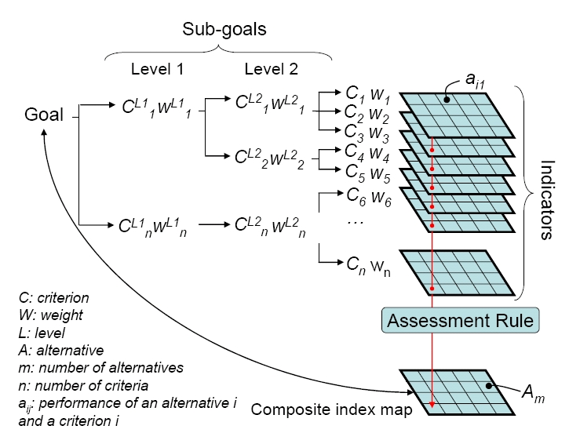
For implementing the semi-quantitative model, the SMCE module of ILWIS-GIS was used. The SMCE application assists and guides users when performing multi-criteria evaluation in a spatial manner (ITC, 2001). The input is a set of maps that are the spatial representation of the criteria, which are grouped, standardised and weighted in a ‘criteria tree.’ The output is one or more ‘composite index map(s),’ which indicates the realisation of the model implemented. The theoretical background for the multi-criteria evaluation is based on the Analytical Hierarchical Process (AHP) developed by Saaty (1980).

We will follow a number of steps which are schematically indicated below:
We are structuring the main groups of indicators, in Generic Social Vulnerability Indicators, Hazard specific Social vulnerability indicators, Hazard Specific Physical Vulnerability Indicators, and Capacity Indicators. Then the following steps are needed:
- Step 1: Generation in SMCE of a criteria tree for Generic Social Vulnerability Indicators, with the groups of factors, the standardization of the factors and definition of weights using pair wise comparison.
- Step 2: Generation in SMCE of a criteria tree for Hazard specific social vulnerability indicators, with the groups of factors related to population affected by earthquakes, landslides, flooding and technological disasters in a daytime, and nighttime scenario, the standardization of the factors and definition of weights using pair wise comparison.
- Step 3: Generation in SMCE of a criteria tree for Hazard specific physical vulnerability indicators, with the groups of factors related to buildings affected by earthquakes, landslides, flooding and technological disaster scenarios, the standardization of the factors and definition of weights using pair wise comparison.
- Step 4: Generation in SMCE of a criteria tree for Capacity indicators, which in this case is limited to only one: the level of awareness.
- Step 5: Combination of the 4 sets of indicators into an overall vulnerability indicator.
The entire exercise might take too much time to complete in one afternoon. Therefore we suggest to at least do parts 1 (Social Vulnerability Indicator) AND 4 (Capacity indicators).

Note: it is also possible to carry out the steps independently and also to skip one or more. If you are working in a group these topics could be done by individual team members.
It is also possible to carry out the full analysis in one criteria tree (next page). However, we advise to do it in the individual components described above.

The final criteria tree that we will make in this exercise looks like this.
The Composite index map contains the final output
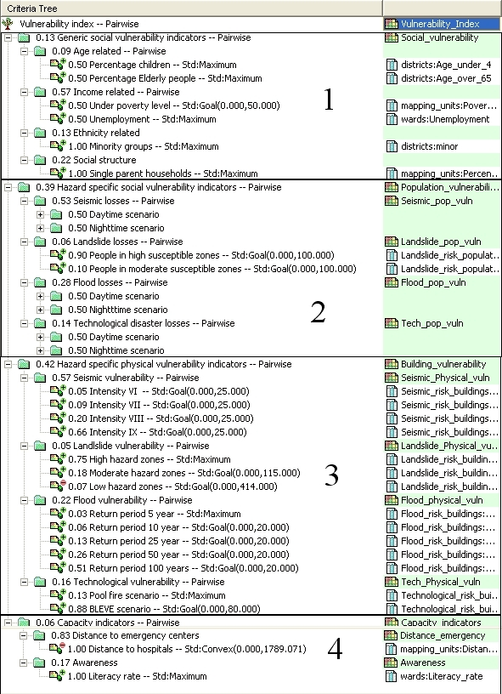
One main goal is obligatory for any criteria tree. The main goal is also called the main root
a Benefit: contributes positively to the output; the more you have (the higher the values), the better it is
A Group defines an intermediate or a partial goal.
Under a Group, you can add one or more Factors and/or other Groups of Factors. Click the plus sign in front of a Group of Factors to expand the group.
The Standardization method is indicated here.
A Subgoal is directly under the main goal, it defines the main groups that together define the overall goal. Each subgoal also has a weight value.
Here are the input tables and columns that contain the data related to the factor
One subgoal can consist of one or more factors. These can be spatial or non spatial. They are all having a weight (value in front) and a standardization method ( e.g. Std: Goal)
The 4 blocks in the criteria tree refer to the main subgoals, indicated above.

Part A: Social vulnerability indicators
In this step we will generate in the ILWIS Spatial Multi Criteria Evaluation (SMCE) software tool, a problem tree that will be used to calculate a generic social; vulnerability indicator. We assume that you have some basic knowledge on SMCE, and will not explain a lot on the background. Please consult the ILWIS help if you need more information. In general SMCE follows a number of steps :
- Definition of the problem. Structuring of the problem into a criteria tree, with several branches or groups, and a number of factors and/or constraints.
- Standardization of the factors. All factors may be in different format (nominal, ordinal, interval etc.) and should be normalized to a range of 0-1. SMCE has some very handy tools for that especially for value data, making use of different transformation graphs.
- Weighting of the factors within one group. SMCE has some very handy tools for that derived from Analytical Hierarchical Processing (AHP), such as pair wise comparison and rank ordering.
- Weighting of the groups, in order to come to an overall weight value.
- Classification of the results.
Below we will take you through the procedure for the generic social vulnerability indicators. Later on you can do it yourself for the other groups.

A.1. Problem definition:
Which criteria to use, and how to order them? This is often one of the most difficult parts of the procedure.
The criteria tree is composed of the following criteria:

Constraints: these criteria are used to mask out the area where the goal can not be reached. In this case, where there is no social vulnerability, because there are no people living.
Factors: those are the criteria that contribute in different way to the goal (social vulnerability score in this case). We can group these into several sub-goals or groups.

- Select Operations / Raster Operations / Spatial Multi Criteria Evaluation. Select the option Problem Analysis. An empty problem tree is opened.
- Change the goal (right click select Edit)to:
Generic_Social_Vulnerability, and the name of the output map (in the right side) to Social_Vulnerability.
- Right click on Generic_Social_Vulnerability and select Insert group. Add the groups: Age_related, Income related, Ethnicity related, Social Structure Related.
- Include the various factors for the individual criteria, as indicated below by right-clicking on the individual criteria and inserting the spatial factors.

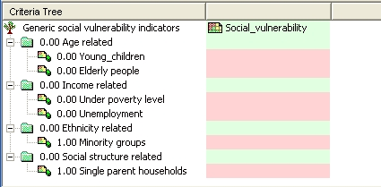
You could also add a constraint, called Built-up area. This would be a Boolean column (True or False) from the Mapping_unit table, in which you indicate for each mapping unit if there are built-up areas or not. This could be done by first making such a Boolean column in the Landuse table, and then joining that with the Mapping_unit table.

QUESTION: Apart from the criteria that are given here, which other indicators do you think could be used in determining social vulnerability? Name a few examples, and indicate where you could get such data from, in your own country.

Next you will have to assign the spatial data that is relevant for each of the criteria that you have defined. These are mostly coming from tables, linked to the maps Mapping_units, Wards, and Districts. All age related data is available only at district level. Note: red areas in SMCE mean that data is still not defined.

- Double click on the red area next to Young_children. Select from the map Districts the column: Age_under_4.
- Find also the relevant spatial information for the other criteria, and the result is indicated below
- Save the criteria tree as Generic_social_vuln..

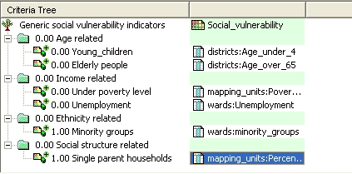
The criteria tree should look like the example shown here to the left.

Note: all parts indicated in red should be completed before you can make the output map.

A.2. Standardization of the factors
In this case all of the factors that we are using in this evaluation are of the “values” type, and they are all stored as attributes in a attribute table linked to one of the three administrative maps. Next we need to standardize these values, and bring them into a range of 0 to 1.

- In the SMCE window, change the Mode from “Problem Definition” to “Multi Criteria Analysis”. Now you can start standardization.
- Double click on the red area indicating 0.00 Young_children. Now a window opens in which a graph is shown fitting the data range of values for this factor over the range of 0-1.

You have the option to select several ways of scaling the values between 0 and 1. The figure below shows the standardization window, and the various options.
Maximum: The input values are divided by the maximum value of the map
Interval: Linear function with the maximum and minimum values of the map
Goal: Linear function with a specified maximum and minimum values
Piecewise linear: Linear function with two breaking points located between the extremes
Convex: Convex function with one user defined value to re-shape the curve
Concave: Concave function with one user defined value to re-shape the curve
U-Shape: U-shape curve with one user defined value to stretch or shrink the curveGaussianBell-shape curve with one user defined value to stretch or shrink the curve

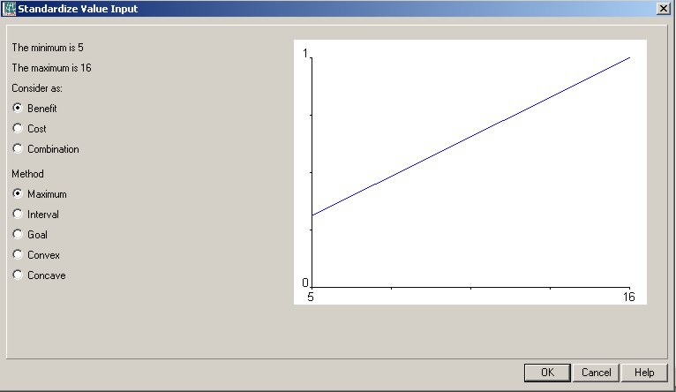

When selecting the boundaries for standardization, you always have to consider the aim of the weighting and standardization procedure (in this case social vulnerability), and how this particular variable is related to that. In this case: the higher the percentage of children in an area, the higher the vulnerability of the population. In that case you can use a simple straight line, between 0 and the maximum value. In other cases there will be a maximum value above which you will always find it high. E.g. for the estimation of the population losses, you could say that anything above 20 is high, and should be 1. In that case you select the Goal option, and you can adjust the values manually.

- Select the goal option and change the minimum X to 0 and the maximum to 20. Do the same for the variable Elderly_people.
- Standardize in the same way the other variables.

After standardizing all factors, your criteria tree will look like the one below in the picture. The red bars are showing the places where still you need to indicate weights.
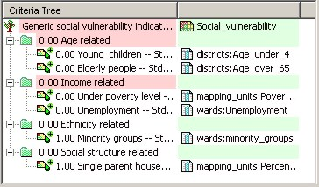
How to standardize?
You have to define yourself the ranges between you standardize. Consider for each factor: how much should the value be in order to consider it very vulnerable? For instance: how large should the percentage elderly people per mapping unit be to give it a 1 value (highly vulnerable). These threshold values are often defined in a group decision making process through workshops etc. Here discuss these values with your neighbors

- To see the result of the standardization: Right click on the name Young_children and select Show standardized. A map opens that contains the standardized values.
- Open PixelInformation and add the map you just created and also the map district , linked to the table District. Compare the original values to the standardized values.

A.3. Determining the weights among factors
The third step in the procedure is to define the weights between the various factors. This can be between the factors in the same group (e.g. the two factors “Young_children” and “Elderly_people” in the group “Age related”), or the weights among the groups (e.g. “Age related” versus “Income related”). There are two groups that have only one factor, and therefore the weights for these two are 1 (see above: “Minority groups”, and “Single parent households”). For the determination of weights SMCE use 3 different methods:
Weights
- Weights are always numbers between 0 and 1.
- Weights cannot be negative.
- For the factors within a group, the sum of the weights of the factors equals 1.
- When a group only has one child, this child automatically obtains weight 1.
- Constraints are not considered during weighing.

- Direct weights (you indicate the weights directly in a table),
- Pairwise comparison (you compare the factors in pairs, and based on the consistency of your selection and relative importance, quantitative values are given to the factors), and
- Rank ordering (you indicate the relative ranking of the factors, and the software converts these in quantitative weights).
In this exercise we will work mostly with pairwise comparison.

- Right-click the red indicated factor group “Age related”, and select Weight. Select the option: Pairwise
- Determine whether for the determination of social vulnerability, the percentage of young-children is more important than the percentage of elderly people, or equal, or less. Discuss this with your neighbors / group members.

- Double-click in the green area next to age related and fill in age_related; Press enter. Double-click on the map name and generate the map. View the result.
- Standardize in the same way the other groups e.g. “Income related”and make the intermediate maps forIncome related , Etnicity related and Social structure related..

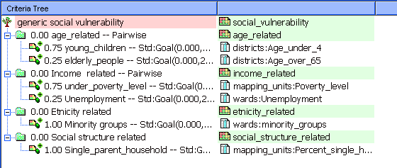
The criteria tree will then look like the one to the left.

A.4 Determining the weights among groups
The fourth step in the procedure is to define the weights between among the groups (e.g. “Age related” versus “Income related”). There are four groups in this example. Also here pair wise method could be used, but you might also try out another one.

- Right-click the red indicated upper line “Social vulnerability indicators”, and select Weight. Select the option: Pairwise
- Determine for each combination the relative importance (see below). Discuss this with your neighbors / group members. .
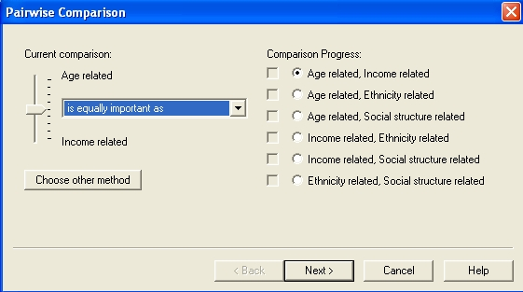

The resulting criteria tree might look like the one below (but the weights could be different, depending on the importance you gave to the different groups of factors.)

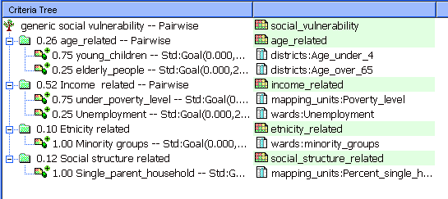

Now all the parameters are given and it is time to calculate the output map.

- Right-click the map icon “Social_vulnerability”, and select Generate selected item.
- Display the result map. Use PixelInfo to compare the resulting map with the input maps. You can adjust the standardization, and weights if you would like to make adjustments.,

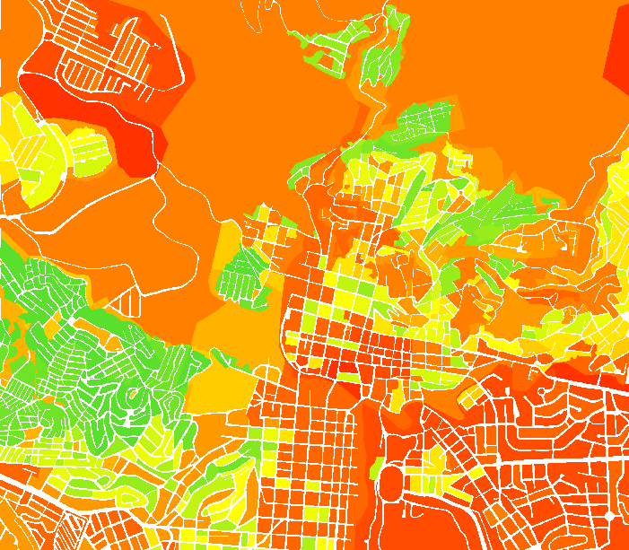
Question
What can you conclude from the pattern of social vulnerability?

Part B. Hazard specific population vulnerability indicators
In this part you will generate the maps required for the population vulnerability indicators using spatial multi-criteria analysis. The population that might be affected by earthquakes, landslides, flooding and technological disasters during a daytime and nighttime scenario, will be combined into one population vulnerability.

B.1 Preparation of input maps
In this step we will generate the maps required for the spatial multi-criteria analysis. In the SMCE software each table containing columns that are used as indicators should be linked to a raster map. As most of the attribute tables with the results of population and buildings losses are linked to the mapping_units map, we need to copy this map several times, so that each table has its own map.

- Rasterize the polygon maps Mapping_units, Wards, and Disticts using the Georeference Somewhere if this hasn’t been done yet.
- Select the map mapping_units and select the Edit / Copy Object to and select New Name. Name the file: Flood_risk_buildings.
- Change the properties of the raster map Flood_risk_buildings, and make sure it is linked to the table Flood_risk_buildings.
- Do the same for all the files in the table listed below, and give them the names as indicated.

Table 4: Copy the raster map Mapping_units to these names, and link each one of them to the table with the same name
Table names.
Flood_risk_buildings | Seismic_risk_buildings
Flood_risk_population | Seismic_risk_population
Landslide_risk_buildings | Technological_risk_buildings
Landslide_risk_population | Technological_risk_population
B.2 Generating the criteria tree
Once the input maps have been generated, you can start with the generation of the criteria tree and the multi criteria analysis. As the procedure was already explained in the previous section, we will not repeat it here again.

- Create a new criteria tree: Population_Vulnerability, and the file name also the same.
- Add groups of the individual groups of factors: Earthquake_losses, Landslide_losses, Flood_losses, Technological_losses.
- Include for each hazard type, two subgroups: Nighttime losses, and Daytime losses.
- Enter the most relevant scenarios for each hazard type. For example, for earthquakes, only adding the IX scenario would be enough. You can compare it with the figure below, but you don’t have to do it exactly the same

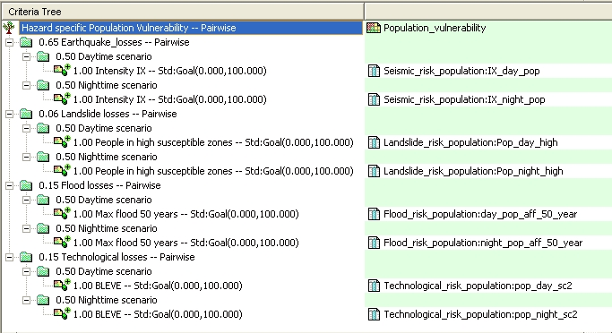

B.3 Standardizing and weighting
Once the criteria tree is made, you can define the related attributes and start the standardization. As the procedure was already explained in the previous section, we will not repeat it here again.

- Choose the relevant attributes from the “Population risk” columns linked to the maps of the Mapping_units for earthquakes, landslides, floods and technological hazards.
- Standardize all columns, using the same “Goal” function with for example the value 100 as the one reaching 1.
- Use the weighting of the daytime-nighttime losses, using a same weight of 0.5
- Use the pairwise method for the hazard and state which hazard you find more important than others.
- Generate the output map Population_vulnerability, and critically evaluate the result. If needed, adjust the criteria tree. An example of a possible criteria tree is given below.
- Do you think that the parameters taken into account are good indicators for the evaluation of the vulnerability? Do you have other ideas?

Part C. Hazard specific physical vulnerability indicators
In this part you will generate the maps required for the hazard specific physical vulnerability indicators using spatial multi-criteria analysis. The procedure for estimating the number of buildings that might be affected by earthquakes, landslides, flooding and technological disasters will be further explained in the exercises of session 6. Here we will combine them into one physical vulnerability index.
- Create a new criteria tree: Physical_Vulnerability, and name the output file name also the same.
- Add groups of the individual groups of factors: Earthquake_losses, Landslide_losses, Flood_losses, Technological_losses.
- Include for each hazard type, all the calculated scenarios for each hazard type. For example, for earthquakes, add scenarios VI, VII, VIII and IX intensity.
- Choose the relevant attributes from the “Building risk” columns linked to the maps of the mapping units for earthquakes, landslides, floods and technological.
- Standardize all columns, using the same “Goal” function with for example the value 25 as the one reaching 1.
- Use the pairwise method for the scenarios within each hazard category
- Also use the pairwise method for comparing the various hazards and state which hazard you find more important than others
- Generate the output map Physical_vulnerability, and critically evaluate the result. If needed, adjust the criteria tree. An example of a possible criteria tree is given below.

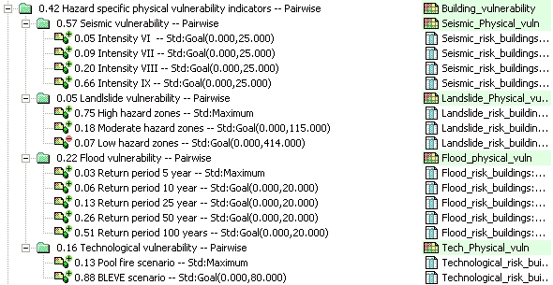

Part D. Capacity indicators

The overall vulnerability indicator also contains an indicator related to capacity. Capacity expresses the positive managerial and operational resources and procedures for reducing risk factors. These actually help to reduce the vulnerability. In our case study we are using only one capacity indicators: awareness level, expressed by the literacy rate.
The capacity indicator should work opposite to the other vulnerability indicator. Remember the formula:

This means that where in case of the vulnerability indicators, higher values are indicating higher vulnerability, we want the capacity indicator to show us that the higher the value the better is the capacity. Later on when combining the values, we will actually divide the Vulnerability Indicator by the Capacity Indicator, according to the formula.

- Create a new criteria tree: Capacity, and the file name also the same.
- Add the group: Disaster_Awareness.
- Under this group, include one factor: Literacy_rate Select the column Literacy_rate from the table Wards.
- Standardize the factor, keeping in mind that high values of literacy rate results in high values of the capacity index.
- Generate the output map Capacity, and critically evaluate the result.

Part E. Combing vulnerability and capacity indicators

The overall vulnerability indicator is made by combining the four indicator that we have calculated thus far:
- Social_Vulnerability (Part A)
- Population_Vulnerability (Part B)
- Physical_Vulnerability (Part C)
- Capacity (Part D)
It is possible to combine all 4 together in SMCE. However, since the Capacity indicator is having the opposite effect as the vulnerability indicators, we have decided to combine the three vulnerability indicators first, and then divide them by the capacity indicator, according to the formula.

- Create a new criteria tree: Total_vulnerability and the file name also the same.
- Add three factors: Social_vulnerability, Population_vulnerability, and Physical_vulnerability.
- Link them to the three maps that were made in Part A , B and C.
- Standardize the three factors, and use the pairwise method for the determination of the weights.
- Generate the output map Total_vulnerability.
- In the command line write the following formula:
Overall_vulnerability:= Total_Vulnerability / Capacity

Use the value domain and a precision of 0.1
- Classify the output map in three classes and critically evaluate the result. (Create an histogram from the Overall_vulnerability and select 3 classes).

WHICH AREAS HAVE THE HIGHEST VULNERABILITY?

