Exercise 4c : Participatory GIS for risk assessment.
Answer sheet.

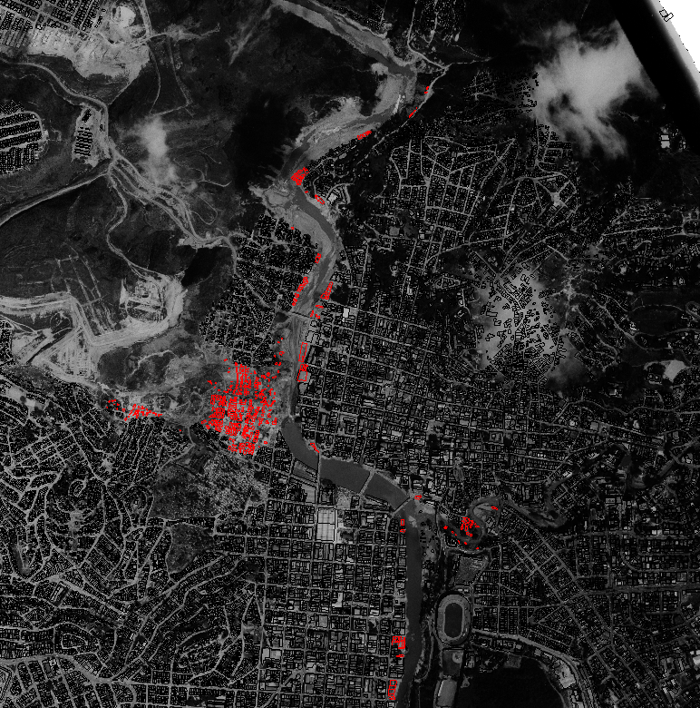

Red = buildings destroyed or subsequently demolished in the disaster event of 1998.

Number of points of the map is 200. 100 for the flood prone area and 100 for the landslide prone area.

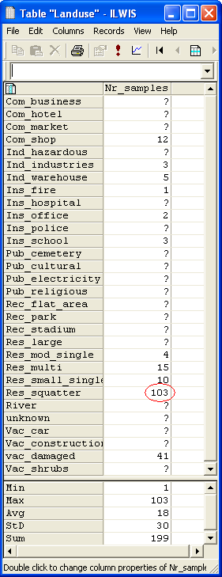
Squatters have the highest number of samples.

 | Number
Number of sampled squatter buildings | 103
Number of sampled buildings that have been destroyed | 41

Part A: Using PGIS for evaluating the building characteristics
 | Wood | Adobe | Fieldstone | Brick in Mud | Brick in Cement | RCC
Com_shop | 0 | 1 | 0 | 3 | 5 | 3
Ins_school | 0 | 0 | 0 | 0 | 0 | 3
Res_mod_single | 0 | 0 | 0 | 0 | 4 | 0
Res_multi | 0 | 0 | 0 | 2 | 7 | 6
Res_small_single | 0 | 0 | 0 | 3 | 5 | 2
Res_squatter | 35 | 6 | 5 | 49 | 8 | 0
Vac_Damaged | 15 | 1 | 4 | 9 | 11 | 1

 | Wood | Adobe | Fieldstone | Brick in Mud | Brick in Cement | RCC
1 floor | x | x | x | x | x
2 floors
3 floors |  |  |  |  |  | x
4 floors
5 floors
> 5 floors
To calculate what the predominant building height is for each type, type the following in the command bar:
Floors_building_type:= Code(Building_type)+String(nr_floors)
Then after creating a new domain, select column → aggregation and select the function “predominant”.

What is the most common building type and number of floors of the destroyed buildings?
Most common building type: wood and other
Most common number of floors : 1

Part B:

Daytime: 3816
Nighttime: 917

What causes the difference?
For example, workers from other areas, that work in RiskCity during day time.

 | Total number of persons | Total floor space in m2 | Average floor space per person
Daytime | 3816 | 67119 | 58.4
Nighttime | 917 | 67119 | 85.2

Land use |  | Floor space in square meters per person
Day | Night | Daytime | Nighttime
School | Squatter | 3 | 9.2
Industry | Res. Small | 10.3 | 13.3
Squatter | Res. multi | 21 | 21.7
Shop | Shop | 26.7 | 24.7
Office | Fire | 29 | 30.4
In the above table, the damaged buildings were not considered, as these consist of various land types.

Land use |  | Average floor space in square meters per person
Day | Night | Daytime | Nighttime
School | squatter | 3 | 17.6
Industry | Res. Small | 13.4 | 23.7
Fire | Fire | 30.4 | 30.4
Office | Res. multi | 36.0 | 41.4
Shop | Res. mod | 44.4 | 56.9

Landuse | Description | Average floorspace per person in M²
Landuse | Description | Daytime | Nighttime
Com_business | Business offices | 40 | 2500
Com_hotel | Hotels | 300 | 30
Com_market | Commercial area: market area | 50 | 500
Com_shop | Commercial: shops and shopping malls | 44.4 | 341.6
Ind_hazardous | Hazadous material storage or manufacture | 20 | 80
Ind_industries | Industries | 13.4 | 111.3
Ind_warehouse | Warehouses and workshops | 64.2 | 111.3
Ins_fire | Fire brigade | 30.4 | 30.4
Ins_hospital | Hospitals | 25 | 50
Ins_office | Office buildings | 36.0 | 2259.5
Ins_police | Police station | 30 | 60
Ins_school | Institutional : schools | 3.0 | 1078.0
Pub_cemetery | Cemetery | 400 | 10000
Pub_cultural | Institutional: cultural buildings such as musea, theaters | 75 | 1000
Pub_electricity | Electricity installations | 0 | 0
Pub_religious | Religious buildings such as churches, mosques or temples | 25 | 2000
Rec_flat_area | Recreational: flat area or foorball field | 250 | 5000
Rec_park | Recreational: park area | 500 | 20000
Rec_stadium | Recreational : stadium | 3 | 15000
Res_large | Residential: large free stading houses | 250 | 75
Res_mod_single | Residential, moderately sized single family houses | 180.9 | 56.9
Res_multi | Residential: multi storey buildings | 109.3 | 41.4
Res_small_single | Residential, small single family houses, mostly in rows | 83.5 | 23.7
Res_squatter | Residencial, low class houses: squatter areas | 46.4 | 17.6
River |  | 0 | 0
Vac_car | Vacant : car parking and busstation | 0 | 0
Vac_construction | Vacant area which is prepared for building construction | 0 | 0
Vac_damaged | Area recently damaged by hazard events | 94.9 | 81.7
Vac_shrubs | Vacant land with shrubs, trees and grass | 0 | 0

Day: 155208
Night: 146509

Difference 8699
The difference can for example be caused by commuters.
Part C: Using PGIS for evaluating landslide problems
One way to calculate this, is by first classifying whether a slope is steep (>30 deg) or not steep (<30 deg). You can do this by using the following statement:
steep_slopes:=IFF((slope_cl = "30 - 40") OR (slope_cl = "40 - 50") OR (slope_cl = "50 - 60") OR (slope_cl = "60 - 90"),1,?)
With this statement you get a map that shows only the steep slopes.
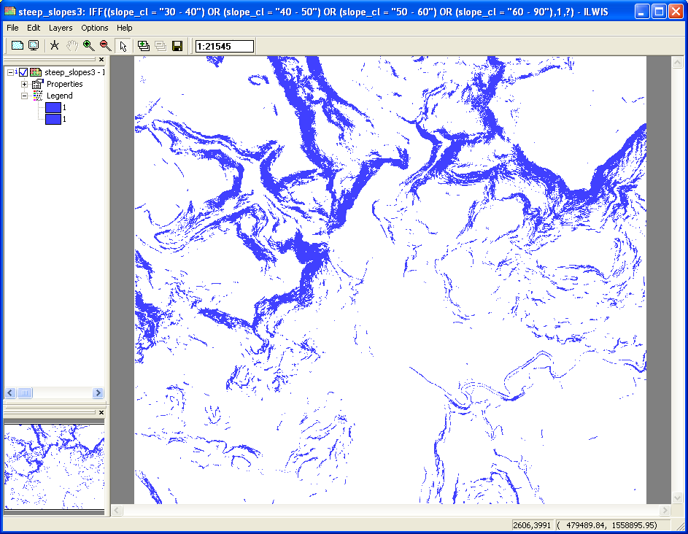
The next step is to cross the steep slopes map with the building map_1998.
From the cross table you can read that there are 2267 Res_squatter buildings on steep slopes.( total amount of Res_squatter is 8558 buildings)

Names of neighborhoods where the mapping was done:
- Lagos
- Athens
- Bogota
- Madras
- Paris
- Damascus
- Dhaka
- Tirane
- Karachi
- Los Angelos
- Guatemala
- Kabul
- Paramaribo
- Djibouti
- Hanoi
- Dakar
- Caracas
- Sofia

Find out the pattern of landslide damage in the neighborhoods that have been interviewed.
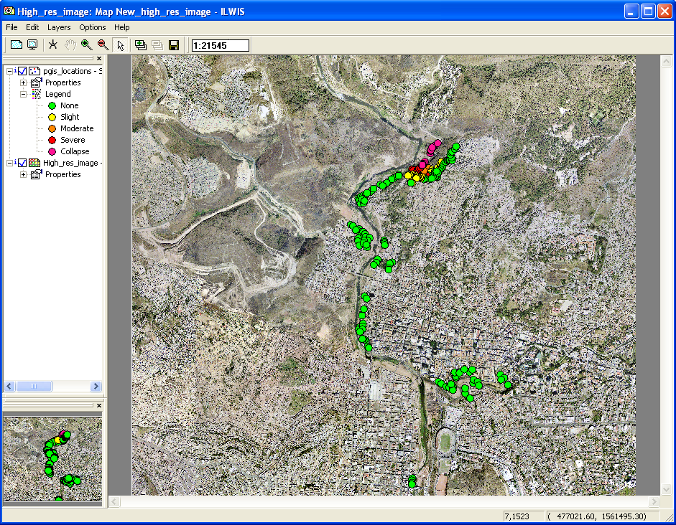

Zoomed in on the landslide prone area:
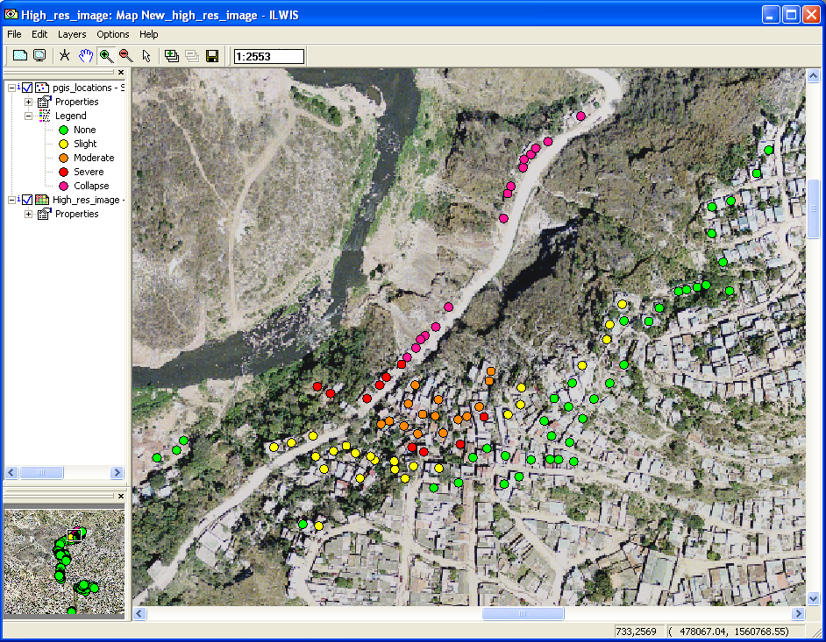
The possible landslide zones are located on the steeper slopes, as can de seen in the figure below. Here the slope class map was added to the previous map (transparency 50%).
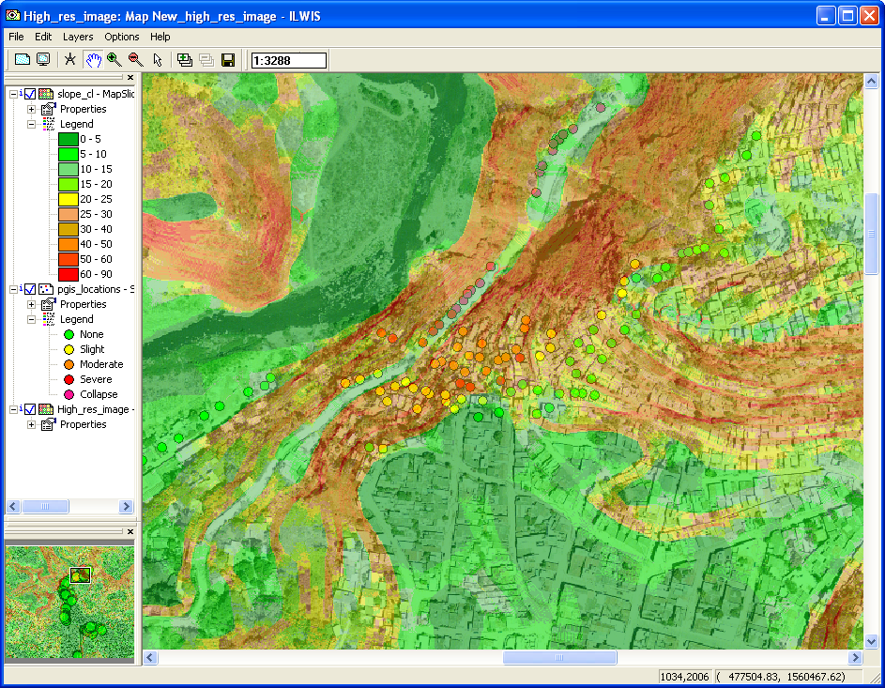
Can you differentiate landslide areas based on PGIS mapping?
Yes, you can differentiate those by looking at the problems with landslides in the buildings.

Alert level | Nr days | How many days without work?
Yellow Alert | 29
Orange Alert | 11
Red Alert | 4

Part D: Using PGIS for evaluating flood problems

Experienced water heights
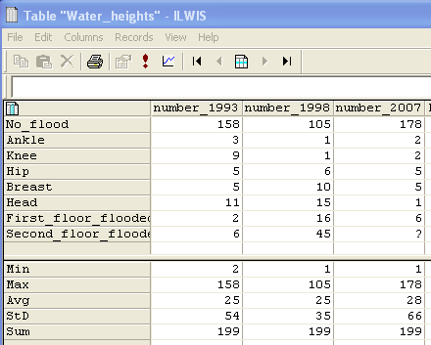

Analyse the different dates of flooding. Are the answers logic, do the people remember the floods correctly. Give some comments.
For example the extent of the disaster and the fact that it is already some time in the past.

- Display the map Flood_100y, and overlay the segment map with the buildings from 1997 (Building_map_1997). Also display the point map PGIS_Location, and select the attribute Remember_flood_1998.
- Open PixelInformation and add the maps Flood_100y, Flood_50y, Flood_10y, and the point map PGIS_Location. Compare the local information with the modeled results.
What can you conclude?
You can see that the local information corresponds with the modeled results pretty well, but it can not be compared very precisely as the estimations made by the local people are made in terms of body parts.

Difference in water height between PGIS and model for | Minimum | Maximum | Average | Standard deviation
1993 (50 year flood) | -0.41 | 1.30 | 0.15 | 0.41
1998 (100 year flood) | -3.69 | 1.47 | 0.03 | 0.88
2007 (10 year flood) | -0.47 | 0.38 | 0.04 | 0.20

These results are quite surprising. As can be seen, the flood of 1993 was estimated more accurately by the local people then was the flood of 1998. This, despite the fact that 1993 is further away in time and that the flood was way less disastrous then the one of 1998.

