Exercise 4b: Generating a database of elements at risk using existing data
Expected time: 3 hours
Data: data from subdirectory:RiskCity_exercises/exercise04b/data
Objectives: This exercise shows you a method for the generation of a database for the elements at risk within RiskCity, focusing on buildings and population. We assume that we have detailed building information available, in the form of a building footprint map, and that we have a LIDAR image from which we can calculate the height of buildings, and the floorspace of buildings per land use type. Population estimates are made based on the building floorspace, and census data.
Risk assessment with GIS can be done on the basis of the following basic equation:
Risk = Hazard * Vulnerability * Amount of elements at risk
The elements at risk that may be affected by hazardous events are numerous, and can be classified in many different ways. The table below provides an example of such a classification.

Physical elements  Buildings: Urban land use, construction types, building height, building age, total floor space, replacement costs.  Monuments and cultural heritage | Population  Density of population, distribution in space, distribution in time, age distribution, gender distribution, handicapped, income distribution
Essential facilities  In this exercise we are limiting ourselves to only the upper row : buildings and population. This is due to the limited time for the exercises. Also because in practice they are considered first. However, a complete risk assessment should also evaluate the direct and indirect impacts of the other types of elements at risk.  Emergency shelters, Schools, Hospitals, Fire Brigades, Police, | Socio-economic aspects  Organization of population, governance, community organization, government support, socio-economic levels. Cultural heritage and traditions.
Transportation facilities  Roads, railway, metro, public transportation systems, harbor facilities, airport facilities. | Economic activities  Spatial distribution of economic activities, input-output table, dependency, redundancy, unemployment, economic production in various sectors.
Life lines  Water supply, electricity supply, gas supply, telecommunications, mobile telephone network, sewage system. | Environmental elements  Ecosystems, protected areas, natural parks, environmentally sensitive areas, forests, wetlands, acuifers, flora, fauna, biodiversity.

The basic unit for risk assessment we will use in this exercise is the so-called mapping unit. It consists of a number of buildings, and can be compared with a city block, or a census tract. The area within a mapping unit can be considered as more or less homogeneous, and the buildings have more or less the same urban land use, and the same building type. We do not carry out risk assessment for individual buildings because the hazard and vulnerability information is not detailed enough to do that at such a detailed level.
Depending on your interest in the topic you may select to either do Exercise 4a (creating a database by starting from scratch), or Exercise 4b (creating a database with available footprint information). You can also decide to do both exercises, although that might perhaps take a bit too much time

The following data will be used in this exercise

Name | Type | Meaning
Image data
High_res_image | Raster | High resolution image of the situation in 2006
Height information
Altitude_dif | raster map | A raster map showing the difference in elevation between the Digital Surface Model from Lidar and a Digital Elevation Model from interpolated contourlines.
Elements at risk
Mapping_units | Polygon map | Mapping units used as the basis for the risk assessment. The table contains a landuse classification
Buiding_map_1998 | Segment map | Updated segment map of buildings for the situation after the disaster of 1998.
Building_map_1998 | Raster map | Updated map of buildings for the situation after the disaster of 1998.
Ward | Polygon map | Map of the wards (neighborhoods) of the city.

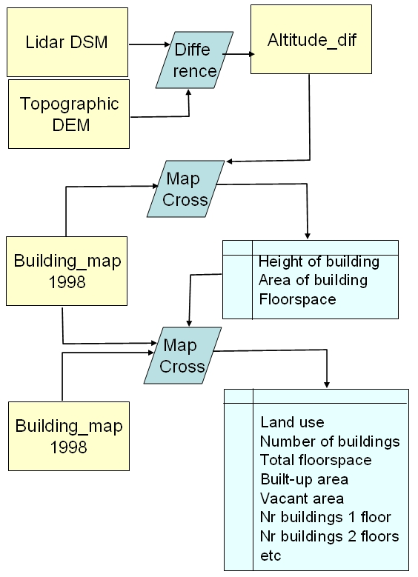
The Procedure that will be followed in this exercise is given in the flowchart. Since we have a building footprint map, which contains the outlines of the the buildings in RiskCity it will be easier to make a good estimate of the nuber of buildings per mapping unit, then in the method explained in exercise 4a. The Building footprint map that was used in the previous exercises was adjusted to remove the buildings that have been destroyed during the disaster of 1998. That is why this map contains less buildings, especially in the flooded area and the area affected by the large landslide that dammed the river.
In this exercise we also have information on the altitude of the buildings, derived from Lidar data. This information (map Altitude_dif) will enable us also to estimate the height of each buidling in number of floors. The map was made in exercise 1 by calculating the difference between the Lidar Digitial Surface Model (DSM) and the Digitial Elevation Model obtained by interpolating contour lines from the topographic map (with 2 meter contour interval).
We will use the Cross operation 2 times and will aggregate the building information in the attribute table linked to the map Mapping_units. This will be the basis for generating the vulnerability and risk maps in the following exercises.

Generating a database of elements at risk using existing data

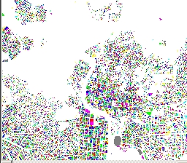
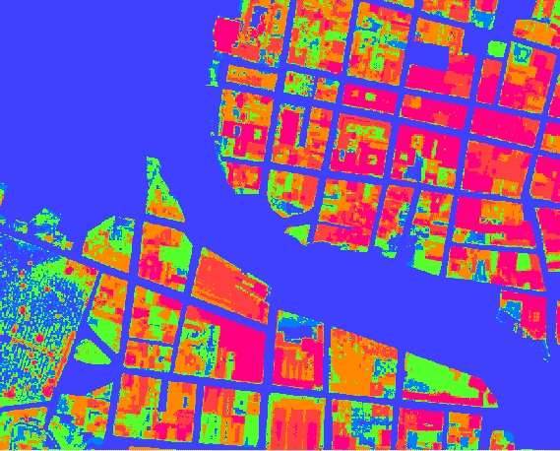
In many cases you might have existing information to build your elements at risk database, and the results you will obtain will be much more accurate. In this case we are including several crucial data layers in the analysis:
- Building footprint map (in this database called Building_map), which contains the location of all buildings prior to the flooding and landslide disaster. This allows us to better calculate the number of buildings per mapping unit.
- The Lidar Digital Surface Model, and the detailed Digital Elevation Model made from contour interpolation. The difference between these (the map Altitude_dif ) gives us detailed information on all objects, including buildings. The Lidar data was obtained after the flood and landslide disaster. This data allows us to better quantify the height of the building, and the total floorspace (= area of the building * the number of floors).
- Census data, which is only available per ward. The table Ward contains information on the residential population, the division male/female and some other attributes. These data are still at a too generalized level, as we would like to have the population distribution per mapping unit instead of wards. So we later will later have to subdivide the population amounts per ward based on the land use and floorspace.

- Display the map Altitude_dif and overlay the segment map Building_map_1998.
- Check out where differences in terrain are not related to buildings. Find some of these and indicate what might be the reason. These areas should be masked out.
- Also check out some areas where there are buildings in the map but no real altitude difference. What could be the reason?

Answer:
There are several reasons why the altitude difference map does show differences even though the building map doesn’t contain buildings.
Also the opposite is true: there are locations where the building map indicates a building but where the difference is almost zero
X | Y | How much Difference? | Possible reason

- Also display the map Mapping_units (boundaries only in red lines) and use PixelInformation to consult the maps Mapping_units, Altitude_dif and Building_map_1998. Evaluate the relation between urban land use, building presence and height of buildings.

Calculate the height of buildings
We start by calculating the elevation elevation of the buildings. We can do that using the altitude difference map (Altitude_dif) that was calculated earlier on in exercise 1, by simply subtracting the Topo DEM from the Lidar DEM.

- Open the map Altitude_dif and overlay the segments of the buildings (file Building_map_1998). Check with Pixel information the altitudes of objects.

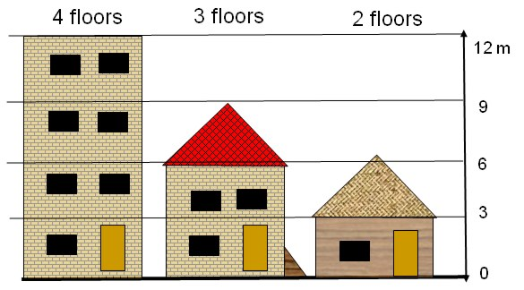
Before we work further with this data we would like to simplify the altitude difference map. Since we are only interested in areas where there are buildings, we can mask out the differences in all other areas. Also it is better to work with the number of floors instead of the actual altitude of the buildings. This makes other operations more easy.
We assume that the average height of 1 floor is 3 meters for all building types. This will be different from building to building, but can only be made more precise after detailed fieldwork.
To calculate the number of floors we divide the object altitude by the average floor height, so that we obtain the number of floors. We assume here that the average floor height is 3 meters.

- This can be done using the following formula on the command line:
floor_nr=iff(Altitude_dif <2,0,iff(altitude_dif<3,1, Altitude_dif /3))

- What do we do here ?: if the difference in elevation is less than 2 meters, then we know for sure that it is not a building, so we change the value to 0. If the altitude is between 2 and 3 meters then we assign it as 1 floor, and if the altitude is more than 3 meters, we divide the altitude by 3 to get the number of floors.
- Make sure to select a precision of 1.
- Open the map floor_nr and check the result with the high resolution image. What are your conclusions?

We can also mask out all areas that are not buildings, and only have the number of floors for those areas where there is an actual building. This can be done with a simple Map calculation statement

- This can be done using the following formula on the command line:
Nr_floors:=iff(isundef(Building_map_1998),0,floor_nr)

- Make sure to select a precision of 1.
- Open the map Nr_Floors and check the result with the high resolution image. What are the main differences with the previous map?

- We now can combine the building map with the map Nr_Floors and find out for each building the number of floors. We do this in a few steps:
- We cross the maps Building_map_1998 with the map Nr_Floors, which gives us all the combinations of floors per building type.
- Then we calculate per building the maximum/predominant number of floors and evaluate which one would be better to use.
- Use the Cross operation and cross the map Building_map_1998 with the map Nr_Floors. Name the Output Table: Building_map_1998_floors. Ignore the Undefs in both maps. Undefs are the undefined values. They are either not in a mapping unit or not in a building.
- See window below left
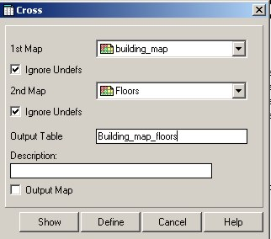
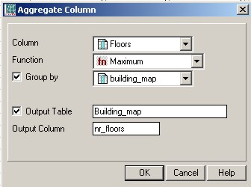
Undefined pixels or polygons don’t have a meaning. They are indicated with a ? when you consult the map. They can be caused by:
- there is no data for the area
- it is outside the study area
- There was an error in the formula
- You specified the wrong data range, and the value is outside of the range.

Histogram: list the frequency information on the values, classes or ID in the map. The results are a table and a graph. You can calculate the Histogram of a rater map, polygon map, segment map and point map. Check the ILWIS guide if you need further explanations.
- In the Cross table Building_map_1998_floors, make the following calculation:
Nr_floors_new:=iff(nr_floors=0,?,nr_floors)
We do this to avoid that there are buildings with the majority of 0 floors.
- Use aggregation: column Nr_Floors_new, aggregation function Maximum, group by Building_map_1998, and store the results in the Table Building_map_1998, column Nr_floors_max. (See above right)
- Check the results in the table Building_map_1998.

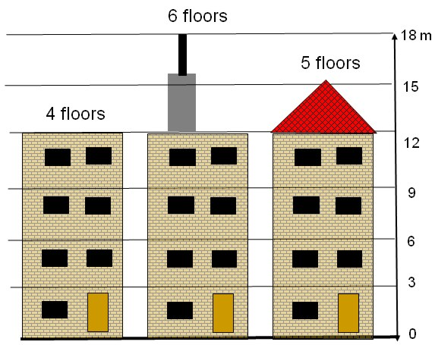
One of the problems with taking the maximum number of floors for each building is that some buildings do not have a straight roof, and some buildings might have an irregular height, with smaller section (elevator shaft, chimneys, flagpoles) sticking out of the building. If we take the maximum number of floors (maximum height) of the building this might lead to problems with some of the buildings. For instance check the stadium (ID: B_29210). The altitude difference is quite variable for the stadium. It also has two small towers that reach up to 23 meters high, but the majority of the stadium is around 15-16 meters high. Also if the polygons of the buildings and the Altitude difference map have a small difference in their x,y location, it is possible that one pixel that is much higher and actually of the neighbouring building, makes that the entire building is considered too high (if we use the Maximum height). It could be possible to use the Predominant number of floors instead of the maximum.

- Now we will calculate the predominant number of floors for each building:
- In the Cross table Building_map_1998_floors, use column Nr_Floors_new, aggregation function Predominant, group by Building_map_1998, weighted by: Area and store the results in the Table Building_map_1998, column Nr_floors_pred.

Now which one is better? Maximum or predominant heights per building? Let us check this. First we will count the total number of buildings with 1, 2, 3 , 3 to 10, and more than 10 floors.

- Make a class/group domain Nr_floors_clas ( if it does not exist already) make the classes indicated in the table below File, Create, Domain, Select Class, Click Group). Use Upper boundaries and class names as indicated in the table below.
- In table Building_map_1998 use the following statements:
Nr_floors_max_class:=CLFY(Nr_floors_max, nr_floors_clas)
Nr_floors_pred_class:=CLFY(Nr_floors_pred, nr_floors_clas)
- Now you can use aggregation function Count for these two columns, (group by the same column) and store results in a table NR_floors_clas. Open this table and you find the data on the number of buildings per class. Fill in the table below.
- Open the map Building_map_1998 and also open PixelInformation, and also add the map Altitude_dif. You can now compare the values for the maximum number of floors and the predominant number of floors. Check out a number of buildings.

This method makes the assumption that a building has a fixed number of floors and is not composed of sections with different heights. Think of patios for example.
Upper boundary | Class  Building height | Use Maximum |  | Use Predominant
Upper boundary | Class  Building height | Number | Percentage of total | Number | Percentage of total
1 | 1 floor
2 | 2 floors
3 | 3 floors
10 | 4-10 floors
25 | >10 floors
Maximum height …….. floors

Now let us look at it in the map

- Open the map Building_map_1998 and also open PixelInformation, and also add the map Altitude_dif. You can now compare the values for the maximum number of floors and the predominant number of floors. Check out a number of buildings. Also check the stadium for instance.

Conclusion: is it better to take maximum height or predominant height for each building for estimating the number of floors?
Make a balanced choice to continue with Nr_floors_pred or with Nr_floors_max
Calculate the floorspace of buildings

Now that we know the height of each building we can also calculate the floorspace per building.
The floor space for each building is the multiplication of the area of the building and the number of floors.

To calculate the total floorspace for each building we need to multiply the number of floors with the area covered by the building. This information can be obtained from the histogram of the Building_map_1998.

- Calculate the histogram of the Building_map_1998.
- In the table Building_map_1998 join with the histogram and read in the Area of each building. Call it: Area_building. See below
- The floorspace per building can now be calculated by:
Floorspace:=Nr_floors_pred*Area_building
Or
Floorspace:=Nr_floors_max*Area_building
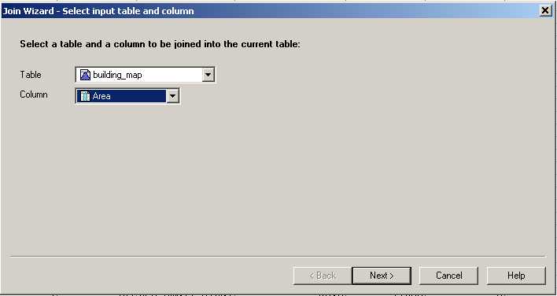
Note that it is possible also join a table with a histogram, because the histogram, as already explained, is composed by a graph part and a table part.

Crossing the Buildings with Mapping units

Now we have the height information and floorspace per building, but we want to aggregate this for the mapping units. We can only do this using a table that contains both domains of the mapping units and that of the buildings.
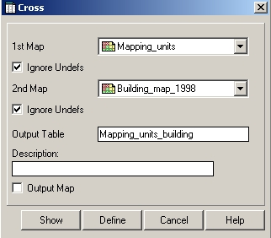
We can start by making a joint frequency table (Cross table) by combining the Mapping_unit and Building_map_1998 data layers. But first rasterize the polygon map Mapping_units with georeference Somewhere.
- Select Operations, Raster Operations, Cross
- Cross the map Mapping_unit with the map Building_map_1998. Ignore Undefs for both maps
- Name the output table: mapping_units_building
- Open the table mapping_units_building and check the result.
- Sort the table by the column Npix

As you can see there are a number of buildings with a very small size (the smallest is 10 square meters).

- Open the cross table Mapping_units_building. And join with the table Building_map_1998. Read in the columns: Nr_floors , Area_building and Floorspace, one by one.

Before we can aggregate the results to the mapping_units we will calculate individual columns with the buildings that have 1 floor, 2 floors, 3 floors, 4-10 floors, and > 10 floors.

- Open the cross table Mapping_units_building. and calculate:
floor1:=iff(nr_floors=1,1,0)
floor2:=iff(nr_floors=2,1,0)
floor3:=iff(nr_floors=3,1,0)
floor4_10:= iff((nr_floors>3)and(nr_floors<11),1,0)
floor_over_10:= iff(nr_floors>10,1,0)

Aggregating the information per mapping_unit

Now we know for each combination of Mapping_units and Building_map_1998 how many buildings there are, how many floors and how much the floorspace is. We can then aggregate these values and calculate the predominant building height per mapping unit, and the total floorspace per mapping unit.

How many building per mapping unit

- Open the cross table mapping_units_building.
- Select Columns, Aggregation. In the window that appears, select the following options. Column: Building_map_1998, Function: Count, Group by: Mapping_units, Output_table: Mapping_units, Output_Column: Nr_b
- Open the table Mapping_units and check the result. How many buildings are there in RiskCity? Fill in the value in the table.
- We still have to adjust for those mapping units where there are no buildings. These are now undefined. We calculate in table Mapping_units_1998:
Nr_buildings:=iff(isundef(Nr_b),0,Nr_b)
- Close the table mapping_units. If you don’t close it you will not see the result of the next aggregation. So close it before doing a next aggregation operation.

Total
Number of buildings
Total building area
Total floor space area

Total floor space per mapping unit

- Open the cross table mapping_units_building.
- Select Columns, Aggregation. In the window that appears, select the following options. Column: Floorspace, Function: Sum, Group by: Mapping_units, Output_table: Mapping_units, Output_Column: Floorsp. (see below)
- Open the table Mapping_units and check the result. How much is the total floorspace are there in RiskCity? Fill in the value
- We still have to adjust for those mapping units where there are no buildings. These are now undefined. We calculate in table Mapping_units_1998:
Floorspace:=iff(isundef(floorsp),0,floorsp)
- Close the table mapping_units. If you don’t close it you will not see the result of the next aggregation. So close it before doing a next aggregation operation.

Total built-up area per mapping unit

- Open the cross table mapping_units_building.
- Select Columns, Aggregation. In the window that appears, select the following options. Column: Area_building, Function: Sum, Group by: Mapping_units, Output_table: Mapping_units, Output_Column: Area_b. (see below)
- Open the table Mapping_units and check the result. How much is the total building area in RiskCity? Fill in the value
- We still have to adjust for those mapping units where there are no buildings. These are now undefined. We calculate in table Mapping_units_1998:
Area_Building:=iff(isundef(Area_b),0,Area_b)
- In order to know how much percentage of the mapping unit is built-up and how much is still vacant we first need to know the area of each mapping unit. We can calculate that using the histogram.
- Calculate the histogram of the map Mapping_units.
- In the table Mapping_units join with the histogram and read in the Area of each Mapping unit. Call it: Area_Mapping_unit (precision 1.0)
- Now you can calculate the area of the mapping unit that is vacant:
Area_vacant:=Area_mapping_unit - Area_building
Perc_vacant:=100*(Area_vacant/Area_mapping_unit)
- Close the table mapping_units. If you don’t close it you will not see the result of the next aggregation. So close it before doing a next aggregation operation.

Note: we will not do the population estimation here. This will come in exercise 4c, dealing with participatory GIS.

For experienced ILWIS users:

Calculate the percentage with buildings of 1,2,3 and more than 3 floors per mapping unit.
Calculate the average building size for each of the land use classes. In exercise 4a we needed to have information on the average building sizes for each land use class. We then based these values on a limited number of samples. Now that we have the information of the building footprint map, we can do this much better. Try to design a method to do this. Hint: use aggregation functions, after bringing in information on the land use in the cross table mapping_units_building. You can then calculate the average building size per land use class and store it in the table Landuse. Also calculate the standard deviation in building sizes. Compare the results with those of exercise 4a.

