Exercise 4a: Generating a database of elements at risk from scratch
Expected time: 3.5 hours
Data: data from subdirectory:Riskcity_exercises/exercise04a/data
Objectives: This exercise gives a method for the generation of a database for the elements at risk within RiskCity, focusing on buildings and population. In this exercise it is assumed that no detailed building information is available, and the number of buildings has to be estimated based on the urban land use type and the average floorspace of buildings per land use type. Population estimates are made based on the building floorspace.
Risk assessment with GIS can be done on the basis of the following basic equation:
Risk = Hazard * Vulnerability * Amount of elements at risk
The elements at risk that may be affected by hazardous events are numerous, and can be classified in many different ways. The table below provides an example of such a classification.

Physical elements  Buildings: Urban land use, construction types, building height, building age, total floor space, replacement costs.  Monuments and cultural heritage | Population  Density of population, distribution in space, distribution in time, age distribution, gender distribution, handicapped, income distribution
Essential facilities  In this exercise we are limiting ourselves to only the upper row : buildings and population. This is due to the limited time for the exercises. Also because in practice they are considered first. However, a complete risk assessment should also evaluate the direct and indirect impacts of the other types of elements at risk.  Emergency shelters, Schools, Hospitals, Fire Brigades, Police, | Socio-economic aspects  Organization of population, governance, community organization, government support, socio-economic levels. Cultural heritage and traditions.
Transportation facilities  Roads, railway, metro, public transportation systems, harbor facilities, airport facilities. | Economic activities  Spatial distribution of economic activities, input-output table, dependency, redundancy, unemployment, economic production in various sectors.
Life lines  Water supply, electricity supply, gas supply, telecommunications, mobile telephone network, sewage system. | Environmental elements  Ecosystems, protected areas, natural parks, environmentally sensitive areas, forests, wetlands, acuifers, flora, fauna, biodiversity.

The basic unit for risk assessment we will use in this exercise is the so-called mapping unit. It consists of a number of buildings, and can be compared with a city block, or a census tract. The area within a mapping unit can be considered as more or less homogeneous, and the buildings have more or less the same urban land use, and the same building type. We do not carry out risk assessment for individual buildings because the hazard and vulnerability information is not detailed enough to do that at such a detailed level.
Depending on your interest in the topic you may select to either do Exercise 4a (creating a database by starting from scratch), or Exercise 4b (creating a database with available building footprint information). You can also decide to do both exercises, although that might perhaps take a bit too much time

Input data
The following table gives an overview of the thematic data and how they are derived.
Name | Type | Meaning
Image data
High_res_image | Raster image | This represents a high resolution color image derived from an IKONOS image. It has been orthorectified, and the panchromatic band is fused with the color bands, and resampled to 1 meter.
Elements at risk
Unit_boundaries | Segment map | A segment map of the boundaries of the mapping units (city blocks) that will be used as the basis for the creation of the polygon map.
Mapping_units_ points | Point map | A point map with a point in each mapping unit, with a unique identifier that can be used to polygonize the segment map Unit_boundaries.
Mapping_units | Polygon map and table | This map represents the mapping units used for elements at risk mapping, but now as polygons. Each of the mapping units has a unique identifier, so that in the accompanying table information can be stored for each unit. The units may be individual large building or plots with a specific landuse, although they are mostly grouping a number of buildings.  In the accompanying table information is given on the number of buildings and number of people
Mapping_units_ population_estimate | Table | Intermediate results. A table containing the correct information on landuse and number of buildings, required for estimating the population per mapping unit.
Roads | Segment map | A segment map of the streets, roads and paths, made by digitizing from topographic maps.

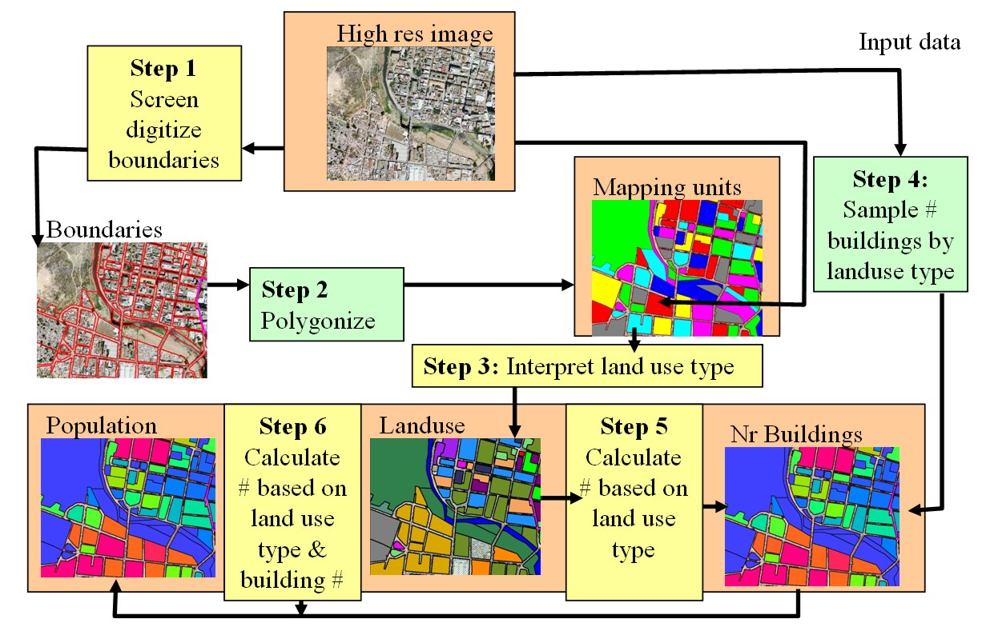
The database generation is done using the procedure shown below. Central in the database is the map Mapping_units, derived from boundary lines that are screen digitized on top of the high resolution image. The attribute information linked to this map is related to urban land use (interpreted from the image), and the number of buildings (estimated from samples taken from the image),. The building information is used to estimate the population distribution.
Figure: flowchart showing the procedure followed for the generation of an elements at risk database from scratch. The steps indicated in green are not part of this exercise.
In the figure a flowchart is given of the procedure that we will follow in this exercise. The steps indicated in yellow will be explained, and you can practice with these. The steps indicated in yellow are skipped, because they might take too much time.

Important: in order to be able to do every step individually we have provided the results of each step so that you can use that to do the next one. For step 1 and 3 you will only do a very smalll part. Given the large size of the area, digitizing the entire area and interpreting all mapping units for the landuse would simply take too much time.

In this case study we only take into account two types of elements at risk: buildings and population. Building information could be obtained from existing cadastral databases, and population data from census database. However, in many cities in developing countries such data are not available, or are restricted, or are not in a digital format. When these data are not available they should be collected. However, the generation of a building database in GIS is a very time-consuming procedure. When high-resolution data sets are available, such as in this exercise, we can use them for interpretation, and the basic mapping units can be digitized on the screen.

Step 1: Screen digitizing the mapping units

In this exercise we will show you a number of steps to generate an elements at risk

As mentioned earlier we base the risk study on so-called mapping units, which consists of a series of buildings, with more or less the same landuse pattern. In exercise we will centrate on the mapping of the basic units for the urban risk assessment. There are two files in the dataset that are most important for that:
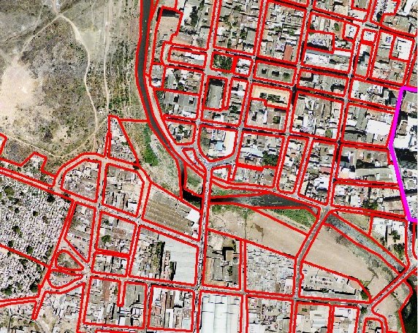
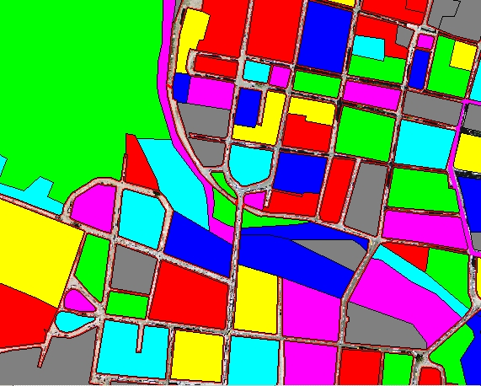
- Unit boundaries: this contains the boundary lines of the mapping units that will be used as basic units for the elements at risk. It has been made through screen digitizing on the high-resolution image. The segments of the street pattern have been used as the basis for the screen digitizing.
- Mapping_units: These polygons represent the mapping units used for elements at risk mapping, but now as polygons. Each of the mapping units has a unique identifier, so that in the accompanying table information can be stored for each unit. The units may be individual large building or plots with a specific landuse, although they are mostly grouping a number of buildings.

We start with the actual screen digitizing the segment of the mapping units. It is possible to do that in three ways:
1. On top of the High_res_image. In this case you will not be able to see stereo, which is a disadvantage in the interpretation. However, you are able to see a lot of detail and the color also adds to it.
Watch Demo 9
for instructions
2. On top of a color stereo image. This is the best way, but you will need a screen stereoscope for that, so not possible now
3. On top of the anaglyph stereo image Anaglyph. You will need anaglyph glasses for the interpretation. The problem is that the lines will not exactly match with the features in the image.
Let us start by using option 1:
- Open the raster image High_res_image.
- On the Layer Menu, go to Add Layer and select the Unit_boundaries segment map.
- Now you can view the segments of the different mapping units in the study area. As you can see the mapping units are mostly bounded by the streets.
- You can also see that there are two areas indicated by a thick line that do not yet have unit boundaries: one in the center of the city and one near the river. Zoom in on the part in the city center, indicated by the purple line. You can see that the mapping units are still lacking
- In the map window of High_res_image select Edit / Edit layer and select the segment map Unit_boundaries

Now you enter into the segment editor, in which you can digitize segments (lines) and edit existing ones.

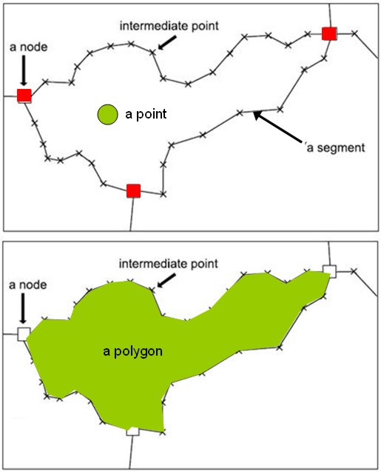
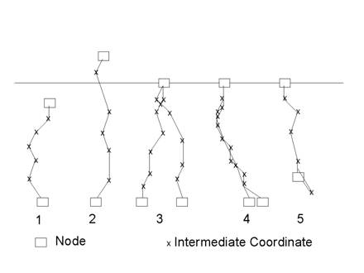
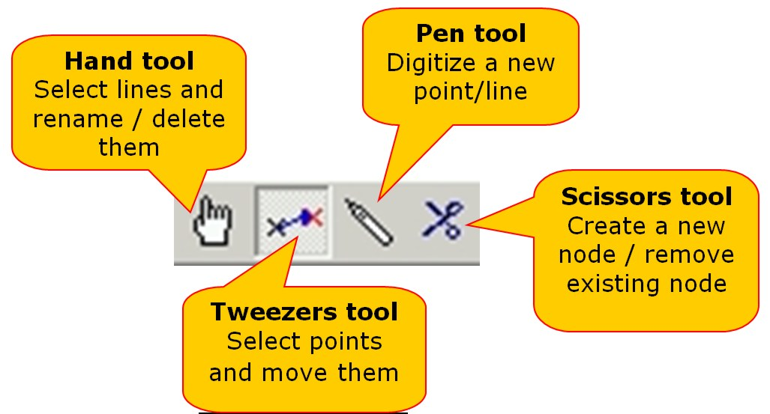
Some more information about digitizing with ILWIS.

ILWIS allows you to digitize two objects: points and lines (called segments). Point digitizing is done using a point map, and in the point editor, and line digitizing is done in the segment editor.
You cannot directly digitize polygons in ILWIS. Polygons are generated by combining a segment map with a point map. The segments will give the boundary lines of the polygons and the points will give the labels. Therefore the domain of the points used in the generation of the polygons is the same as the domain of the resulting polygon map. (Polygons can also be made by vectorizing a raster image, but that is another procedure). You can also edit polygons in a polygon editor, but then you can only change the names of the polygons, and not the boundary lines. These should be changed in the segment editor.
How to digitize
You can digitize in two ways:
- Using a digitizing tablet. This used to be the standard method in the past. Paper maps were fixed on the tablet and a digitizer cursor was used to digitize.
- Screen digitizing. This is now the standard method. The map or image you want to digitize is scanned and is displayed on the screen as a raster map. You then digitize directly with the mouse. This method is followed here.
Digitizing segments.
A segment always consists of nodes (the beginning and the end) and intermediate points. The intermediate points are connected by straight lines, so to make complicated curved segments you need to digitize more intermediate points than when you digitize straight lines.
You can digitize in two ways:
- Point mode: you press the mouse (digitizing) button and move further and then press again. Only when you press the button an intermediate point is digitized. This is OK for rather straight lines.
- Stream mode: you keep the mouse (digitizing) button pressed continuously while following the line you want to digitize
Segments that are used for the generation of polygons should always be connected. All the nodes should connect to another node, and lines cannot cross each other or themselves without a node. This requires careful digitizing. And it is required that you check the segments before you can create polygons. During digitizing several errors can occur that are illustrated in the figure:
- Dead end in segment (1 in figure): A node of a segment is not connected to another node. You have to create a node in the upper segment (by cutting it with the scissors tool) and connect the nodes with the tweezers tool.
- Intersection without node (2&3 in figure). The lines cross without a node. Edit with Scissors and tweezers tools.
- Self overlap (5 in figure). A segments overlaps itself. Use tweezers to untie the knot.
- Double line (4 in figure). In case you accidentally digitized the same line twice. Use the hand tool to select one and delete.
Important: always manually edit the errors, and don’t accept the automatic corrections suggested by ILWIS, as this normally makes things only worse.

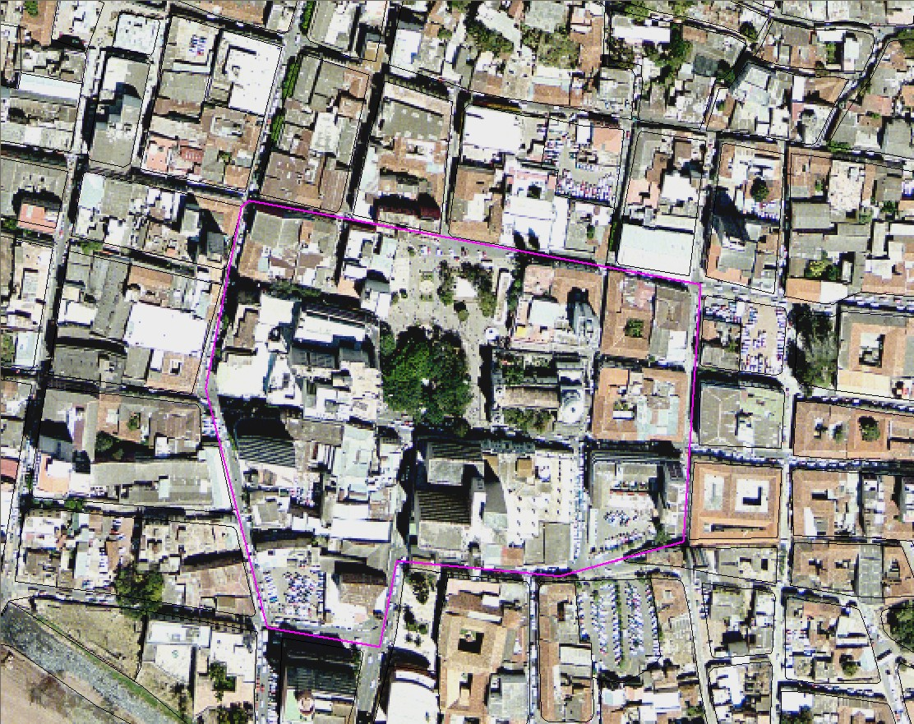
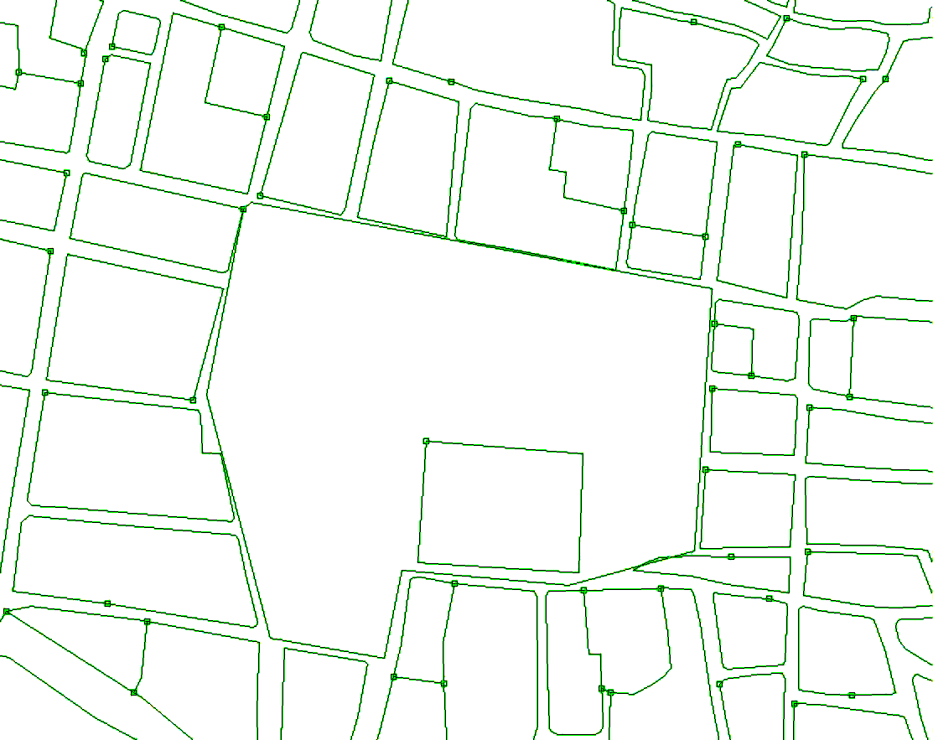
Added segment
As you can see it may not always be so easy to digitize the mapping units, because the buildings are of different sizes, and the shadows of the buildings also play a role.

Figure: Left: High-resolution image and right segments of mapping units. One new segment has been added.
- You can use the on-screen-digitizing functionality to create the boundary of the mapping units inside it. Given the resolution of the imagery available, it will be very difficult to digitize individual buildings (also because there are just too many). If the building is large enough, you may also decide to map individual buildings. Also digitize vacant land. Use the pen in the editor menu to digitize.
- Make sure that the lines are given the code: Unit_boundaries
- When you finish digitizing one segment, select the segment with the Select Mode icon (the hand) and choose the correct class. Next select the Insert Mode icon (the pencil) and digitize the following segment.

The image that you see when digitizing the blocks in the center of the city is shown in the figure below.
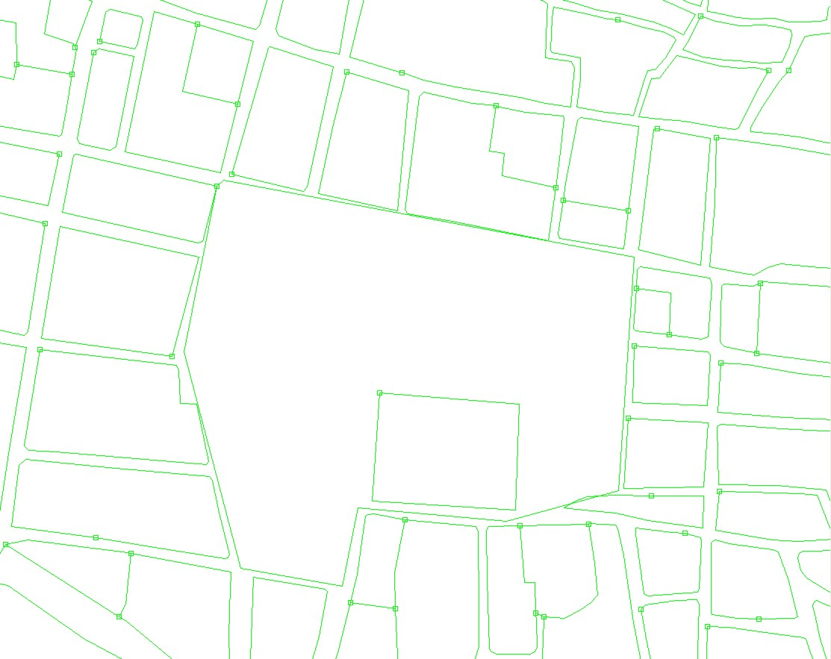
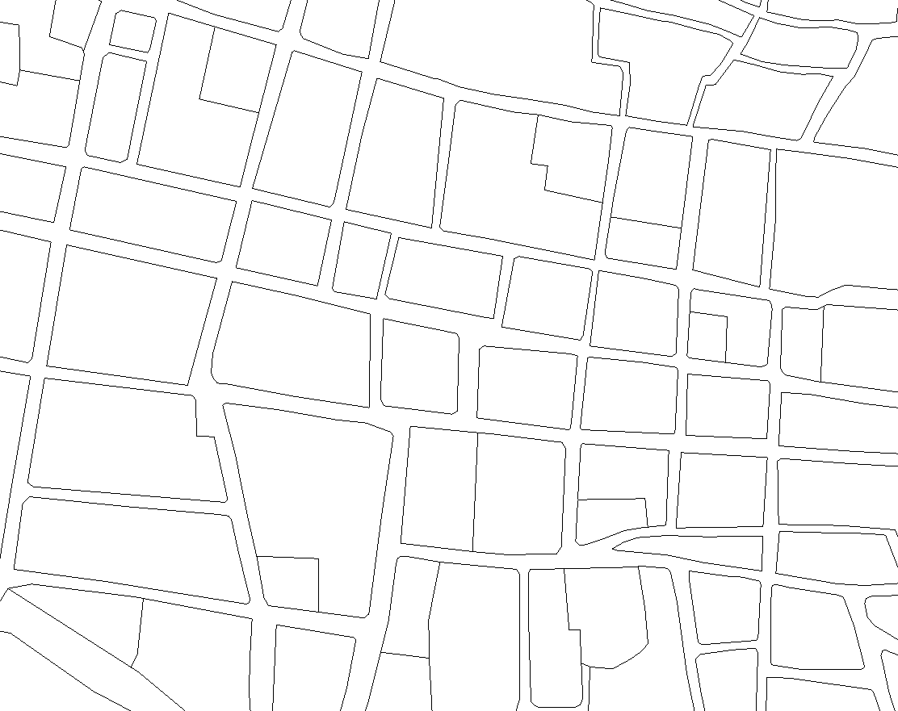
Added segment
It doesn’t matter if you do not finish the exercise. The aim of this exercise is just to make you aware how the mapping units have been defined

Watch Demo 10
for instructions
Figure: Right: completed section of digitized mapping units
- .
- After finishing (part) of the digitizing, go to the File menu and select Check Segments. Select Self Overlap. Repair the mistakes. Ask a teacher to assist you the first time, if you have no experience with it.
- Then check segments using Dead Ends, and Intersections. Repair all mistakes.
- Close the map editor (using the symbol), and close the map window.

After digitizing the segments of the boundaries of the mapping units, the next step would be to create polygons from them. This polygonization procedure takes more time, because the segments should be checked for errors, and in each polygon there should be a point with an Identifier domain, indication the number of the mapping unit. This procedure takes a bit too much time to do this right now.
Step 2: Polygonize from segments.
- We will not do the actual polygonization of the segments now because that might take to much time, as you will have to edit the segement map. For that you have to make sure that all the segments are digitized, and that they connect to each other, without overlaps or dead ends. This is done through checking the segments in the segment editor. After all segments are OK, the next step is to select Operations, Vectorize, Segment to Polygons. Instead of having digitized the points within the mapping units with a unique identifier, it is also possible to do this automatically. Select the option Unique Identifiers in the operation window Segments to Polygons. This will result however, in a random selection of identifiers. The resulting polygon map will have different identifier than the polygon map Mapping_units which is already in the dataset. Make sure to name the output polygon file differently, e.g. Mapping_unit_polygons.Urban land use.
- You can also use pre-existing points in the segment to polygon operation. We have generated the points for you, in the point map Mapping_units_points.

Step 3: Estimating urban land use from image interpretation
After you have had an idea on how the segments were made using screen digitizing, and how these were used to generate polygons, let us look at the attributes that can be obtained. In the following exercises we will estimate these attributes. We start by estimating the urban land use. The vulnerability assessment will be largely based on the urban land use mapping, which will be combined with other information such as the number of buildings, and the height of the buildings.
In the exercises we generate a database where the polygon map Mapping_units is the central map, and attribute information is stored for the following attributes:
- Urban land use
- Percent vacant area
- Number of buildings
- With 1 floor
- With 2 floors
- With 3 floors
- With > 3 floors
- Population
- Daytime
- Nighttime

For the multi-hazard loss estimation the urban land use is very important, as we can later define the population amount which might be in the mapping unit at a particular time of the day. That is why it is important to differentiate between the land use types that would have different activity patterns, at the same time of the day. For example, in residential areas, the population is supposed to be highest during the night, and lowest during the day, whereas in office buildings and schools it is reverse. On the other hand there are landuse types that have a very large number of people during a small period (e.g. stadium, religious buildings). Also it is important to map the areas that normally have no people (e.g. vacant areas). For the land use classification we have made the following legend (in ILWIS terms called a “domain”).
- Open the domain Landuse , ( )
- In the table below, indicate the importance of a number of the classes for characterizing the population and building vulnerability.

Important because

Having done this, let us now look more closely to the map Mapping_units, and you can define what the landuse should be yourself by interpreting the characteristics of the image.
- Open the polygon map Mapping_units. If you click on one of the polygons, you can see that each of them has a unique identifier, so that it is possible to give each of them different attributes, which come from the attached table.
- Click with the right mouse button in the map, and select Display Options, and select 1 pol mapping_units. The Display Options window opens again. Now select the option Attribute, and make sure the option Pred_landuse (predominant landuse) is selected. Select representation: Landuse. Now the map is displayed again, but now with the colors representing different land use types. Check this with the legend on the left. There are a number of white areas, which have been left open, and for which the landuse still needs to be indicated.

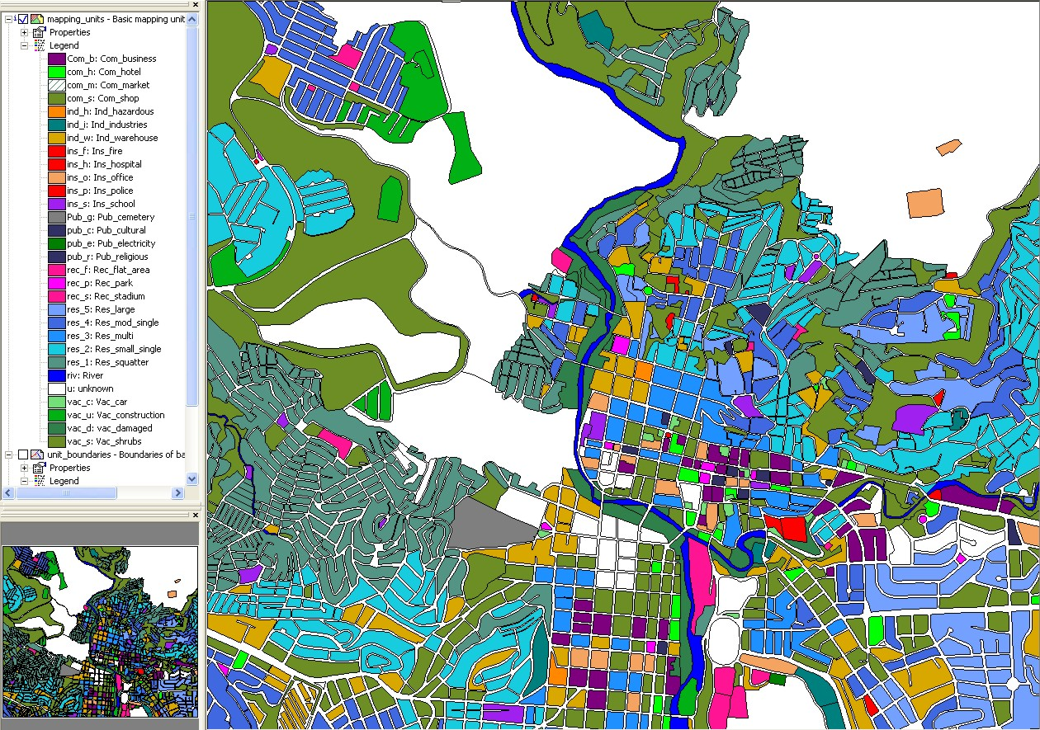
The map is now shown with white areas that do not have any land use classification. You can now use the information from the high resolution image to decide what is the most likely landuse type. For instance you can easily define the vacant areas, and the areas that have been damaged by the recent flood and landslide disasters that occurred in the area. If you look closely you can also find evidence in the city centre that there are religious building (e.g. churches), commercial buildings (e.g. market place), different types of residential buildings (e.g. those with single houses in gardens, houses in rows, squatters etc. See also the information in Chapter 4 of the Guide book.

Try to estimate the urban landuse for a number of the white areas in the map yourself.

- Select Layers / Add layers and add the raster image High_res_image. Now you can see that the high resolution image is shown for the areas which are not coded.
- Zoom in on one of the areas without a land use class, and double click in it. The attribute window is now opened, and the attribute Landuse_interpretation is indicated: unknown. Click in this window on the name unknown. You can now open a list of other possible land uses. Select the one you consider right, and double click on another polygon.
- You can also select the other attribute “Easy_to_interpret” to indicate wheter it is easy to interpret the landuse class for this polygon based on what you see in the image.
- If you click the button, you will see that the map is updated and the polygon will become colored.
- Zoom in on another unclassified area, and select again the right landuse.
Note: Alternatively click on the attributes Landuse_interpretation and Easy_to_Interpret. If you only click on one, the next time you can’t select from the list, and then you click first on the other
- Do this for a number of the polygons that don’t have a land use code yet.
- Which of the land use classes are most difficult to decide?

Land use type | Easy to Interpret? | Why?
In reality you might have to carry out fieldwork to better characterize urban land use, or you might have an existing land use map. These are however, often too general in terms of the categories used.
Later on in exercise 4c we will show how you can use Participatory GIS for collecting this type of information

Step 5: Estimating the number of buildings
The number of buildings per mapping unit is also a very important attribute that is required for risk assessment. The estimation of the number of buildings per mapping unit can be done in two ways, considering the situation of a data poor environment:
- An accurate way is to actual count the number of buildings for all mapping unit from the high-resolution image. However, this would cost an enormous amount of time and is not very feasible.
- A less accurate way is to make a number of samples per mapping units for each land use type and count the number of buildings. Then the average building size is calculated, and for those mapping units where no samples were taken these average building sizes are used in combination with the area of the mapping unit to estimate the number of buildings.
We will follow the second method here. We did the sampling for you (lucky for you), and counted for a number of mapping units (approximately 140) the number of buildings. The sampled mapping units are stored in the table Buildings_sampled.
- Open the table buildings_sampled.
The accuracy of this method depends on the amount of samples that you make, and the amount of field checks you make. So as such the method might lead to good results in a data poor environment.
The table has the following columns:
- Pred_landuse: the urban land use that you estimated in the previous exercise
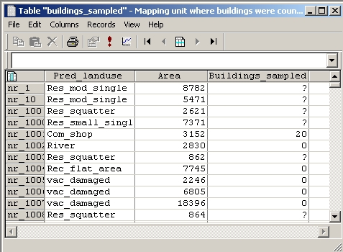
- Buildings sampled: an indication of the number of buildings that was manually counted in some of the mapping units. This was done directly from the high resolution image.
As you can see most of the records of Buildings samples have a ?, meaning that they are not sampled. Those that have a 0 value do not have buildings, as can be deduced from the urban landuse (vacant). We will now use some steps to make a rough estimation of the number of buildings for each mapping unit. We do this by making the following assumptions:
- Step A: We can calculate the average area of buildings for the mapping units that were sampled.
- Step B: We assume that buildings in the same land use class have more or less the same area.
- Step C: We then divide the area of the mapping units that were not sampled by the average building area to obtain a rough estimation of the number of buildings.

The ILWIS procedure to do this is given below:

In the procedure we make use of several ILWIS tools: Table operations including table calculations and aggregate functions.
Map and Table Calculation:
ILWIS has two options for calculation:
Map calculation, where the output is always a map. You type the formulas in the command line of the main window.
Table calculations where the output is always a column. You type the formulas in the command line of the table window.
The syntax for both types of calculations is very similar.
Check on the ILWIS HELP for an overview of the operators and functions used in map and table calculation. Check for instance the use of the conditional IFF function and the logical operators (and, not, or, xor).

- Open the table buildings_sampled.
- Step A: Use the following formula to calculate the building size in the mapping units, where samples were taken.

building_size:=iff(buildings_sampled=0,0,area/ buildings_sampled)
Use a precision of 1.

This formula means “if the value in the column building_sampled is 0 (meaning that the areas are vacant and don’t have buildings) then the resulting building size is 0. If not divide the area by the number of buildings sampled. Now for all sampled mapping units we have calculated what the building size was.
- Step B: Now we want to know the average building size per land use . Select Columns / Aggregation. Select the column Building_size, and the function Average. Group by Pred_landuse. Name the output column: avg_building_size. See the example screen.

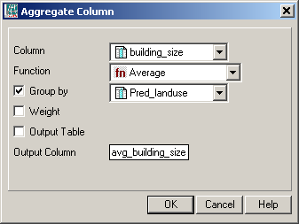
Aggregation functions.
They aggregate the values of a column in the current table. The following aggregation functions are available: Average, Count, Maximum, Median, Minimum, Predominant, Standard deviation, Sum.
- All aggregation functions can be used to aggregate the values of a whole column: you obtain one output value. For all records, the same aggregation value will appear.
- All aggregation functions can be used to aggregate values in a column per group: use a 'group by' column. Then, for all records that have the same class names or IDs in the selected 'group by' column, the same aggregation value will appear.
- The Average, Median, Predominant and Standard Deviation functions can be used to calculate weighted averages, etc.: use a weight column.
- If you do not select a 'group by' column, you will obtain one output value.
- If you also select a 'group by' column, you will obtain one aggregation value per group.

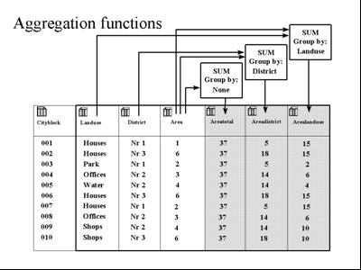

- Step C: Use the following formula to estimate the number of buildings for all units:
nr_buildings:=iff( isundef(buildings_sampled) , area/avg_building_size, buildings_sampled)
Use a precision of 1.

This formula means: if the column Buildings_sampled is undefined (has no value) than we divide the area of the mapping unit by the average building size (based on the same land use). If the column Buildings_sampled is not undefined, then we use the information from the column: Buildings_sampled.
Undefined values in ILWIS can mean several things:
- No data is available for a pixel.
- A pixel is located outside the study area.
- The result of calculation was wrong (for example if the formula is wrongly made).
- Calculated values in an output map fall outside the value range defined by the output range values.
Isundef() function tests whether a field in the column or a unit in a map is undefined or not known. Check the ILWIS guide for further explanation.
Now we can bring in the number of buildings that we have calculated in the table Buildings_sampled into our standard table that is linked to the map we use in risk assessment: mapping_units. We use the operation: table joining for that.

- Close the table Building_samples and open the table Mapping_units.
- Select Columns / Join, and join with the table Buildings_sampled, and select first the column Pred_landuse. Click Next, Next and Finish in the join wizard.
- Select Columns / Join, and join with the table Buildings_sampled, and select the column Nr_buildings. Click Next, Next and Finish in the join wizard.

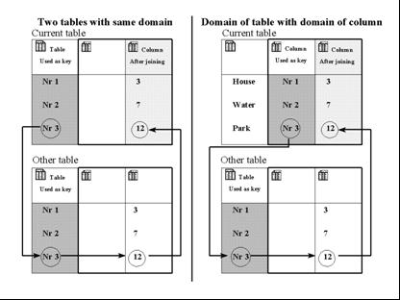
The figure shows two different ways of table joining. Dark shaded columns are used as key. The arrows indicate how the link is made. Left: The domain of the current table is the same as the domain of the other table from which you want to join a column. Right: The domain of a column in the current table is the same as the domain of the other table from which you want to join a column. The easiest way to join columns from another table into a current table is to use the Join Column wizard. The wizard needs to know the table name from which you wish to get a column, the name of the column that you wish to join from that table into the current table, and the relation or link between the two tables. This link is made via a common domain that is used either by the tables themselves or by a column in the tables. This link or key, through which a join can be performed, should be a (common) Class or ID domain.

We can now display the results.

- Open the map Mapping_units, and display the attribute Nr_buildings. Stretch between 0 and 100 (first make sure that you change the properties of the polygon map Mapping_units, and link to Attribute: Mapping_units). Overlay the high resolution image.
- Evaluate the results by comparing the number of calculated buildings with those that you can see in the image

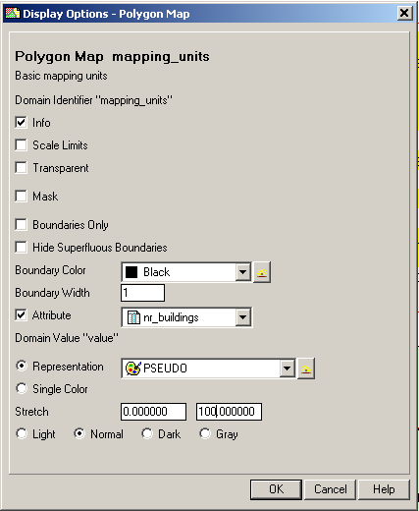
Naturally, if you check the actual number of buildings, the values of the estimated number of buildings will not be the same as the actual ones, because there may be exceptionally large or small buildings in the same landuse. It also doesn’t consider the presence of vacant areas within the mapping units. We will check the accuracy of this method in section 3.2.

Step 6. Estimation of population distribution
Once we have estimated the number of buildings we can also estimate the population per mapping unit. Also here we assume that we do not have any other available data, such as population census data for the study area. We have to assume an average number of people per building, which depends on the land use type, as office buildings have more population than single houses. This information is already provided in the table Landuse. We can also calculate the population for a daytime and a nighttime scenario. For that we have also added two columns indicating the percentage of population that would be present in each type of building during the day and during the night.
In this analysis of population distribution we assume standard number of people per building for different land use type. We ignore the fact that larger buildings have more people.

- Open the table Landuse and check the values for the three columns: Person_building, Daytime and Nighttime.

The table indicates the average number of people that would be in a typical building of a particular land use class. For instance, a building in a squatter area has an average of 7 people, whereas a large residential building has approximately 5 people. These value indicate the maximum number of persons that would be in a building. Depending on the day or night scenario these values would be multiplied by a factor, which would decrease these. For instance commercial buildings would be at full capacity during the day, and be empty during the night .
Make your own evaluation of the number of people and the daytime and nighttime factors that you find appropriate. You can of course simply agree with our estimates…

 | Our estimation |  |  | You estimation
Land use class | People per building | Daytime | Nighttime | People per building | Daytime | Nighttime
Com_business | 20 | 1 | 0
Com_hotel | 100 | 0.1 | 1
Com_market | 1000 | 1 | 0
Com_shop | 10 | 1 | 0
Ind_hazardous | 10 | 1 | 0
Ind_industries | 25 | 1 | 0
Ind_warehouse | 20 | 1 | 0
Ins_fire | 25 | 1 | 1
Ins_hospital | 800 | 1 | 1
Ins_office | 100 | 1 | 0
Ins_police | 50 | 1 | 1
Ins_school | 300 | 1 | 0
Pub_cemetery | 0 | 0 | 0
Pub_cultural | 200 | 0 | 1
Pub_electricity | 0 | 0 | 0
Pub_religious | 500 | 1 | 0
Rec_flat_area | 0 | 0 | 0
Rec_park | 0 | 0 | 0
Rec_stadium | 20000 | 0 | 0
Res_large | 5 | 0.2 | 1
Res_mod_single | 6 | 0.2 | 1
Res_multi | 20 | 0.2 | 1
Res_small_single | 6 | 0.2 | 1
Res_squatter | 7 | 0.3 | 1
River | 0 | 0 | 0
unknown | 0 | 0 | 0
Vac_car | 0 | 0 | 0
Vac_construction | 0 | 0 | 0
vac_damaged | 0 | 0 | 0
Vac_shrubs | 0 | 0 | 0

We have provided you the correct results for the previous steps in a table Mapping_units_population_estimate.

- Open the table Mapping_units_population_estimate and compare the results with the ones you obtained in the earlier part of this exercise.
- We can now read in these three columns into the table Mapping_units_population_estimate. (We have already calculated the number of buildings resulting from the previous exercise in this table). Open this table and use the join operation with the table Landuse for that. Read in the columns Person_building, daytime and nighttime.
- Now it is simply a matter of multiplying the number of buildings with the population per building and the correction factor for day- or nighttime.
Daytime_population:=nr_buildings * person_building * daytime
Nighttime_popultion:= nr_buildings * person_building * nighttime
(make sure to use a precision of 1, as we cannot have half a person)
- Display the results (make sure to link them with the map in the properties of the map Mapping_units), and check the pattern.
- Also make attribute maps of both. In the catalog right click on the polygon map mapping_units, then select vector operations, attribute map. Select the table Mapping_units_population_estimate, the attribute Daytime and call the output map Daytime_population. Do the same for the Nighttime_population. See the image below

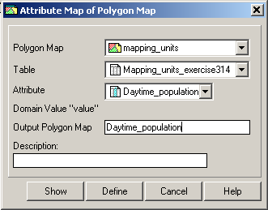
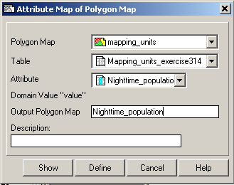

Answer:
Is there an accurate division of population if you compare daytime and nighttime?
What could be the reason? How could this be improved?
Period | Total population
Daytime
Nighttime
Difference

Pocket Line Calculator:
To temporally view the outcome of an expression, without storing the results in a column, you can use the command line as a Pocket line calculator.
On the command line type a “?” followed by an expression.

- You can read the total Daytime and Nighttime population in the table Mapping_units_population_estimate , activating the statistic pane in view, statistic pane, and reading the value sum under the column Daytime_population and Nighttime_population.
- For the evaluation of the difference you can use a generic calculator or typing directly in the command line of ILWIS the following formula:
?183779-143379

Now you have generated a basic elements at risk database from scratch, basically only based on the interpretation of a high resolution image.

