Exercise 3V: Modelling erosion from pyroclastic flow deposits on Mount Pinatubo
Expected time: 4-5 hours
Data: data from subdirectory: RiskCity exercise/exercise03V/data
Objectives: This exercise deals with the evaluation of erosion from pyroclastic flow deposits on Mount Pinatubo, Philippines, which erupted in 1991 and produced an enormous deposit of hot ashes, up to 200 meters thick. In the years after the eruption, heavy rainfall in the area triggered large erosion and lead to a series of lahars. The data from this exercise was provided by Art Daag, from the Philippine Institute of Volcanology and Seismology (PHIVOLCS), who made his MSc study on this topic.

Background information
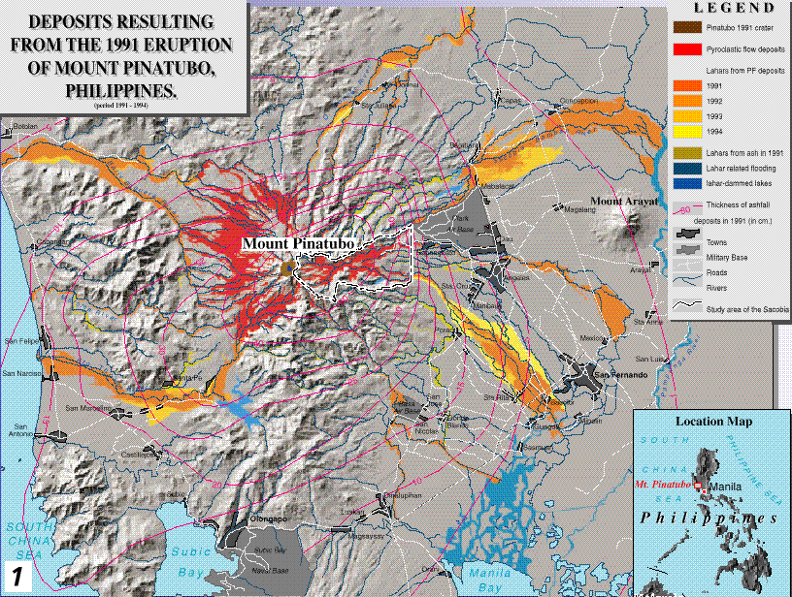
Mount Pinatubo is situated on the island of Luzon, about 80 km northeast of Manila, the capital of the Philippines. The volcano, with K-Ar datings of approximately 1.1 million years, and with youngest C¹⁴ dating of ±400 years BP, is the youngest volcano in the Zambales range and in the western Luzon volcanic arc.

Figure 1: Overview of situation after the eruption of Mt Pinatubo

- The map View3d gives an overview of the region around Mount Pinatubo. This figure was prepared from an extensive digital terrain model (DTM), derived from 16 1:50.000-scale topomaps.
- Display this map. Close it after you have seen it.
Mt. Pinatubo began spewing ash on June 3, 1991 at 0730H, and continued for 3 months until the end of August 1991. It peaked during the eruption of June 15 1991, propelling ash up to 30 km above the vent. Mount Pinatubo is located in a densely populated area, with major cities such as San Fernando, and Angeles. Before the eruption 2 large US military bases were present in the area (Clark Air Base, and Subic Bay Naval Base).

- An overview of the area surrounding Mount Pinatubo, and the deposits resulting from the 1991 eruption, as well as the lahar deposits from 1991 till 1994, are shown in the map Location.
- Display this map. The legend can be found in the map Legend

The 1991 eruption had deposited about 6.83 km³ of pyroclastic flows into the different watershed namely: O'Donell (0.6 km³), Sacobia (1.78 km³), Porac-Gumain (0.05 km³), Marella-Sto. Thomas (1.3 km³) and Balin-Baquero (3.1 km³). The Sacobia watershed, which is the watershed analyzed in this study, starts at the eastern crater rim of the volcano (see map location) and extends downslope until reaching the lowland Candaba swamp (50 km east) and Manila bay (60 km southeast).
The rapid erosion or removal of the 1991 pyroclastic flow deposit is one of the major social and scientific concerns after the 1991 eruption of the Pinatubo Volcano because this generates life threatening and destructive lahars of enormous magnitude. This will continue to occur for several years. The lahars from Pinatubo resulted in losses of lives and damage to properties in areas surrounding the volcano. About 50,000 persons were left homeless and the indirect impacts such as flooding and isolation have affected more than 1.3 million people in 39 different towns and 4 large cities. About 1,000 square kilometers of prime agricultural lands are at risk. Lahars predominantly occur during the rainy season in the southwest monsoon period, which lasts from June till November. The average annual rainfall varies from 1946 millimeter in the East of Pinatubo, to 3900 millimeters in the West. Long duration and high intensity rainfall are associated with the occurrence of strong typhoons, which are responsible for the production of large magnitude of destructive lahars.
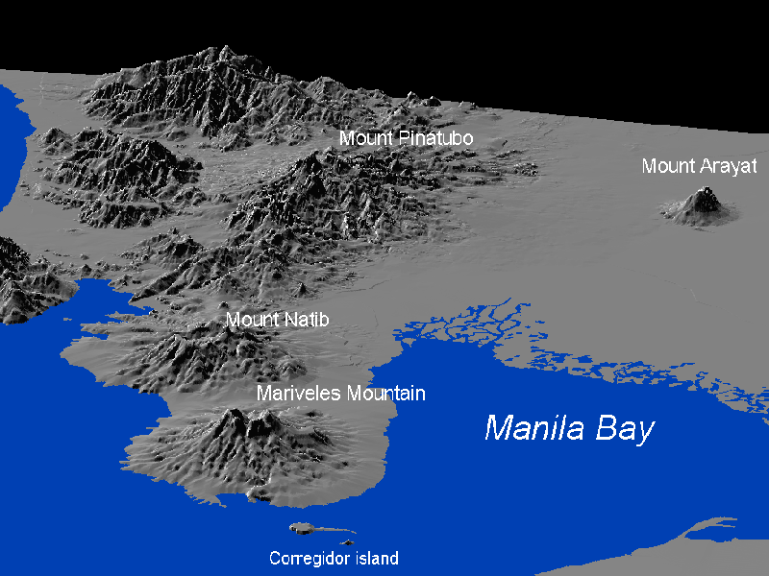
Figure 2: 3-D view of Mt Pinatubo

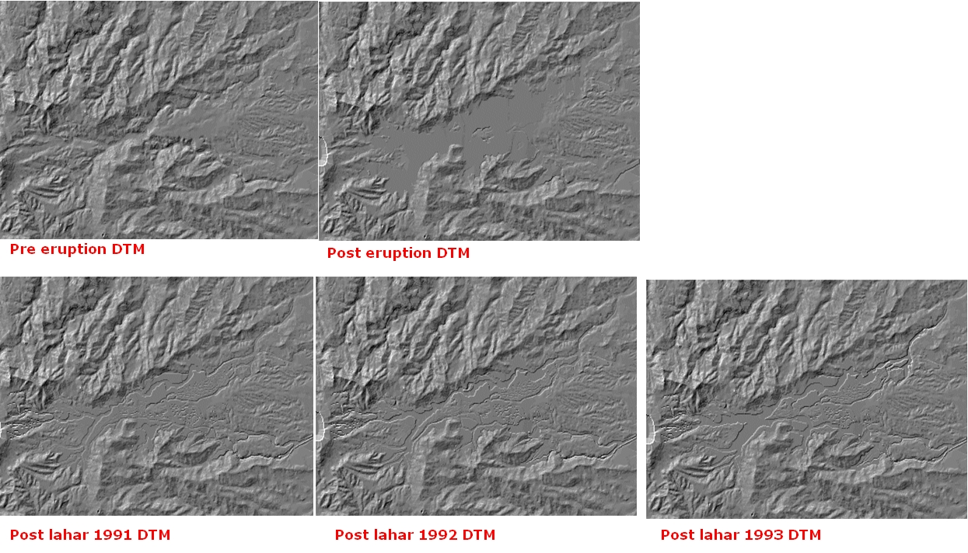
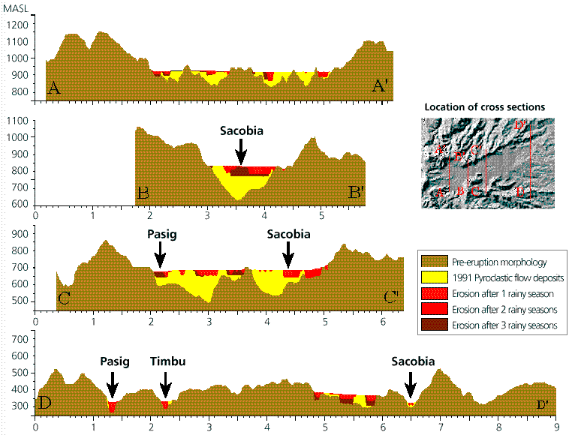

Figure 3: Above: cross sections showing the progressive rapid erosion of pyroclastic flow deposits. Below: the DEMs for different periods used in this exercise
Methodology
The main objective of this study was to evaluate the geomorphologic changes in the upper Sacobia catchment, where pyroclastic flows have been deposited. The following activities were undertaken during the investigation:
- Elaboration of geomorphologic maps for the pre- and post-eruption situations, up till 1993. This was done in order to evaluate the changes in the catchment areas and their significance in producing lahars.
- Creation of digital terrain models for each year, from which the thickness of pyroclastic flows, and the yearly eroded volume can be calculated.
The study of geomorphologic changes was based on the interpretation of both vertical and hand-held oblique aerial photos, video tapes, and satellite images taken at different time periods.
To calculate the volume of the 1991 pyroclastic flow deposits and the yearly eroded sediment volumes, a DTM overlaying technique using GIS was applied. For this procedure it was necessary to construct DTMs of several periods: i.e. the pre-eruption DTM; the post-plinian eruption DTM which renders the undisturbed deposits of the 1991 pyroclastic flows; a post-lahar 1991 DTM; a post-lahar 1992 DTM; and a post-lahar 1993 DTM.

Pre-eruption situation
The DTM of the pre-eruption situation is called Dtmpre. This DTM was generated in ILWIS using the following steps:
- Digitizing the contours (with contour interval of 50 m) from the 1:50.000 scale topographic map before the eruption.
- Interpolating the rasterized contour lines using the InterpolSeg operation in ILWIS.
- Display the Digital terrain model Dtmpre by double clicking on the map icon. Change the representation to Pseudo. Press OK in the Display Options dialog box. The map will now be displayed in pseudo colors, which are stretched between the minimum value of 140 m and the maximum value of 1740.
- Move the cursor over the map and press the left mouse button to see the values in the map.
- Close the map window again.

A better way to see the DTM is to generate a so-called hill-shading image from it. A hill-shading image simulates the shadows created by the sun from the NE. Slopes directed to the northeast are shown in bright gray, and slopes directed to the southwest in dark gray.

- Calculate a hillshading image of the map Dtmpre (by selecting Operations, Image processing, Filter from the main ILWIS menu). Select the filter name shadow. Name the output map Shadpre.
- Display this map in gray tones. Stretch the map between -500 and +500.
- Overlay the segment information from the polygon map Catchpre (use Layer, Add layer, Polygon map). Select Info and Boundaries only, and use a red color for the boundary lines.
- Overlay the segment information from the segment map Drainpre. Accept the defaults; the drainage will be displayed in blue.
- When you move through the map and press the left mouse button, the name of the catchment will be displayed.
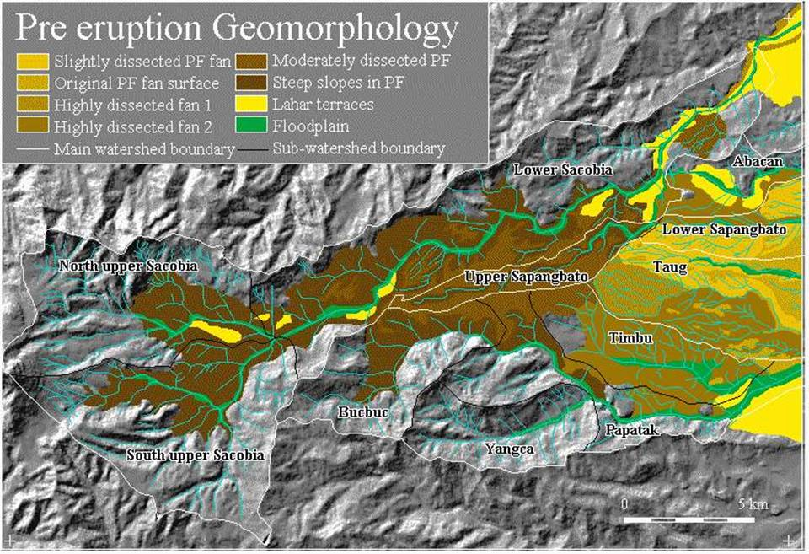
The pre-eruption river system in the study area consists of 2 major rivers namely: Sacobia, and Pasig. The largest watershed is the Sacobia river which is divided in the North Upper Sacobia (9.97 km2), South Upper Sacobia (11.73 km²), and the Lower Sacobia (18.12 km²) sub-catchments. The second largest watershed is Pasig, and it contains the following sub-catchments; Bucbuc (5.95 km²), Yangca (4.55 km²), Papatak (6.46 km²), and Timbu (4.94 km²). Other, small, catchments in the study area are Abacan (2.54 km²), Taug (6.60 km²), and Sapangbato (5.29 km²). These sub-catchments are located in the distal part of the study area at about 12 km from the crater.
At least 6 major eruptive episodes have been identified throughout the modern history of Mount Pinatubo with repose periods of several centuries or millennia. The youngest eruption, before the 1991 event, was dated 400 ± 70 Before Present. The strongest eruption was dated to have occurred in the period between 30,390 ± 890 and 35,000 years B.P.
This calderagenic eruption produced an extensive pyroclastic flow-fan on the eastern side of the volcano which occupies an area 5 times larger than the 1991 pyroclastic flow deposits. The deposits resemble broad coalescing fans reaching up to about 20 km east of the volcano. They were subjected to a high degree of erosion as evidenced by the intricate patterns of deeply dissected gullies in the Lower Sapangbato, Taug and Timbu catchments. These resistant pyroclastic flow deposits partly serve as watershed divides of the Abacan, Sacobia and Pasig rivers.
The original pre-1991 pyroclastic flow level was severely eroded in the upstream section leaving deep valleys of about 200 meters. At altitudes between 500 to 200 m.a.s.l., in between Pasig and Sacobia rivers, this pyroclastic flow level can still be recognized, forming a large broad fan, in the upper Sapangbato catchment. The broad and extensive lahar deposits build the large alluvial fan landscape around the volcano which mantles the highly built-up areas and had formed fertile agricultural areas.

- Save the contents of the map window in a map view called Viewpre. Close the map window.
- Rasterize the polygon map Catchpre using the georeference Dtmpre. This map you will used later in the analysis.

The situation shortly after the 1991 eruption
The DTM of the post-eruption situation is called Dtmerp.

- Calculate a hillshading gray image of the map Dtmerp and display it on the screen.
- Overlay the segment (boundary) information from the polygon Catcherp and the segment Drainerp.
- Save the contents of the map window in a map view called Viewerp.
- Display both map views from the period before and after the eruption, and compare the results visually.
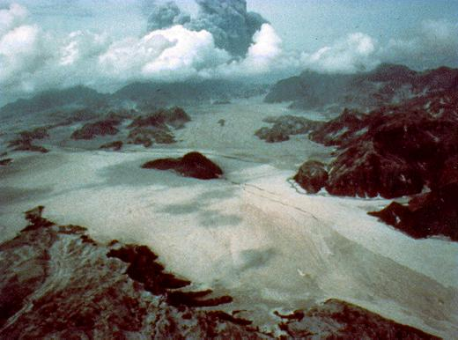
The new pyroclastic flow deposits covered about 24 km² and obliterated 3 major water divides leaving only the high hills, which form distinct “islands” in the middle of new and featureless flat pyroclastic flow deposits. The pre-eruption pyroclastic fan in the catchments of Sapangbato and Taug, which was not covered, acted as a wedge dividing the pyroclastic flow into two directions: North in to the lower catchment of the Abacan and Sacobia rivers, and South into the Pasig river.
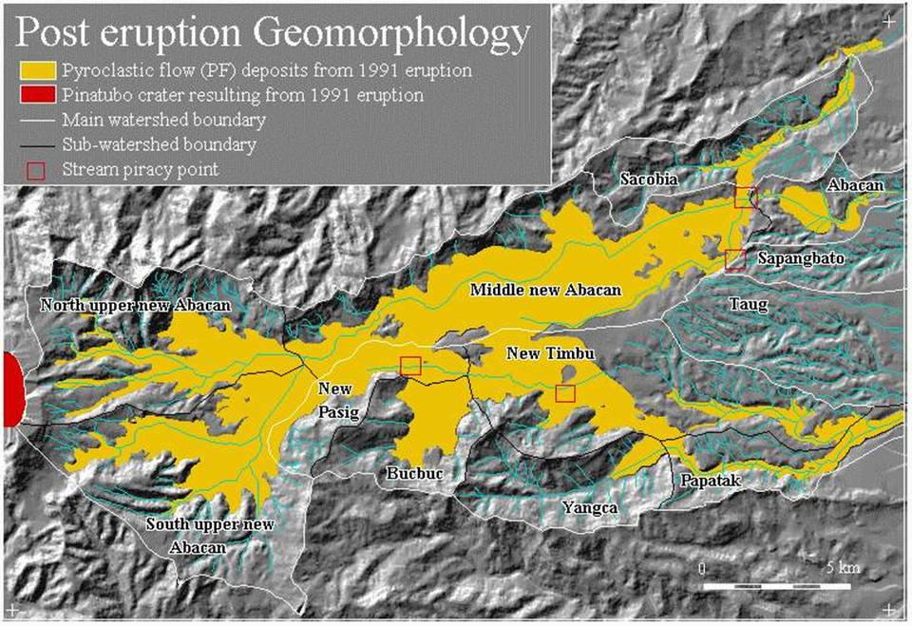
One of the most significant effects of the deposition of the extensive pyroclastic flow deposits was the change in the hydrological situation. Since the pre-eruption river valleys were completely filled up, new streams developed on top of the pyroclastic flow level, with courses that were partly different from the pre-eruption situation. The most striking example is the covering of the drainage divide between the Sacobia and the Abacan rivers. Pyroclastic flow deposits overtopped this drainage divide by about 20 meters and were deposited in the upper reaches of the Abacan catchment. Therefore, during and directly after the eruption, lahars resulting from the passing of typhoon Yunya did not follow the pre-eruption river valley of Sacobia, but were drained through the Abacan river valley, causing destruction in the city of Angeles. The Upper Sapangbato catchment was also diverted towards the Abacan catchment.
Another crucial change in the hydrological situation took place in the Pasig river, where a section of the pre-eruption South upper Sacobia catchment was captured, thus extending the pre-eruption catchment of the Pasig river over the water divide. This was covered by 80 meters of pyroclastic flow deposits. Further downstream stream piracy took place in the headwaters of the Timbu creek, which captured the main Pasig river.
First you calculate the changes in the catchments that resulted from the accumulation of the pyroclastic flow deposits.

- Rasterize the map Catcherp using the georeference Dtmpre.
- Cross the two raster maps Catchpre and Catcherp. Use the menu options Operations, Raster operations, Cross. The first map: Catchpre, the second map: Catherp. Output table: Cerppre. Click Show and OK.
- Have a look at the resulting cross table. You see the areas of the changes between the two periods, displayed in square meters. As you can see there are some combinations with undefined values. This is caused by the formation of the crater, which no longer forms part of the Sacobia catchment after the eruption.
- To convert these values to square kilometers, type the following command in the command line of the cross table:
Areakm2=Area/1.0E+6↵
(use a precision in the output column of 0.001).
- Fill in the values in table 1.
- Close all map and table windows.

Table 1: Changes of catchment sizes before and after the eruption. Fill in the table based on the results from the cross table

 | After the eruption
Before |  | Sacobia | Pasig | Abacan | Taug | Sapangbato | Total
Before | Sacobia
Before | Pasig
Before | Abacan
Before | Taug
Before | Sapangbato
Before | Total

Now that you know the changes in catchment areas after the eruption, you can also look at the volumes of pyroclastic flow materials that have been deposited in the different catchments. If you consider a cross section through one of the valleys in the area: the pre-eruption situation is given by the map Dtmpre (showing the pre-eruption topography). The topography after the eruption is given by the map Dtmerp.
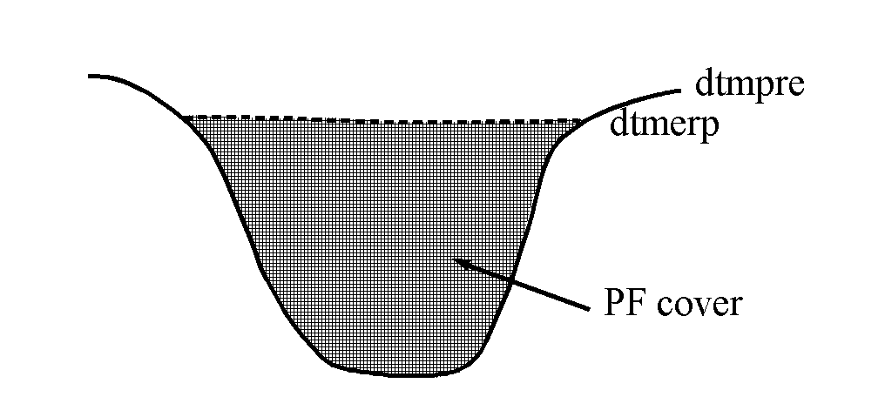
Figure: Schematic cross-section showing the situation after the eruption

You can subtract the two maps to find the pyroclastic flow (PF) thickness:
Pfthick=Dtmerp-Dtmpre.
The positive values in the resulting map indicate accumulation area. Negative values indicate where the crater has been formed

- Type the following formula on the command line of the main window:
Pfthick=iff(Dtmerp-Dtmpre>0,Dtmerp-Dtmpre,0)↵
Make sure the output map has a precision of 1. Display this map in gray and read the values together with those of the input maps by clicking Pixel Information.
- Cross the catchment map after the eruption (Catcherp) with the map Pfthick. The output table is called Pferp.
- Open the cross-table Pferp and look at the columns. The column Area gives you the area occupied by pyroclastic flow deposits of a certain thickness. The thickness itself is given in the column Pfthick. To know the volume of pyroclastic flow deposits for each thickness you have to multiply the column Area with the thickness. Type the following formula on the command line in the table:
Volerp=Area*Pfthick/1.0E+6↵
The output values are then in million cubic meters. Use a precision of 0.0001.
- Create a new table (Total) with the domain Catchm. In this table you will aggregate the results. Open this table.
- Now the volumes from the cross table will be aggregated into this table. Type the following formula on the command line of the table:
Volerp=aggsum(Pferp.Volerp,Pferp.Catcherp)
This means, calculate the sum of the values in the column Volerp from the table Pferp, and use the column Catcherp as the column by which the grouping should be done. Note that this column Catcherp has the same domain (Catchm) as the table Total.
- Have a look at the result, and close table windows.

Now you know the volume of pyroclastic flow that was deposited in each of the catchments.

The situation after the first rainy season
The geomorphology of the Sacobia catchment changed dramatically during the first rainy season, following the 1991 eruption. Due to heavy rainfall, the original pyroclastic flow surface was eroded, resulting in a series of terrace levels with a high gully density, separated by deep valleys. Within a few months after the eruption, the main rivers had eroded into impressive gorges, up to about 35 meters.

- Calculate a hillshading image of the map Dtm91 and display it on the screen.
- Overlay the segment information from the polygon boundaries Catch91 and segment Drain91. Save as map view View91.
- Compare the resulting map view with those of the previous exercises.

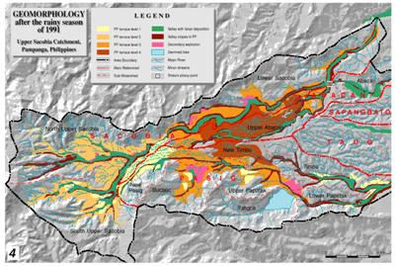
Due to the deposition of the pyroclastic flow and lahar materials the Yangca creek, which is a tributary of the Pasig river, was blocked, and a dammed lake started to develop.
Another serious geomorphologic feature is the presence of secondary explosions. Secondary explosions are phreatic explosions occurring in the pyroclastic flow deposits. These are produced when water comes into sudden contact with the hot in-situ pyroclastic flow deposits, producing expanding steam. The mechanisms for generating secondary explosions are not yet fully understood. However, they commonly occur simultaneously with heavy rains, although in some instances they can occur also during little or no rainfall. In these latter cases they may be related to groundwater flow within the pyroclastic flow material. Moderate to minor explosions can also occur more frequently due to large valley-side collapse of the newly exposed hot pyroclastic flow deposits produced during the passage of erosive lahars. Most of the secondary explosions in the Sacobia watershed result in deep semi-circular to oblate craters or crown features with a relatively flat base. The depth of secondary craters ranges from 20 to about 80 meters. One of the effects of secondary explosions may be the triggering of secondary pyroclastic flows. They can remobilize volumes of considerable thickness over large distances.
The most important secondary explosion after the rainy season of 1991, occurred on April 4, 1992 at the water divide between Sacobia and Abacan. The secondary explosions at the so-called Abacan gap produced 2-3 km of channel-confined secondary pyroclastic flow deposits and resulted in the recapture of the upper catchment by the Sacobia river causing large destructive lahars in 1992 in the downstream section which buried several villages and destroyed hundred of hectares of agricultural lands. The secondary pyroclastic flows completely buried the lahar retaining structures constructed along the Sacobia river which were recently built. Only a small area of the pyroclastic flow covered zone still drained towards the Abacan, but this section was captured later by the Sacobia as well. Due to the loss of connection with the pyroclastic flow deposits the Abacan river ceased to cause any serious lahar threats to the city of Angeles. The lahars were now flowing along the main courses of the Sacobia and the Pasig rivers, with the former being the most important, as it had the largest catchment area within the pyroclastic flow deposits. Another important stream capture took place by the Pasig river, which recaptured its old course, and reduced the lahar activity via the Timbu river.
You will first calculate the changes in the catchments that resulted from the accumulation of the pyroclastic flow deposits.

- Rasterize the polygon Catch91 using the georeference Dtmpre.
- Cross the two raster maps Catcherp and Catch91. Use the menu options: Operations, Raster operations, Cross. The first map: Catcherp, the second map: Catch91. Output table: C91erp. Click Show and OK.
- Have a look at the resulting cross table. You see the areas of the changes between the two periods, displayed in square meters.
- To convert these values to square kilometers, type the following command in the command line of the cross table:
Areakm=Area/1.0E+6↵
Use a precision in the output column of 0.001.
- Fill in the values in table 4.2
- Close table windows.

Table 2: Changes of catchment sizes after the first rainy season, and shortly after the eruption. Fill in the table based on the results from the cross table

 | After first rainy season of 1991
After eruption |  | Sacobia | Pasig | Abacan | Taug | Sapangbato | Total
After eruption | Sacobia
After eruption | Pasig
After eruption | Abacan
After eruption | Taug
After eruption | Sapangbato
After eruption | Total

Now that you know the changes in catchment areas, after the first rainy season, you can also look at the volumes of pyroclastic flow materials that still remain and the volumes that have been eroded.
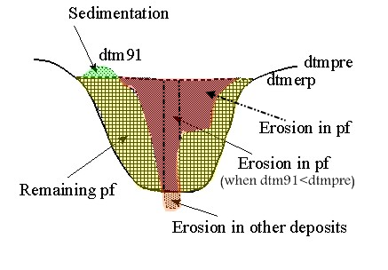

Figure3: Schematic cross-section showing the situation after the first rainy season following the eruption
Calculations are given below to derive the thickness of eroded materials:
Total erosion
Ero91=iff(Dtm91<Dtmerp,Dtmerp-Dtm91,0)
Erosion in PF deposits:
Eropf91= iff((Ero91>0)and(Dtm91>Dtmpre),Dtmerp-Dtm91,iff((Ero91>0)and(Dtm91<Dtmpre),Dtmerp-Dtmpre,0))
Erosion in other deposits:
Eroot91=iff((Ero91>0)and(Dtm91<Dtmpre),Dtmpre-Dtm91,0)
Sedimentation in 1991:
Sed91=iff(Dtm91>Dtmerp,Dtm91-Dtmerp,0)
Remaining PF material in 1991:
Pfth91=iff(Dtm91>Dtmerp,Dtmerp-Dtmpre, iff(Dtm91<Dtmpre,0,Dtm91-Dtmpre))
or
Pfth91=(Dtm91-Dtmpre)-Sed91
and use only the positive values.

- Start by calculating the total erosion after the rainy season of 1991. Type the following formula on the command line:
Ero91=iff(Dtm91<Dtmerp,Dtmerp-Dtm91,0)↵
Make sure the output map has a precision of 1.
- Now calculate the erosion in PF deposits. Type the following command:
Eropf91=iff((Ero91>0)and(Dtm91>Dtmpre),Dtmerp-Dtm91,iff((Ero91>0)and(Dtm91<Dtmpre),Dtmerp-Dtmpre,0))
Make sure the output map has a precision of 1.
- The next map to calculate is the erosion in 1991 in other deposits. Type:
Eroot91=iff((Ero91>0)and(Dtm91<Dtmpre),Dtmpre-Dtm91,0)↵
Again, the precision should be 1.
- Now you calculate the thickness of the sedimentation in 1991. Type:
Sed91=iff(Dtm91>Dtmerp,Dtm91-Dtmerp,0)↵
Also here, the precision should be 1.
- Finally you can calculate the remaining thickness of PF deposits in 1991. Type:
Pfth91:=iff(Dtm91>Dtmerp,Dtmerp-Dtmpre,iff(Dtm91<Dtmpre,0,Dtm91-Dtmpre))
Precision should be 1.
- Have a look at the results, use the pixel information window and the ILWIS pocket line calculator to check them, and close all map and table windows.

Now the erosion and sedimentation maps for 1991 have been calculated. The next step is to cross these maps with the catchment map after the first rainy season (Catch91), and to aggregate the results in the table Total.

- Cross the map Catch91 with the map Ero91. Make a cross table: Ero91, and calculate the volume of erosion in million cubic meters, in a column called Erosion91. Open the table Total and calculate for each catchment the erosion by aggregating the values from the cross table.
- Cross the map Catch91 with the map Eropf91. Make a cross table Eropf91 and calculate the volume of erosion in PF in million cubic meters, in a column Erosionpf91. Calculate the values for each catchment in the table Total.
- Cross the maps Cathc91 and Eroor91, and follow the same procedure.
- Cross the maps Catch91 and Sed91, and follow the same procedure.
- Cross the maps Catch91 and Pfth91, and follow the same procedure.

After finishing this, the table Total contains for each catchment how much was eroded and sedimented in 1991, and how much pyroclastic flow material is still remaining.

The situation after the second rainy season
After the second rainy season the valleys in the study area were widened and deepened considerably in relation to the year before. Most valleys established their course following the former deep pre-eruption valley axis where new pyroclastic flow deposits are thick. This may be due to the resistant pre-eruption pyroclastic flow terraces which are only mantled by less than 30m of new pyroclastic flows. Some of the gullies at Sacobia partly incised the pre-eruption deposits.

- Calculate a hillshading image of the map Dtm92 and display it on the screen.
- Overlay the segment information from the map Catch92 and Drain92. Create a map view View92.
- Compare the result with the one from the previous year.

The area of the terraces rapidly diminished as a result of valley widening at the base of the terrace, gully widening, and secondary explosions. Isolated terraces began to form as a result of the erosion along several sides. In 1992, large secondary explosions occurred in both the Sacobia and Pasig catchments. The main explosion which occurred along the Sacobia river had an area of 0.3 km² and depth of 30 m. This is located in an area which has a circular low depression in the pre-eruption morphology, and which is likely a former site of pre-historic secondary explosions.
Several minor explosions from side wall collapse had occurred as a result of lateral erosion. The secondary explosion crater at the confluence of Bucbuc and Pasig and the large crater at the Sacobia river were not active in 1992. Their features are gradually diminishing as a result of gully side erosion.
The lake at the confluence of Yangca creek and Pasig river had again generated large lake-breakout related lahars. At the same time the lake was being filled by lahars spreading out from the Pasig river.
During the second rainy season only minor changes in drainage areas took place, resulting from stream captures. The only change took place at the Sacobia river, which captured the last 0.3 km² from the Abacan river in direct contact with pyroclastic flow deposits.
You can now calculate the changes in the catchments that resulted from the accumulation of the pyroclastic flow deposits

- Rasterize the map Catch92 using georeference Dtmpre.
- Cross the two raster maps Catch91 and Catch92. Follow the same procedure as used earlier to calculate the changes in catchment sizes (in square kilometers).
- Fill in the values in table 4.3.
- Close table windows.
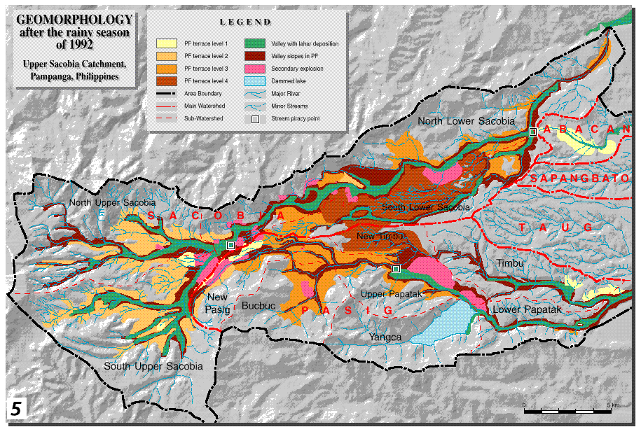
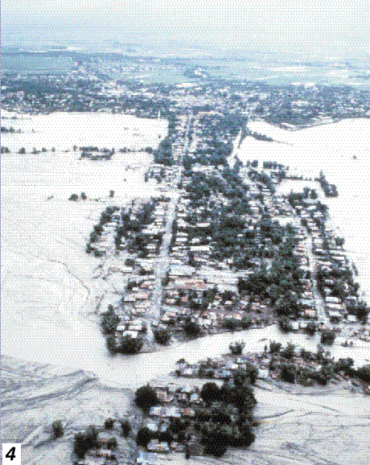

Table 3: Changes of catchment sizes between the first and second rainy season following the eruption. Fill in the table based on the results from the cross table

 | After second rainy season of 1992
After first rainy season of 1991 |  | Sacobia | Pasig | Abacan | Taug | Sapangbato | Total
After first rainy season of 1991 | Sacobia
After first rainy season of 1991 | Pasig
After first rainy season of 1991 | Abacan
After first rainy season of 1991 | Taug
After first rainy season of 1991 | Sapangbato
After first rainy season of 1991 | Total

The exact calculations for obtaining the erosion and sedimentation, and the remaining PF volumes in 1992 are not given here anymore, but you are requested to formulate them yourself.
Figure 4: Schematic cross-section showing the situation after the second rainy season following the eruption
- Design the formulas yourself and write them in the spaces below.
- Calculate the volumes for:
- total erosion in 1992,
- erosion in PF deposits in 1992,
- erosion in other deposits in 1992,
- sedimentation in 1992,
- remaining PF volume in 1992.
- Store the results in the table Total.
Total erosion:
Ero92=
Erosion in PF deposits:
Eropf92=
Erosion in other deposits:
Eroot92=
Sedimentation in 1992:
Sed92:=
Remaining PF material in 1992:
Pfth92=

The situation after the third rainy season

- Calculate a hillshading image of the map Dtm93 and display it on the screen.
- Overlay the segment information from the maps Catch93 and Drain93. Create a map view View93.
- Compare the result with that of the previous year.

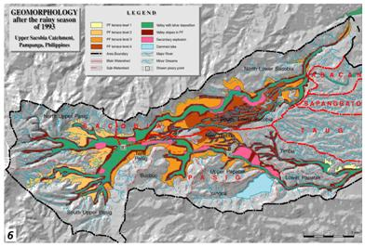
Valleys have grown rapidly in the upper portion of the catchment near the confluence of the 2 large valleys. This massive erosion was triggered by a large secondary explosion which occurred on October 6, 1993, and as a result, a large secondary pyroclastic flow was directed towards the Pasig river. This event caused the capturing of the entire upper Sacobia catchment by the Pasig river, and brought a major shift in lahar delivery from the Sacobia to the Pasig river. From aerial reconnaissance, the secondary pyroclastic flows covered the major gullies both in Sacobia and Pasig catchments by at least 20 meters of hot secondary pyroclastic flow deposits. The event did not leave clear secondary craters due to the large subsequent erosion, but only broad flat valleys. The capture occurred during typhoon Kadiang. The relative timing of capture can be reconstructed by the change of lahar magnitude of both channels as measured by the acoustic sensors in the lahar monitoring stations.
As a result of the capture of the upper section of the Sacobia catchment, the erosion in the Pasig river increased dramatically. Rapid vertical and lateral erosion in the pyroclastic flow deposits, which were still hot, resulted in numerous secondary explosions along the Pasig river. At the lower part of Sacobia, the valleys were considerably incised into the pre-eruption deposits attaining a vertical valley wall of about 50-80 meters.
The upper pyroclastic flow level was by now completely eroded, and the second level remained only in the eastern part of the catchment. In the lower terrace levels erosion reached the underlying pre-1991 pyroclastic flow deposits in several places.
The capacity of the temporary lake to retain water had decreased considerably due to the deposition of lahars into the Yangca creek. No large lake-failure related lahar occurred during 1993, since the lahar dam at Yangca creek was much higher than the active channel. In 1994 however, the lahar dam failed, resulting in a major lahar in the downstream Pasig catchment.
Now you can calculate the changes in the catchments that resulted from the accumulation of the pyroclastic flow deposits.

- Rasterize the map Catch93 using the georeference Dtmpre.
- Cross the two raster maps Catch92 and Catch93. Follow the same procedure as used earlier to calculate the changes in catchment sizes (in square kilometers).
- Fill in the values in table 4.
- Close all map and table windows.

Table 4: Changes of catchment sizes between the second and third rainy season following the eruption. Fill in the table based on the results from the cross table

 | After third rainy season of 1993
After second rainy season of 1992 |  | Sacobia | Pasig | Abacan | Taug | Sapangbato | Total
After second rainy season of 1992 | Sacobia
After second rainy season of 1992 | Pasig
After second rainy season of 1992 | Abacan
After second rainy season of 1992 | Taug
After second rainy season of 1992 | Sapangbato
After second rainy season of 1992 | Total

The exact calculations for obtaining the erosion and sedimentation, and the remaining PF volumes in 1993 are not given here anymore. Again, you are requested to formulate them yourself.
Figure 5: Schematic cross-section showing the situation after the third rainy season following the eruption

- Design the formulas yourself and write them in the spaces above.
- Calculate the volumes for:
- total erosion in 1993,
- erosion in PF deposits in 1993,
- erosion in other deposits in 1993,
- sedimentation in 1993,
- remaining PF volume in 1993.
- Store the results in the table Total.

Optional exercise:
- Make a synthesis of the sediment changes and catchment changes for the investigated period.

References
Daag, A. and Van Westen, C.J. (1996). Cartographic modelling of erosion in pyroclastic flow deposits of Mount Pinatubo, Philippines. ITC Journal 1996-2: 110-124.
Pierson, T.C., Janda, R.J., Umbal, J.V. and Daag, A.S. (1992). Immediate and Long Term Hazards from Lahars and Excess Sedimentation in Rivers Draining Mt. Pinatubo, Philippines. United States Geological Water Survey Resources Investigation Report 92-4039. USGS Vancouber, Washington, 35pp.
Punongbayan, R.S., Tungol, N.M., Arboleda, R.A., DelosReyes, P.J., Isada, M., Martinez, M.L., Melosantos, M.L.P., Puertollano, J., Regalado, T.M., Solidum, R.U., Tubianosa, B.S., Umbal, J.V., Alfonso, R.A. and Remotique, C.T. (1993). Impacts of the 1993 Lahars and Long-Term Lahar hazards and Risks Around Pinatubo Volcano. Philippine Institute of Volcanology and Seismology (PHIVOLCS). PHIVOLCS publication, Quezon City, 72 pp.

