Part 1

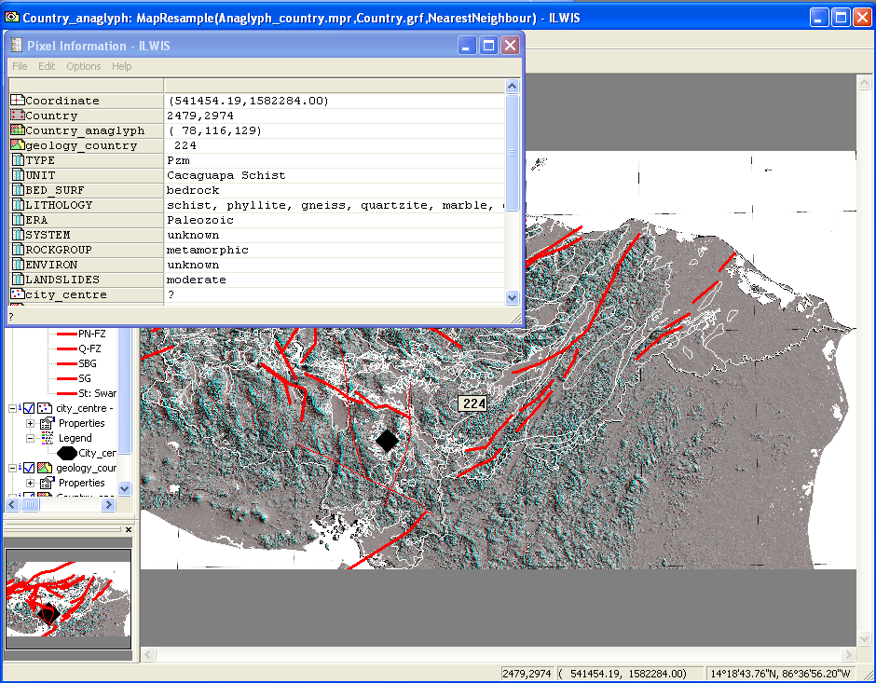

Attributes:
Year: the year in which the earthquake took place
Month: the month in which the earthquake took place
Day: the day that the earthquake took place
Magnitude: Magnitude of the earthquake
Depth: Depth of the earthquake
Latitude: the latitude of the place where the earthquake happened
Longitude: the longitude of the place where the earthquake happened

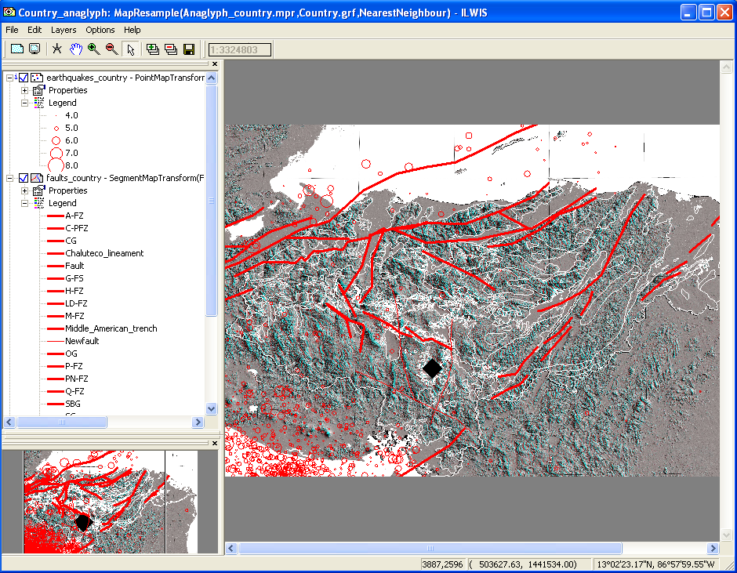

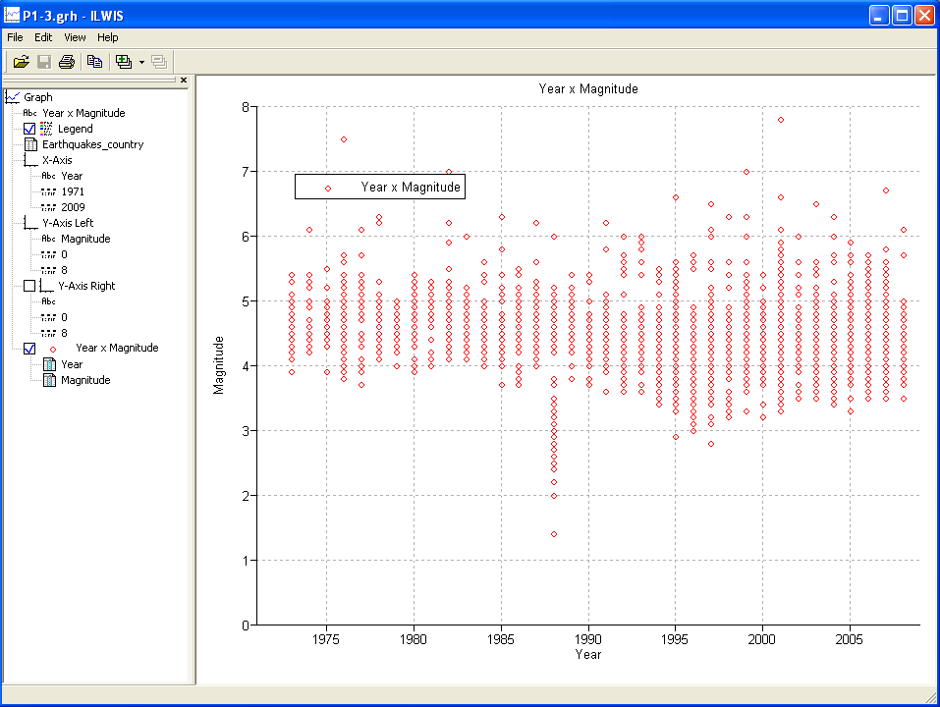

Why is 1988 so different from the rest?
- Apparently more small magnitude earthquakes took place compared to other years.

How to run the distance program?
Go to: Operations → Raster Operations → Distance Calculation
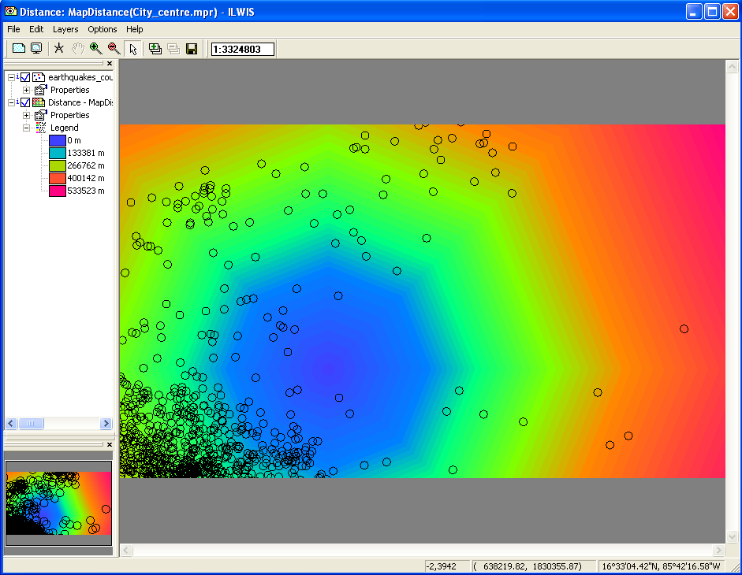

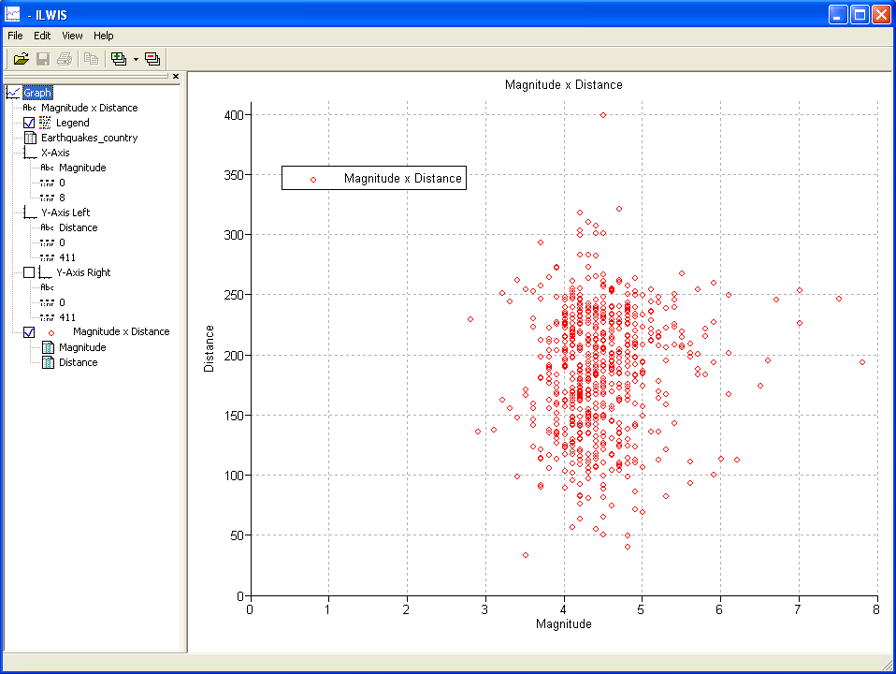

Most earthquakes are between 100 and 250 kilometers from RiskCity and are of magnitudes between 4 and 5.

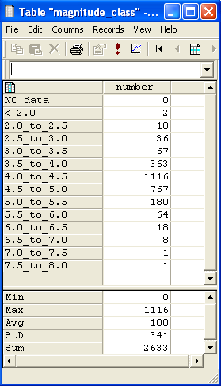

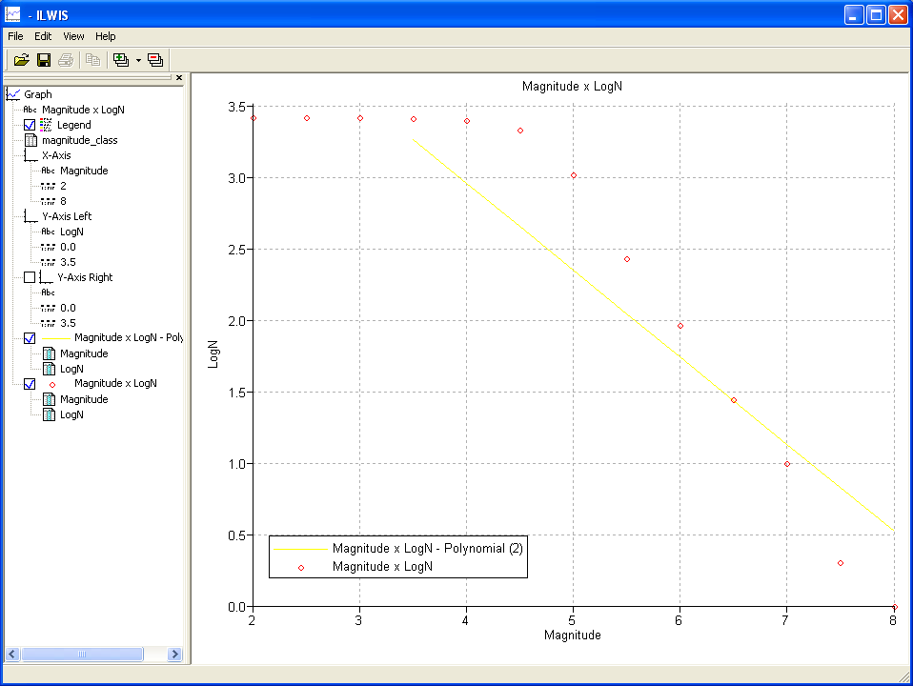

A value is positive and equals 5.399
B value is negative and equals -0.609

The fit is not very good (see the yellow line in the figure above).

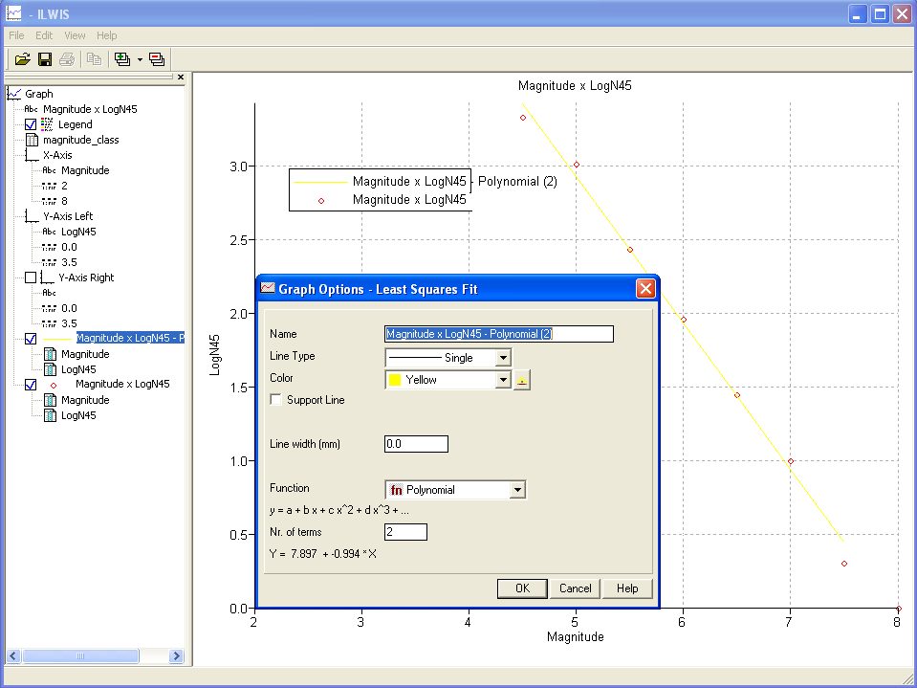

LogN = 7.897 – 0.994 * Magnitude

Part 2

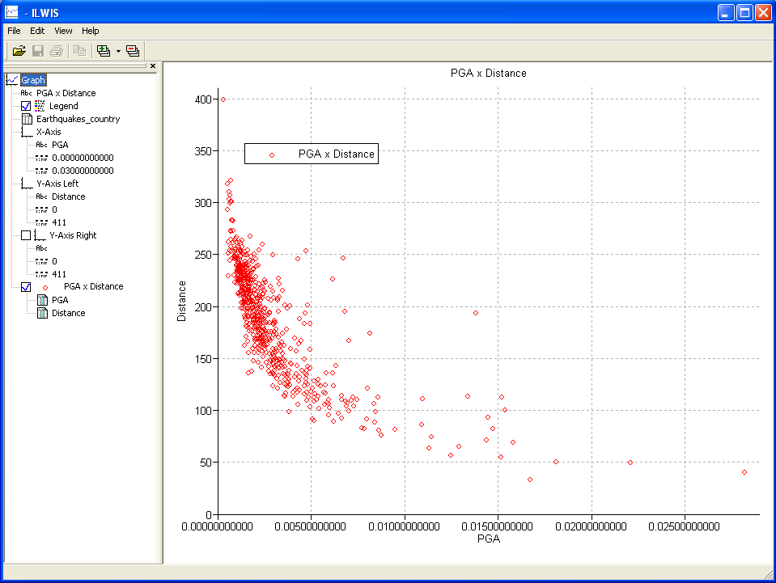
Questions:
- That, overall, the PGA values with a greater distance (km) to RiskCity are smaller. The relationship between PGA and distance to RiskCity is exponential
- Yes, the PGA values are at their peak near the epicenter of the earthquake. But of course you have to bear in mind that only epicentral distance and earthquake magnitude are taken into account here, and that, for example, the lithology is not considered.
- Many data are missing. The catalog is thus incomplete.

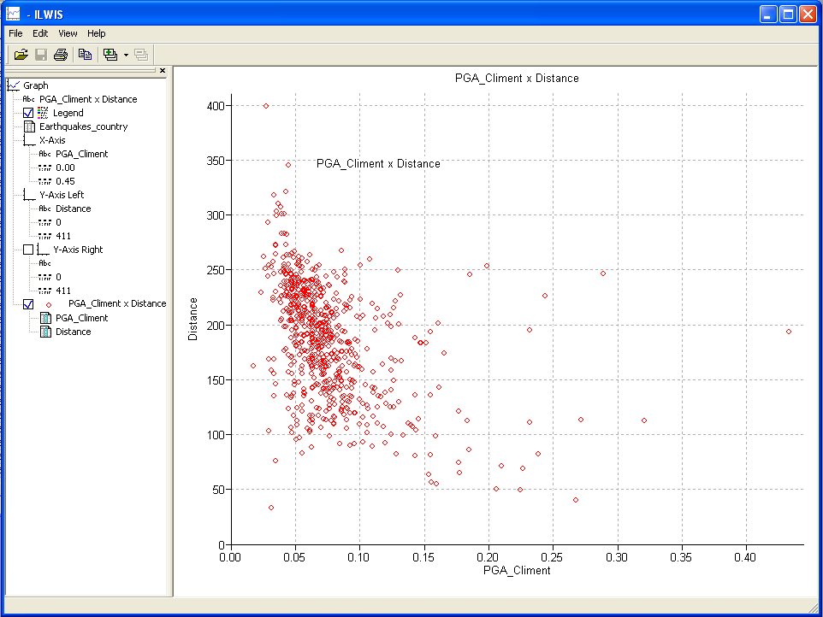

The Climent PGA values are around 20 times higher then Joyner and Boore PGA values. The fact that the site coefficient in Climent PGA is set to 0 (rock site), plays a great role.

Part 3

D = 80.33 PGA = 0.0613
Reclassify the geological units with the amplification factors:
Raster map Lithology and select Raster Operations → Attiribute map.
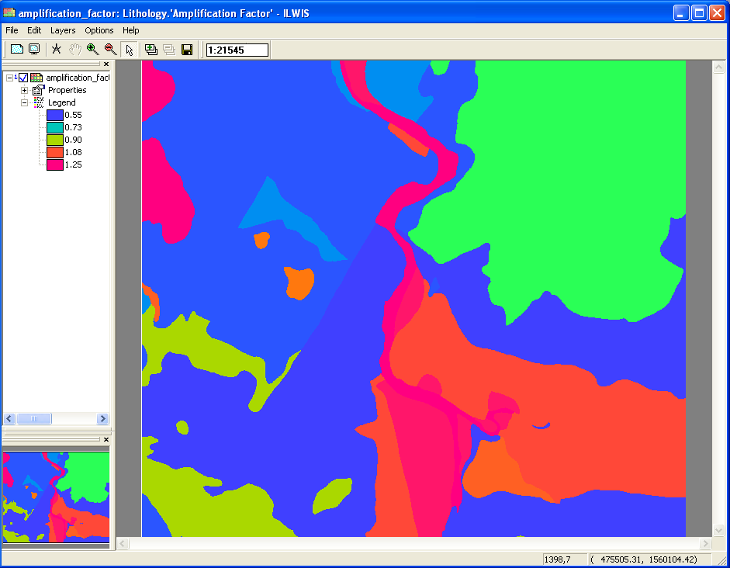
PGA:
