Modeling Forest Fire Hazard Using Remote Sensing
And Geographic Information System GIS

A case study of
Kali Konto, East Jawa, Indonesia

Yousif Ali Hussin Dirk Boon Neeraj Sharma

International Institute for Aerospace Survey and Earth Science
ITC
Enschede The Netherlands

November 2000



1. Summary

This case study has been developed to calculate the forest fire hazard in the area of interest. It is based on a MSc thesis called Spatial Modelling for Forest Fire Hazard Prediction, Management and Control in Corbett National Park, India by Neeraj Sharma.

The output of the final forest fire hazard model is a map that tells decision makers and interested and affected parties where in the area the highest possibility for the outbreak of a fire exists. This map will help decision makers to make appropiate management plans for fire prevention and fire fighting in the area. It will also tell them where best to put logistical support in case of a fire.

The forest fire hazard model is calculated from three submodels which deal with different aspects of the outbreak of forest fires. They are:
- the Fuel Risk Submodel (fuel type, slope of area etc.)
- the Detection Risk Submodel (can the fire be seen?)
- the Fire Response Submodel (how quick can fire fighters reach the fire?)
By adding the maps with weighting (assigning higher values to certain areas, lines or points of interest) of the above-mentioned submodels, the final forest fire hazard areas can be calculated.

Tip: When reading the paragraphs and doing the exercises, try to think WHAT are you reading and doing, AND try to remember HOW you did it. This will make things easier to understand in case you have to something

2. Getting started

The course presenter will provide the data for this case study. Save this data to an appropriate location on the hard drive of your machine like c:\ilwis\firehazard. Start up ILWIS and change the subdirectory to where the data files for this chapter are stored on your machine, c:\ilwis\firehazard.

☞
- Double-click the ILWIS program icon in the ILWIS program group.

- Change the working drive and the working directory until you are in the directory c:\ilwis\firehazard

Now you are ready to start with the exercises of this case study.

3. Something on our area of interest
(From: Thalen and Smiet, 1984; Malaon, 1990)

3. 1 Location
Our area of interest is in the upper Konto river watershed, with an area of approximately 233 km², which is part of the Brantas watershed in East Java. The Konto river is a tributary to the Brantas river, which drains most of East Java. The 233 km² upper watershed is situated in the Kecamatans (sub-districts) of Pujon and Ngantang, which are part of the Kabupaten (district) Malang (Figure 1). The Kecamatan Ngantang consists of 12 villages, and the Kecamatan Pujon consists of 10 villages.
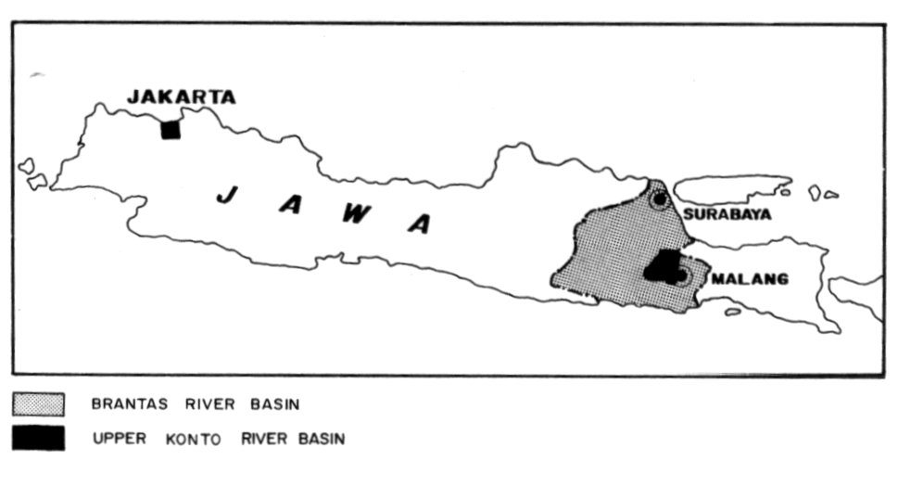

Figure 1: The upper Konto river watershed.

The area ranges in altitude from 620 to 2650 meter above sea level. At the lowest part of the upper watershed the Selorejo dam and lake are found. The dam has been constructed in 1970 and is part of a much larger complex of engineering works to control and regulate the Brantas river system.

Three mountain systems of volcanic origin shape the area into a landscape that can be characterized as an upland plateau surrounded by steeply sloping mountains. Signs of gully erosion and sheet erosion are very common, especially in the agricultural area.

3.2 Climate
The climatic characteristics of the area are typical for the higher elevations in the tropics, showing a distinct dry and wet season. The wet season commonly occurs from mid November to the end of March, and the dry season occurs from early June to the end of September. April-June and October-November are transitional periods.
Rainfall data are available from a number of climate stations in the area, such as Gunung Butak (2868 m), Pujon (1150 m), Kedungrejo (800 m), Sekar (700 m) and Ngantang (620 m). The rainfall data for the stations are shown in table 1 below.

Table 1: Rainfall data (in mm) for different stations in the vicinity of the Upper Konto River
Watershed.
 | Jan | Feb | Mar | Apr | May | Jun | Jul | Aug | Sep | Oct | Nov | Dec
Gn Butak | 400 | 393 | 353 | 235 | 130 | 78 | 54 | 19 | 18 | 25 | 148 | 290
Pujon | 393 | 355 | 311 | 156 | 115 | 49 | 51 | 33 | 42 | 115 | 218 | 308
Kedungrejo | 490 | 393 | 344 | 160 | 126 | 55 | 43 | 24 | 38 | 120 | 209 | 337
Sekar | 509 | 435 | 427 | 259 | 180 | 71 | 50 | 28 | 32 | 108 | 264 | 388
Ngantang | 470 | 422 | 372 | 225 | 145 | 49 | 37 | 42 | 55 | 148 | 203 | 327

According to the rainfall data, the area falls in agro-climatic zone C2 (Oldeman, 1972) with approximately four consecutive dry months receiving less than 100 mm of rain (June - September) and five to six consecutive wet months receiving more than 200 mm of rain (November - April).

Temperature data for the area are only available for the climate station in Ngantang (table 3):

Table 3: Temperature data for the climate station in Ngantang.
 | Jan | Feb | Mar | Apr | May | Jun | Jul | Aug | Sep | Oct | Nov | Dec
Ngantang | 23.0 | 23.1 | 23.5 | 24.4 | 23.7 | 23.3 | 22.7 | 23.0 | 23.3 | 24.2 | 24.2 | 23.8

3.3 Geology
Geological formations in the area are typical for inland Java. The watershed consists of a series of upland plateaus surrounded by steep slopes of several volcanic complexes, partly active (Kelud) and partly dormant or extinct (Kawi-Butak and Anjasmoro). The crests an steep ridges of the mountain complexes determine the boundaries of the watershed.
The Anjasmoro complex is the oldest volcanic complex in the area, stemming from old quaternary origin. One volcano, the Kelud, is still active and more than 10 major eruptions have been recorded in the last 200 years. A second complex is formed by the Kawi and the Butak, which consists of the two volcanic peaks connected by a saddle. This complex is of young quaternary origin. The Luksongo is a fourth and minor complex of old quaternary ranges in the northwestern corner of the watershed. These volcanic complexes form the bulk of the area together with interconnecting highland plateaus, raised with eruption material and colluvial sediments.

3.4 Landforms and Soils
The landforms can be grouped into five major geomorphological landscapes: 1.Alluvial landforms, 2. intervolcanic plateaus, 3. foot slope areas, 4. hill land, 5. volcanic mountains. The alluvial landforms are lilited to the generally narrow alluvial and colluvial valleys, U-shaped or concave and without terraces. In our area of interest there are two major "intervolcanic" colluvial plains: the Pujon plain, a slightly concave and sloping plain between Gunung Kawi and Gunung Anjasmoro, and the Ngantang plain between Gunung Kelud, Gunung Kawi and the Anjasmoro range. The two plains are not connected. They are separated by the lower slopes of the Gn. Kawi volcano and the foothills of the Anjasmoro range, with the narrow deeply incised valley of the Konto river in between. The largest portion of the watershed is occupied by hilly landforms between the volcanic plains and mountain ranges. The steeper middle and upper slopes of the volcanoes are more mountainous in character. Most land is strongly dissected with deep, V-shaped valleys.

The area is situated in several agro-climatic zones and the generally young, fertile and deep soils derived from volcanic material permit the cultivation of a relatively broad range of crops.
The soils in the area are clearly associated with the recent volcanic nature of the region: Andosols (Eutrandept, Vitrandept and Dystrandept) and Cambisols (Ustropept, Eutropept and Humitropept), with minor areas of Mediterans (Tropudalf). Depending on vegetation, slope length, and soil depth the soils are very susceptible to erosion.

3.5 Land cover and Land use

The bulk of the village land where agricultural activity is concentrated, is located in the relatively flat and accessible plains along the main rivers. Most of the original vegetation has been converted into agricultural land, forest plantation or shrub land. The remaining, relatively undisturbed forest area is confined to high altitudes and the relatively steep, surrounding mountain slopes.
In the project area there are two major agriculture areas, each situated in a different agro-ecological zone and with different types of agriculture and cropping systems. The largest single block of agricultural land is found on the lower plains surrounding Lake Selorejo. Large parts of this area have a continuous and abundant water supply, permitting two rice crops per year (or even five crops in two years).

Figure 2: Mountainous landscape in the upper ranges of the Konto River catchment
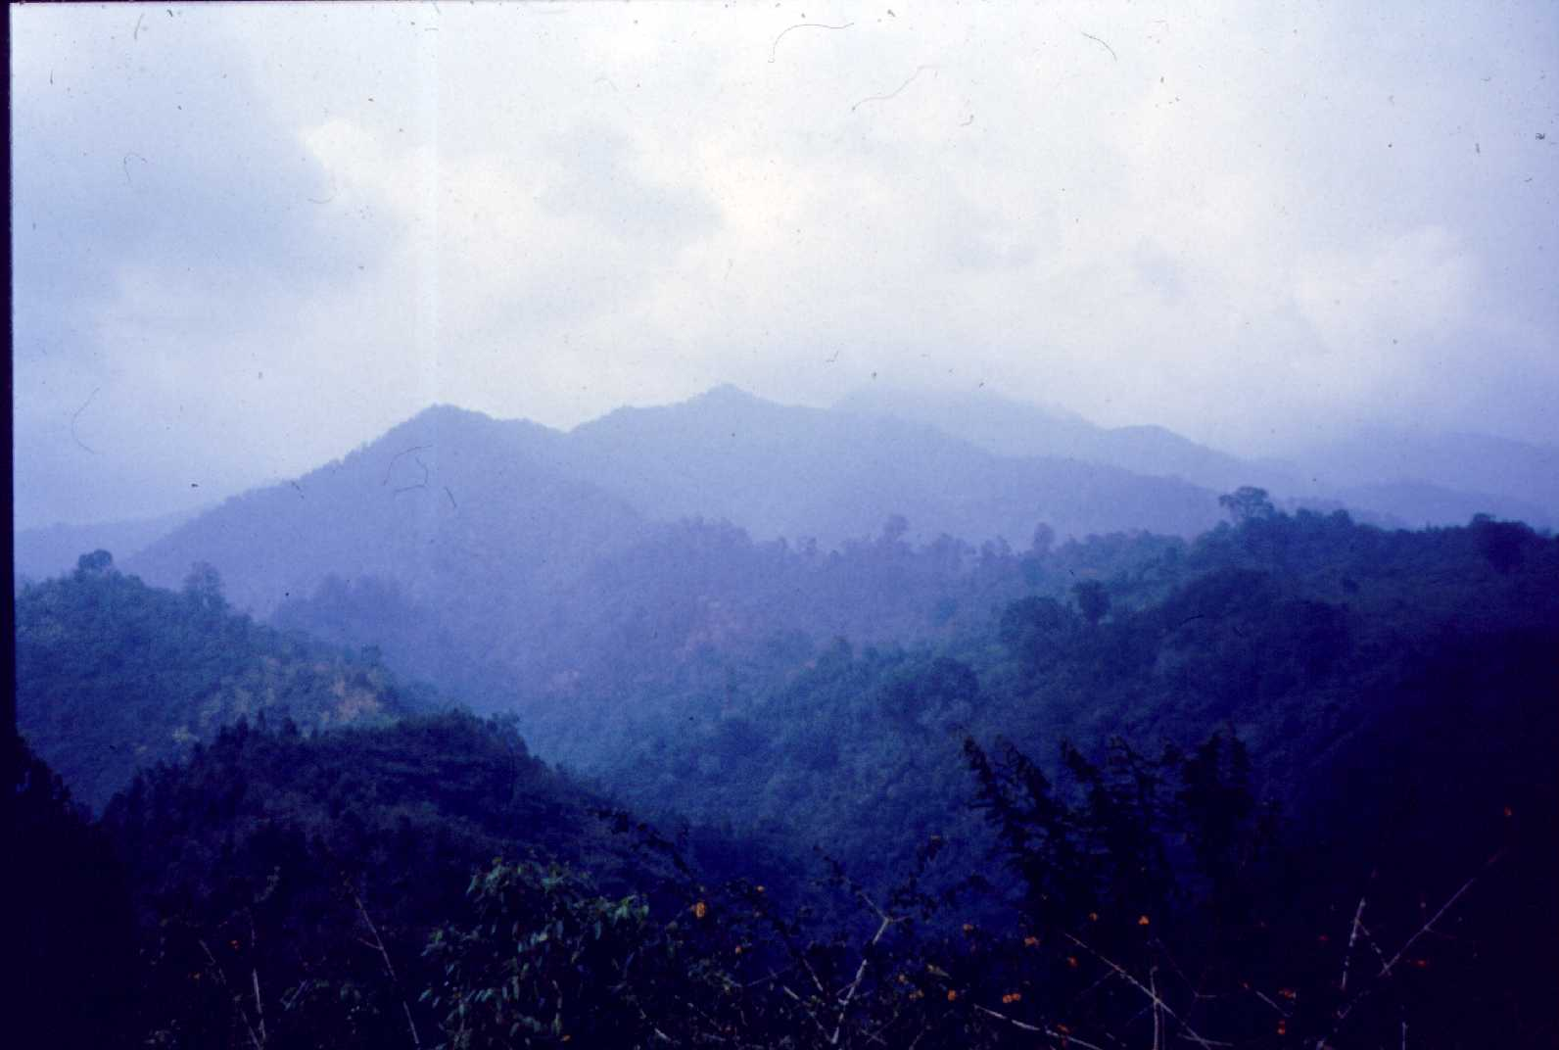

Figure 3: Agricultural land in the lower ranges of the Konto River catchment
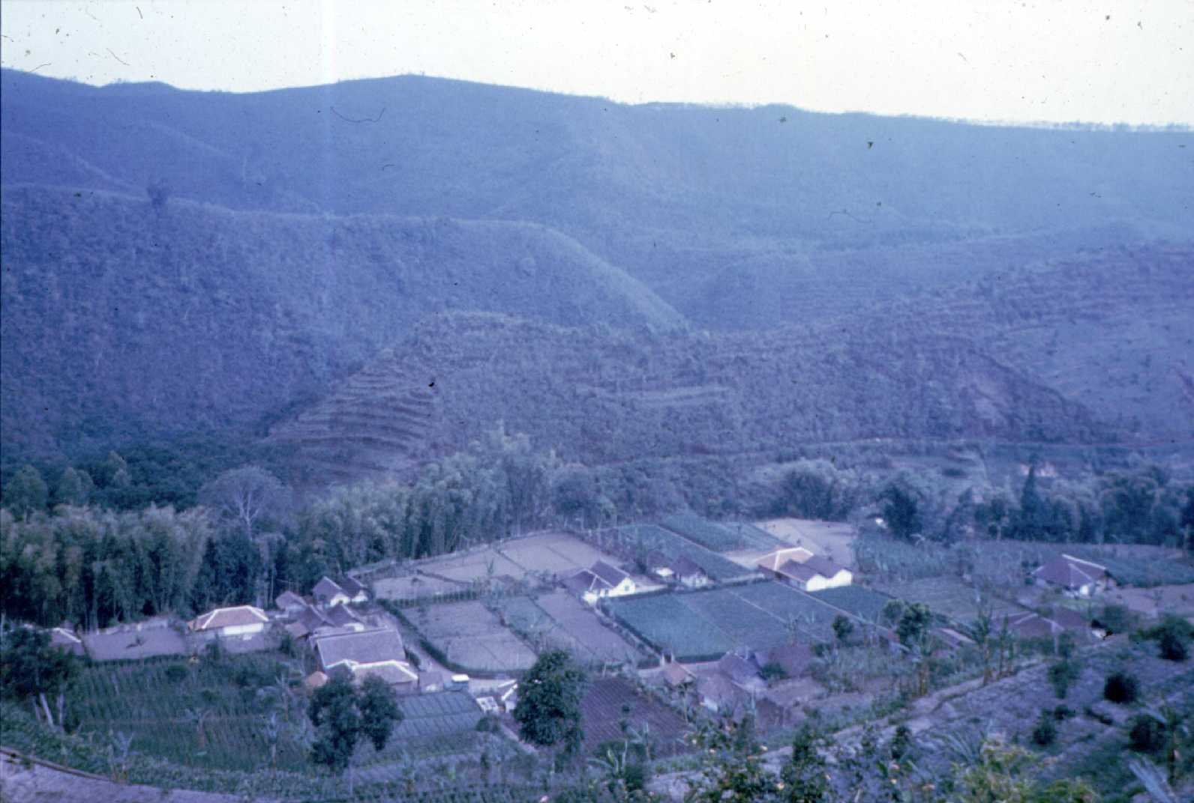
Where water supply does not permit continuous wetland rice cultivation, maize and other secondary crops (locally called palawija) are cultivated in the dry season. Typical crops used in this type of rotation are: maize, red pepper, sweet potatoes, peas/beans, vegetables, cassave.
In the non-irrigated areas mixed perennial crops and coffee gardens (robusta) are common. Coffee is an attractive cash crop and is often cultivated in mixed stands with many other perennials (coconut, clove, citrus, avocado, banana, jackfruit, durian, papaya, vanilla and some food crops and vegetables). Tobacco is an important cash crop in the non-irrigated areas.
The second agricultural area is found around Pujon on the higher plains. About half of this area is regularly or occasionally irrigated. The Pujon area is a major vegetable growing area producing cabbage, irish potatoes, carrots, onions, beans, leek and peppers.

In line with the State Forest Corporation's policy to contribute to the improvement of the living conditions of the rural population, agro-forestry projects have been initiated in the watershed as well. The purpose of the agro-forestry systems is to allow farmers, for a restricted period of time during the establishment of plantation forest, to cultivate food and fodder crops in the newly planted forest areas. This cultivation system is called Tumpang Sari. In exchange, the farmer tends the forest plantations.

3.6 Forest
About two-thirds of the upper watershed of the Konto river (about 15,625 ha) falls within the boundaries of what is officially known as "forest land". About half of this area is covered with natural montane forest. These are essentially production forests with important ecological function such as soil and water conservation. The two most common types of natural forests are: mixed montane high forest (with characteristic species such as Lithocarpus spp, Engelhardia spicata, several Myrthacaea and tree ferns) representing the natural climax vegetation of the higher mountainous areas, and the Cemara forests (consisting often of fairly pure stands of Casuarina junghuhniana).
A significant factor influencing the natural forests is the human practice of cutting timber and fuel wood, as well as the collection of fodder. Degradation of the natural forests is particularly severe in the most accessible parts of the forests on the middle and lower slopes of the mountain complexes. Degradation and exploitation have gradually changed the natural vegetation from a closed canopy forest to scrub lands.
Approximately 1100 ha of the forest land are covered by plantation forest. Important species here are: pinus (Pinus merkusii), eucalyptus (Eucalyptus spp), damar (Agatha loranthifolia), and calliandra (Caliandra spp).

  - Population
Judging by ancient records of irrigation and dam-building, as well as archeological remains in the area, the Ngantang area of the Konto River watershed is one of the oldest populated and cultivated areas in East Java. Records describing the presence of farmers practicing irrigated agriculture in the area date back as far as 800 AD.
Presently, the upper Konto river watershed is a very densely, overpopulated area. The 1980 census sets the total population of the area at 91,300. Comparing this figure with the population data for 1972 shows that there has been a population growth of 1.75 %. The average population density was approximately 1150 people per km².

4. Introduction to the Forest Fire Hazard Model

The fire risk model (figure 4.1) is divided into three submodels namely, fuel risk submodel, view exposure risk submodel (detection risk) and response risk submodel. The variables (data layers) chosen for the creation of the submodels, are comprehensively recognized as determining factors in forest fire prevention and suppression. To get tot the data layers in each submodel, linkages of different locality variables like fuel type, elevation, slope, aspect, land features etc. are evaluated and established, as a primal imperative. Then variables of every submodel are given quantitative fire risk values, depending upon their capacity to promote a fire situation. For example in the fuel risk submodel, fuel type (the different species of trees which can burn) is given a higher weight (besides its fuel risk value), followed by slope, aspect and elevation, respectively. The detection risk submodel have roads and habitation view exposure, as its components. The response risk submodel evaluates the friction offered by different land features and terrain to travel over them, as a response in distance units, from the head quarters. Finally, these submodels were combined, imparting proper weight factors,to get to the fire risk model.

In this case study, every submodel will be described as you continue with each exercise. Try to link what you read have in the paragraph above with the information provided to you in the exercise. This will be good to form a complete and holisitc picture of the fire risk model and how it can be applied and used.

Figure 4.1: The fire risk model

5. Data needed for the calculation of the forest fire hazard model.

The following datasets are needed for the calculation of the Forest Fire Hazard Model:

- Landsat TM (bands 1,2,3,4 and 5). These images are used to classify the land and forest cover in the area. The output land cover classes (forest cover type classes) can be compared to a land cover map of the area to see how the land cover classes correspond. Ground verification is also necessary before it is used in the Forest Fire Hazard Model.
- Land Cover map (or a forest cover type map). This is the combined output map from the classification process, comparison to other land cover maps as well as ground verification. This map will be used extensively in the Forest Fire Hazard Model.
- DEM (Digital Elevation Model). This dataset is created from the contour map by means of the Line Interpolation function in ILWIS. The contours can be digitized from a topographical map of the area, or be obtained from local geographical data suppliers. The DEM is then used for the generation of gradient maps, slope maps and an aspect map of the area which will all be used in the Forest Fire Hazard Model.
- Roads. They can be digitized from a topographical map of the area, or be obtained from local geographical data suppliers. This dataset is used in the Detection Risk Submodel (viewshed analysis).
- Villages. They can be digitized from a topographical map of the area, or be obtained from local geographical data suppliers. This dataset is used in the Detection Risk Submodel (viewshed analysis).
- A map of the location of the Head Quarters of the fire department. This will be used in calculating the distance from the Head Quarters to all pixels in the map.

Remark: It is recommended to copy all these datasets into ONE directory in ILWIS.

- Other data that is included are Coordinate System and Georeference files provided with the above-mentioned data. This is to ensure that all the data uses the same coordinate systems and georeferences.

6. Creating the data needed in the submodels

Before we start to calculate the Forest Fire Hazard model, we need to create some data from the given datasets that will be used in the model.

The following datasets will be created:
- Gradient maps (use DEM as input).
- Slope percentage map (use gradient maps as input).
- Slope degrees map (use slope percentage map as input).
- Aspect map (use gradient maps as input).

6.1 DEM

☞
- In the ILWIS Catalog, double click on the Raster Map DEM.

- The Display Options – Raster Map dialog box is opened. Accept the defaults by clicking the OK button. The map will be displayed.

- Click on several locations in the map and read the altitude values.

- Select from the Layers menu the command Display Options and select the map DEM. The Display Options dialog box is re-opened.

- Select representation Clrstp12 and display the map again.

- Display the map DEM with various other representations and evaluate the differences.

- Add the segment map contours to the displayed raster map DEM. Check the box Info in the Display Options – Segment Map box. Compare and evaluate the two data layers.

6.2 Displaying the DEM in 3D with an image draped over it

☞
- Select the operation Display3D from the Operations list and start the operation.

- Create a georeference geodem and select the raster map DEM as the DTM to be considered in the 3D display.

- Click on OK in the Display 3D dialog box.

- In the Display Options – 3D Grid dialog box, check the box Raster Drape and select raster image tmcor432 to be draped over the 3D DEM.

- Click on OK in this dialog box

- Take a look at a 3D view of the Kali Konto area. Select from the Edit menu – Georeference to change the 3D view and other parameters. Close it when you are finished.
6.3 Constructing gradient maps using gradient filters

☞
- Double click on the operation Filter in the Operation-list. The Filter Map dialog box is opened.

- Select the raster map DEM from the map list as input map.

- Open the Filter Name list box and select the filter dfdx to construct a X-direction gradient map.

- Define DX as the Output Map name and click on the Show box to display the result immediately after calculation. Accept the default Domain, Range and Precision.

- Click on OK to start the operation

- Once the filter operation is executed the Display Options – Raster Map Dialog box is opened.

- Accept all the defaults and click OK to start the display.

- Scroll through the displayed map while pressing the left mouse button. Evaluate its content.

☞
- Repeat the procedure, using the filter dfdy, thus constructing a Y-gradient map DY.

6.4 Constructing a slope percentage map

☞
- Determine the pixel size of the DEM by right clicking on it. Select Properties.

- Enter the following expression on the Command line in the Main Window and press Enter to execute it:

Slopeper = ((HYP(dx,dy))/pixelsize)*100

- The Raster Map Definition Box is opened. Accept the given defaults and click the OK button to define the raster map slopeper.

- Display the map slopeper and evaluate its content.

6.5 Constructing a slope degree map

☞
- Enter the following expression on the Command line in the Main Window and press Enter to execute it:

Slopedeg = RADDEG(ATAN(slopeper/100))

- The Raster Map Definition Box is opened. Accept the given defaults and click the OK button to define the raster map slopedeg.

- Display the map slopedeg. Change the upper stretch value to 53. Evaluate its content.

6.6 Constructing an aspect map

☞
- Enter the following expression on the Command line in the Main Window:

Aspect = RADDEG(ATAN2(DX,DY)+pi)

- Press Enter. The Raster Map Definition Box is opened.

- Click on the Create button next to the list box Domain. The create domain dialog box is opened.

- Type compass as the Domain Name.

- Select the option Value.

- Type for the Description: compass direction

- Click OK. The Edit Domain dialog box is opened.

- Enter the Min and Max: 0 and 360. Enter the Precision: 1.0

- Click OK. You return to the Raster Map Definition dialog box. Click OK once again.

☞
- Open the File Menu and select Create, Representation. The Create Representation dialog box is opened.

- Type a name for the representation: compass

- Select the domain compass and accept its domain type Value. Click OK.

- The Representation Value/Gradual Editor is opened. It shows the default compass value range from 0º (black) to 360º (white), with 5 intermediate steps.

- Open the Edit menu in the Representation Editor and select the Insert Limit command. The Insert Limit dialog box is opened.

- Enter the value 180 and select the colour white. Click OK.

- Double-click the limit 360. The Edit Limit dialog box will be opened. Select the colour black. Click OK.

- From the Edit menu select the command Stretch Steps. Enter 8 stretch steps. Click OK.

- Close the Representation Editor.

☞
- Double-click on the map Aspect. It will be calculated first, and then the Display Options dialog box will be opened.

- In the Display Options dialog box select the Representation compass. Click OK. The map will be displayed.

- Add segment map Contours to the map window. Display the contour lines using only one colour (red).

- Check the slope directions by scrolling through the map while clicking on the pixels.

- Close the map window when finished.

7. Fuel Risk Submodel

Different aspects that may stimulate the spread of a fire are used to calculate this submodel (Fig 4.1).
- Certain fuel types (tree species or grasses) burn easier than others do. E.g. A forested area will burn easier than a moist area of agricultural land.
- A fire will spread more easily and quickly on an upward sloping hill than on a flat area.
- Areas facing the sun will be drier and hotter and thus more susceptible to fire.
- Certain elevation heights will also be more susceptible to fires. An area that is very high above sea level will be less receptive to a fire than a lower laying area where there is more oxygen.

Figure 4.1: The fuel risk submodel

7.1 Fuel type Risk

The classification of fuel type depends on the inherent characteristics of plants and other land cover types. Dry plants and forest areas will be much more susceptible to fire than for example irrigated rice fields that are moister. For this exercise a simple classification will be used in classifying land cover into different fuel types.

☞
- In the ILWIS Catalog, double-click on the raster map lctot (land cover total). In the Display options – Raster map, check the box Legend. Accept all other defaults and click OK.

- Evaluate this map by holding down the left mouse button. After evaluating, close the map. The raster map lctot uses the domain lctot to display the different land cover types.

☞
- Create a table by using the domain lctot. Right click on this domain and select the option Create Table.

- The Create Table dialog box is opened. Type a name for this table (e.g. lctot) and a description for this table (e.g. land cover classes). Accept the default domain lctot as this domain will be used to create the row names in the table. Click OK.

A table is created where the row names correspond to the different land cover types in the map lctot. The next step is to create a column in this table called FireRisk.

☞
- Open Columns from the menu bar and select Add Column.

- The Add Column dialog box is opened. Type the name for the new column: FireRisk. Accept domain type Value. Change the Value Range like follow: minimum = 0, maximum = 10. Change Prescision to 1.0. Type a description for this column: Fire Risk of different land cover types. Click OK.

- The column FireRisk is created.

Now we can classify these land cover types into different classes of fuel risk. A very flammable area will get a high value, while a non-flammable area will get a low value. Use table 7.1 to assign different values to the different land cover types.

Table 7.1: Fuel risk types and corresponding fire risk values.

Class name | Fire risk value
No fuel risk | 1
Very low fuel risk | 2
Low fuel risk | 3
Moderate fuel risk | 4
High fuel risk | 5
Very high fuel risk | 6

Each land cover type was assigned to a class to indicate its fuel risk:
Road - No fuel risk
River - No fuel risk
Village - Very low fuel risk (although houses can burn, there are usually some people in the vicinity to stop the fire)
Lake - No fuel risk
Agricultural land - Low fuel risk (Normally agricultural land is not very flammable and still relatively easy to put out)
Shrub land - Moderate fuel risk
Plantation - High fuel risk
Natural Forest - Very high fuel risk

☞
- In the column FireRisk of table lctot, assign values to the different land cover types using the information above. Click in the column next to the land cover type names and add the appropiate value. Please note that the row with the name B00 is also a river. The rows with the names 1, 2 and 3 are roads.

- When you are finished, close the table lctot.

After the table with land cover types and corresponding fuel risk values have been created, an attribute value map will be created where the land cover types will receive their corresponding fuel risk values.

☞
- In the ILWIS Catalog, right-click on raster map lctot. Select the option Raster Operations, Attribute Map.

- The Attribute Map dialog box is opened. Select Table lctot and Attribute FireRisk. Accept domain Value, as well as the given Value Range. Type lcrisk in the Output Raster Map box, and click on Show. Type a description for this map: Fuel risk of different land cover types. Click OK

- After the map has been calculated, the Display Options – Raster Map dialog box is opened. Accept all defaults and click OK.

- The new raster map lcrisk is opened. Evaluate its content and close the map when you are finished.

The first input map for the fuel risk submodel has been created.

7.2 Slope risk

Topographical factors have a large effect on the spreading speed of a fire. The steepness of slope has a big influence on the spreading speed of a fire. The spreading speed of a fire front on a flat (0%-8% slope) surface can be expected to double on an 18% slope, and double again on a 36% slope. It is expected that a moderately burning fire doubles the rate of spread as it burns up a steep (40-70%) and again doubles as it burns up a very steep slope (70-100%). Later a ten percent increase in slope may double the spreading speed of a fire (FAO, 1984).

Although slope has been expressed in terms of percentage in the paragraph above, the slope map in degrees will be used to classify the slope in this exercise. Try to pinpoint the exact differences between a slope percentage map, and a slope degrees map.

☞
- To classify the slope degrees map, a new domain has to be created.

- In the ILWIS Operation-list, double-click on the operation New Domain. The Create Domain dialog box is opened.

- Type slopclas for Domain Name. Type a description for this domain. Check the box Group. Click OK.

- A dialog box is opened where classes with their upper value limits can be specified.

- From the menu bar- Edit, use the Add Item, Edit Item and Delete Item commands (whenever they are necessary) to enter the following classes:

Class name Upper value in degrees Code
Flat to gently sloping 5 Fg
Sloping 15 Sl
Moderately steep 30 St
Very steep 90 Vs

- From the menu bar, select Edit, Representation. The Edit representation dialog box is opened. By double-clicking on the colours below every slope class name, edit the colours in which the slope classes should be shown in a map. A new representation is created called slopclas.

- After editing the representation, close the Edit Representation box.

- Then close the dialog box where you specified the different slope classes.

The raster slope degree map uses a value domain. However, the newly created domain will be used to classify the slope degree map. After that, different slope risk values will be assigned to the different slope classes, which forms part of the fuel risk submodel.

☞
- Double-click the MapCalc operation in the ILWIS Operation-list. The Map Calculation dialog box is opened.

- Type the following expression in the Expression box:

clfy(slopedeg,slopclas) (this means: Classify the map slopedeg with class domain slopclas)

- Type slopclas as Output Raster Map and check the box Show. Select Domain slopclas. Type a description of the map to enable you to recognise the map at a later stage. Click OK.

- The Display Options - Raster Map dialog box is opened. Select representation slopclas. Accept all other default values and click OK to view and evaluate the map.

The slope degrees map has been classified into 4 classes. The next step is to assign slope risk values to the slope classes to indicate their supportiveness to start a fire. For this, a table and an attribute value map have to be created.

☞
- In the ILWIS Catalog, right click on the domain slopclas. Select the option Create Table. The Create Table dialog box is opened.

- Type slopclas as the Table Name. Type a description for the table and accept domain slopclas. Click OK.

- From the menu bar in Table slopclas, select Columns, Add Columns.

- The Add Column dialog box is opened. Type FireRisk as the name of the new column. Accept the value domain. Change the range like follow: minimum = 0, maximum = 4. Change the Precision value to 1.0. Type a description for this column and click OK.

- The Column FireRisk is created.

Now we can classify the slope classes into different classes of slope risk. A very steep slope will get a high value, while a flat area will get a low value. Use table 7.2 to assign different values to the different slope classes.

Table 7.2: Slope types and corresponding fire risk values

Class name | Fire risk value
Low | 1
Moderate | 2
High | 3
Very high | 4

Each slope type was assigned to a class to indicate its slope risk:
Flat to gently sloping - Low risk
Sloping - Moderate risk
Moderately steep - High risk
Very steep - Very high risk

☞
- In the column FireRisk of table slopclas, assign values to the different slope types using the information above. Click in the column next to the slope class names and add the appropiate value.

- When you are finished, close the table slopclas.

After the table with slope classes and corresponding slope risk values has been created, an attribute value map will be created where the slope types will receive their corresponding slope risk values.

☞
- In the ILWIS Catalog, right-click on raster map slopclas. Select the option Raster Operations, Attribute Map.

- The Attribute Map dialog box is opened. Select Table slopclas and Attribute FireRisk. Accept domain Value, as well as the given Value Range. Type sloprisk in the Output Raster Map box, and click on Show. Type a description for this map: Fire risk of different slope types. Click OK.

- After the map has been calculated, the Display Options – Raster Map dialog box is opened. Accept all defaults and click OK.

- The new raster map sloprisk is opened. Evaluate its content and close the map when you are finished.

The second input map for the fuel risk submodel has been created.

7.3 Aspect Risk

Aspect, the direction in which a slope faces, also relates to the amount of exposure of the slope to the sun. Indonesia is situated in the southern hemisphere. Here the northern slopes are exposed to sun. Slopes to the south and east are oriented most parallel to the sun's rays. They are shaded during most of the day, and the fuels (trees that can burn) on them remain more moist and cooler than the fuels on slopes in other directions. Northern and north-western slopes are nearly perpendicular to the rays of the sun. They are exposed to the sun for a longer time during the warmest part of the day. The fuels on them become warmer and drier and burn more intensely and completely than the fuels on slopes in other directions. They also allow the radiant heat to transfer fire across slopes easier than broad canyons or valleys do. These conditions usually increase fire spread rates faster than normally would be expected.

The Aspect map that was created earlier in this case study shows values in degrees. The direction east will have a value of 90 degrees, south 180 degrees and north west 315 degrees etc. These values have to classified in order to be able to assign different aspect risk values. Aspect risk values will be high if the aspect is conducive to fire, and low if a fire will begin more difficult on a specific aspect. Draw yourself a picture of a compass with degrees and wind directions (and later the aspect fire risk values) to make it easier to understand.

☞
- To classify the aspect map, a new domain has to be created.

- In the ILWIS Operation-list, double-click on the operation New Domain. The Create Domain dialog box is opened.

- Type aspect for Domain Name. Type a description for this domain. Check the box Group. Click OK.

- A dialog box is opened where classes with their upper value limits can be specified.

- From the menu bar- Edit, use the Add Item, Edit Item and Delete Item commands (whenever they are necessary) to enter the following classes:

Class name Upper value in degrees Code
North – north east 45 N - NE
North east - east 90 NE - E
East – south east 135 E - SE
South east - south 180 SE - S
South – south west 225 S - SW
South west - West 270 SW - W
West – north west 315 W – NW
North west - north 360 NW - N

- From the menu bar, select Edit, Representation. The Edit representation dialog box is opened. By double-clicking on the colours below every aspect class name, edit the colours in which the aspect classes should be shown in a map. A new representation is created called aspect.

- After editing the representation, close the Edit Representation box.

- Then close the dialog box where you specified the different slope classes.

The raster aspect map uses a value domain. However, the newly created domain will be used to classify the aspect map. After that, different aspect risk values will be assigned to the different aspect classes, which forms part of the fuel risk submodel.

☞
- Double-click the MapCalc operation in the ILWIS Operation-list. The Map Calculation dialog box is opened.

- Type the following expression in the Expression box:

clfy(aspect,aspect) (this means: Classify the map aspect with class domain aspect)

- Type aspclass as Output Raster Map and check the box Show. Select Domain aspect. Type a description for the map. Click OK.

- The Display Options - Raster Map dialog box is opened. Select representation aspect. Accept all other default values and click OK to view and evaluate the map.

The aspect map has been classified into 8 classes. The next step is to assign aspect risk values to the aspect classes to indicate their supportiveness to a fire. For this, a table and an attribute value map have to be created.

☞
- In the ILWIS Catalog, right click on the domain aspect. Select the option Create Table. The Create Table dialog box is opened.

- Type aspect for the Table Name. Type a description for the table and accept domain aspect. Click OK.

- From the menu bar in Table aspect, select Columns, Add Columns.

- The Add Column dialog box is opened. Type FireRisk as the name of the new column. Accept the value domain. Change the range like follow: minimum = 0, maximum = 6. Change the Precision value to 1.0. Type a description for this column and click OK.

- The Column FireRisk is created.

Now we can classify the aspect classes into different classes of aspect risk. An aspect that faces the sun directly will get a high value, while aspects in the shadows of mountains will get a lower value. Use table 7.3 to assign different values to the different aspect classes.

Table 7.3: Aspect types and corresponding fire risk values

Class name | Fire risk value
None | 1
Very low | 2
Low | 3
Moderate | 4
High | 5
Very high | 6

Each aspect was assigned to a class to indicate its aspect risk:
North – north east - High
North east – east - Low
East – south east - Very Low
South east – south - None
South – south west - None
South west – west - Very Low
West – north west - Moderate
North west – north - Very high

☞
- In the column FireRisk of table aspect, assign values to the different aspect types using the information above. Click in the column next to the aspect class names and add the appropiate aspect risk value.

- When you are finished, close the table aspect.

After the table with aspect classes and corresponding aspect risk values has been created, an attribute value map will be created where the aspect types will receive their corresponding aspect risk values.

☞
- In the ILWIS Catalog, right-click on raster map aspclass. Select the option Raster Operations, Attribute Map.

- The Attribute Map dialog box is opened. Select Table aspect and Attribute FireRisk. Accept domain Value, as well as the given Value Range. Type asperisk in the Output Raster Map box, and click on Show. Type a description for this map: Fire risk of different aspect types. Click OK.

- After the map has been calculated, the Display Options – Raster Map dialog box is opened. Accept all defaults and click OK.

- The new raster map asperisk is opened. Evaluate its content and close the map when you are finished.

The third input map for the fuel risk submodel has been created.

7.4 Elevation risk

The elevation of an area above sea level affects the length of the fire season and the availability of the fuels. Relatively lower areas have longer fire seasons. As the elevation rises the availability of the fuels becomes lesser after a certain limit. The fact also remains that fire spreads quicker up hill than down hill. The phenomenon of rolling fires occurs after a comparatively higher elevation. The study site has a highly undulating terrain with elevations as low as 600 m above mean sea level to 2700 m amsl (above mean sea level). This makes the site more vulnerable to the effect of elevation. It has been observed from field experience of the local forest managers, that the middle elevations are most vulnerable to fuel risk.

The apparent reason is that these elevations (1600-1800 Mts.) have fairly high sun exposure and dense vegetation cover. The highest elevations have lower vegetation cover and are at times act as natural fire breaks. The lower elevations as valleys and depressions have a microclimate with high relative humidity and natural fire breaks as streams and rivers.

☞
- The DEM will be classified into different elevation classes. A new domain has to be created to do this.

- In the ILWIS Operation-list, double-click on the operation New Domain. The Create Domain dialog box is opened.

- Type demelev for Domain Name. Type a description for this domain. Check the box Group. Click OK.

- A dialog box is opened where classes with their upper value limits can be specified.

- From the menu bar- Edit, use the Add Item, Edit Item and Delete Item commands (whenever they are necessary) to enter the following elevation classes:

Class name Upper value Code
600 – 875m 875 leave open
875 – 1150m 1150
1150 – 1425 1425
1425 – 1700 1700
1700 – 1975 1975
1975 – 2250 2250
2250 – 2525 2525
2525 – 2800 2800

- From the menu bar, select Edit, Representation. The Edit representation dialog box is opened. By double-clicking on the colours below every elevation class name, edit the colours in which the elevation classes should be shown in a map. A new representation is created called demelev.

- After editing the representation, close the Edit Representation box.

- Then close the dialog box where you specified the different slope classes.

The raster DEM uses a value domain. However, the newly created domain will be used to classify the DEM to an elevation map. After that, different elevation risk values will be assigned to the different elevation classes, which forms part of the fuel risk submodel.

☞
- Double-click the MapCalc operation in the ILWIS Operation-list. The Map Calculation dialog box is opened.

- Type the following expression in the Expression box:

clfy(dem,demelev) (this means: Classify the map dem with class domain demelev)

- Type demelev as Output Raster Map and check the box Show. Select Domain demelev. Type a description for the map. Click OK.

- The Display Options - Raster Map dialog box is opened. Select representation demelev. Accept all other default values and click OK to view and evaluate the map.

The elevation map has been classified into 8 classes. The next step is to assign elevation risk values to the elevation classes to indicate their supportiveness to a fire. For this, a table and an attribute value map have to be created.

☞
- In the ILWIS Catalog, right click on the domain demelev. Select the option Create Table. The Create Table dialog box is opened.

- Type demelev for the Table Name. Type a description for the table and accept domain demelev. Click OK.

- From the menu bar in Table demelev, select Columns, Add Columns.

- The Add Column dialog box is opened. Type FireRisk as the name of the new column. Accept the value domain. Change the range like follow: minimum = 0, maximum = 8. Change the Precision value to 1.0. Type a description for this column and click OK.

- The Column FireRisk is created.

Now we can classify the elevation classes with different fire risk values. Use table 7.4 to assign different values to the different aspect classes.

Table 7.4: Elevation classes and corresponding fire risk values

Class name | Fire risk value
Low | 1
Moderate | 2
High | 3
Very high | 4

Each elevation part was assigned to a class to indicate its elevation risk:
600 – 875m Low
875 – 1150m Moderate
1150 – 1425 High
1425 – 1700 Very high
1700 – 1975 Very high
1975 – 2250 High
2250 – 2525 Moderate
2525 – 2800 Low

☞
- In the column FireRisk of table demelev, assign values to the different elevation types using the information above. Click in the column next to the elevation class names and add the appropiate elevation risk value.

- When you are finished, close the table demelev.

After the table with elevation classes and corresponding elevation risk values has been created, an attribute value map will be created where the elevation types will receive their corresponding elevation risk values.
☞
- In the ILWIS Catalog, right-click on raster map demelev. Select the option Raster Operations, Attribute Map.

- The Attribute Map dialog box is opened. Select Table demelev and Attribute FireRisk. Accept domain Value, as well as the given Value Range. Type elevrisk in the Output Raster Map box, and click on Show. Type a description for this map: Fire risk of different elevation types. Click OK.

- After the map has been calculated, the Display Options – Raster Map dialog box is opened. Accept all defaults and click OK.

- The new raster map elevrisk is opened. Evaluate its content and close the map when you are finished.

The fourth and last input map for the fuel risk submodel has been created.

7.5 Total fuel risk

The slope risk, elevation risk and aspect risk maps along with the fuel type risk (from the land cover) map will be added together in a systematic way, providing them with proper weights. The reason behind assigning weights to the classes was to give extra significance to certain classes. The fuel type map (from land cover, lcrisk) will be given a higher weight of 3 and slope will be given a weight of 2. This will have influence on the outcomes of the fuel risk submodel. These weights assign prominence to the weighted maps. The resultant map is thus influenced by the values of the contributing maps. The final fuel risk map will have high values. This map will be reclassified using an attribute table.

The slope, aspect and elevation risk maps will first be added to each other without any weights to create one index map.

☞
- From the ILWIS Operation-list, double-click on the MapCalc operation.

- Type the following expression in the Expression box:

elevrisk + sloprisk + asperisk (Map addition)
(elevrisk + sloprisk + asperisk = esarisk)

- Do you think that weighting factors are needed when calculating this map?

- Type esarisk as the Output Raster Map. Select domain value. Change the precision to 1.0 and accept the default Value Range. Click the check box Show. Type a description for this map. Click OK.

- The Display Options – Raster Map dialog box is opened. Accept all defaults and click OK.

- The raster map esarisk is displayed. Evaluate this map and close it afterwards.
The fuel type map (from land cover, lcrisk) will now be added to the newly created and combined slope, aspect and elevation map (esarisk) by using the weights as described in the last paragraph on the previous page.

☞
- From the ILWIS Operation-list, double-click on the MapCalc operation.

- Type the following expression in the Expression box:

(2*esarisk)+(3*lcrisk) (Map addition with weights)

- Type fuelrsk1 as the Output Raster Map. Select domain value. Change the precision to 1.0 and accept the default Value Range. Click the check box Show. Type a description for this map. Click OK.

- The Display Options – Raster Map dialog box is opened. Accept all defaults and click OK.

- The raster map fuelrsk1 is displayed. Evaluate this map and close it afterwards.

- Determine the minimum and maximum value of fuelrsk1. Do this by right clicking on fuelrsk1 the ILWIS Catalog, select Properties.

The values in the map fuelrsk1 is quite high. You should also remember that this map will be used in the final fire hazard model together with maps from the detection risk and response risk submodels. It will thus be better to reclassify fuelrsk1 with values that are lower to be able to join them (MapCalc) with the output maps from the other submodels.

☞
- Use the knowledge that you gained in this exercise to reclassify the map fuelrsk1. Create the necessary domains, representations, tables and attribute value maps to get to a final map of the fuel risk submodel called fuelrisk.

- Use the information in Table 7.5 for this purpose.

Table 7.5: Information to be used to create the final fuelrisk map.

Reclassified values from fuelrsk1 | Fuel Risk Classes | Risk value
1 – 10 | Minimum fuel risk | 1
11 – 20 | Low fuel risk | 2
21 – 30 | Medium fuel risk | 3
31 – 40 | High fuel risk | 4
41 – 50 | Maximum fuel risk | 5

- Do you agree with the reclassified values as displayed in table 7.5? Note down some clear reasons as to why you agree / disagree.

Raster map fuelrisk will be used in the final calculation of the fire risk model.
8. Detection risk submodel

Part of the fire risk model is the detection risk submodel. This refers to the visibility of a fire from certain viewpoints. A fire that cannot be seen, will cause more damage to forests as it can continue burning without being stopped. Areas that are not visible to people from certain areas will thus have a higher fire risk than areas that can be seen. When somebody sees a fire, the risk that the fire will cause more havoc is smaller. This means that areas that are visible from certain viewpoints have a smaller fire risk.

In the case of this submodel, the viewshed analysis (to identify visible and invisible areas from certain viewpoints) has been done in ERDAS Imagine. Although ILWIS does have viewshed analysis functions, they are more time consuming to use when compared to ERDAS. The map has been imported from ERDAS and georeferenced and reclassified in ILWIS.

The viewshed analysis has been done by using the roads and villages maps as input maps. Most people that will see fires, will be in a village or on a road.

☞
- Open the map DEM.

- Drag segment maps roads and villages into the DEM map window. Select appropriate representation colours.

- Try to identify areas that will not be visible from any road or village. These areas will have a high fire risk because a fire is less likely to be seen in these areas.

- If there is a ‘screen’ next to a road (e.g. a very high row of trees, or a building) do you think that the viewshed analysis will be accurate? How can this be solved when calculating the viewshed maps of an area?

- Close the map window when you are finished.

The following exercise will show you the visible and invisible areas in the Kali Konto area. See whether the invisible areas that you identified in the exercise above, correspond to the invisible areas in the following map.

☞
- Open the map viewshva (viewshed value map).

- Evaluate the map together with the information provided in Table 8.1.

Table 8.1 Fire risk of visible and invisible areas

Class name | Fire risk value
Visible area | 1
Invisible area | 3

This map will be used as one of the three input maps to create the forest fire hazard model.
9. Response Risk Submodel

Fire response (Figure 9.1) involves not only the reaction to a fire situation by reaching the place but it includes the activities after detection and also includes communication, despatching and getting to the fire (Brown, 1959). Response to a fire situation is further subjected to two considerations i.e. transport surface and friction offered. Finally these two factors are calculated as a distance from the headquarters i.e. place of dispatch. Distance and time are the major criteria for a good fire response and their interrelation is dependent on slope, cover type, off road and on road travel and barriers.
Figure 9.1: The Response Risk Submodel

9.1 Response slope map

Slope offers resistance to travel. Increasing slope has a prominent effect on response interval. It is considered that for first marginal slopes of 0-10% (in a slope percentage map) there will be little effect on response interval, while any increase of slope thereafter proportionally increases the response time, to a limit of maximum 110-120% slope, after which the slope becomes inaccessible to human beings. In a fire situation or from management point of view conditions become even more intense, owing to urgency of the situation.

The slope percentage map will be reclassified into a map with response friction values. A steep slope will receive a high response friction value, while a flat area will receive a low response friction value.

☞
- Create a new domain (class, group) with the information provided in table 9.1

- Call this domain slopfric

- To get the maximum value of the slope percentage map, right click on slopeper in the ILWIS Catalog and select Properties. You will need this value as upper value of the last slope percentage class as in table 9.1.

Table 9.1: Slope percentage and corresponding response friction values

Slope Percentage |  | Slope friction value
Lower percentage | Upper percentage
0 | - 10% | 1
10 | - 25% | 2
25 | - 40% | 3
40 | - 55% | 4
55 | - 65% | 5
65 | - 75% | 6
75 | - 85% | 7
85 | - 95% | 8
95 | - 105% | 9
105 | - 110% | 10
110 | - 115% | 11
> 115% |  | 16

☞
- Reclassify the slope percentage map (slopeper) with the domain slopfric by using the MapCalc operation in ILWIS.

- Call the output map slopfric. Evaluate its content and close the map.

The next step is to create a value attribute map where slope friction values are assigned to the slope percentage classes as in table 9.1.

☞
- Create a table called slopfric by right clicking on domain slopfric.

- Create a new Column in table slopfric and call it FrictionValue.

- Assign the appropriate friction values to each slope percentage class as given in table 9.1.

- Create an attribute value map called slopfrva (slope friction value) by right clicking on raster map slopfric, selecting Raster Operations, Attribute Map.

This map is the first map that will be used in the Fire Response submodel.
9.2 Friction map

As discussed earlier in this section, the response to a fire mainly depends on speed of travel. Friction is the sum total of all the factors responsible for retarding the speed of response. It includes the cover type, road type, rivers etc. To generate a friction map, the land cover map will be used. Every land cover type will receive a friction value corresponding to the difficulty of traveling over that area.

☞
- Add a column to the table lctot called FrictionValue.

- Use the information in Table 9.2 to assign friction values to every land cover type.

Table 9.2: Friction (difficulty of travel) of different land cover types.

Land cover type | Class name | Friction value
Road | No friction | 1
River | High friction | 8
Village | Very low friction | 2
Lake | Very high friction | 10
Agricultural land | Low friction | 3
Shrubland | Medium friction | 5
Plantation | High friction | 8
Natural forest | High friction | 8

☞
- Create an attribute value map lcfrict by right clicking on raster map lctot.

- Select Raster Operations, Attribute Map. After evaluating this map, close it.

This map is the second map that will be used in the Fire Response submodel.

9.3 Elevation friction map

The elevations map (DEM) will be reclassified into classes of friction caused by elevation using Table 9.3 . Studies of inertia (Chandler,1983) indicate that with a subsequent rise in elevation the capacity to do work decreases. Many factors including the structure of human body, reduced supply of oxygen, high rate of caloric combustion, raised centre of gravity, principal load of body along with equipments are of importance in this case.

☞
- Create a domain (class, group) called elevfric by using the first two columns of Table 9.3.

- Reclassify the DEM to raster map elevfric by using domain elevfric. Use the following formula with the MapCalc operation:

clfy(dem,elevfric)

- Create table elevfric by using domain elevfric. Assign the different friction values as given in Table 9.3.

- Create an attribute value map elevfrva (elevation friction value) by using raster map elevfric.

Table 9.3 Elevation friction classes

Elevation class | Class name | Friction value
600 – 800 | Extremely low | 1
800 – 1000 | Very low | 2
1000 – 1200 | Low | 3
1200 – 1400 | Moderate | 4
1400 – 1600 | Medium | 5
1600 – 1800 | High | 6
1800 – 2000 | Very high | 7
2000 – 2200 | Extremely high | 8

This map (elevfrva) is the third map that will be used in the Fire Response submodel.

9.4 The total friction map

The three friction maps calculated in the exercises above will be used to calculate a total friction map of the area. This will include slope friction, land cover friction and elevation friction.

☞
- Create a raster map frictval my using the MapCalc function of ILWIS:

lcfrict + slopfrva + elevfrva

- Evaluate this map.

- Move the mouse pointer to the following coordinates in this map:

0º 00’07,80’’N
0º 04’55,08’’E

- Will it be easy to reach this place if there is a forest fire?

9.5 Response friction map (distance map with weight map)

Although the last map created in the exercise above tells us how difficult it is to travel through a certain area, it is also important to know how far these areas are from the Head Quarters (HQ) of the Fire Department. The problem is that a normal distance calculation from the HQ will not take into account the difficulty to travel through a certain area. However, it is possible in ILWIS to calculate the distance from the HQ to all points in the map while taking into account the difficulty to travel through all the areas. In the Distance Calculation operation of ILWIS, the total friction map (frictval) will be used as a so-called weight map.

☞
- Double click on the Distance operation in the ILWIS Operation-list. The Distance Calculation dialog box is opened.

- Select raster map HQ as Source Map. Check the Weight Map box and select raster map frictval as weight map.

- Type respdist as the Output Raster Map and check the box Show.

- Accept domain distance, as well as the value range and precision.

- Click OK to calculate respdist. This calculation may take a while to complete.
Please read on while the distance calculation is running.

The new map respdist is a value map. To make it usable in the response risk submodel, it has to be classified into classes of response risk. This will be done with the information provided in Table 9.4.

Table 9.4: Distance classes and corresponding response risk classes and values

Distance class | Response risk class | Response risk value
0 – 29 000 | Very low response risk | 1
29 001 – 57 000 | Low response risk | 2
57 001 – 86 000 | Moderate response risk | 3
86 001 – 115 000 | Medium response risk | 4
115 001 – 143 000 | High response risk | 5
143 001 – 172 000 | Very high response risk | 6

☞
- When the calculation is finished, evaluate the distance map respdist. In what units are the values of this map measured?

- If it takes 1 minute to travel 1 km, how long will it take to travel from the Head Quarters to the following place on map respdist:

X 12577,50
Y 16318,50

- Try the same for other places on the map. When finished, close the map.
To classify raster map respdist, do the following:

☞
- Create a domain (class, group) called resprisk by using the first two columns of Table 9.4.

- Classify the raster map respdist by using domain resprisk. Use the MapCalc function of ILWIS. The output raster map name should be rrclass (response risk class). Evaluate this map after it has been created.

- Create a table called resprisk by using domain resprisk. Create a new column in this table called RespRiskValue and assign the response risk values to the response risk classes as given in table 9.4.

- Create an attribute value map resprisk by using raster map rrclass, table resprisk and column RespRiskValue. Evaluate its content and close it afterwards.

Raster map resprisk will be used in the final calculation of the fire risk model.

10. Fire risk model (final)

The addition of the fuel risk, detection risk and the response risk maps gives the fire risk scenario. To generate a fire risk model (Figure 10.1), mentioned sub models were combined together in a logical sequence. It was done in the MapCalculation facility of ILWIS. The submodels were given proper weights depending upon their risk priority.

Fig 10.1: The Fire Risk Model

The three calculated submodels are to be combined into a fire risk model, by giving them appropriate weights. The fuel risk submodel, being the most significant in terms of hazard area identification as well as from a fire behavioral point of view, will be given a weight factor of 4. The response risk submodel, being part of the overall fire suppression plan, also needs a high weight factor. At the same time however it has to be considered that fire response activities in the developing countries include discovery, report and dispatch. It does not include modern fire fighting techniques. The attack is still done by means of fire beating using the local flora and few unsophisticated tools. The response risk submodel is thus given a value of 2. The exposure risk submodel, although important, does not really serve the purpose unless special arrangements for detection, watch & communication are available. It was realistic not to provide weight factor to the exposure risk submodel.

☞
- Create a fire risk map called fireris1 by adding the submodels to each other. Use the MapCalc function in ILWIS and type the following formula with the appropriate weights in the MapCalculation box:

- (4*fuelrisk) + (2*resprisk) + viewshva

- Select domain value and check the box Show.

- Open all three the input maps as well as the output map. Drag all of them into the Pixel Information Window. Compare and evaluate the results. Close the maps when you are finished.

This value map needs to be reclassified into classes of fire risk in the area. From these classes it will be possible to see where the biggest fire risk exist. In the areas where there is a very high fire risk, management decisions can be taken to minimise this fire hazard.

☞
- Create a new domain (class group) called firerisk with the information in Table 10.1. Create an appropriate representation by selecting Edit, Representation.

- Reclassify raster map fireris1 with domain firerisk. Call the output map fuelrisk.

Table 10.1: Reclassified values for the final fire risk map
Reclassified value ranges | Class name
0 – 8 | Minimum fire risk
9 – 12 | Low fire risk
13 – 16 | Moderate fire risk
17 – 20 | Medium fire risk
21 – 24 | Medium high fire risk
25 – 28 | High fire risk
29 – 32 | Very high fire risk
33 – 36 | Maximum fire risk

- Evaluate the map. Write down some recommendations as to measures that can be taken to minimise the fire risk in these areas. Also compare this map to the land cover map, the DEM, HQ etc. to help you in your recommendations.

- Do you think that the building of lookout towers may solve some problems? Where do you think should they be placed? Write down the coordinates of those places.

- Also try to identify new routes where roads and firelines can be built to make the high fire risk areas more accessible.

- Will there be a difference in the fire risk of the area during different times of the year? Refer to paragraph 3.2. Write down when the fire risk will be the highest, and when it will be the lowest.

- How can this forest fire hazard model be validated to compare its results with the reality in the real world? Write down some methods of how it can be done.

- Write a short paragraph on the following topic: The influence of the practical implementation of this forest fire hazard model in the Kali Konto area on the sustainable development of this area.

11. What you have learnt in this case study

- The forest fire hazard model can be used to calculate and show areas where a high fire risk exists. This indispensable information can be used to make appropriate management decisions with regard to fire control and dispatch of fire fighting teams. It is a area specific model. Although the input information will be the same for other areas, the final forest fire hazard map will use different parameters and weights.

- Three sub-models are needed to calculate the forest fire hazard model. They are:
- the Fuel Risk sub-model
- the Detection (exposure) Risk Sub-model
- the Fire Response sub-model

- Weighting can be used to give certain value maps a higher priority when calculating a sub-model, or when calculating the forest fire hazard model.

- Creating domains, tables, representations and attribute value maps in the right sequence makes it easier to calculate the sub-models and the forest fire hazard model.

- Creating gradient, slope and aspect maps as input maps to be used in the forest fire hazard model.

- Classifying and reclassifying maps with the ILWIS MapCalc function.

- Adding maps to each other to create new output maps in the ILWIS MapCalc function.

- Calculating a distance map from a certain point of origin with a weight map. The weight map contains values that provide ‘friction’ when travelling through an area. This means that although the area seems to be a certain distance from the point of origin, this distance is actually longer because of the difficulty to travel through the area.

- Some geographical facts on the Kali Konto area and the upper Konto watershed.

