Answer sheet: Forest fire hazard.

step 6.2

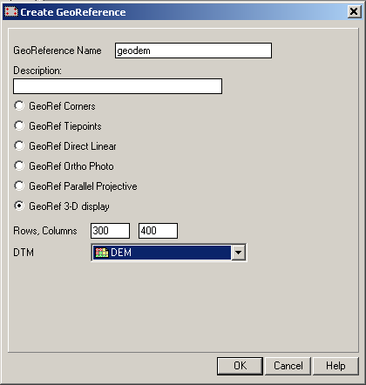
- In the main window of ILWIS go to file, create, georeference. The box shown on the right will open. Call the new georeference “geodem” and select GeoRef 3-D display. Choose “DEM” in the DTM box. Click the OK button.
- Now you have to select the image that you want to overlap to the DEM. In order to do that, select in the field Drape Map the image “tmcor432”. Click OK.
- Try to change the parameter (ex: view angle, horizontal rotation, vertical rotation, etc).
MISUNDERSTANDING
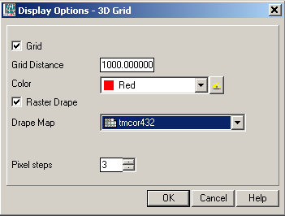
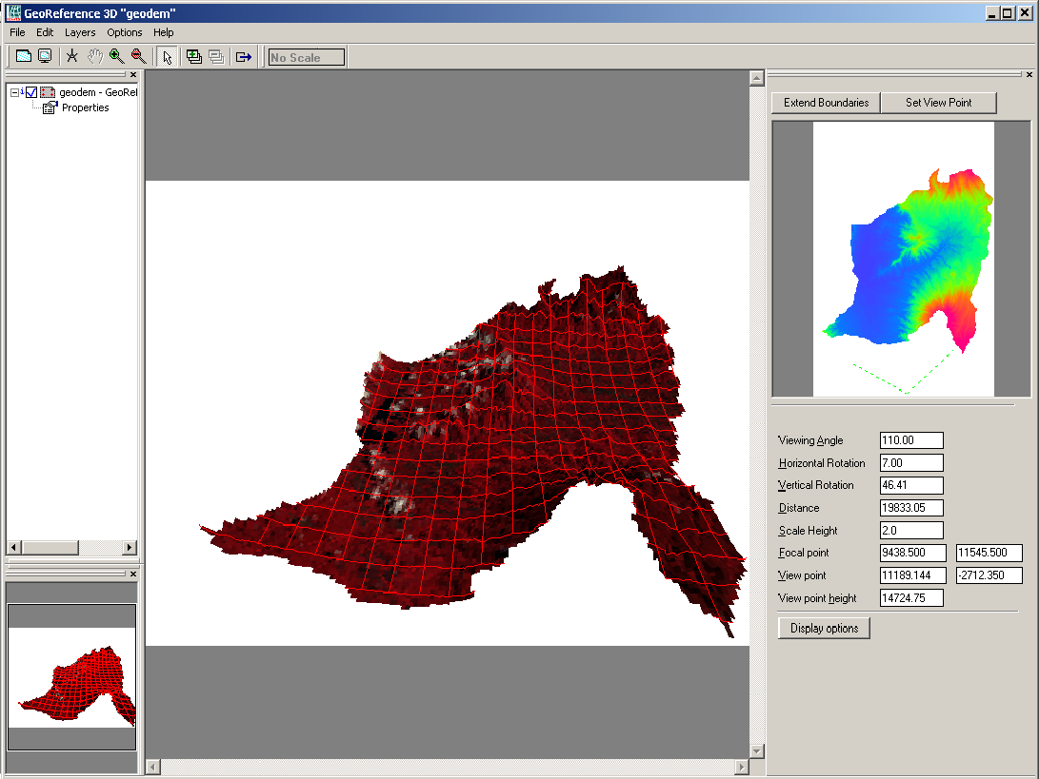
(the explanation on the text about this steps is a little confused becouse is mixed the case when you already have a georeference (in this case you can select display 3d from the operation list), and the case when you have to create the georefernce, as explained here (in this case the window georeference 3d appear directly and you can directly modify the parameters).

Added the selection of filter type (see the text in yellow)

7.2
Little clarification about the step (See in yellow).

7.3
Same of 7.2 (see yellow).
7.4
The value value range of the coumn riskfire (table elevadem) should be 1-4 (see on the text in yellow. In the original was 1-8)

9.5
The distance from the Head Quarter and the point X=12577,50
Y=16318,50 is:

35555m (distance)
Time estimated=35.5km*1min/km=35min

The respdist map and so the resprisk map evaluated are different from the maps in the folder “all data”. I used the procedure described (with my data and with the data given), but the results is different. Check.
So also the value of the table 9.4 are not comparable with my output map.
For the continuation of the exercise I used my data and I stored it in separate folder. This is called continuation_jp and is stored in the folder final exercise/exercise 4/forestfire.

This is the table adapted with the value of my data. (tab. 9.4)

Distance class | Response risk class | Response risk value
0 – 10 000 | Very low response risk | 1
10 001 – 20 000 | Low response risk | 2
21 001 – 30 000 | Moderate response risk | 3
31 001 – 40 000 | Medium response risk | 4
41 001 – 50 000 | High response risk | 5
51 001 – 62 000 | Very high response risk | 6

