*Session 3.C Task 12*

Monitoring the change of the Solo River delta , East Java, Indonesia

with multi-temporal satellite images & historic topographical map

**Expected time:** 1.5 hour

**Data:** Data file: 3**.C Task 12: MonitoringSoloDelta**

After this exercise you will be able to:

**-** display multi-temporal and multi-resolution coastal images of a delta environment

- analyze processes leading to changes in surface area;

- quantify the changes of surface area using multi-temporal satellite data and an old topographical map;

**1. Introduction**

The Solo River delta in Indonesia is one of the largest on the island of Java, situated at the Northern coast. The delta can be characterized as a highly mud dominated and rapidly prograding single finder delta system. The east monsoon generated coastal currents and waves cause the mouth to be deflected eastward. The delta system consists of one major straight channel with pronounced natural levees and a few river outlets. The size of the drainage basin of the Solo River covers 16.000 km2 and the total length of the river is 550 km.

The river flow regime is highly influenced by the monsoons. Most discharge takes place during the wet season (December – March). The mean annual discharge is 1350 m3/sec (max 4000 m3/sec – min. 80 m3 sec.). The suspended sediment concentrations may vary from > 5000 mg/l (wet season) to less than 50 mg/l in the dry season. Almost 95 % of the suspended matter has a grain size < 50 microns.

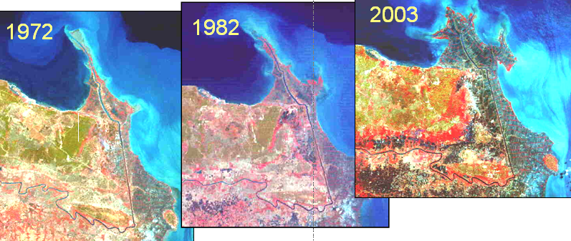

**2. Exploring the input data**

In the data catalog you see the icons of the available input data of this case study.

|  |  |  |
| --- | --- | --- |
| **Name** | **Type** | **Meaning** |
| **Solo_Topomap_1883** | Raster | Scanned topographical map of 1883 |
| **Solo_MSS_1972** | Raster | Landsat MSS image. Acquisition date: 27-09-1972 |
| **Solo_MSS_1982** | Raster | Landsat MSS image. Acquisition date: 11-09-1982 |
| Solo_ETM_2002 | Raster | Landsat ETM image. Acquisition date: 23-08-2002 |
| Solo_Aster_2003 | Raster | Aster VNIR image. Acquisition date: 22-09-2003 |
| **Polygon maps of the coastline:** | | |
| Solo_Coastline_1883 | Polygon | Digitized coastline from topographical map of 1883 |
| Solo_Coastline_1972 | Polygon | Digitized coastline from Landsat MSS image of 1972 |
| Solo_Coastline_1982 | * Polygon | Digitized coastline from Landsat MSS image of 1982 |
| **Solo_Coastline_2002** | * Polygon | Digitized coastline from Landsat ETM image of 2002 |
| **Solo_Coastline_2003** | * Polygon | Digitized coastline from Aster VNIR image of 2003 |
|  |  |  |

**3. Display and analysis of the individual satellite images**

Display of the satellite images of the Solo River delta.

|  |
| --- |
| 1. Display the satellite images in color composites. Do this in screen windows with the different images next to each other. 2. Analyze the images; try to recognize the coastline, the rivers(s) etc. Analyze the differences in respect to land and water characteristics, suspended materials in the sea and river water. 3. Answer *Question 1.* |

***Question 1.***

Which five or six terrain classes do you recognize? Give them a name:

1. ……………………………………………………………………………………..
2. ……………………………………………………………………………………..
3. ……………………………………………………………………………………...
4. ……………………………………………………………………………………...
5. ………………………………………………………………………………………
6. ……………………………………………………………………………………….

|  |
| --- |
| 1. Display a color composite of the most recent satellite image together with the 1883 topographical map in screen windows next to each other 2. Answer *Question 3 a* 3. Display the segment file of the 1883 coastline on top of the most recent satellite image 4. Answer *Question 3 b* 5. Calculate the surface area of the land for each year we have polygon maps available 6. Answer *Question 3 c* |

**4. Change analysis of the Solo River delta**

Analyze the change of the Solo River delta using the data from different years.

***Question 2.***

Which trends do you see in respect to the delta development?

…………………………………………………………………………………………………………………………………….

…………………………………………………………………………………………………………………………………….

…………………………………………………………………………………………………………………………………….

***Question 3.***

Calculate the surface area of the land for each year from which we have the data

|  |  |
| --- | --- |
| **Year** | **Surface area (km2)** |
| 1883 |  |
| 1972 |  |
| 1982 |  |
| 2002 |  |
| 2003 |  |