Session 3.C – Task 10
Modelling of Land Subsidence & Sea level rise in Semarang city, Indonesia
Expected time: 2.5 hour
Data: Data file: 3C Task 10_ModellingSubsidenceSemarang.zip
Objectives: After this exercise you will be able to:
- analyze flooded areas with a Landsat ETM image;
- compare the coastline of 2001 with an older digitized one (1871);
- analyze and interpolate point data of elevation and rate of subsidence;
- to model with multi temporal DEMs future relative sea level rise from different scenarios;
- display of the results maps in clear colors.

1. Introduction
The exercise deals with the use of GIS for the study of the impact of land subsidence and sea level rise in the city of Semarang, Central Java, Indonesia.
Semarang city is suffering from two types of flooding: from rivers and high tides. The extend and magnitude of the floods seriously increased in recent years. This appears to be related to the ongoing processes of land subsidence and global sea level rise that this coastal city is faced with. The rate of subsidence in the city is at places up to a maximum of 12 cm/yr. Medium estimates of sea level rise in the region indicate that the sea level in Indonesia will rise by 9, 13, and 45 cm for the years 2010, 2019, and 2070 respectively.
To assess the combined effect of these phenomena and its spatial distribution, a procedure has to be applied which combines up-to-date geo-information sources on terrain elevation and land use.
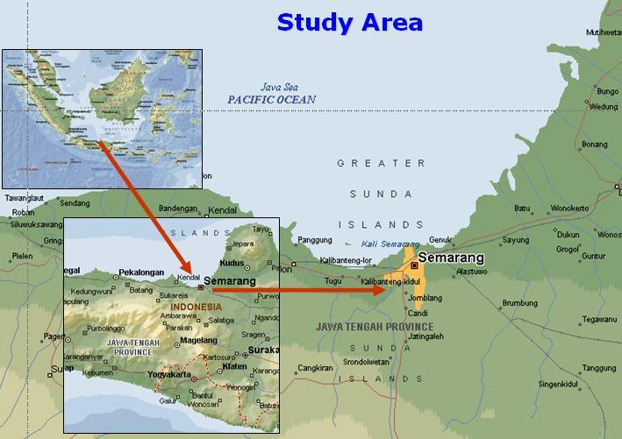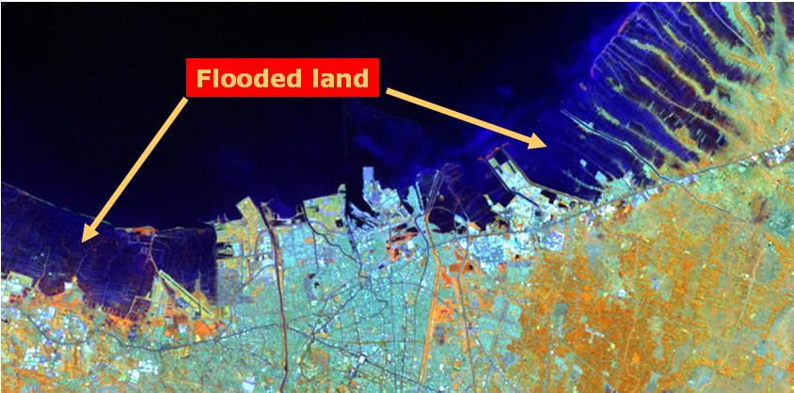

Figure 1:
Landsat TM image of Semarang showing flooded areas along the coast
In the exercise, a Digital Elevation Model (DEM) will be generated using a point map of photogramm-etrically- derived data.
The present land use in the area can be assessed using high-resolution satellite imagery of Landsat-7 ETM+
Also available is a scanned topo map of the area.
In the exercise you are asked to make result maps of the land subsidence and sea level. It aims to be applicable to other ‘sinking cities’ as well.
The methodology for the exercise has been derived from:
- Heri Sutanta (2002) - “Spatial modeling of the Impact of Land Subsidence and Sea Level Rise in a Coastal Urban Setting”, ITC-MSc study.

2. Exploring the input data
In the data catalog you see the icons of the available input data for this the case study.

Name | Type | Meaning
ETM01b1,…b2,…b3,…b4, …b5,…b8 | Raster | Enhanced Thematic-Mapper image of 2th August 2001, bands 1 →5 and band 8.  Resolution bands 1 → 5 is 30m and of band 8: 15 m.
Topo_1871, Topo_1908, Topo_1937, Topo_1992 | Raster | Scanned topographical maps of the years 1871, 1908, 1937 and 1992 with a pixel resolution of 5.
Administration | Segment, polygon and table | Administrative subdivision of the city of Semarang in ‘kampungs’ and the population densities in a table.
Benchmarks | Point | Point map of benchmarks with a known subsidence rate in mm per year
Eleva01 | Point | Point map of the elevations in 2001, in the central part of Semarang in meters
Coastlines | - Segment | Digitized Coastlines based on the topographical maps of 1871 and 1992.
Waterbodies | - Segment and polygon | waterbodies, such as the Java sea, rivers and canals (digitized from topographical map)
Roads | - Polygon | Polygon map of the main roads
SubsMask | - Raster & polygon | Raster, polygon map. Mask of study area for subsidence
StudyArea | - Segment | Segment map of the boundary of the study area.

3. Comparing the Landsat ETM image of 2001 with the digitized coastline of 1871
First display the Landsat Thematic Mapper image of 2001 as a color composite. You will see in the Catalog of the Main Window the list of individual Landsat image bands, displayed with a raster icon.
- Double mouse-click the ETM01b5 image. Accept the default settings in the “Display Options- Raster Map” window by selecting OK.
- Browse through the image with the mouse pointer and try to recognize certain surface features; for instance the difference between the land and sea area, the infra-structure of Semarang, etc. Zoom in at certain areas.
- Do the same for ETM01b8. Compare the result in screen windows next to each other. As you will see, the image ETM01b5 has a lower spatial resolution (30 m pixel size) than the panchromatic ETM01b8 (15 m pixel size).
- Create a color composite of the Enhanced Thematic Mapper bands: 4, 5 & 3 for red, green and blue. Save the result as: ETM01b453
To do this select from the Menu Bar:
  - Operations, Image Processing, Color-Composite…
  - Select in the Colour-Composite window the following bands:
Red – Green – Blue: ETM01b4–ETM01b5–ETM01b3
  - Type for Output Raster map: ETM01b453
  - Keep the defaults and Press: Show
- Study the colors of the image, and zoom-in at selected sites.

Comparing the coastline of 1871 with the coastline during image acquisition
The coastline of Semarang and surroundings, as visible on the color-composite of the Enhanced TM Image can be compared with the historic coastline, digitized from a topographical map of 1871
- First display the Landsat ETM color-composite image.
- Add the data layer Coastlines by selecting from the Map window: Layers > Add Layer…
- In the Add Data Layer window select the segment map: Coastlines, OK. In the Display Options-Segment Map window select all defaults by also OK.
- Zoom in at the coast and compare the historical coastline (1871 – orange color) with the more recent one (1992 – red color)
4. Display of elevation point data and topographical maps
First we will have a look at the administrative map and table, and the point map of the elevations, from which the Digital Elevation Model has to be constructed.
- Select the polygon map administration. In the Display Options – Polygon Map window you keep all defaults. Select: OK.
- Double mouse-click in the administrative units (“desas”) of Semarang. An Attribute window pops-up with information on the population density in that unit( =PopDens).
Note that the population density in the Java Sea is of course 0;
population data of the surrounding Kabupaten is not known ( = ? )
and all population data are stored in the table Administration.

To add other data layers, such as a satellite image or a topographical map, you have to display the administration map with the boundaries only.
- Select in the Polygon Map window: Layers > Display Options > 1 pol. Administration. In the Display Options – Polygon Map window you select the Check Box Boundaries Only. Select: OK. Now, the Administration map is displayed with boundaries only in a red color.
- In the Polygon Map window select: Layers > Add Layer. Now you can choose a map to add to the polygon map.

Add the maps one by one: Topo_1992
or Topo_1871, Topo_1908, Topo_1937 or ETM01b453,

- Study the change of the coastline and the extension of the city, compared to the historic data.

You can use the layer management pane (left window) to
hide or display maps of your own choice (find out yourself)

Remark You can add only ETM images, or Topo maps to the Adminstration map. This has to do with differences in the geo-reference.

The display of the point map of the elevations in meters, with mm accuracy, and the benchmarks of the land subsidence rate (cm/year), can be done as follows.
- Display a map, for instance the Landsat ETM image or the topographical map of 1992.
- Add as data layer the point map eleva01 and/or benchmarks. Mouse click on the points to see the values.
- Improve the display of the points by selecting: Layers > Display Options > 2pnt_eleva01.
- In the Display Options – Point Map window press the Symbol button. Use the Help function for more information on the different display options.

5. Interpolation of the elevation points and benchmarks of land subsidence
To speed up the procedure of interpolation, only the city center of Semarang will be used as a test area. For this, a special georefer_subsidence is available with a pixel size of 30 m.
To make the DEM of 2001 we will use a simple interpolation algorithm: Moving Average with Inverse Distance. In ILWIS a more advanced interpolation is well possible, for instance kriging, but that will take too much time for the exercise.

- In the ILWIS Menu Bar select: Operations > Interpolation > Point Interpolation > Moving Average. In the Moving Average window Select or type:
  - Point Map: eleva01
  - Weight Function:  Linear Decrease
  - Weight Exponent: default value
  - Limiting Distance: 1500 (value in meters)
  - Output raster Map: Eleva01 (value in meters)
  - Georeference: Georef_Subsidence (30 m pixels)
  - Value Range: default values
  - Precision: 0.01 (value in cm)
  - Type for Description: Elevation 2001 in meters
  - Select: Show
  - Select all default values in the Display Options – Raster Map window.
- Browse through the map and look at the elevation values
- Add Map layers, such as roads, waterbodies and administration

To make the raster map SubsRate, in which the subsidence rate in cm per year is given, we have to interpolate the point map Benchmarks. For this, we follow basically the same interpolation procedure as for the map Eleva01 (see above).
We also use Georef_Subsidence (same area as eleva01). The only difference is, that the data to be interpolated are stored in a table benchmarks, and not in a map. The second difference is the limiting distance; this is set to 15.000 meter, to overcome the wide spacing of the benchmark point locations.
- In the ILWIS Menu Bar select: Operations > Interpolation > Point Interpolation > Moving Average. In the Moving Average window Select or type:
  - Point Map: benchmarks
Select: Subs-cmyr ( remark: to select click the small box with
a + in it front of the map benchmarks)
  - Weight Function:  Linear Decrease
  - Weight Exponent: default value
  - Limiting Distance: 15.000 (value in meters)
  - Output raster Map: SubsRate (value in cm/year)
  - Georeference: Georef_Subsidence (30 m pixels)
  - Value Range: default values
  - Precision: 0.01 (value in cm)
  - Type for Description: Subsidence rate in cm/year
  - Select: Show
  - Select all default values in the Display Options – Raster Map window.
- Browse through the map and look at the subsidence values in cm/year
- Add Map layers, such as roads, waterways and administration

6. Modelling future relative sea level rise
The scenarios in this exercise will produce maps with estimations of the relative sea level rises for the years 2010, 2019 and 2070. This means the sea level relative to the elevations of the land, taking into account land subsidence and enhanced sea level rise.
The prediction from the study by the Asian Development Bank (1994) is taken as a basis for the absolute Enhanced Sea Level Rise scenarios in Semarang.
Scenario | 2010 | 2019 | 2070
Low (cm) | 3 | 6 | 15
Medium (cm) | 9 | 13 | 45
High (cm) | 15 | 25 | 90
For the exercise, the medium values for the years 2010, 2019 and 2070 have been selected in the calculations of future land subsidence relative to enhanced sea level rise. This means a rise of 9 cm in 2010, of 13 cm in 2019 and 45 cm in 2070.
The calculation for the DTM for the year t1 (=2010, 2019 or 2070), starting at the year t0 (=2001) is (H. Sutanta, 2002):
${\text{ELEVA}}_{t1}={\text{ELEVA}}_{t0}−({\text{SLR}}_{t1}+(\text{SUBSRATE}∗t_{1}−t_{0}))$ Where:
ELEVA_{t0} = elevation at the initial condition (file: Eleva01)
ELEVA_{t1} = elevation at the year to be estimated (file: Eleva10, Eleva19, Eleva70)
SLR_{t1} = sea level rise at the year to be estimated (2010, 2019 and 2070)
SUBRATE = map of the rate of land subsidence (file: SubsRate)

In ILWIS, the necessary calculations based on the above formula, can be carried out using Map Calculations, to be typed in the Command Line. The equations are the following:
$$\begin{aligned}\text{Eleva10}=\text{Eleva01}−(0\text{.}\text{09}+\text{9xSubsRate/100}) \\ \text{Eleva19}=\text{Eleva01}−(0\text{.}\text{13}+\text{18xSubsRate/100}) \\ \text{Eleva70}=\text{Eleva01}−(0\text{.}\text{45}+\text{69xSubsRate/100})\end{aligned}$$

Remark: the values SubsRate are divided by 100, to make units in meters
in stead of cm.

- To make the map Eleva10, the following Map Calculation has to be performed (type in the Command Line):
Eleva10 = Eleva01 –(0.09+9*SubsRate/100)
Accept the defaults in the Raster Map Definition window and select:
Show.
- Make with Map Calculation also the maps: Eleva19 and Eleva70
- Check the result and add map layers such as Administration.
As you will see did the interpolation of the points not stop at the coastline itself. To overcome this, you have to combine the resulting maps with a mask of only the land area of 2001. This is the map SubsMask, of which the coastline is digitized from the Landsat ETM image of 2001.
- Display the map: SubsMask
- To ‘take out” or mask only the land area of the created elevation maps of the years 2010, 2019 and 2070, perform the following Map Calculation:
ElevaMask10 = iff(SubsMask=”Land”, Eleva10,0)

Meaning: Create a map with the name ElevaMask10 only for
the areas which are “land” in the map SubsMask. Make the
Sea: 0
- Accept the defaults in the Raster Map Definition window.
- Create the same way as above the maps ElevaMask19 and
ElevaMask70.
- Check the results. Add data layers of your own choice.

To get a better idea, on how badly the land has subsided in 2010, 2019 and 2070 compared to 2001, we display the topographical map of 1992 and browse with Pixel Info through the map, with the elevations of the three future years displayed in the Pixel Info window.

- Display topomap Topo_1993 (or satellite image of 2001)
- Open Pixel Info from the Standard Toolbar
- Add the maps Eleva01, ElevaMask10, ElevaMask19, ElevaMask70, SubsRate to the Pixel Information window by selecting: File > Add Map.
- Analyze the results.

7. Display of the result data
The final step is to slice the ElevaMask 10, ..19, ..70 maps in such a way, that the subsided is represented in steps with clear and nice color.
For this, there is already made a domain with the steps elevation and a color look-up table with the same name. The output maps will be given the names: Elevation 2010, Elevation 2019 and Elevation 2070.
- Select: Slicing from the Operations List (left side of window). Type or select in the Slicing window:
- Raster Map: Elevamask10
- Output Raster Map: Elevation2010
- Domain: Elevation
- Description: Elevation Map 2010
- Select: Show
- Accept the default values in the Raster Map Definition window and Check / analyze the resulting map
- Make the same way maps Elevation2019 and Elevation2070

