*Session 3.C Task 10 ANSWERS*

Modelling of Land Subsidence & Sea level rise in Semarang city, Indonesia

**Expected time:** 2.5 hour

**Data:** Data file: 3**C** **Task 10 Modelling Subsidence Semarang.zip**

**Objectives:** After this exercise you will be able to:

**-** analyze flooded areas with a Landsat ETM image;

- compare the coastline of 2001 with an older digitized one (1871);

- analyze and interpolate point data of elevation and rate of subsidence;

- to model with multi temporal DEMs future relative sea level rise from different scenarios;

- display of the results maps in clear colors.

***Answers***

**3. Comparing the Landsat ETM image of 2001 with the digitized coastline of 1871**

**Comparison Landsat ETM Band 5 (left image with 30 m pixels) with Landsat ETM band 8 right image with 15 m. pixels**

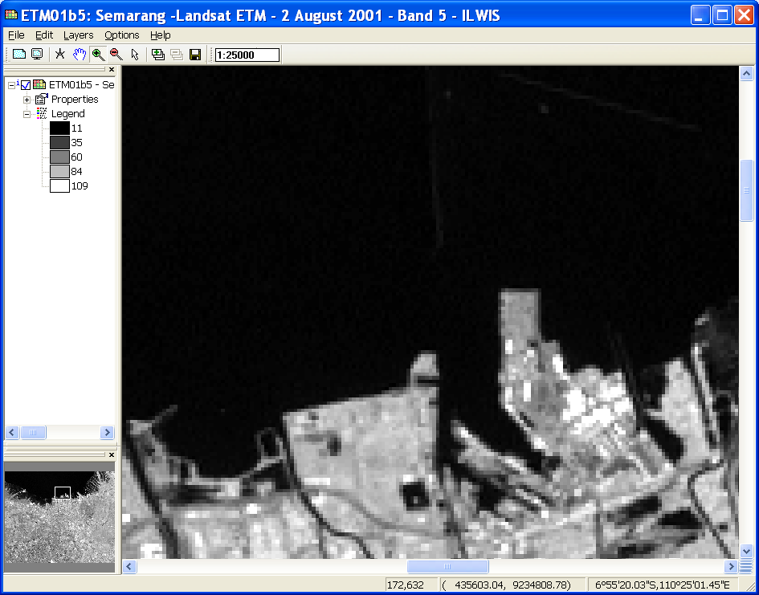

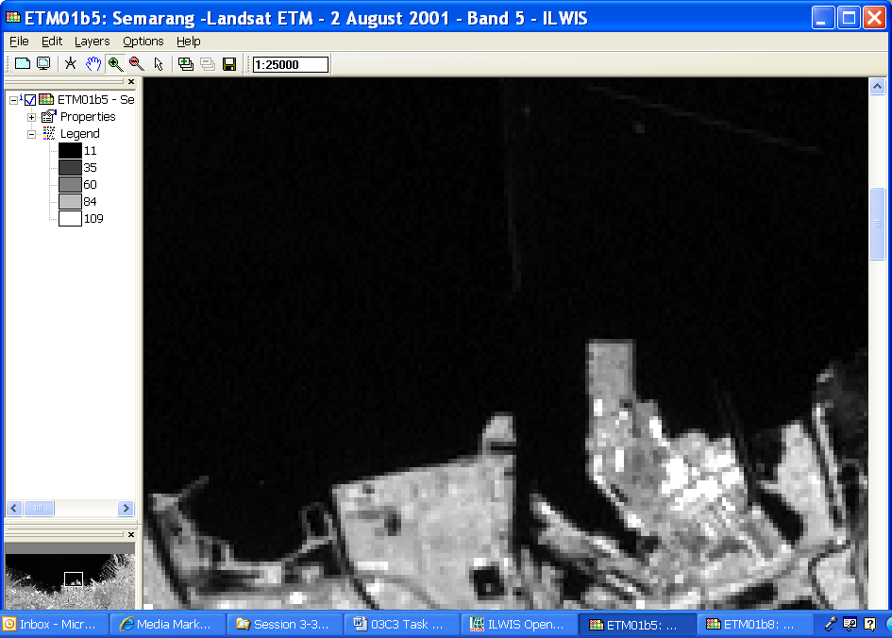

## Comparing the coastline of 1871 with the coastline during image acquisition

The coastline of Semarang and surroundings, as visible on the color-composite of the Enhanced TM Image can be compared with the historic coastline, digitized from a topographical map of 1871 (yellow coastline)

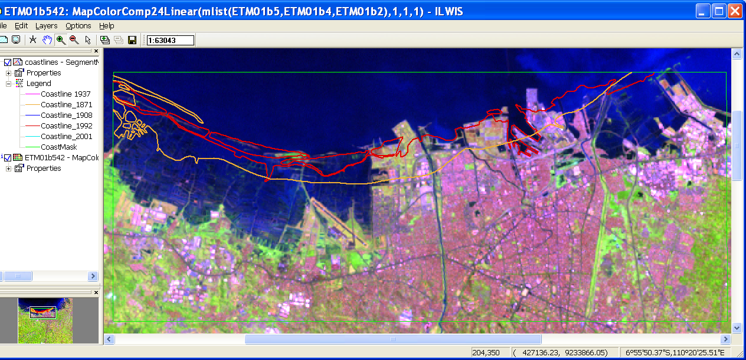

4. Display of elevation point data and topographical maps

**Display of the administrative map and information from the table in PixelInfo ,**

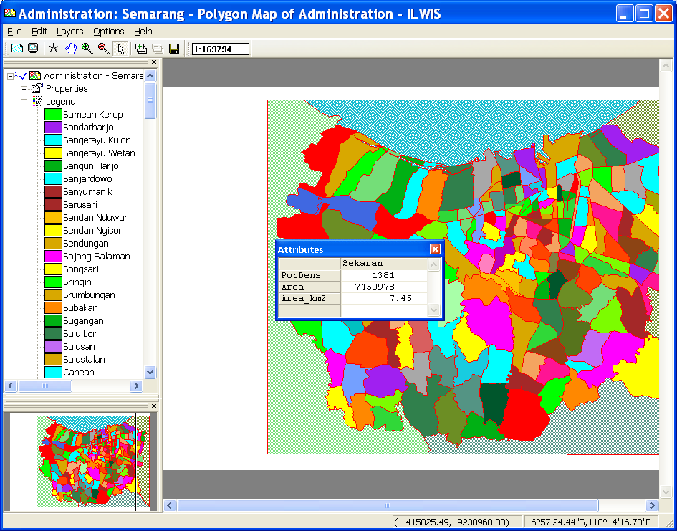

T

**To add other data layers, such as a satellite image or a topographical map, you have to display the administration map with the boundaries only. Example Topomap 1937**

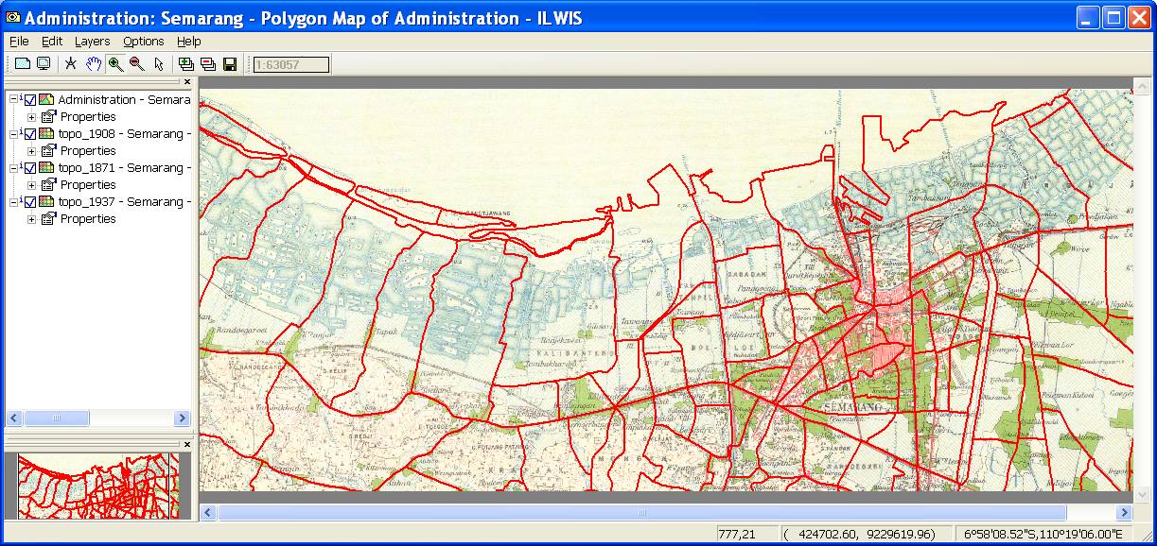

**Display of the point map of the elevations in meters , and the benchmarks of the land subsidence rate (cm/year) **

## 

## 5. Interpolation of the elevation points and benchmarks of land subsidence

**Interpolated raster map of the Eleva01 points (Moving Average / Inverse Distance). On top layers: Roads, Waterbodies and Administration boundaries.**

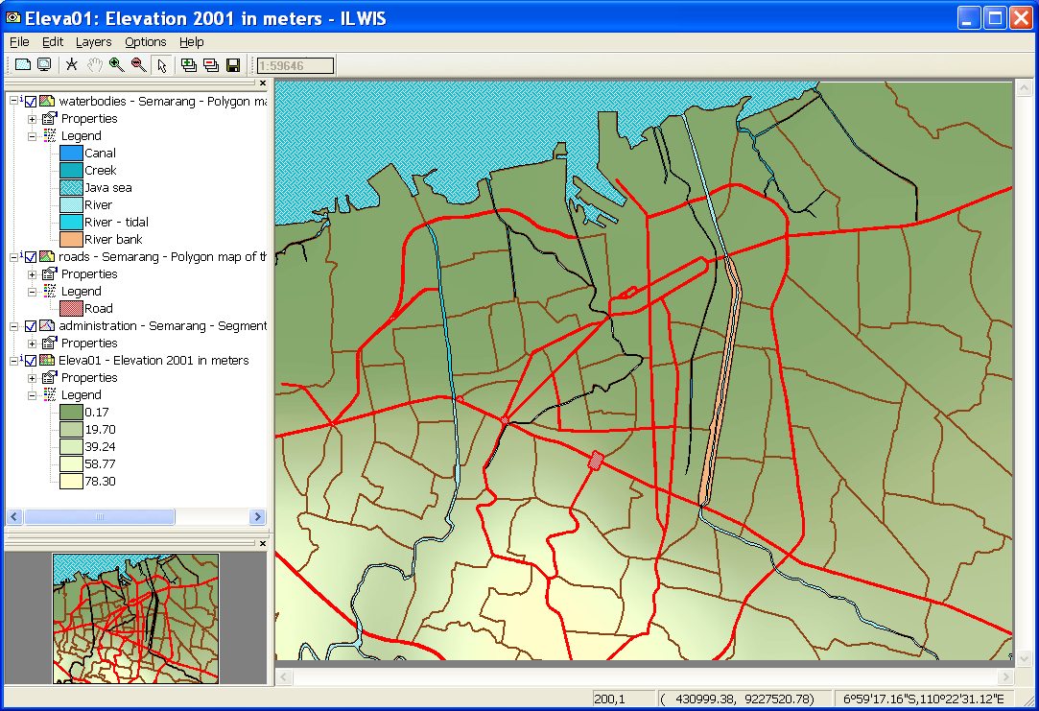

**Raster map Subsidence Rate, interpolated from the points Benchmarks.**

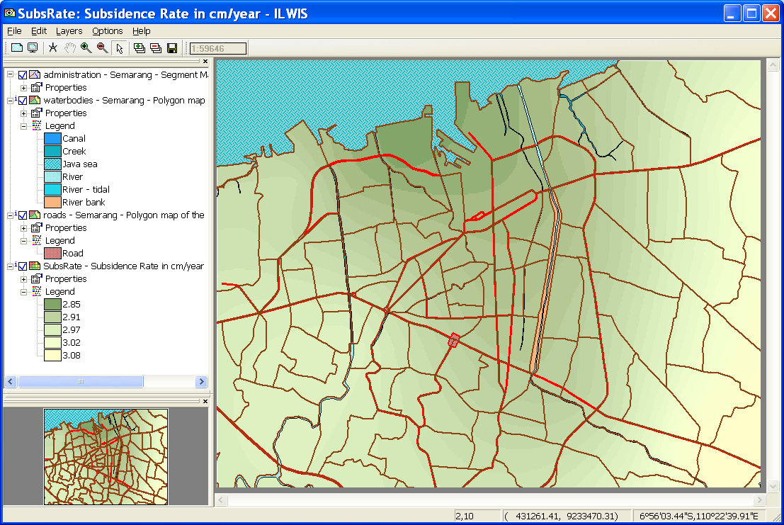

## 6. Modelling future relative sea level rise

The scenarios in this exercise will produce maps with estimations of the relative sea level rises for the years 2010, 2019 and 2070. This means the sea level relative to the elevations of the land, taking into account land subsidence and enhanced sea level rise.

|  |  |  |  |
| --- | --- | --- | --- |
| **Scenario** | **2010** | **2019** | **2070** |
| Low (cm) | 3 | 6 | 15 |
| **Medium (cm)** | **9** | **13** | **45** |
| High (cm) | 15 | 25 | 90 |

The prediction from the study by the Asian Development Bank (1994) is taken as a basis for the absolute Enhanced Sea Level Rise scenarios in Semarang.

For the exercise, the medium values for the years 2010, 2019 and 2070 have been selected in the calculations of future land subsidence relative to enhanced sea level rise. This means a rise of 9 cm in 2010, of 13 cm in 2019 and 45 cm in 2070.

The calculation for the DTM for the year **t1** (=2010, 2019 or 2070), starting at the year **t0** (=2001) is (H. Sutanta, 2002):

 Where:

*ELEVAt0* = elevation at the initial condition (file: Eleva01)

*ELEVAt1* = elevation at the year to be estimated (file: **Eleva10, Eleva19**, **Eleva70**)

*SLRt1*  = sea level rise at the year to be estimated (2010, 2019 and 2070)

*SUBRATE* = map of the rate of land subsidence (file: **SubsRate**)

In ILWIS, the necessary calculations based on the above formula, can be carried out using Map Calculations, to be typed in the Command Line. The equations are the following:



Remark: the values *SubsRate* are divided by 100, to make units in meters

in stead of cm.

**IlWIS Raster Map Definition for Eleva10:**

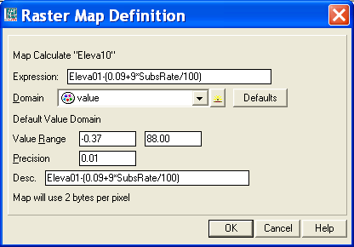

**IlWIS Raster Map Definition for Eleva19:**

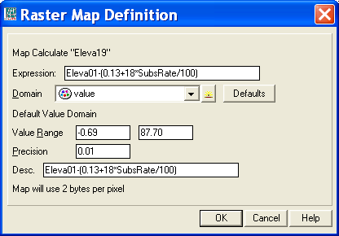

**IlWIS Raster Map Definition for Eleva70:**

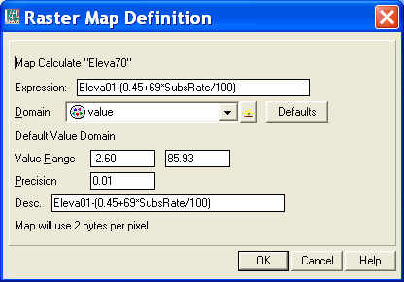

**To get a better idea, on how badly the land has subsided in 2010, 2019 and 2070 compared to 2001, we display the topographical map of 1992 and browse with Pixel Info through the map, with the elevations of the three future years displayed in the Pixel Info window.**

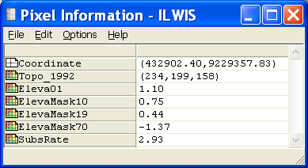

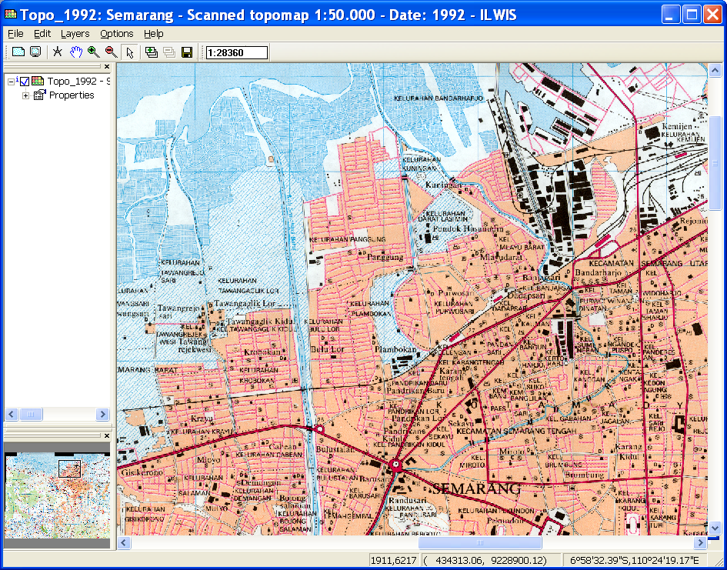

**7. Display of the result data**

**The final step is to slice the ElevaMask 10, ..19, ..70 maps in such a way, that the subsided is represented in steps with clear and nice color.**

**Elevation Map 2010**

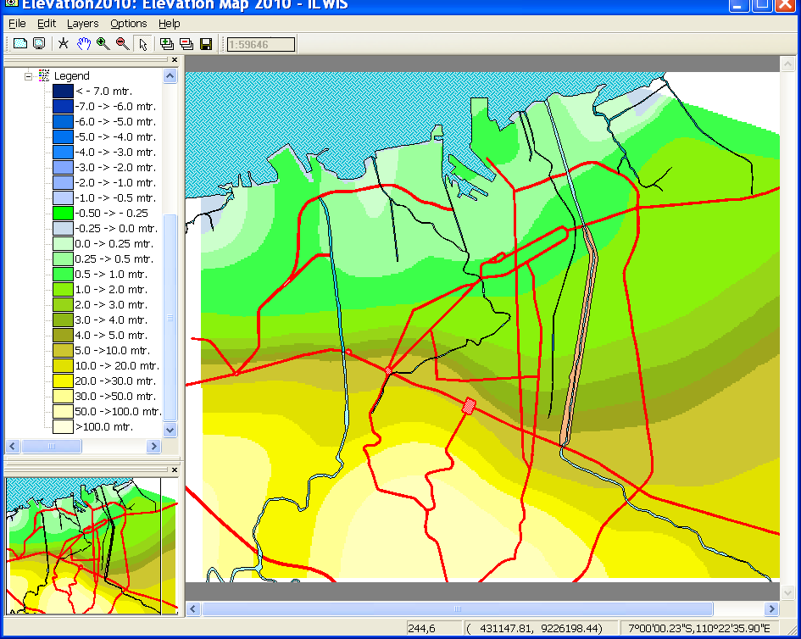

**Elevation Map 2019**

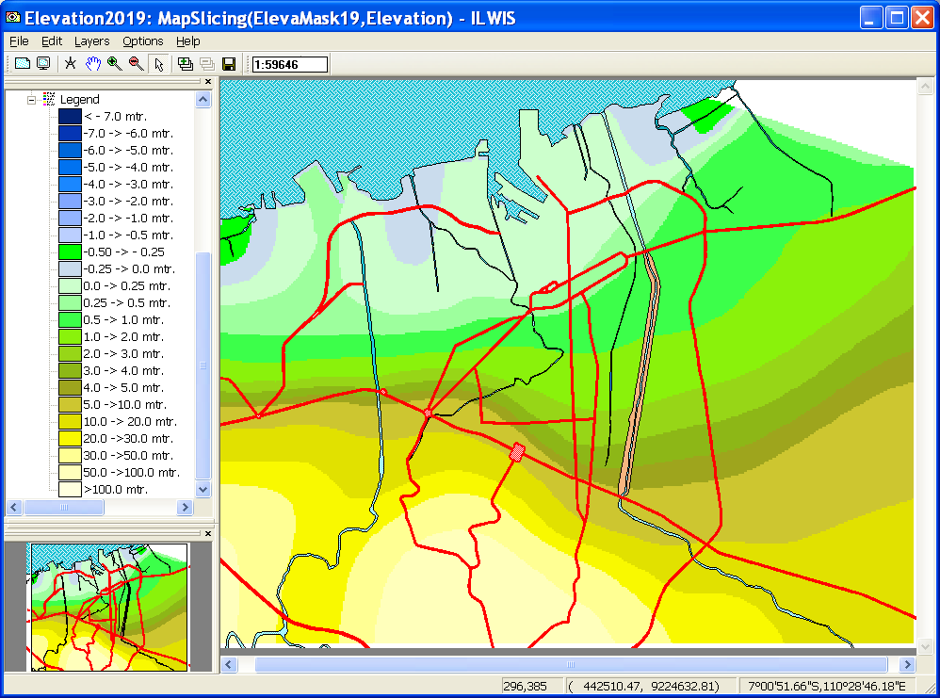

**Elevation Map 2070**

