*Session 3.C Task 8 ANSWERS*

Analysis of coastal areas vulnerable to Enhanced Sea Level Rise

**3. Analyzing the SRTM data of Java and Bali**

**Answer of Question 1**

Pixel size of SRTM **8587,7** square meter

Calculation method

* The radius of the earth (value **a** in the coordinate system): **6378137** meter
* $Pi$ (π): 3.14159
* Circomference of the earth in meters: **2 x π x a** = **40035400 meter** (40035.4 km)
* Circumference of the earth in ArcSeconds: 360 x 60 x 60 = **1296000**
* Pixel size SRTM is 3 ArcSeconds: (40035400 / 1296000) x 3 = **92, 7** meter

**4. Display & calculating areas vulnerable to Enhanced Sea level Rise**

Display of areas that will be affected by a future sea level rise of for instance 1 meter

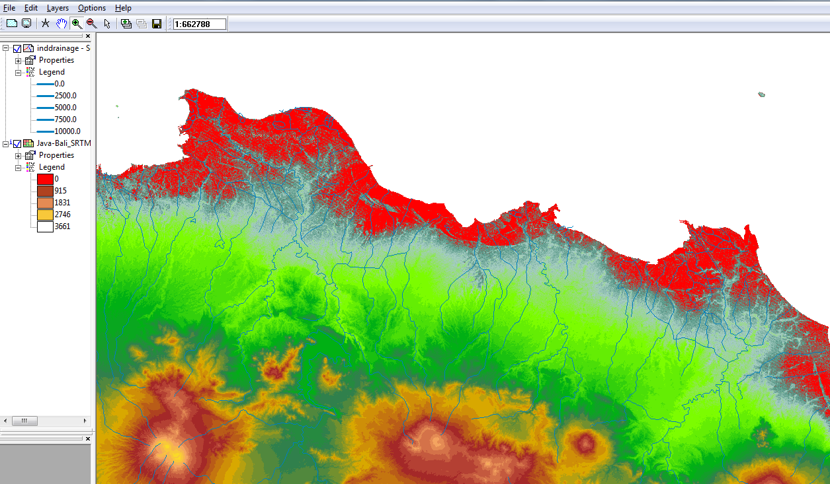

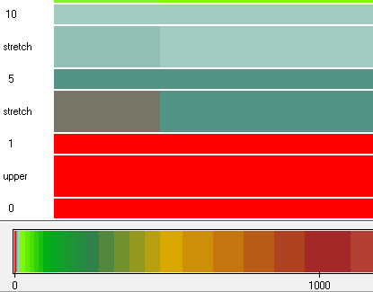

**Answer of Question 2**

Surface area in km2 of elevations between 0 and 1 meter: **2475,5** km2

Calculation method

* Values histogram Java_Bali_SRTM: Value 0 =Npix: **157472**; Value 1 = Npix: **130790**
* Total area in pixels: 157472 + 130790 = **288262** pixels
* Total area in km2 : (288262 x 8587,7) / 1000000