*Session 3.C Task 3-B Answers*

Hazard analysis of cyclone flooding in Bangladesh

*Part B: Hazard Analysis of cyclone flooding in Bangladesh*

1. 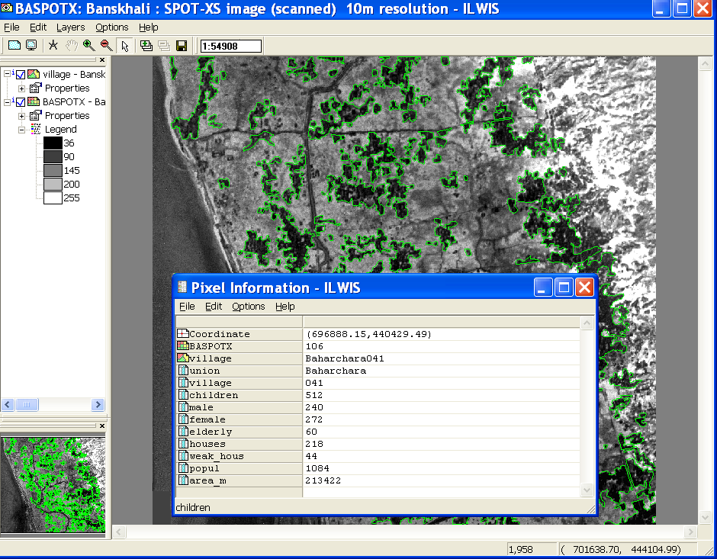**Display of SPOT image and polygon map villages (with boundaries in green) from the Banskhali area.**

**Also Pixel information from the table villages**

1. 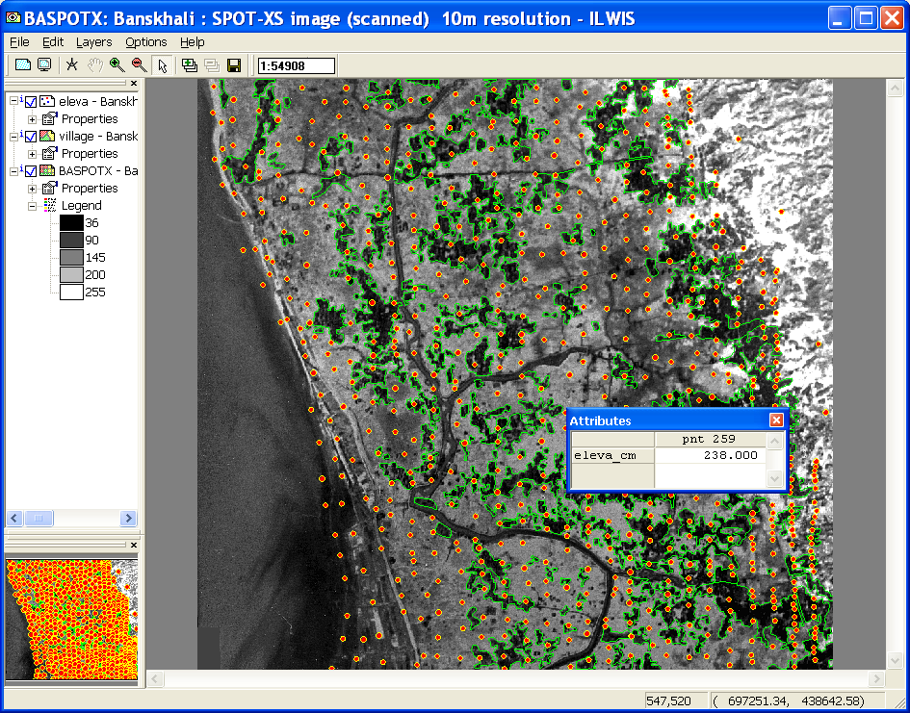**Elevation points (terrestrial measurements in rows)**

1. 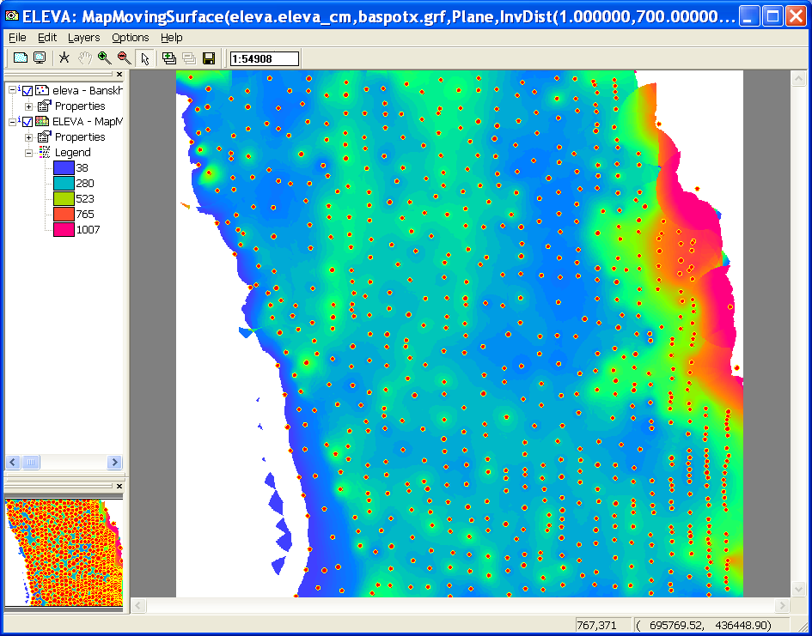**Interpolated raster map ELEVA with on top the elevation points from which the interpolation was done :**
2. 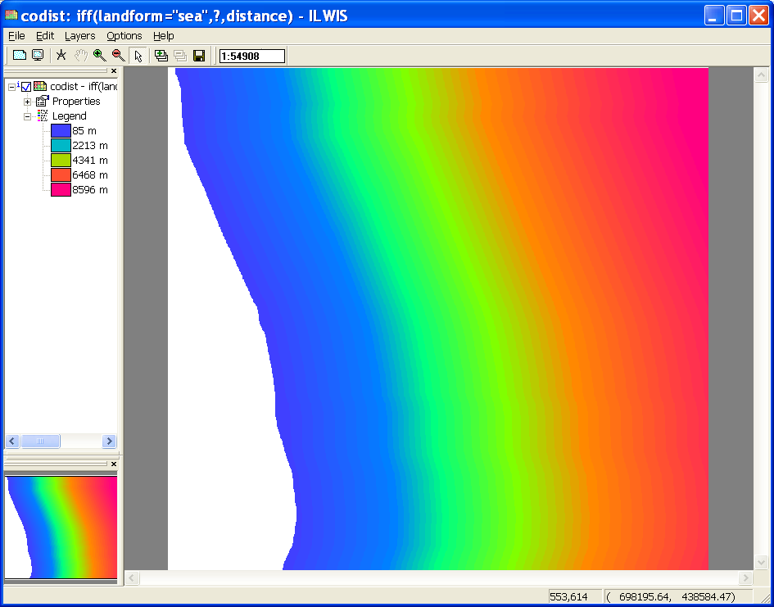**Map Codist (distance map excluding the sea)**

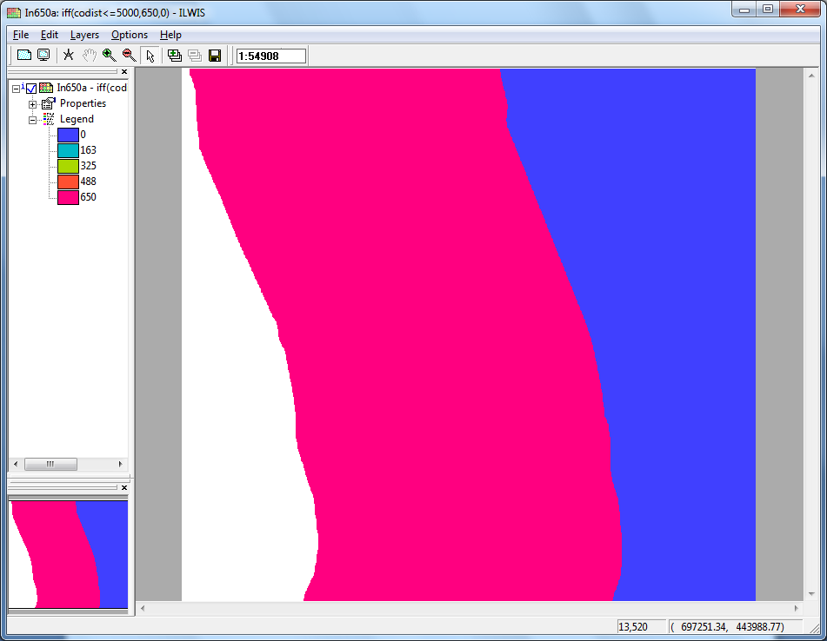

1. **Map In650a**
2. 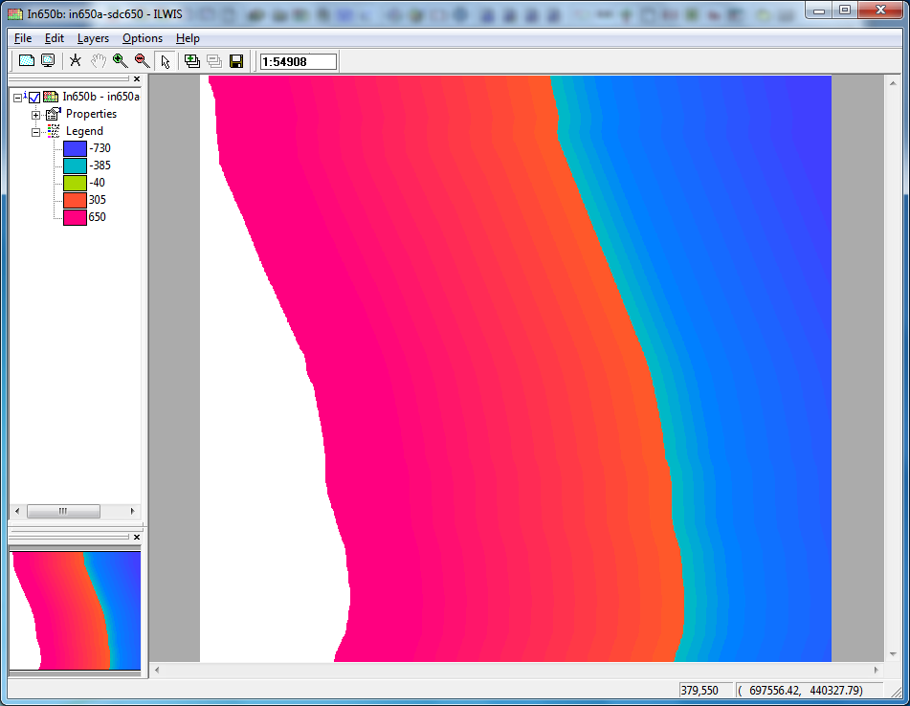**Map In650b**

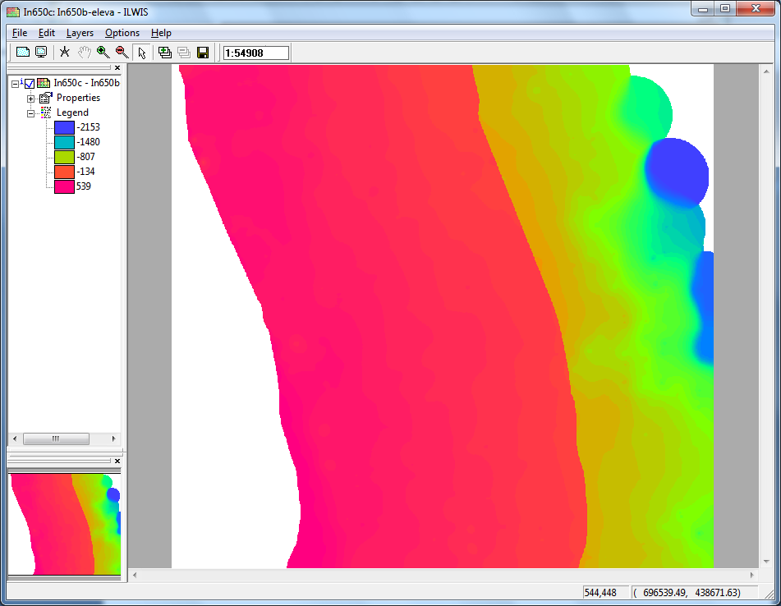

1. **Map In650c**

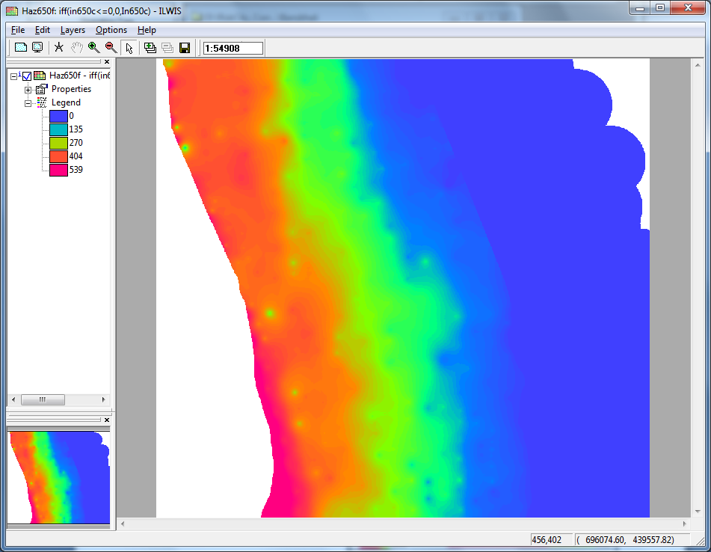

1. **Map Haz650f**
2. **Table to completed manually (Table 3)**

|  |  |  |  |  |  |
| --- | --- | --- | --- | --- | --- |
| **Return**  **period** | **Wave height**  **Chittagong**  (cm) | **Area under**  **const. Surge** (meters) | **Inundated**  **Area**  (meters) | **Avg. elev. at**  **end of surge** (cm) | **SDC**  (cm/m) |
| **5 yr.** | **370** | **415** | **2000** | **274** | **0.061** |
| **10 yr.** | **410** | **520** | **2900** | **287** | **0.052** |
| **20 yr.** | **470** | **580** | **3900** | **274** | **0.059** |
| **50 yr.** | **510** | **670** | **4200** | **282** | **0.065** |

1. **Table to be completed, containing input parameters for the script (Table 4)**

|  |  |  |  |  |  |
| --- | --- | --- | --- | --- | --- |
|  | **%** | **5 yr.** | **10 yr.** | **20 yr.** | **50 yr.** |
| **Wave height at coast (cm)** | **x (cm)** | **370** | **410** | **470** | **510** |
| **Map: Inxa** | **% 1** | **In370a** | **In410a** | **In470a** | **In510a** |
| **Width of inundation (m)** | **% 2** | **2000** | **2900** | **3900** | **4200** |
| **Flood height at coast (cm)** | **% 3** | **370** | **410** | **470** | **510** |
| **SDC** | **% 4** | **0.061** | **0.052** | **0.059** | **0.065** |
| **Width of constant surge (m)** | **% 5** | **415** | **520** | **580** | **670** |
| **Map: Sdcx** | **% 6** | **Sdc370** | **Sdc410** | **Sdc470** | **Sdc510** |
| **Map: Inxb** | **% 7** | **In370b** | **In410b** | **In470b** | **In510b** |
| **Map: Inxc** | **% 8** | **In370c** | **In401c** | **In470c** | **In510c** |
| **Map: Haz*ret*y** | **% 9** | Haz***05***y | Haz***10***y | Haz***20***y | Haz***50***y |

1. **The Input for the script based on table 4**







1. 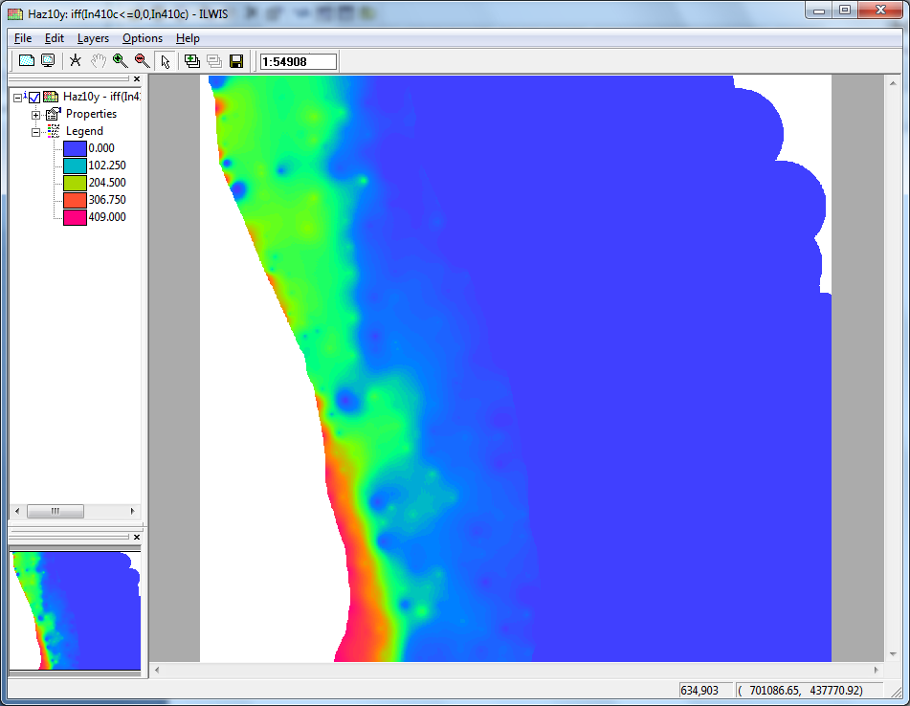 **Map Haz10y**

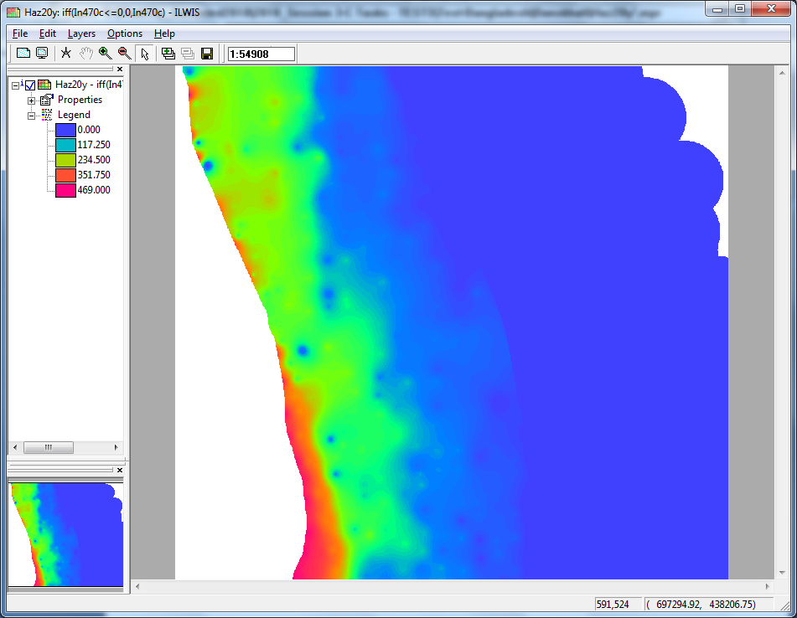

1. **Map Haz20y**

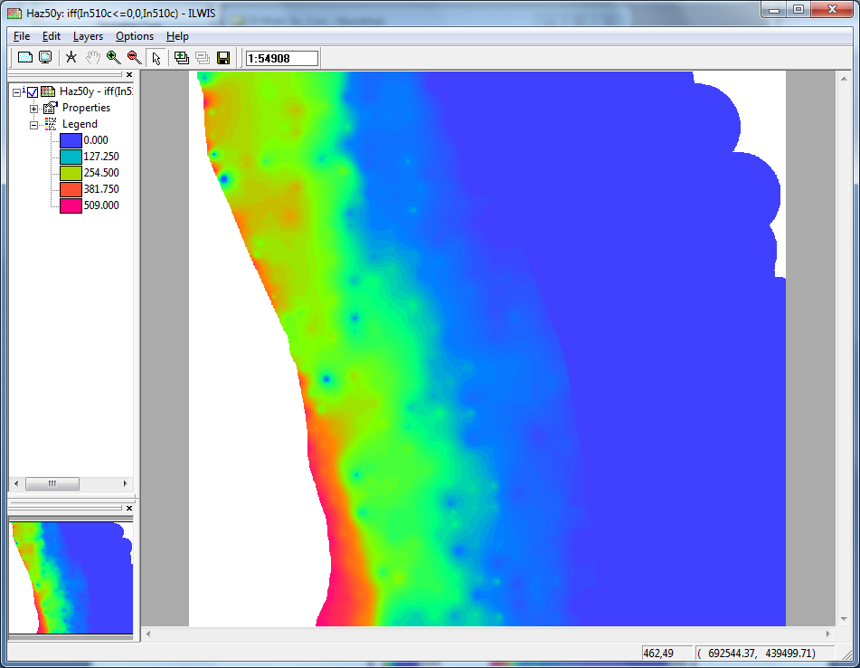

1. **Map Haz50y**