GIS for multi hazard risk assessment

Exercise 02.C Download of Landsat ETM Data and import in ILWIS.

Various aerospace data can be downloaded for free from the Global Land Cover Facility website: http://glcf.umiacs.umd.edu/index.shtml
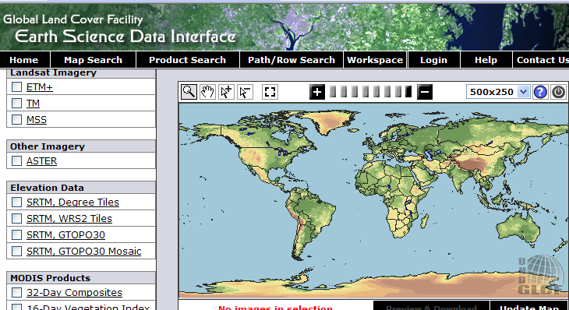
This are LANDSAT sate-llite data and MODIS image composites. SRTM data are available up to processing level 3, meaning that the voids (pixels with missing data) are not filtered out completely. For SRTM you better use the CGIAR-CSI website and follow the instructions of the exercise on “How to Downloads SRTM data”. Aster images are only provided from selected areas. Some Landsat data is in GeoTiff with UTM WGS84.
In the exercise an example is given on how to download a Landsat ETM data of the RiskCity area in Honduras. In case your internet connection is not so fast, you can also use the already downloaded example Landsat data file from RiskCity (filename: xxxxxxxxxxx).
You select the Landsat scene to be downloaded using the coordinates in Lat /Long from the RiskCity study area. After this you download the data as GeoTiff. Remark: the data can also be browsed for via the Map Search option.
The unzipped data can be imported directly into the ILWIS program. Further processing can be carried out in the Image Processing module of ILWIS.
More information on Landsat: http://landsat.usgs.gov/

A. Coordinates of area to be downloaded

First select the coordinates in Lat. Long ofthe area to be downloaded from the GLCF website.
RiskCity  (Tegucicalpa, Honduras) | Latitude | Longitude | UTM X  (Zone 16) | UTM Y  (Zone 16)
Upper Left corner | 14⁰ 15’ 00” N | 88⁰ 00’ 00” W | 448.000 | 1.570.000
Lower Right corner | 13⁰ 30’ 00” N | 87⁰ 00’ 00” W | 497.000 | 1.532.000

Own study areav (optional):

Upper Left corner

Lower Right corner
Remark: Lat-Long to UTM Conversion: ww.cellspark.com/UTM.html
B. Download of Landsat ETM+ data from the GLCF
website
Some selected Landsat data can be downloaded from the GCLF Website in scenes of 185 x 185 km. The data is in UTM -WGS 84.
- Browse to the GLCF website:
http://glcf.umiacs.umd.edu/index.shtml
- Select Download Data 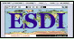
- Select Map Search
- Select: Landsat Imagery : ETM+ 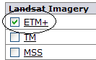
- Select: Tab Lat Long
- Fill in the Min. & Max. Latitude and Longitude of the area to be downloaded. Use degrees, minutes and seconds. Example RiskCity:
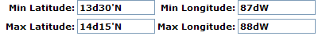
- Click to select the available images
- Select: Update Map The available image scene footprint covering the selected area will become red
- Select: Preview and Download
- Click image by image the ID and look at the image footprint and Quick look.
Select the image of RiskCity with Path / Row: 018 / 050 and Acquisition date : 2000-03-29. File format: GeoTIFF.
- Select: Download
A list is displayed with downloadable individual image bands, quicklooks and a metadata file (*.met).
- Download the metadata file first. You can do this by: Right-mouse clicking > Save target as…
Task: Open the metadata file with MS Word and study the contents, such as image band names, date of acquisition, pixel size, etc.
- Download also the other bands in your data folder by Right-mouse clicking > Save target as…
Advice: first download the bands 2, 3 and 5. With this image bands it will already be possible to create a nice color composite image.
- UNZIP all data.

C. Import and display of Landsat data in ILWIS
The downloaded individual image bands in GeoTIF data can be easily imported in the ILWIS program. After this the bands can be combined to a color composite display.
- Open the ILWIS program.
- Browse with the Navigator to the folder with the downloaded and unzipped Landsat ETM data
- Select in the ILWIS Main menu: File > Import > Via GDAL
- Select in the Import window one of the *.TIF files; type the Output File name. Add the image band number in the file name. Example for ETM band 3: ETM_b3. If done: OK
- Do this for the other Unzipped Landsat ETM image bands as well.
- Display the Properties of Raster window of one of the image bands (to do this: right mouse-click the raster icon). You will see that the Pixel Size is 28.5 meter and the Domain: VALUE. For further image processing of the Landsat ETM bands in ILWIS, they have to be given a Domain: Image.
- Select in the Properties of Raster window for the first image band in the drop-down list Domain: IMAGE. If done select: Apply > OK. Repeat this for all the other bands.
- To display a color composite select: in the ILWIS Main menu: Operations > Image Processing > Color Composite.
- Select in the Color Composite window the following image bands:
- Red Band : ETM_b5
- Green Band: ETM_b3
- Blue Band: ETM_b2
- Type the Output Raster Map name: ETM_b532
- Leave all the other values, such as Linear Stretching, Percentage and RGB in default
- If done: Show
- Zoom in to the RiskCity area and browse the image.

D. Creating a subset of the RiskCity area
- To create a subset of each Landsat ETM image band, you do the following:
- Right mouse-click the first ETM Image band you want to make a subset of and select: Raster Operations > Sub Map…
- Select in the Sub Map of Raster Map window:
- Coordinates
- Fill in: First Coordinate and Opposite Coordinate
Remark: This are the UTM coordinates of the Upper Left and Lower Right corners of the RiskCity subset
- Type the Output Raster Map name
- If done: Show
- Repeat for the other image bands;
- Create a color composite and browse the image

