Assignment
Calculation of landslide- and lake volume using multi-temporal DEM's: Vaiont case study, Italy
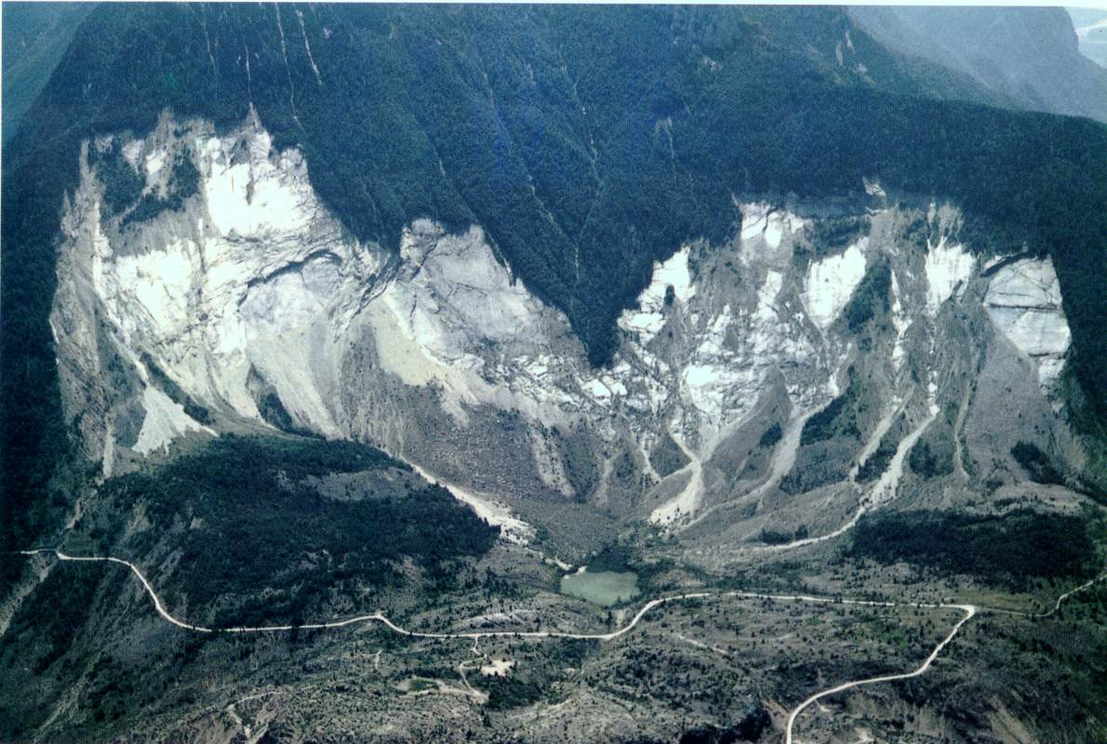
The objective of this assignment is to carry out volume calculations of the massive rockslide that occurred during the night of 9 October 1963 in Vaiont, Italy. The calculations are done using the contours maps before and after the disaster occurred.
The study area
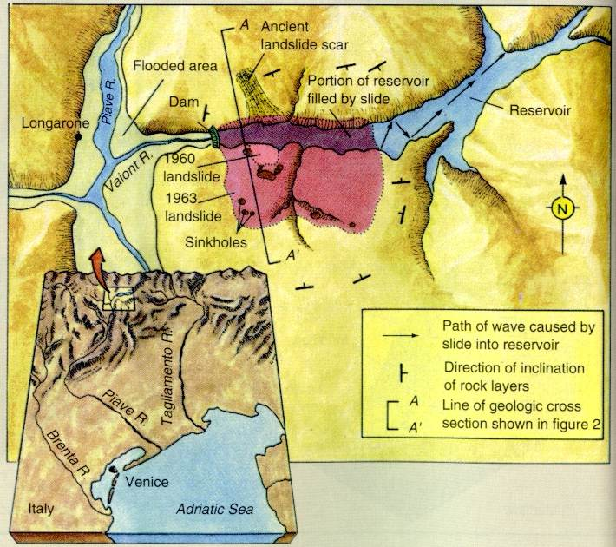
The Vaiont reservoir is located in the lower reaches of the river bearing the same name, not far from its confluence with the River Piave. The Vaiont dam, a dome-shaped shell, is one of the highest arch dams in the world, being 265 m high with a 160 m chord, which spans a very deep and narrow gorge. The rock on both sides of the gorge had been skilfully reinforced.

During the night of 9 October 1963, a mass of rock estimated at 270 million m3, broke loose from the sides of Mount Toc and crashed into the reservoir below in which the water level was about 700 m above sea level (The dam was designed for a water storage level of 722.5 m a.s.l.).
The slide moved a 250 m-thick mass of rock some 300 to 400 m horizontally, with a velocity of 20 to 30 m/sec, which rose more than 100 m to 150 m on the opposite bank.
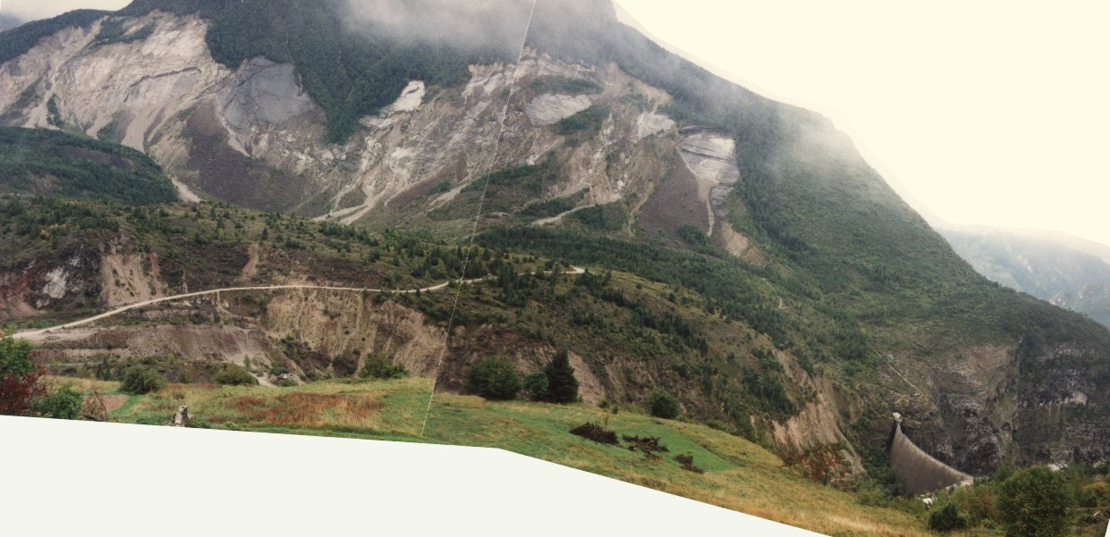
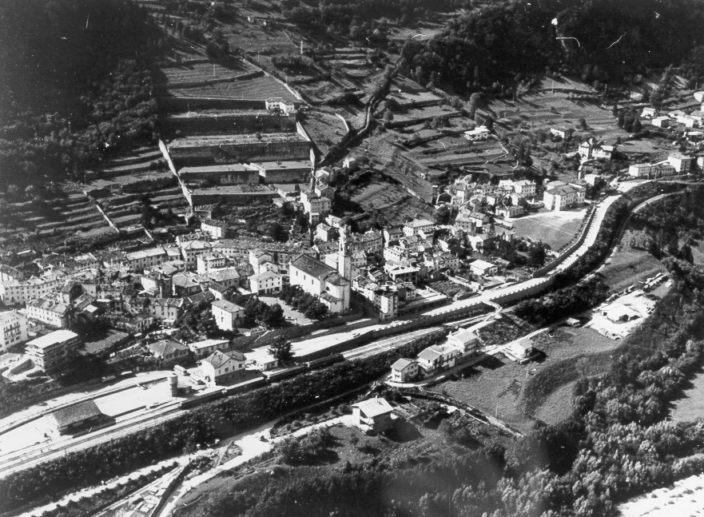
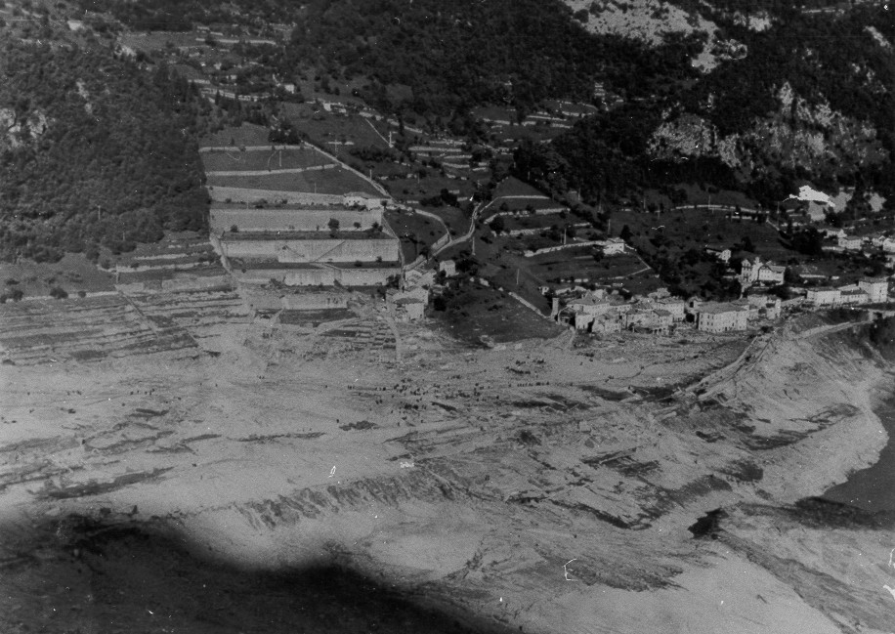
When the disaster occurred, the volume of the reservoir above water level was about 55 million m3. It occurred very suddenly, with extreme violence, and the wave which spilled over the dam crest, overtopped it by 250 m at one point on the right bank and 150 m on the left bank. It is estimated that about 30 million m3 of water poured into the narrow gorge which has a depth of over 240 m and a width of only 150 m at the crest and 20 m at the bottom. The water gushed through this narrow canyon at tremendous speed until it reached the River Piave, where after a right-angle turn it entirely destroyed the small town of Longarone and nearby villages. The collapsed material is now heaped up in what used to be lake and its total height exceeds the dam crest elevation by some 100 m.

Objectives
The assignment has the following objectives
Make a photointerpretation of three periods:
- 1. Before construction (1954): recognise the paleolandslide
- 2. After construction (1962): map lake extend
- 3. After the landslide (1964 or 1984): map the new situation
GIS work:
- Calculate the total volume of waterin the reservoir prior to the landslide
- Calculate the volume of water that was removed from the reservoir during the landslide
- Calculate the total volume of eroded materials of the landslide
- Calculate the total volume of accumulated materials of the landslide
- Calculate the total volume of the landslide.

Input data
The input data consists of
- Airphotos from 1954, 1962, 1964 and 1984.
- Beforeco: a segment map with the contours before the landslide happened
- Before: a segment map with other information before the landslide happened
- Afterco: a segment map with the contours after the landslide happened.
- Carte3: a polygon map with unique ID polygons, linked to a table with geological , geomorphological and landslide information.

Assignments:
- Work in a group of 2 persons.
- Make a photointerpretation of three periods:
- 1. Before construction (1954): map the paleolandslide
- 2. After construction (1962): map lake extend
- 3. After the landslide (1964 or 1984): map the new situation
- Use the map before in order to match the map Carte3 with the other ones, using a coordinate system tiepoints.
- Generate a DEM before the landslide using the segment map Beforeco, and a Georeference with 2 m resolution.
- Generate a DEM after the landslide using the segment map Beforeco, and a Georeference with 2 m resolution.
- Create a mask for the study area, and mask out the area from the two DEM's
- Create a mask for the waterlevel at 700 meter altitude.
- Calculate the water volume in the reservoir before the landslide.
- Combine with the DEM after, and calculate the remaining water volume after the landslide.
- Overlay the two DEM's and calculate the volumes of accumulation and erosion due to the landslide.
- Use the additional information from the cross sections of reports of Vaiont to construct a contourmap of the failure surface. Use this to calculate a DEM of the failure surface.
- Calculate the total volume of the landslide, using the DEM before, DEM after and DEM of failure surface.
- Write a small report on the method (max 5 pages) in which you explain which factors you have selected and how you produced the final prediction map.

