Deterministic landslide hazard zonation
By:
C.J. van Westen
Department of Earth Resources Surveys,
International Institute for Aerospace Survey and Earth Sciences (ITC),
P.O. Box 6, 7500 AA Enschede, The Netherlands.
Tel: +31 53 4874263, Fax: +31 53 4874336, e-mail: WESTEN@ITC.NL
Summary
In this exercise a simple slope stability model (the infinite slope model) is used to calculate safety factor maps for different conditions. The effect of groundwater depth and seismic acceleration is evaluated using input maps of these factors for different return periods of rainfall (related to the groundwater level) and earthquakes (related to the seismic acceleration). The model is generated as an ILWIS function. The different scenarios are calculated by changing the variables of the function. The model is applied to a data set of the city of Manizales, in central Colombia.
Getting started
The data for this case study is available under the blackboard title “Ilwis data case study deterministic landslide hazard zonation”. To copy the data into your local pc proceed as follows: create a folder with the name “DeterministicLandslideHazardZonation”; download the zip file, and extract its contents to the folder previously created. If you have already installed the data on your hard-disk, you should start up ILWIS and change to the subdirectory where the data files for this exercise are stored,.

- Double-click the ILWIS program icon in the ILWIS program group.
- Change the working drive and the working directory until you are in the directory where the data are stored.

Now you are ready to start the exercises of this case study.

1.1 Introduction
The final aim of large scale landslide hazard analysis (scales larger than 1:10,000) is to create quantitative hazard maps. The hazard degree can be expressed by the Safety Factor, which is the ratio between the forces that make the slope fail and those that prevent the slope from failing. F-values larger than 1 indicate stable conditions, and F-values smaller than 1 unstable. At F=1 the slope is at the point of failure. Many different models exist for the calculation of Safety Factors. Here we will use one of the simplest models, the so-called infinite slope model. This two dimensional model describes the slope stability of slopes with an infinitely large failure plane. It can be used in a GIS, as the calculation can be done on a pixel basis. The pixels in the parameter maps can be considered as homogeneous units. The effect of the neighboring pixels is not considered, and the model can be used to calculate the stability of each individual pixel, resulting in a hazard map of safety factors. The safety factor is calculated according the following formula (Brunsden and Prior, 1979) :
$F\text{ = }\frac{{c^{'}\text{ +}(g−mg_{w})\text{z }{\text{cos}}^{2}b\text{tan \{}f}^{'}}{g\text{z sin}b\text{cos}b}$ [6.1]
in which:
c’ = effective cohesion (Pa= N/m²).
γ = unit weight of soil (N/m³).
m = z_{w}/z (dimensionless).
γ_{w} = unit weight of water (N/m³).
z = depth of failure surface below the surface (m).
z_{w} = height of watertable above failure surface (m).
β = slope surface inclination (°).
φ‘ = effective angle of shearing resistance (°).

The infinite slope model can be used either on profiles as well as on pixels, as shown in figure 6.1. The entire analysis requires first the preparation of the data base. This will be shown in chapter 7. The parts on groundwater modelling and the modelling of seismic acceleration are not shown here. For more information see Van Westen (1993). In this exercise only part 3b1 will be demonstrated: the calculation of average safety factors for different scenarios. These average safety factor maps could be used in the creation of failure probability maps.
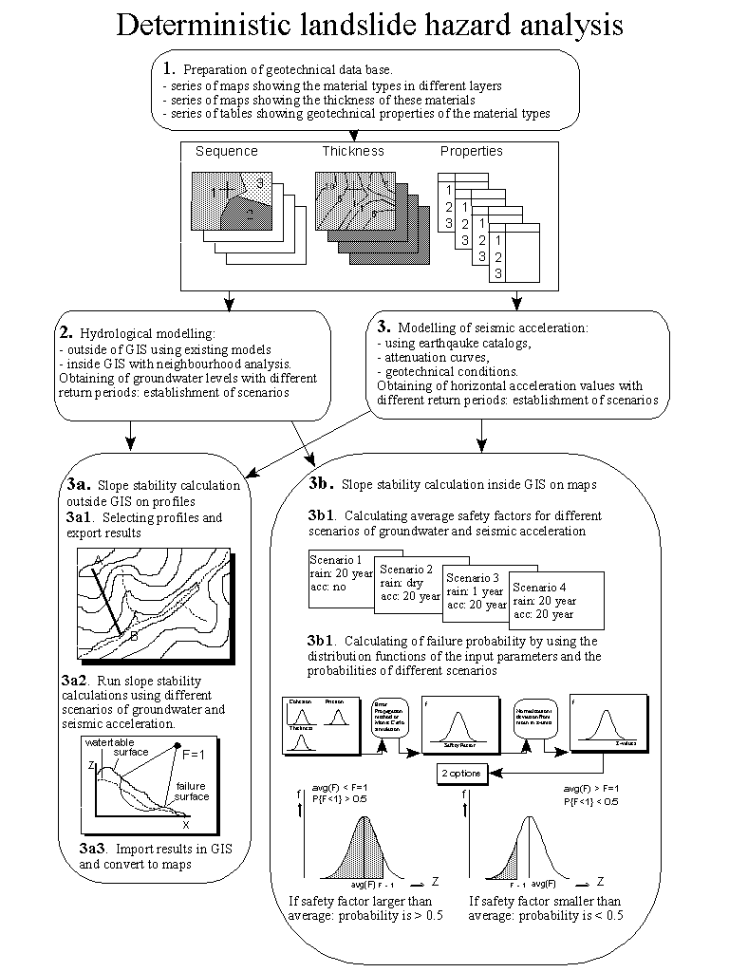
Figure 6.1: Flowchart for deterministic landslide hazard analysis

1.2 Visualization of the input data
In this exercise the slope stability analysis is made by using only two parameter maps: Asht (thickness of volcanic ashes) and Slope (slope angles in degrees).

- Double-click the map Asht. Click OK in the Display Options dialog box. The map is displayed.
- Move through the map and press the left mouse button to see the information. As you can see the area outside of the study area reveals a ? when you press the left mouse button. These pixels are called undefined. This means that no information is stored for them.
- Also display the map slope. This map contains slope angles in degrees.

Practically the entire study area of Manizales is covered by a mantle of volcanic ashes. In this exercise you will calculate the stability of the volcanic ash cover. This means that the depth of the possible failure plane is taken at the contact of the volcanic ashes and the underlying material. The consequence of that is that safety factors will not be calculated for the entire area, but only for the areas where there is volcanic ash at the surface.
Besides of the thickness of the ashes, which is the depth of the failure surface, and the slope of the terrain, we also need to know the other parameters of formula 6.1. From laboratory analysis the following average values are known:

c' = effective cohesion (Pa= N/m²) = 10000 Pa
γ_{w} = unit weight of water (N/m³) = 10000 N/m³
z = depth of failure surface below the surface (m) = map ASHT
β = slope surface inclination (°) = map slope
φ’ = effective angle of shearing resistance (°) = 30 °
tan(φ') = tangent of the effective angle of shearing resistance = 0.58

The only unknown parameter yet is the depth of the water table. In formula 6.1 this is expressed as the value m, which is the relation between the depth of the watertable and the depth of the failure surface.

1.3 Preparation of the data
Before you can start with the analysis, you need to reorganize the map Slope. In the calculation we need three parameters that are derived from the slope:
sin(slope) = the sine of the slope
cos(slope) = the cosine of the slope
cos²(slope) = cos(slope)*cos(slope)

The ILWIS functions for sine and cosine only work with input values in radians, while our map Slope is in degrees. Therefore we need to convert to slope map from degrees to radians first. ILWIS has the function Degrad for that:
Degrad(Slope) degrees to radians function: slope*2/360

- Type the following formula on the command line:
- Slrad:=degrad(Slope)↵
Accept the default minimum, maximum and precision.
- Open the result map and compare the values of the map Slrad with those of the map Slope. Calculate it with the ILWIS pocket line calculator or the Windows calculator for some pixels, using the formula given above.

Now you have the slope in radians, and you can calculate the sine and cosine. You will calculate individual maps for these so that the Safety factor formula (formula 6.1) can be calculated easier.

- Type the following formula on the command line:
- Si:=sin(Slrad)↵
- (with this formula you calculate the sine of the slope).
Accept the default minimum (-1), maximum (+1) and give a precision of 0.001.
- Open the result map and compare the values of the map Si with those of the map Slrad. Calculate it with the pocket line calculator or the Windows calculator for some pixels, using the formula given above.
- Type the following formula on the command line:
- Co:=cos(Slrad)↵
- (with this formula you calculate the cosine of the slope).
Accept the default minimum (-1), maximum (+1) and give a precision of 0.001.
- Open the result map and compare the values of the map Co with those of the map Slrad. Check it for some pixels, using the formula given above.
- Type the following formula on the command line:
- Co2=sq(Co)↵
- (with this formula you calculate the square of the cosine, using the ILWIS function Sq()).
Accept the default minimum, maximum and precision
- Check your results again.

Now all necessary parameters for the formula 6.1 are known, except for the parameter m related to the groundwater depth.

1.4 Creating a function for the infinite slope formula
In the following sections you will use formula 6.1 extensively for different scenarios, and different input data. To avoid that you have to retype the formula each time, it is better to create a user-defined function for it.
Besides many internal pre-programmed functions, ILWIS gives the user an opportunity to create new functions. Especially when you need to execute certain calculations which require a lot of typing work several times, user-defined functions may be time saving. A user-defined function is an expression which may contain any combination of operators, functions, maps and table columns.

- Double-click New Function in the operations list. The Create function dialog box is opened.
- Type for the Function Name: Fs
Type for the expression:
(Cohesion+(Gamma-M*Gammaw)*Z*Co2*Tanphi)/
(Gamma*Z*Si*Co)
Type the Description: Safety factor.
- Click OK. The Edit Function dialog box is opened. Click OK.

In this dialog box you can edit the expression of the function. Now the expression is:

Function fs(Value Cohesion,Value Gamma,Value M,Value gammaw,Value Z,Value Co2,Value Tanphi,Value Si,Value Co) : Value
Begin
Return (Cohesion +(Gamma-M*Gammaw)*Z*Co2*Tanphi) /(Gamma*Z*Si*Co)
End;

As you can see the function contains the following variables (listed in the first line):
- Value Cohesion: the value for the effective cohesion.
- Value gamma: the value for the unit weight of soil.
- Value m: the value for the relation z_{w}/w.
- Value gammaw: the value for the unit weight of water.
- Value z: the value for the depth of failure surface below the surface.
- Value co2: the value for the square of the cosine of the slope.
- Value tanphi: the value for the tangent of the effective angle of shearing resistance.
- Value si: the value for the sine of the slope.
- Value co: the value for the cosine of the slope.

However, a number of these variables are fixed. You will use them for all calculations: The fixed variables are: Value Cohesion (10000 Pa), Value Gammaw (10000 N/m³ ), Value Z (raster map Asht), Value Co2 (raster map Co2), Value Tanphi (0.58), Value Si (raster map Si), and Value Co (raster map Co).
So you can simplify the function considerably, so that it looks like:

Function fs(Value Gamma,Value M) : Value
Begin
Return(10000+((Gamma-m*10000)*Asht*Co2*0.58))
/(Gamma*Asht*Si*Co)
End;

As you can see there are only two variables: Value Gamma and Value M.

- Edit the Function until it is the same as above. Click OK.

1.5 Calculating Safety Factors for groundwater scenarios
Now that the function is created, you can start to calculate safety factor maps for different scenarios. In the first part you will calculate the safety factors for different scenarios where only rainfall is the triggering factor. You will not yet look to the influence of an earthquake.
Dry condition

You will first calculate the safety factor for the volcanic ashes under the assumption that the soil is completely dry. In that case the parameter m is equal to zero.
Remember the other parameter that were given on the previous page:
c' = Effective cohesion (Pa= N/m²) = 10000 Pa
γ = Unit weight of soil (N/m³) = 11000 N/m³
γ_{w} = Unit weight of water (N/m³) = 10000 N/m³
z = Depth of failure surface below the surface (m) = map Asht
m = Relation z_{w}/z (dimensionless) = 0
β = Slope surface inclination (°) = map Slope
φ’ = Effective angle of shearing resistance (°) = 30 °
tan(φ') = Tangent of the effective angle of shearing resistance = 0.58
sin(β) = Sine of slope angle = map Si
cos (β) = Cosine of slope angle = map Co
cos²(β) = Square of the cosine of slope angle = map Co2

Now you can start with the actual calculation of the average safety factor map representing the situation under dry conditions. The two variables for the function fs are 11000 (Value Gamma) and 0 (Value M).

- Type the following formula on the command line:
- Fdry:=fs(11000,0)↵
- Use a minimum of 0, a maximum of 100, and a precision of 0.1. Use the georeference Manizal.
- Open the result map and compare the values of the map Fdry with those of the input maps. Calculate the safety factor manually for some pixels with the Pocket line calculator or the Windows calculator, using formula 6.1.

As you can image a situation with a completely dry situation does not occur in a tropical region such as Manizales, which receives quite a lot of rainfall each year. In any case the map Fdry gives the most stable situation. Let us see how much percent of the area is unstable under these conditions. In order to know that we will first classify the map Fdry into three classes:
Unstable = safety factor lower than 1
Critical = safety factor between 1 and 1.5
Stable = safety factor above 1.5

- Create a new domain Stabil (type class, group) with the following three classes:
Boundary Name
1 Unstable
1.5 Critical
100 Stable
- Use the Slicing operation to classify the map Fdry with the domain Stabil into the map Fdryc.
- Calculate a histogram of the map Fdryc and write down the percentages of the three classes in a table on a sheet of paper with the column name Dry. Later we will calculate the values for other situations.

The percentage of the pixels classified as unstable gives you an indication of the error, since the occurrence of unstable pixels under fully dry conditions is not possible.
Completely saturated condition
The next scenario that you will evaluate is a condition in which the slopes are completely saturated. This is also not a very realistic situation, but it will give us the most pessimistic estimation of slope stability, with only one triggering factor involved (rainfall leading to high watertables).
When we have a saturated soil, the m factor from formula 6.1 is equal to 1. This means that the watertable is at the surface. There is also another factor which is different for saturated conditions γ:
c' = Effective cohesion (Pa= N/m²) = 10000 Pa
γ = Unit weight of soil (N/m³) = 16000 N/m³
γ_{w} = Unit weight of water (N/m³) = 10000 N/m³
z = Depth of failure surface below the surface (m) = map Asht
m = Relation z_{w}/z (dimensionless) = 1
β = Slope surface inclination (°) = map Slope
φ’ = Effective angle of shearing resistance (°) = 30 °
tan(φ') = Tangent of the effective angle of shearing resistance = 0.58
sin(β) = Sine of slope angle = map Si
cos (β) = Cosine of slope angle = map Co
cos²(β) = Square of the cosine of slope angle = map Co2

The two variables for the function fs are 16000 (value gamma) and 1 (value m).

- Type the following formula on the command line:
- Fsat:=fs(16000,1)↵
- Use a minimum of 0, a maximum of 100, and a precision of 0.1. Use the georeference Manizal.
- Open the result map and compare the values of the map Fsat with the maps Fdry and the input map. Calculate the safety factor manually for some pixels with the ILWIS pocket line calculator or the Windows calculator for some pixels, using the formula given above.
- Use the Slicing operation (under image procession) to classify the map Fsat with the domain Stabil into the map Fsatc.
- Calculate a histogram of the map Fsatc and write down the percentages of the three classes in a table on a sheet of paper with the column name Sat. Compare them with the column Dry. Later we will calculate the values for other situations.
Other groundwater scenarios
Using these formulae and the input files created in the previous exercises, a number of scenarios can be calculated. We have chosen some scenarios, based on the following combinations:
- Groundwater peaks occurring during 2 months a year: (return period: 0.164 year)
m = map M016, γ= 14000
- Groundwater peaks occurring once a year (return period: 1 year)
m = map M1, γ = 14000
- Groundwater peaks occurring once every 20 years (return period: 20 years)
m = map M20, γ = 14000
- Groundwater peaks occurring once every 50 years (return period: 50 years)
m = map M50, γ = 14000

The maps M016, M1, M20 and M50 were calculated with a hydrological model. The explanation on how they were calculated is beyond the scope of this exercise.

- Display the maps M016, M1, M20 and M50.
- Compare the values of these maps in the pixel information window.
- To calculate the safety factor map for the first scenario, type the following formula on the command line:
- Fm016:=fs(14000,m016)↵
- with this formula you calculate the safety factor for a situation where there is a groundwater peak that occurs once every two months. For m we now use a map: M016, since the m values are different for different terrain conditions. Compare the formula with formula 6.1 given in the text. Use a minimum of 0, a maximum of 100, and a precision of 0.1. Use the georeference Manizal.
- Use the Slicing operation to classify the map Fm016 with the domain Stabil into the map Fm016c.
- Calculate a histogram of the map Fm016 and write down the percentages of the three classes in a table on a sheet of paper with the column name 2 months/year. Compare them with the columns Dry and Sat.
- Then calculate safety factor maps for the other three conditions:
- Fm1 for the condition of a groundwater table occurring once a year, and using the map M1.
- Fm20 for the condition of a groundwater table occurring once every 20 years, and using the map M20.
- Fm50 for the condition of a groundwater table occurring once a year, and using the map M50.
- Classify all maps using the domain Stabil and calculate the percentages of the three classes (unstable, critical, stable). Write these values in your table, and compare them.

Now that we have calculated all scenarios, we can compare them. This can be done in a table.

- Create a table from the domain Stabil.
- Go to Columns, Join and select Table histogram of Fdryc; use the column Npixpct. The output column is Dry. Accept the default values.
- Also join the histogram files of the maps Fm016c, Fm1c, Fm20c, Fm50c and Fsatc. Give them the names M016, M1, M20, M50 and Sat.
- Select Options, Show Graph and display each of these columns as y against the Stabil value as bar graphs in different colors.
- Draw conclusions on the effect of the groundwater on the stability of the volcanic ashes in the area.

References
Soeters, R. and Van Westen, C.J. (1996). Slope Instability Recognition, Analysis and Zonation. In: Turner, A.K. and Schuster, R.L. (eds), Landslides, investigation and mitigation. Transportation Research Board, National Research Council, Special Report 247, National Academy Press, Washington D.C., U.S.A., p 129-177.
Van Westen, C.J., Van Duren, I, Kruse, H.M.G., and Terlien, M.T.J. (1993). GISSIZ: training package for Geographic Information Systems in Slope Instability Zonation. ITC-Publication Number 15, ITC, Enschede, The Netherlands. Volume 1: Theory, 245 pp. Volume 2: Exercises, 359 pp. 10 diskettes.

