ROCK BLOCK SLIDE

F. Luino – CNR-IRPI Torino

The Langhe Hills cover an area of about 2300 km² in southeast Piedmont, northern Italy. They are bordered by the Tanaro River to the North and West, by the Orba River to the East and by the Apennines to the South (Figure 1).
During the most severe hydrological events these hills are affected by rock block slides because of their geomorphologic setting. The Langhe Hills are characterized by an asymmetric slope profile due to the isoclinal bedding of marly-silty and arenaceous-sandy alternances: these landslides occurred on the gentler hillsides.
These landslides involve Tertiary flyschoid complexes represented by rhythmical series of marly-silty and sandy-arenaceous lithotypes (Figure 2). Sliding surface corresponds with a thin marly-clayey level, where infiltration water concentrates, penetrating deeply along systems of discontinuities. Mineralogical analysis has put in evidence the presence of smectitic clays with percentage of about 30%, but laboratory swelling test results, also performed on samples of the sliding surface, have demonstrated a scarce bent to swell.
More than 2000 rock block slides have been surveyed in the Langhe Hills. They can be considered the most characteristic process in this area in terms of volumes involved and patterns of development. Several of these movements occurred during the events of May 1926, February-March 1972, February 1974, November 1994. In many cases these landslides provoked severe damage or the complete destruction of buildings and roads (Figures 3 and 4), with rare consequences for people.
Most of the observed landslides turned out to be reactivations of similar phenomena already identified in the past. The geometry of the unstable masses is determined by pre-existing discontinuities from ancient slide scarps and opened fractures.
Some authors (Govi & Sorzana, 1982) have recognized three different phases in the development of these landslides. The first can be distinguished from a sudden opening of cracks in the ground surface, in particular in the upper part of the slope; at the same time in the middle and lower part some swellings are surveyed.
The second evolutive stage is characterized by a quiescence period, which can last several years: a great increase of the system fracture density, with vertical displacements and morphological steps are clearly surveyed (Figure 5). These cracks are often hidden by the readjustments by human intervention.
In the third phase, without particular premonitions, the collapse of a slope portion occurs, with sliding of huge disjointed rock blocks.
Rock block slides involve the bedrock (Figure 6 and 7) from depths measuring anywhere from a few to 30 metres, which, for the time being, is the maximum known value.
The landslide area extends from a few tens of m² to several thousands, so it involves very different volumes estimated to range from a few hundreds up to about one million m³. On February 18, 1974, a rock block slide involved a volume of about 10 million cubic metres near the village of Somano (Figure 8).
During the event of November 5-6, 1994, up to 10 rock block slides occurred in one square km in the Ceva territory (Luino, 1999). According to local residents, some slides lasted only a few minutes while others continued for hours. During the peak phase, movements reached speeds varying from a few decimetres up to some hundreds of metres per hour. The movement of rock blocks, calculated between main scarp and the lower edge of displaced mass, can reach a distance greater than 100 m (Forlati & Campus, 1998)(Figure 9).
At the end of the observed movement the sliding surfaces appear smooth like an inclined plane, sometimes showing the shallow tracks left by the sliding rock block (Figures 10 and 11). Rock block slides develop along bedding planes on slopes with gradients of 8°-18°. Sliding surface is usually parallel to slope dip.
Rock block slides occurred during or after intense and continued rainfalls that influence their evolution. They trigger in the autumnal period because of severe meteorological event or during the spring together with rainfalls and the snow melt.
A group of researchers (Govi et al., 1985) at the CNR-IRPI of Turin has studied possible correlations between rainfall heights and mass movements. From data collected over the last 30 years two different values have been identified (Figure 12).

References

Forlati F & Campus S. (1998) – Scivolamenti planari nelle Langhe piemontesi: individuazione, elaborazione ed analisi di alcuni elementi significativi. Proceedings of the Conference: “La prevenzione delle catastrofi idrogeologiche: il contributo della ricerca scientifica”, edited by F. Luino. Alba (Cn-Italy), 5-7 November 1996. Vol. I, p.173-183.
Govi M. & Sorzana P.F. (1982) - Frane di scivolamento nelle Langhe cuneesi: Febbraio-Marzo 1972, Febbraio 1974. Boll. Ass. Min. Sub., Torino, XIX, 1-2, p. 231-264.
Govi M., Mortara G. & Sorzana P.F. (1985) - Eventi idrologici e frane. Geol. Appl. e Idrog., Bari, 20, II, p. 359-375.
Luino F. (1999) – The Flood and Landslide Event of November 4-6 1994 in Piedmont Region (Northwestern Italy): Causes and Related Effects in Tanaro Valley. “XXII General Assembly of European Geophysical Society”. Vienna (Austria). 21-25 April 1997. Ed. Elsevier Science Ltd, Vol. 24, N. 2, p. 123-129.

FIGURES

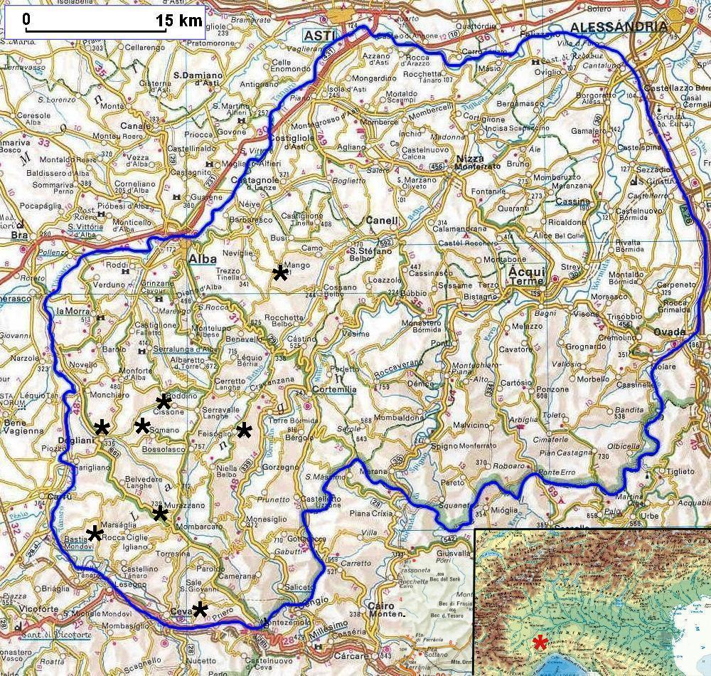
Figure 1 – Langhe Hills, a large area in southeast Piedmont (northern Italy). All place-names mentioned in the text and in the captions are marked with a black asterisk.

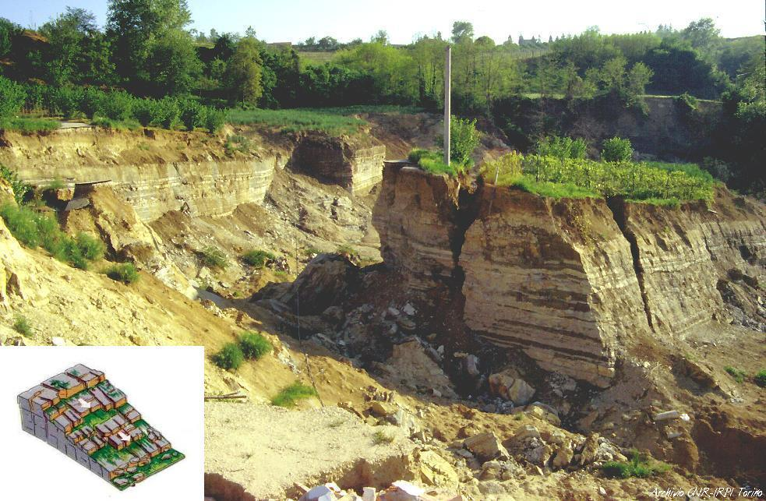

Figure 2 – Example of a rock block slide near Mango, occurred on November 5, 1994.

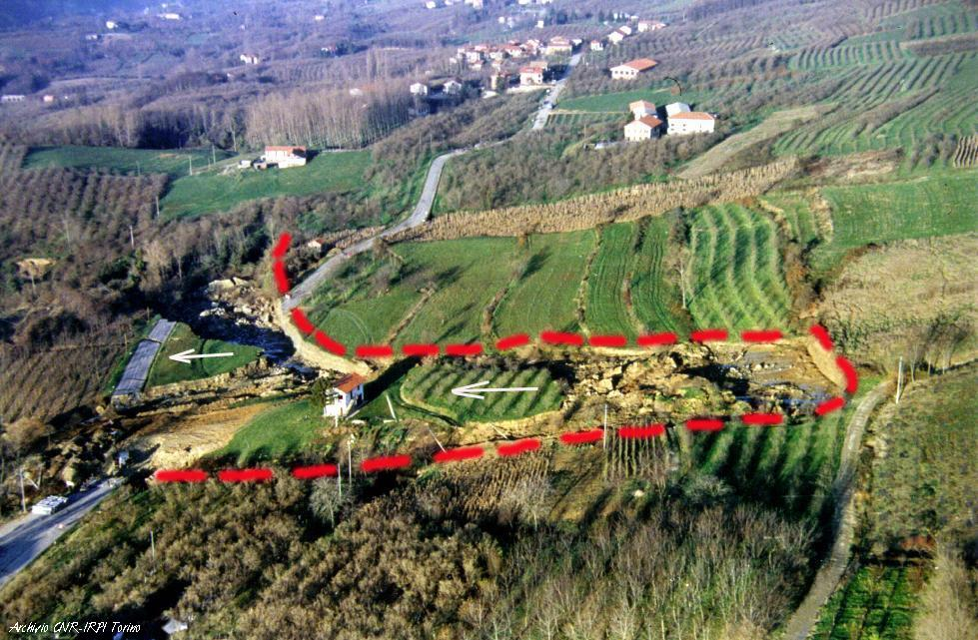

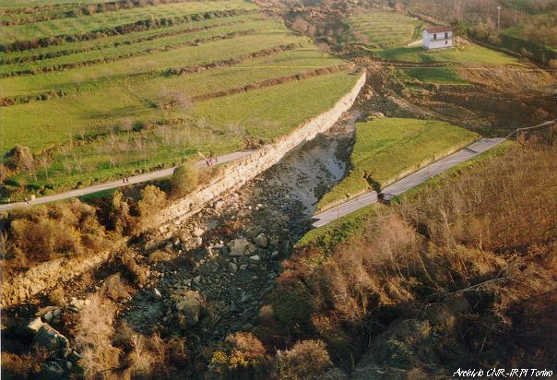
Figures 3 and 4 – Large rock blocks slid about 60 m from their original position, destroying a road near Feisoglio. Evident are the layer surfaces in the upper and lower part of the involved area. The little house moved together with the rock block without damage.

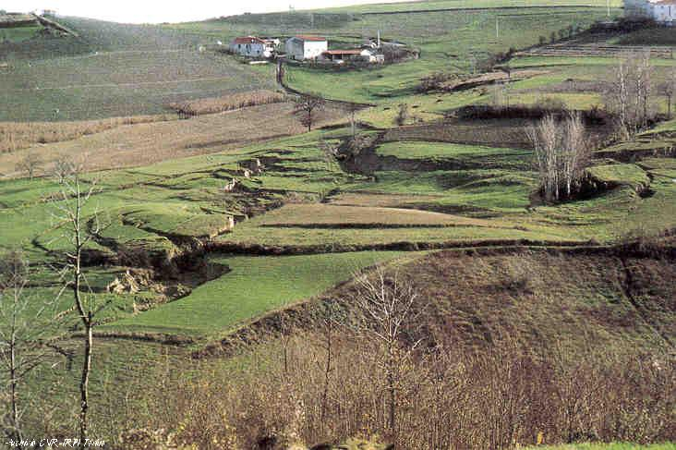
Figure 5 – Second phase of a typical rock block slide near Rocca Cigliè: the hill is characterized by deep fractures longitudinal and transversal to the slope. This condition is surveyed for many years, if there are not heavy readjustments by human intervention.

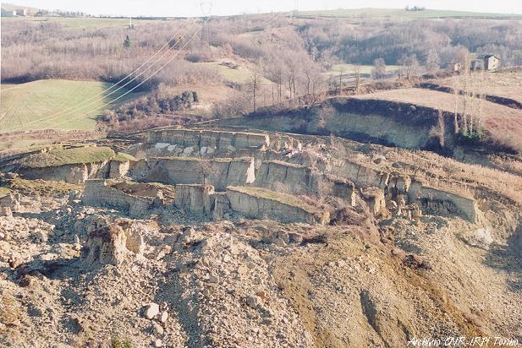
Figure 6 – Murazzano (C.na Fascinea). This large rock block slide, with a volume of about 500,000 m³, triggered during the meteorological event of the November 1994. The blocks, ten metres thick, involved a gentle hillside: they slid along the stratigraphic surface preserving often the characteristic of the bedrock.

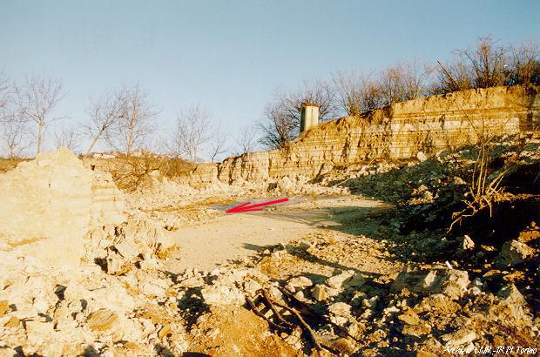

Figure 7 – Rock block slide near Cissone (Frazione Pianezza). The displaced mass moved about 60 m from its original position; the sliding surface (10°-11°) correspond to layer joints forming the interface contact between sandy-arenaceous and marly-silty levels.

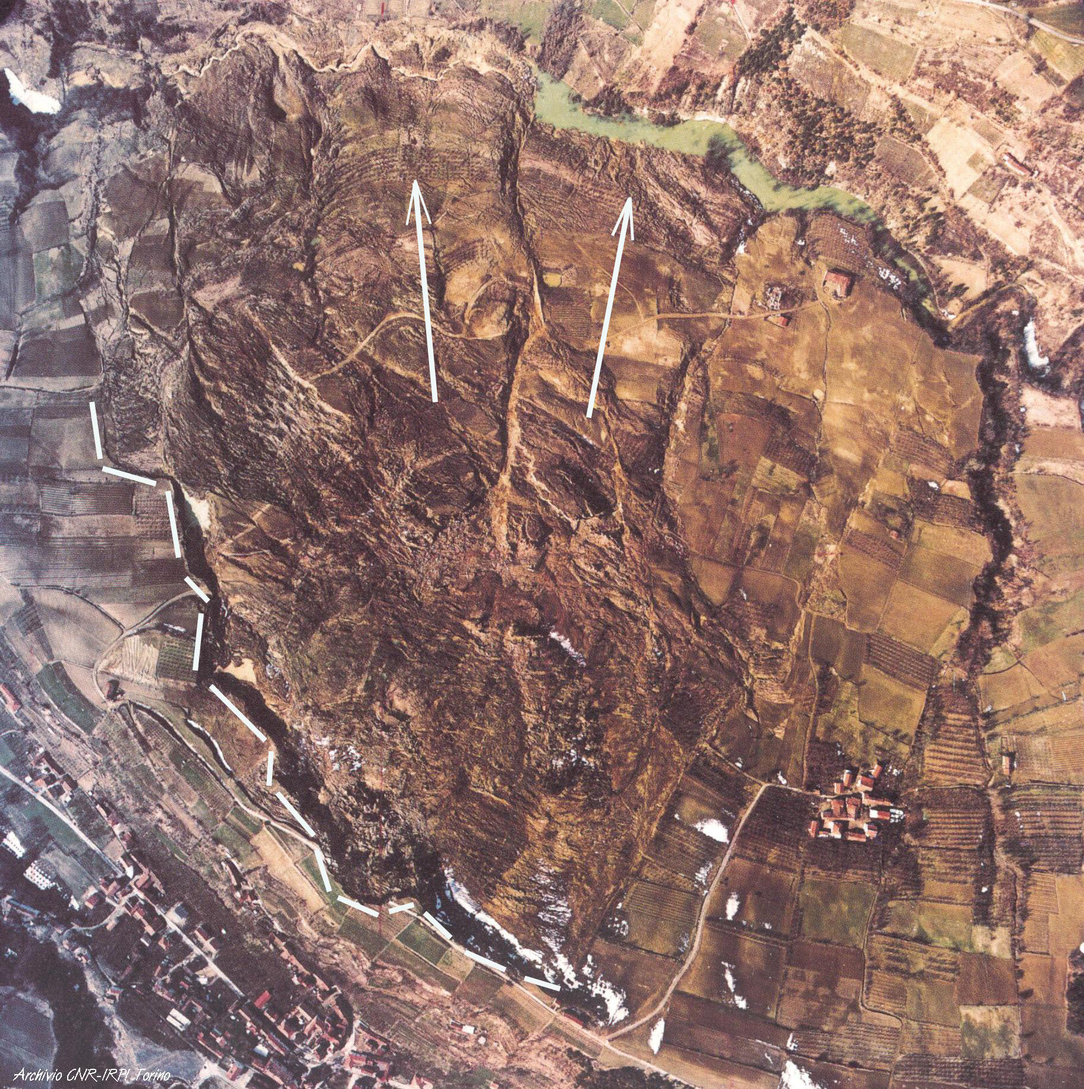

Figure 8 – Aerial photograph of the most famous rock block slide occurred in the Langhe Hills on February 1974. The displaced mass dammed the valley bottom of the Gamba Stream producing a temporary lake. The white dashed line borders the main scarp.

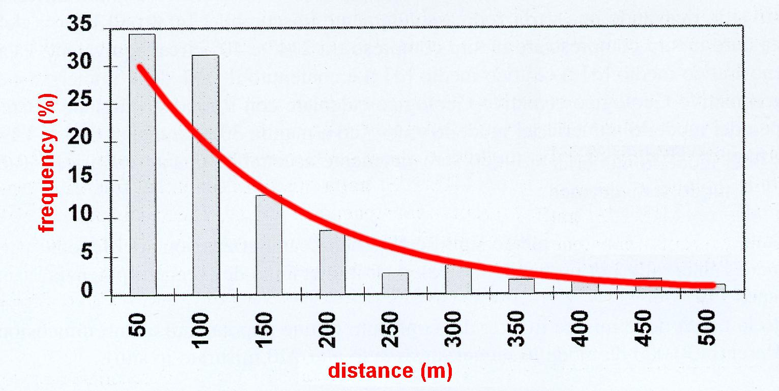

Figure 9 – Distance between main scarp and lower edge of displaced mass. More than 65% of the distances are less than 100 m. Results obtained from an analysis on 108 rock block slides occurred in the Langhe Hills in the last 25 years (from Forlati & Campus, 1998, modified).

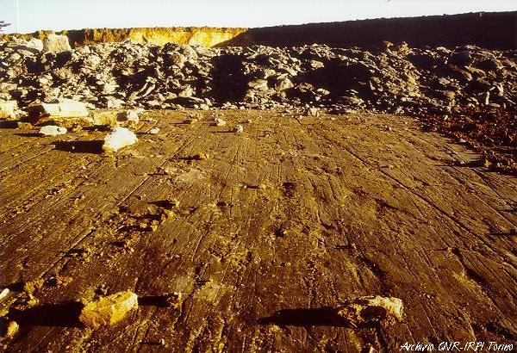

Figure 10 – Sliding surface of the Murazzano landslide: the shallow tracks left by the sliding rock blocks are clearly surveyed.

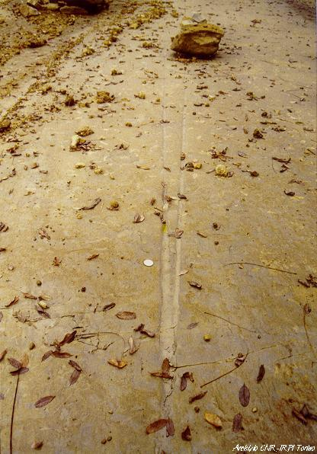
Figure 11 – Riavolo Stream Valley, near Dogliani: two forked stripes 3-m long left by the blocks movement are recognizable.

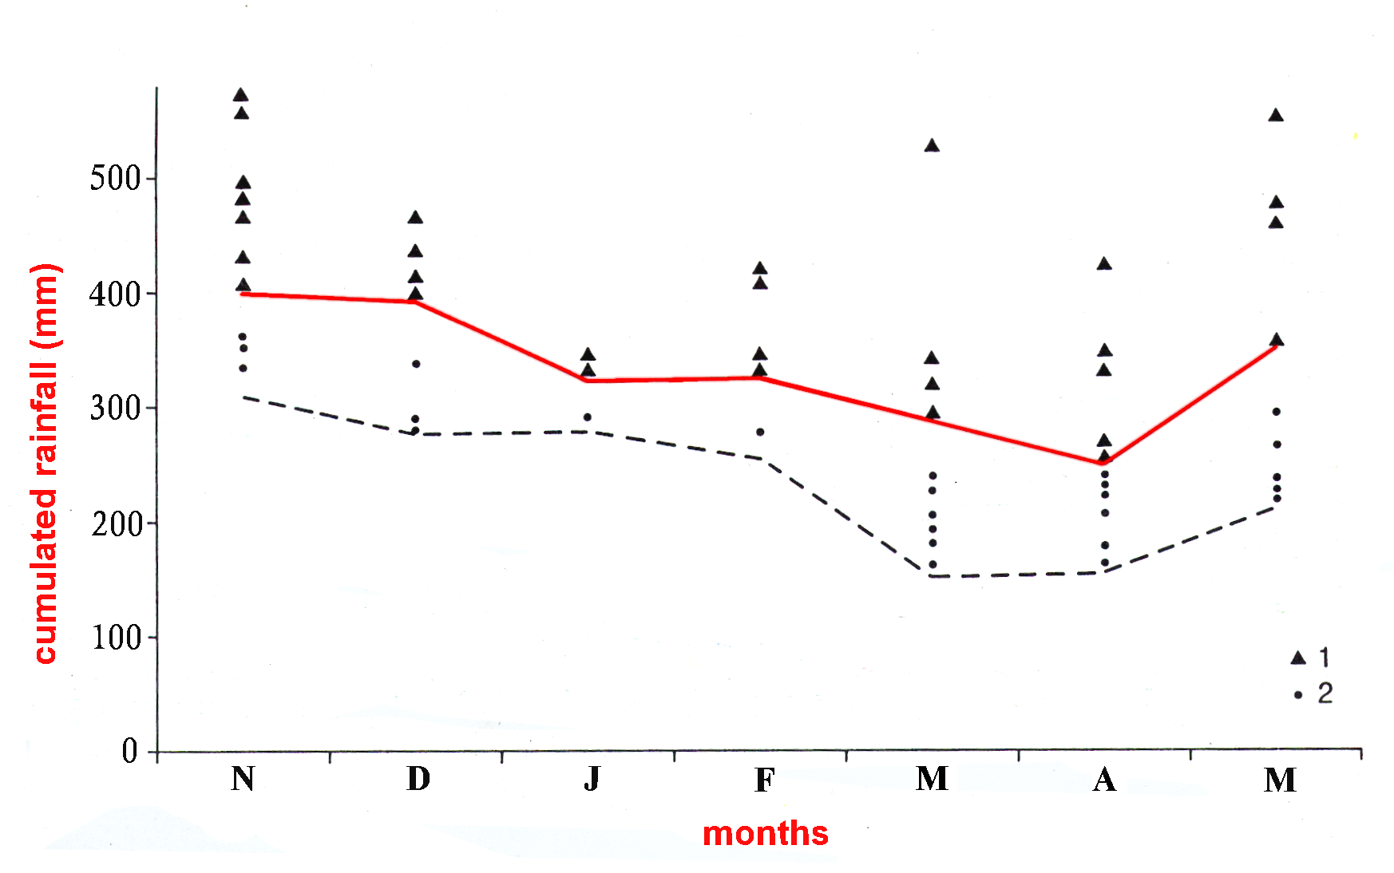
Figure 12 – Diagram showing precipitation amounts triggering planar rock slides in the Langhe Hills. The dashed line defines the area of minimum values of rainfall for the 60 days before the collapse. The red line corresponds to the threshold totals values (previous rainfall + event rainfall) which cause landslides (1 - cumulated rains triggering landslides; 2 – cumulated rains that did not trigger landslides)(from Govi et al., 1985, modified).

