Management summary

To be completed.

Hi Norman

I have finalized the initial draft the the FC2015 report for this year. I tried to set it up in such a way that it should be clear to you what is still needed, a test of the classification accuracy using OOA, based on true color data, false color data, and ALS-derived maps.

All of the data, you can find on [ftp.itc.nl\straatsma](ftp://ftp.itc.nl\straatsma), I still have access to that server. It contains 5 folders that are self explanatory, but I will list a few peculiarities:

*AerialImages* contains the .sid files of the tiffs that Sarkar used to work with. If you need the original scanned aerial images (not georeferenced) that were taken with 60% overlap, I can provide them to you, but they are around 1 GB each.

*2007ALSdata* contains the derived maps as described in the report, but also DWall.laz, the raw point cloud that you could possibly import in Definiens directly. It is a zipped .las file (.laz extension) If needed you can convert using the las2las executable from lastools (<http://www.cs.unc.edu/~isenburg/lastools/>), which will increase the size around 5-7 times.

*FieldData* The available field data is quite limited, perhaps additional visual validation might be required

*Report* shows the latest version of the report, the template and the progress report that I filled in last April. Updates will be required later on in the year in September and November. Albrecht Weerts (Deltares) coordinates the progress report. I will introduce you two in a separate email.

I suggest that you read the report to see if you understand where the derived maps come from, and have a look at the data. After that we can have a skype call to discuss any further issues. Please let me know if you have downloaded the data.

Regards

Menno

Table of contents

Management summary 3

About 3

Table of contents 4

1 introduction 5

1.1 Problem description and objectives 5

2 Study areas 7

2.1 Brabantse delta 7

2.2 Duursche Waarden en Fortmond 8

3 Methods 9

3.1 Field measurements 9

3.2 Airborne remote sensing data 9

3.3 Plot level analyses 10

3.4 Application in fluvial environment 12

3.5 Classification accuracy 13

4 Results 14

4.1 Fli-MAP400 prediction of height and density of low vegetation 14

4.2 Application of plot level analyses to the Duursche Waarden floodplain 17

4.3 Segmentation 19

4.4 OO classification 19

5 Discussion and conclusions 20

Appendix 1 : ALS analyses 21

List of figures

Figure 1 Location of the study areas ‘Brabantse Delta,’ and ‘Duursche Waarden’ 8

Figure 2 Location of the field plots, sized 15 by 15 m, in the red dots 9

[Figure 3 Location of the field plots in the ‘Duursche Waarden’ floodplain section   
in purple dots. 9](#_Toc330483170)

[Figure 4 Classified ALS point cloud with terrain points in brown and vegetation   
points in green. Plot size if 15 m, vertical range is 50 cm 15](#_Toc330483171)

Figure 5 Residual analysis of 2007 vegetation height data 17

Figure 6 Residual analysis of 2009 vegetation height data 17

Figure 7 ALS-derived products 19

List of tables

Table 1 Fli-MAP 400 ALS scanner characteristics   
(http://www.fugro.ca/services/asm/lidar01.htm) 9

[Table 2 Correlation coefficients for Hv, field derived vegetation height, and   
ALS-derived statistics, percentiles (p..), standard deviation (std), and average   
scan angle over the plot area. Area above the diagonal represents the 2009   
campaign, the area below the diagonal represents the 2007 campaign. 14](#_Toc330483197)

[Table 3 Correlation coefficients for vegetation density of low vegetation (Dv),   
and ALS-derived statistics (PI, and VAI). Area above the diagonal represents   
the 2009 campaign, the area below the diagonal represents the 2007 campaign. 15](#_Toc330483198)

Table 4 Regresssion output for vegetation height (Hv in m) 15

# introduction

Every five years the flood hazard needs to be determined in The Netherlands according to the law on flood defense. Uncertainty in friction parameterization has been quantified by Straatsma and Huthoff (2011a) for floodplain friction and Warmink et al. (submitted) for the combined effect of floodplains and the main channel. Straatsma and Huthoff (2011a) showed that, regarding floodplain roughness, the land cover classification accuracy contributes most to uncertainty in predicted flood water levels. They showed that a 69% classification accuracy of the floodplain landcover leads to a 27 cm uncertainty (68% confidence interval) in water levels for the Rhine branches in The Netherlands. Other error sources related to the floodplain roughness parameterization appeared to be less relevant. (Straatsma and Huthoff, 2010) showed the inverse relationship between classification accuracy and model uncertainty. At a 95% classification accuracy, the 68% confidence interval reduces to 13 cm uncertainty in water levels. Warmink et al. (submitted) showed that the 95% confidence interval for the combined effect of uncertainty in friction parameterization of channels and floodplain together was 70 cm for the river Waal. These uncertainty values represent the uncertainty at the design discharge without taking into account the uncertainty-reducing effect of model calibration.

The current roughness map for the Rhine Branches in The Netherlands is based on the ecotope map (Jansen and Backx, 1998; Houkes, 2007) using manual segmentation and classification of the land cover. The classification accuracy of terrestrial ecotopes of this map has been evaluated by Knotters et al. (2008). They found an overall classification accuracy of 69% for eight broad ecotope groups. Other classification studies on floodplain vegetation report accuracies between 70 and 90% (Van der Sande et al., 2003; Geerling et al., 2007; Straatsma and Baptist, 2008). Geerling et al. (2007), and Straatsma et al. (2008) found that Airborne Laser Scanning (ALS) improves the classification accuracy when combined with spectral remote sensing data. However, Straatsma and Middelkoop (2007) also showed that vegetation height prediction of low vegetation using ALS needs to be calibrated with field data.

## Problem description and objectives

Between 2008 and 2013 a new nation-wide ALS dataset is being collected (AHN2) with an average point density of 10 points m-2. The data is collected using the FliMAP400 ALS system operated by Fugro-Inpark. While it would be cost-effective to use this data for floodplain roughness parameterization as well, it is unclear how this data can be used for increasing the estimates of the vegetation height of low vegetation. It is also not known which parameters should be extracted from the ALS data in classification of floodplain land cover. In addition, it is not known what improvements in classification accuracy may be reached with automatic object-oriented classification methods, compared to the current manual method.

Therefore the objectives of this study are to:

* Assess the ability of FliMAP400 airborne laser scanning data to predict vegetation structure of herbaceaus vegetation and meadows.
  + Establish regression equations for ALS-derived statistics to predict vegetation structure
  + Create vegetation structure maps for low vegetation and forest of the Duursche Waarden floodplain section.
* Determine the classification error of object oriented classification methods using true color, false color airborne imagery and ALS-derived vegetation maps.

This is a follow up study of the FC2015 projects reported by Straatsma and Alkema (2009), Straatsma and Huthoff (2010), and Straatsma and Huthoff (2011b). This research was carried out within the Flood Control 2015 program. For more information please visit <http://www.floodcontrol2015.com>.

# Study areas

In this study, we used data of two study areas: The area of the water board ‘Brabantse Delta’ in the Southwest of The Netherlands (BD), and the ‘Duursche Waarden’ 10 km to the south of the town of Zwolle (DW) (Figure 1).

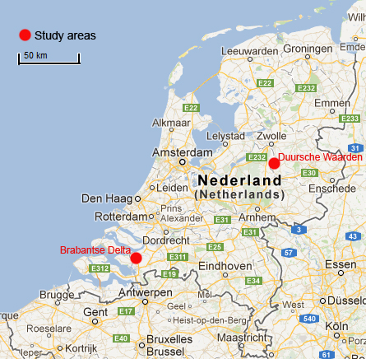

Figure 1 Location of the study areas ‘Brabantse Delta,’ and ‘Duursche Waarden’

## Brabantse delta

The Brabantse Delta is located in the Southwest of The Netherlands. This location was choosen as it contains a large difference in vegetation structural data and it is the only area where field data of vegetation structure is available for the AHN2 campaign. The field data were collected in February 2009, simultaneously with the ALS campaign using the Fugro Fli-MAP400 airborne laser scanning system. The ALS data had an average point density of 10 points m-2 as part of the AHN2, the up to date height model of The Netherlands. Between 2008 and 2013 the whole dutch territory will be flown with the same system, hence the results of this area will be applicable country-wide. The BD area is not part of the fluvial area.

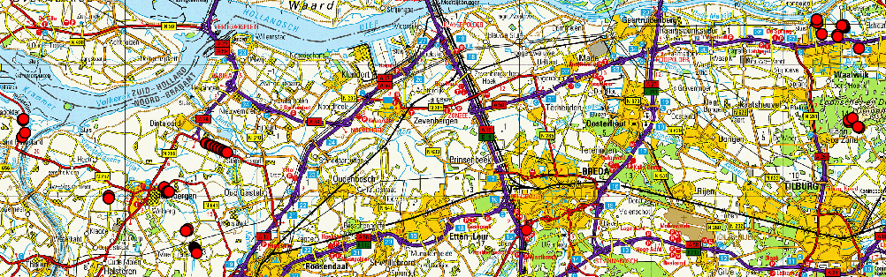

Figure 2 Location of the field plots, sized 15 by 15 m, in the red dots

## Duursche Waarden en Fortmond

The ‘Duursche Waarden’ floodplain (DW) section along the right bank of the River IJssel is part of the fluvial area of The Netherlands. In this floodplain section, landscaping measures have been carried out to reduce flood levels and to restore the ecology. For these floodplains, high-density laser data were acquired by the Dutch Ministry of Transport, Public Works and Water Management as a monitoring pilot in March 2007. False color airborne photographs were taken in summer 2005. Vegetation presently consists of hardwood and softwood forest and shrubs, but is dominated by herbaceous vegetation. Vegetation is characterized by a heterogeneous pattern of vegetation types and structure. Herbaceous vegetation consists mostly of sedge [*Carex hirta L*.], sorrel [*Rumex obtusifolius L.*], nettle [*Urtica dioica L*.], thistle [*Cirsium arvense L*.] and clover [*Trifolium repens L.*].

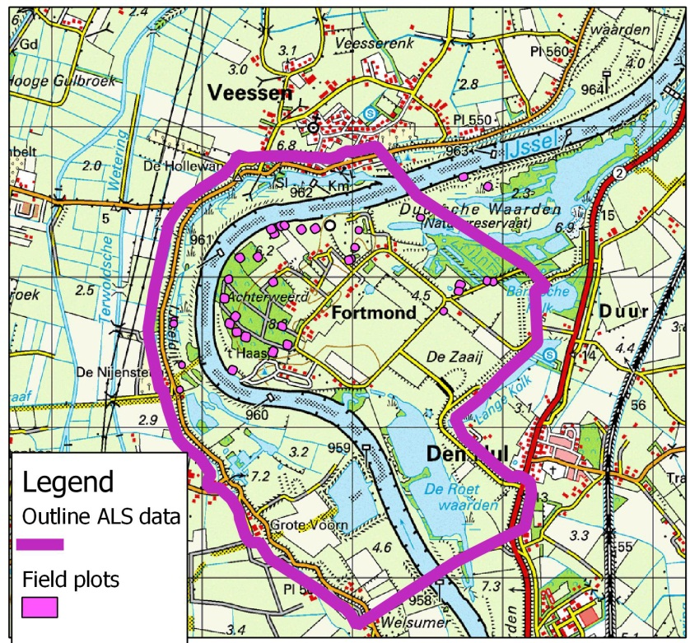

Figure 3 Location of the field plots in the ‘Duursche Waarden’ floodplain section in purple dots.

# Methods

To establish the relation between ALS derived statistics and vegetation, we collected field data simultaneously with the ALS campaign. Here, we describe the field data, and airborne data, then the ALS data processing and object oriented classifications are explained.

## Field measurements

We measured vegetation height and density in 13 plots in the DW floodplain in March 2007, and in 32 field plots of homogeneous vegetation in BD in February 2009. The plots represented a large range of herbaceous vegetation types. Plot size was at least 200 m2, to ensure a sufficient number of laser points available for subsequent analysis. The plots were geo-located using a differential GPS resulting in a decimeter horizontal accuracy. Vegetation height was measured in two steps: (1) We estimated the average vegetation height as an imaginary plane through the average top of the vegetation and (2) we measured the length of 30 randomly selected stalks reaching at least to half the height of step 1. Mean and standard deviation of the 30 measured heights were registered. Vegetation density was determined from the product of the number of stalks per unit area and the average stalk diameter, which was based on the same 30 stalks using a sliding gauge.

## Airborne remote sensing data

### Airborne laser scanning data

The laser data were acquired by Fugro-Inpark using the FLI-MAP 400 system mounted on a helicopter. FLI-MAP, Fast Laser Imaging and Mapping Airborne Platform, is a scanning laser range finder combined with a dGPS and an Inertial Navigation System for positioning. An overview of the laser scanning technique used is given by Wehr and Lohr (1999). Both data sets were flown at a height of 360 m above the terrain. (table 1).

Table 1 Fli-MAP 400 ALS scanner characteristics (http://www.fugro.ca/services/asm/lidar01.htm)

|  |  |
| --- | --- |
| Two laser range finders ± 7º from nadir looking | ± 30º scan angle  1 cm range accuracy (1sigma)  1.5 cm accuracy for hard surfaces |
| Point density | 8-40 points m-2 |
| Flying height | 100-400 m, 360 in these studies |
| Scan frequency | 150-250 kHz |
| Number of recoded returns | Up to 4 returns per pulse |
| Intensity registration | yes |
| Positioning | 2 Trimble L1/L2 GPS receivers, at 10 Hz  Omnistar RTK dGPS |
| Attitude | Applanix PosAV V5 INS  200 Hz IMU data sampling |

### Airborne spectral data

The Fli-MAP scanner is integrated with a line scan RGB camera. The line-scan camera records RGB values of the surveyed corridor that can subsequently be assigned to the laser data resulting in a true color point cloud. These RGB data were collected in 2007, but not in 2009.

As part of the 5 year roughness parameterization cycle false colour aerial images were taken in summer 2005. The images were taken with a 60 % forward and sideway overlap to enable photogrammetric analyses. The images were taken using a Leica RC20 analogue camera, images were developed and scanned, which resulted in 25 cm resolution orthophoto. The orthophoto was delivered as part of the Ecotope dataset.

## Plot level analyses

### DTM extraction and labeling

For the determination of the vegetation height, the effect of the undulations of the terrain should be eliminated. This can be done by constructing a Digital Terrain Model (DTM) based on points that are expected to represent the ground. This is the common practice, as reported in most literature. Sithole and Vosselman (2004) gave an overview of eight different DTM extraction methods. They concluded that all methods perform well in relatively flat terrain, which is the case for lowland river floodplains.

To establish the regression equations, only the laser points that were located inside the field plots were considered. For each plot, a DTM was constructed using iterative residual analysis based on a simplified version of the method of Kraus and Pfeifer (1998). In each step, a surface was computed as a local second order trend surface in a moving window. The window radius was 1.5 m to ensure enough points are available for a robust fit. A larger window would lead to a loss of detail. The residual distance to this surface was computed for each point. Points with positive residuals are likely to be vegetation points. Since the range of values for an unvegetated, flat surface was computed and proved to be approximately 10 cm, a simple weight function was applied to compute the surface in the next iteration: points with an residual value of more than 5 cm were excluded from further analysis in the DTM processing. With the remaining points a new DTM surface was computed. Iterations were continued until all points had residuals less than 5 cm. The final DTM was a smooth surface running through the middle of these ground points. Heights relative to the DTM were used in subsequent computations.

### Vegetation height prediction

To predict the vegetation height of low vegetation, all points with a height above the DTM of more than 5 cm were assumed to represent the vegetation. For each plot, these vegetation points were characterized by the following statistics related to the vertical distribution of the points: percentiles (P80, P90, P95, P98), and the standard deviation. In addition, the average incidence angle was computed over each of the plots. The time stamp on the scanner positions and the point position facilitated the computation of the incidence angle (*α*) for each point. The incidence angle was computed by:

 (4)

where *dx, dy* and *dz* are the differences in *X, Y* and *Z* coordinates between scanner and point position in the raw data. The average incidence angle was stored as an attribute for each plot.

The statistics and the incidence angle were subsequently checked for correlations before multiple regression was applied. Different additive and multiplicative models were tested to predict vegetation height. Field derived vegetation height of low vegetation was the dependent variable and the statistics, or angle the independent variable. For forested vegetation, no regression was carried out. In these areas with a vegetation height above 2 m, the vegetation height was computed by the difference between the canopy height and the terrain heigt.

### Vegetation density prediction

For vegetation density of low vegetation and forest, two methods were applied, following Straatsma (2008), the percentage index, and the vegetation area index.

*Percentage Index*

Vegetation density was predicted from ALS data by two indices. The percentage index (*PI*) computes the percentage of laser hits that fall within the height range (h1 to h2) that could be inundated by the water:

 (1)

in which *Nh1-h2* is the number of points between height 1 and 2 above the forest floor, *Ntot* is the total number of points in the field plot including canopy and ground surface points. The distance between *h1* and *h2* should not be too small, otherwise too few points would be present within the height interval of interest. Moreover, *h1* was set to 0.5 m to remain well above the noise height of the ground surface points. This method does not take occlusion from the crown area into account. Tree crowns reflect part of the laser pulses, thereby reducing the number of points available for detection of stems or the ground surface. However, the crown density is small (25 percent) under leaf-off conditions.

*Vegetation Area Index*

The Vegetation Area Index (*VAI*) method, introduced by MacArthur and Horn (1969), compensates for occlusion. Later, it was verified by Aber (1979). This method calculates a Leaf Area Index for specific height increments, in a similar way as the extinction of light in a semi-transparent medium. Recently, Lefsky et al. (1999a) successfully modified the MacArthur-Horn method to generate canopy height profiles. Canopy height profiles not only include foliage, but also woody vegetation. The forests considered in the present study were all leafless. The assumption was made that the mechanism of occlusion from trees in leaf-off condition is similarly to occlusion from trees in leaf-on conditions. Laser hits are in this case intercepted by branches instead of leafs. The resulting value is therefore not a *Leaf* Area Index, but a woody *Vegetation* Area Index (*VAI*). Like *PI*, the *VAI* is computed only over the height interval that is inundated by the water using the following equation:

 (2)

in which *Nh1* and *Nh2* are the number of points below heights *h1* and *h2* (*h2* > *h1*), which includes ground points. The first term in the formula is introduced to make the *VAI* independent of the height interval. However four assumptions underlie this method: (1) all laser pulses enter the forest with an equal incidence angle, (2) no clumping is present, which means that the horizontal distribution of vegetation elements is random (Jonckheere et al., 2004), (3) all vegetation elements have an equal angle with a horizontal plain and (4) all elements have an equal probability of detection, which means an equal reflectivity

For low vegetation h1 and h2 were set to 0.05, and 0.20 m, respectively. For forest, the values were 0.15 and 4.0 m, respectively. The choice for low vegetation was based on the height above the terrain that contained vegetation. For forest the range was based on the vertical range that could be inundated by the water during flood stage.

## Application in fluvial environment

To apply the results of the plot level analyses to the DW study area, a number of changes to the data processing were required for computational efficiency. The DW ALS data set contained 125 Mpoints, which limited processing in popular spatial statistics programs as GSTAT, or R. Therefore, we used lastools, in combination with freeware python, gdal, and PCRaster.

In order to make the method scalable to large areas, and to limit memory usage we used a tiling scheme for all the operations. A typical map production would have the following structure:

* Tiling:The study area was divided in 200 m tiles, with an additional 5 m buffer for each tile to limit boundary effects. The computational capacity of any computer can be used to the full by using all cores for the ALS processing.
* ALS data processing per tile in its original format, being .laz files.
* Exporting of tiles to ARC-info ASCII grids. Gridding leads to loss of data, but it is an essential step when combination with spectral data is required.
* Merging of grids and conversion to PCRaster files
* Map algebra for post-processing raster files

The following products were generated from the ALS data (Appendix 1):

* Digital terrain model (DTM),which was generated in two steps using a progressive TIN densification algorithm as implemented in Lastools (<http://www.cs.unc.edu/~isenburg/lastools/>). In the first step a large step size (25 m) was used to eliminate large buildings from the point cloud. In the second iteration a smaller step size (5 m) was used to create a more accurate DTM in the forest.
* Normalized Digital Surface Model (nDSM), which is the difference between the highest laser point per grid cell and the DTM height of that cell. For measows and very low vegetation, the nDSM will be zero, as all the points are labelled as terrain points.
* Forest vegetation density (DvForest), following the method as explained in section 3.3.3 to determine PI. The resolution of this map is 10 m to get a realistic average value of the density. Forest density can not be computed on very high resolution as the density would be either zero (open place in the forest), or 1 (vegetation present). Vegetation density was computed by applying the regression equation as developed by Straatsma {, 2008 #54}:  
  *Dv* = 0.008 * 1.18 * *PI* (3)
* Height of low vegetation (HvLow), based on standard deviation of vegetation points. To cancel out the noise in the terrain height representation the average terrain height is computed for each 1 m pixel. The height above this smoothed terrain is computed as the vegetation height. Low vegetation is defined as the height range between 0 and 2 m, and includes open spaces in the forest. The standard deviation of these low points is computed and written out to a grid. The vegetation height is computed using the results of the 2007 plot level campaign as described in section 4.XXX. The regresion also required the incidence angle, which was computed as the average at a 10 m resolution, which was subsequently resampled to a 1 m resolution similar to the standard deviation value. The lower initial resolution was required as the regression equations were also based on plot level averages:  
  Hv = std + angle + std*angle. (4)
* Buildings and trees were classified in the ALS data using an automatic classification tool. The outlines of buildings and tall trees were written to shapefiles.
* Spectral information from the line scanner that was on the Fli-MAP platform (8 bit RGB values) was originally delivered as attributes of the laser points. For classification purposes, these RGB values were converted to geotiff format.

## Classification accuracy

OOA

Segmentation

Classification methods

Validation data / number of classes

Overall classification accuracy / error matrix

# Results

## Fli-MAP400 prediction of height and density of low vegetation

ALS data of low vegetation (Fig. 4) does represent the differences between ground points and vegetation points. Even low vegetation in winter does give clear signal in the Fli-MAP 400 data.

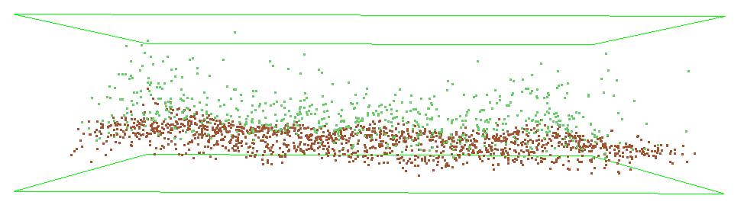

Figure 4 Classified ALS point cloud with terrain points in brown and vegetation points in green. Plot size if 15 m, vertical range is 50 cm

The results of the plot level analyses are shown as a correlation table between field data, and ALS-derived statistics (Table 2), and as regression output. The correlations for the 2007 dataset, the area below the diagonal in Table 2 (first column) are higher than for the 2009 dataset (first row). In both cases the same scanner was used. The reason for the difference is probably the larger variety of vegetation in 2009, when dense heathland vegetation led to outliers and lowered the correlations. Correlation for vegetation density with PI and VAI values were less than 0.6, or less and negative, whereas positive correlations were expected.

Table 2 Correlation coefficients for Hv, field derived vegetation height, and ALS-derived statistics, percentiles (p..), standard deviation (std), and average scan angle over the plot area. Area above the diagonal represents the 2009 campaign, the area below the diagonal represents the 2007 campaign.

|  |  |  |  |  |  |  |  |
| --- | --- | --- | --- | --- | --- | --- | --- |
|  | Hv | p80 | p90 | p95 | p98 | std | angle |
| Hv |  | 0.876 | 0.851 | 0.857 | 0.903 | 0.897 | 0.260 |
| p80 | 0.934 |  | 0.981 | 0.947 | 0.859 | 0.909 | 0.405 |
| p90 | 0.924 | 0.986 |  | 0.986 | 0.893 | 0.945 | 0.427 |
| p95 | 0.913 | 0.970 | 0.997 |  | 0.942 | 0.979 | 0.406 |
| p98 | 0.923 | 0.970 | 0.996 | 1.000 |  | 0.990 | 0.295 |
| std | 0.916 | 0.965 | 0.994 | 0.999 | 0.999 |  | 0.347 |
| angle | 0.082 | 0.223 | 0.255 | 0.257 | 0.244 | 0.254 |  |

Table 3 Correlation coefficients for vegetation density of low vegetation (Dv), and ALS-derived statistics (PI, and VAI). Area above the diagonal represents the 2009 campaign, the area below the diagonal represents the 2007 campaign.

|  |  |  |  |
| --- | --- | --- | --- |
|  | Dv | VAI | PI |
| Dv |  | -0.176 | -0.196 |
| VAI | -0.560 |  | 0.990 |
| PI | -0.605 | 0.996 |  |

The quality of height prediction of low vegetation showed adjusted R-squared values between 0.82 and 0.93 for 2007, and between 0.8, and 0.85 for 2009 (Table 4). We chose ALS-derived standard deviation as independent variable as this is easier to create raster maps of than for percentile values, and the correlations are high. The scan angle had an important effect on the explained variance in the multiple regression when a multiplicative model was chosen. When comparing the coefficients in the regression equation it becomes clear that large differences are present between 2007 and 2009. The slope of the regression line in 2007 was 6.551, whereas it was 4.602 in 2009. This shows that a calibration for vegetation height carried out for a specific campaign can not be used in another campaign. Hence to predict vegetation height of low vegetation accurately, repeated calibration is still necessary. Prediction of vegetation density of low vegetation was not attempted due to the low correlations that were found.

Table 4 Regresssion output for vegetation height (Hv in m)

|  |  |  |  |
| --- | --- | --- | --- |
| Regression equation | R-squared | Adj. R-squared | Residual error |
| 2007 n=10 |  |  |  |
| Hv = 0.078 + 6.551 * std | 0.84 | 0.82 | 0.23 |
| Hv = 0.332 + 6.842 * std - 0.019 * angle | 0.86 | 0..82 | 0.22 |
| Hv = -0.131 +18.040 *std + 0.009 * angle - 0.641 * std * angle | 0.96 | 0.93 | 0.14 |
| 2009 n=31 |  |  |  |
| Hv = 0.094 + 4.602 * std | 0.8 | 0.8 | 0.17 |
| Hv = 0.110 + 4.705 * std - 0.001 * angle | 0.81 | 0.79 | 0.17 |
| Hv = 0.033 + 6.621 *std + 0.001 * angle - 0.036 * std * angle | 0.87 | 0.85 | 0.14 |

The residual analyses (Figs. 5, and 6) show that the regression lines are strongly influence by plots with vegetation heights between 1 and 2 m. These plots have a large influence on the regression coefficients. It also showns that the residuals for low vegetation, like meadows and natural grassland are higher than the measured values in the field. Hence the percentage error for these plots can be more than 100%, and the prediction of the height of these vegetation types will be accompanied with a 14 cm error.



Figure 5 Residual analysis of 2007 vegetation height data



**Figure 6** Residual analysis of 2009 vegetation height data

## Application of plot level analyses to the Duursche Waarden floodplain

The ALS derived products are shown in figure 7. The area was flown in a northwest to southeast direction as can be seen from the stripy pattern on the water and in the incidence angle image. The DTM (Fig. 7a) shows the embankments along the edges of the floodplain in red as well as the windblown ridges on the inside of the river meander. The normalized digital surface model (Fig. 7b) shows the location of the softwood floodplain forest in the northeast and the hardwood production forest in the west. Meadows and natural grasslands have low values. The forest vegetation density (Fig. 7b) clearly shows the different forest stands in the west having different densities. The density of scattered trees is also computed, due to the low resulution, this will give an overestimation of the forest area. The vegetation height of low vegetation (Fig. 7e) shows two patterns: (1) because of the varying vegetation height, the required signal, and (2) a variation along the flight lines due to bad flight strip adjustments. Especially in meadows, such as in the middle east of the study area, this effect led to vegetation height differences of up to 30 cm. Also the RGB image of the line scanner (Fig.7f) showed differences in intensity due across the flight lines.

REM Depending on the classifation outcome this section may be extended.

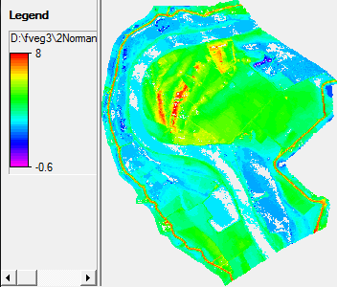 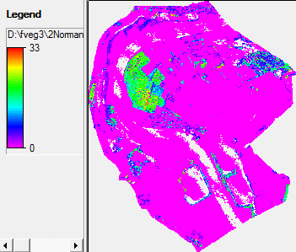

a) Terrain height (m) b) nDSM (m)

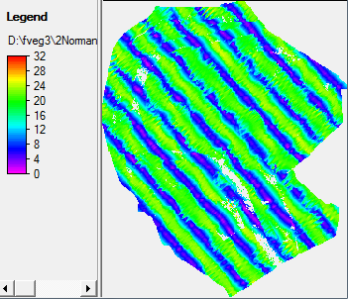 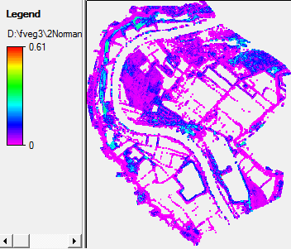

c) Incidence angle (º) d) Forest vegeatation density (m2/m3)

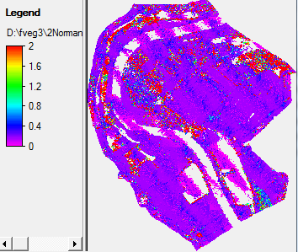 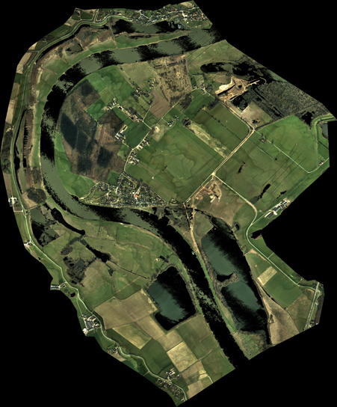

e) Vegetation height of low vegetation (m) (f) RGB values from ALS integrated line scanner

Figure 7 ALS-derived products

## Segmentation

## OO classification

# Discussion and conclusions

Comparison with 2001

# References

Geerling, G.W., Labrador-Garcia, M., Clevers, J., Ragas, A., Smits, A.J.M., 2007. Classification of floodplain vegetation by data-fusion of Spectral (CASI) and LiDAR data. International Journal of Remote Sensing 28, 4263 – 4284.

Houkes, G., 2007. Ecotopenkartering Rijntakken-Oost 2005: Biologische monitoring zoete rijkswateren (in Dutch). RWS-AGI, Delft, report nr. pp. 40.

Jansen, B.J.M., Backx, J.J.G.M., 1998. Ecotope mapping Rhine Branches-east 1997 (in Dutch). RIZA, Lelystad, report nr. 98.054, pp. 41.

Knotters, M., Brus, D.J., Heidema, A.H., 2008. Validatie van de ecotopenkaarten van de rijkswateren. Alterra, Wageningen, report nr. Alterra-rapport 1656, pp. 47.

Sithole, G., Vosselman, G., 2004. Experimental comparison of filter algorithms for bare-Earth extraction from airborne laser scanning point clouds. ISPRS Journal of Photogrammetry and Remote Sensing 59, 85-101.

Straatsma, M., Huthoff, F., 2011a. Uncertainty in 2D hydrodynamic models from errors in roughness parameterization based on aerial images. Physics and Chemistry of the Earth, Parts A/B/C 36, 324-334.

Straatsma, M.W., 2008. Quantitative mapping of hydrodynamic vegetation density of floodplain forests using airborne laser scanning. Photogrammetric Engineering and Remote Sensing 47, 987-998.

Straatsma, M.W., Alkema, D., 2009. Error propagation in hydrodynamics of lowland rivers due to uncertainty in vegetation roughness parameterization FloodControl2015, report nr. 2009-06-05, pp. 44.

Straatsma, M.W., Baptist, M.J., 2008. Floodplain roughness parameterization using airborne laser scanning and spectral remote sensing. Remote Sensing of Environment 112, 1062-1080.

Straatsma, M.W., Huthoff, F., 2010. Relation between accuracy of floodplain roughness parameterization and uncertainty in 2D hydrodynamic models. Faculty of ITC, University of Twente, Enschede, report nr. pp. 49.

Straatsma, M.W., Huthoff, F., 2011b. Extrapolation error of peak water levels from uncertain floodplain roughness in 2D hydrodynamic models. Faculty of ITC, University of Twente, Enschede, report nr. pp. 49.

Straatsma, M.W., Middelkoop, H., 2007. Extracting structural characteristics of herbaceous floodplain vegetation for hydrodynamic modeling using airborne laser scanner data. International Journal of Remote Sensing 28, 2447-2467.

Van der Sande, C.J., De Jong, S.M., De Roo, A.P.J., 2003. A segmentation and classification approach of IKONOS-2 imagery for land cover mapping to assist flood risk and flood damage assessment. International Journal of Applied Earth Observation and Geoinformation 4, 217-229.

Warmink, J.J., Huthoff, F., Straatsma, M.W., Booij, M.J., Van der Klis, H., Hulscher, S.J.M.H., submitted. Combining uncertainty in channel and floodplain roughness to assess the uncertainty in design water levels for a lowland alluvial river. Water Resources Research.

Wehr, A., Lohr, U., 1999. Airborne laser scanning - an introduction and overview. ISPRS Journal of Photogrammetry and Remote Sensing 54, 68-82.

1. ALS analyses

The batchfile below list the commands that were used in lastools to create area-wide maps of vegetation structure. It is based on lastools, python, gdal, and PCRaster

del tiles*.laz

del *.asc

del *.xml

del *.tif

del *.map

del *.txt

del *.xyz

lastile -i dwall.laz -o tiles -olaz -tile_size 100 -full_bb

REM ############ DTM #############################

/* Initiate with large step size

lasground -i tiles*.laz -olaz -odix _g -step 25 -all_returns -cores 1

lasheight -i tiles*_g.laz -olaz -odix _h -cores 1

lasclassify -i tiles*_h.laz -olaz -odix _c -cores 1

/* iterate with smaller step size, and houses left out

lasground -i tiles*_c.laz -olaz -odix _g5 -step 5 -ignore_class 6 -all_returns -cores 1

lasheight -i tiles*_g5.laz -olaz -odix _h5 -cores 1

lasclassify -i tiles*_h5.laz -olaz -odix _c5 -cores 1

lasgrid -i tiles*c5.laz -oasc -odix _g.asc -elevation -average -step 1 -keep_class 2 -cores 1

gdal_merge.py -o dtm_g.tif -of GTiff -ot Float32 -a_nodata -9999 *.asc

gdal_translate -of PCRaster -ot Float32 dtm_g.tif dtm_g.map

REM ####################################################

REM ####### Forest Veg. Density 0-4 m ##################

REM ####################################################

REM compute point density of vegetation between 0 and 4 m

lasheight -i tiles*_c5.laz -olaz -odix _n -replace_z -cores 1 # normalize data

las2las -i tiles*_n.laz -olaz -odix _04 -clip_z 0.15 4.0 -cores 1 # select vegetation points between 0.15 and 4 m.

lasgrid -i tiles*_04.laz -oasc -odix _PD -density_16bit -step 10 # export point density of buildings and ground points to grid

gdal_merge.py -o veg04Pden.tif -of GTiff -ot Float32 -a_nodata -9999 *PD.asc

gdal_translate -ot Float32 -of PCRaster veg04Pden.tif veg04Pden.map

REM compute point density of all points

lasgrid -i tiles*_c5.laz -oasc -odix _AD -density_16bit -step 10 # export point density of buildings and ground points to grid

gdal_merge.py -o allPden.tif -of GTiff -ot Float32 -a_nodata -9999 *AD.asc

gdal_translate -ot Float32 -of PCRaster allPden.tif allPden.map

REM resample veg point density data and compute vegetation density

resample --clone allPden.map veg04Pden.map veg04PdenR.map

pcrcalc DvForest.map = min(0.6, 0.008 + 1.18 * 0.25 * veg04PdenR.map / allPden.map)

REM #################################################

REM ########### Low veg ###########################

REM #################################################

REM Smooth DTM for low vegetation detection

python smooth.py

REM output vegetation height maps and aggregate

lasgrid -i tiles*_S.laz -oasc -odix _Av -elevation -average -step 1 -clip_z 0.0 2 -cores 1

gdal_merge.py -o LowVegAv.tif -of GTiff -ot Float32 -a_nodata -9999 *Av.asc

gdal_translate -ot Float32 -of PCRaster LowVegAv.tif LowVegAv.map

lasgrid -i tiles*_S.laz -oasc -odix _Max -elevation -max -step 1 -clip_z 0.0 2 -cores 1

gdal_merge.py -o LowVegMax.tif -of GTiff -ot Float32 -a_nodata -9999 *Max.asc

gdal_translate -ot Float32 -of PCRaster LowVegMax.tif LowVegMax.map

lasgrid -i tiles*_S.laz -oasc -odix _Sd -elevation -stddev -step 1 -clip_z 0.0 2 -cores 1

gdal_merge.py -o LowVegSd.tif -of GTiff -ot Float32 -a_nodata -9999 *Sd.asc

gdal_translate -ot Float32 -of PCRaster LowVegSd.tif LowVegSD.map

REM ##################################################

REM ########### Buildings and Trees ##################

REM ##################################################

lasmerge -i *_n.laz -o nDSM.laz

lasboundary -i nDSM.laz -o trees.shp -keep_class 5 -disjoint -concavity 2.5

lasboundary -i nDSM.laz -o buildings.shp -keep_class 6 -disjoint -concavity 2.5