Files to use in QGIS:
Towards a Random-Representative Sampling Scheme
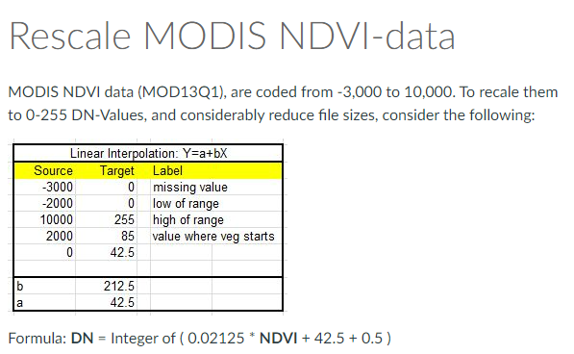
- stack_masaimara_18feb00_8jun16_cln.img
a spatial-temporal stack of 375 cleaned MODIS-Terra NDVI-images. Each NDVI-image is rescaled to the 0-255 DN-value range. Each image represents the Maximum Value Composite of daily imagery across a 16-day period. There are 23 images each year. Cleaning is carried out through the TimeSat upper-envelop filter. source: MOD13Q1 v5 see: https://lpdaac.usgs.gov/products/mod13q1v006/
- Mamase_AOI.shp
A polygon that defines the study-area for (benchmark-) mapping the grazing lands of the Masai Mara.
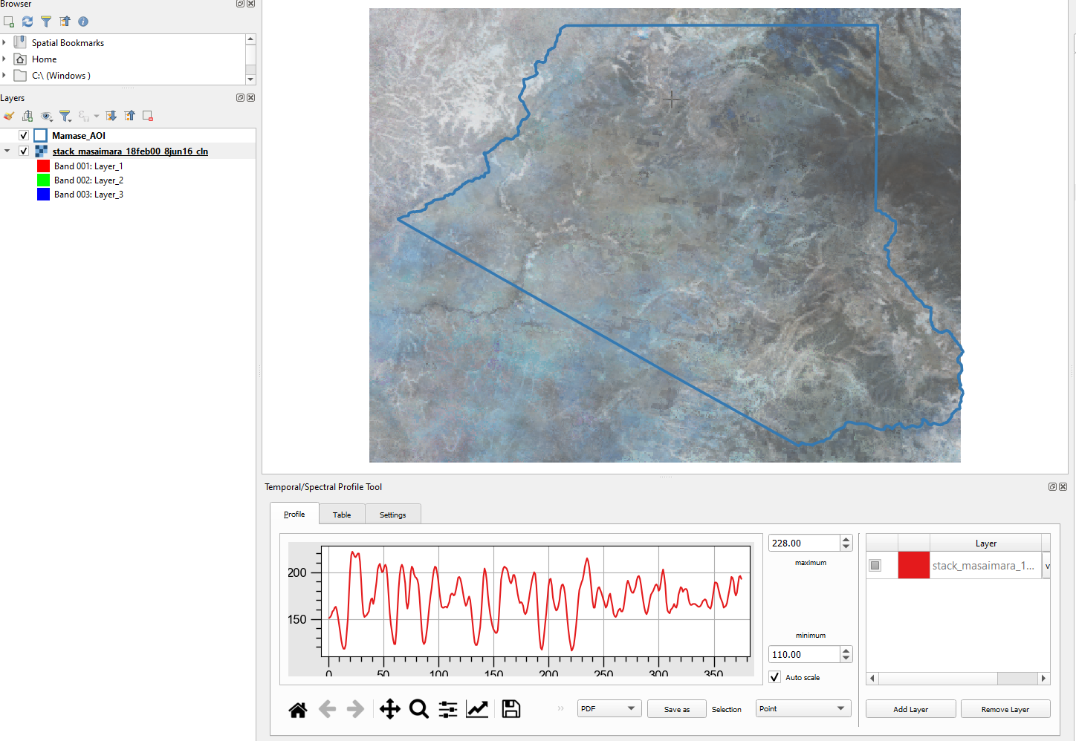

Explore the Stack
- Install the plugin: “Temporal/Spectral Profile Tool”
- Select the raster file
- Select the option (the plugin), and select any raster-cell to see its temporal NDVI-profile
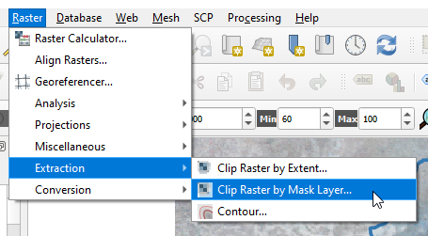

Mask the raster through the AOI polygon
- Select the IMG and SHP
- Save the result as: Stack_Mamase_AOI.TIF

Calculate the SD and Median Images
- Select: 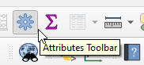
- Select: 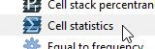
- Then: Select as input layer the AOI-stack,
Select either Standard Deviation or Median
Specify output files [NOTE: it seems this routine is providing incorrect outputs]
- NOTE: Under directory /ORIG/ I have provided correct output files: stack_masaimara_Median.img and stack_masaimara_SD.img, and two masked files Median_AOI.TIF and SD_AOI.TIF.
You are advised to use this very set of TIFs.

K-Means unsupervised classification
- Install the plugin:
Refer for info to: https://www.youtube.com/watch?v=tRDk0tAkQ94
- And select: 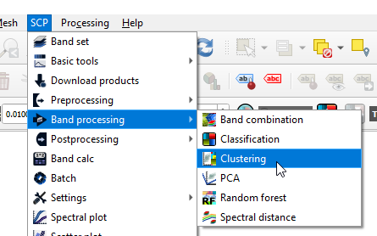
- Then first select a single “Band set”, and then use from “Band processing” the K-Means clustering method, to create a 5 (or more) clusters TIF. Select to use “0” as no-data.
Also save the resulting signatures to a file. Various iterations will follow. Repeat this for both files (SD and Median). I got using the above, the following clusters.
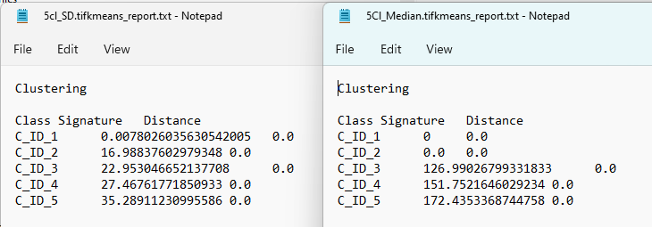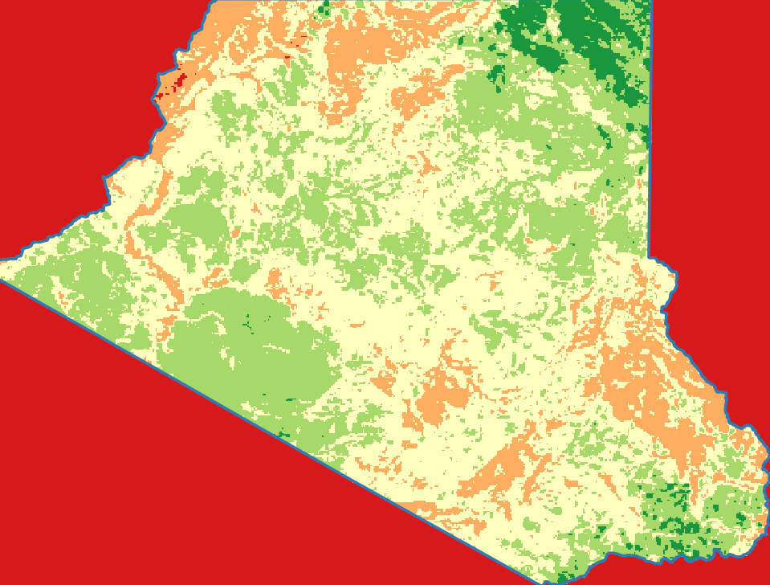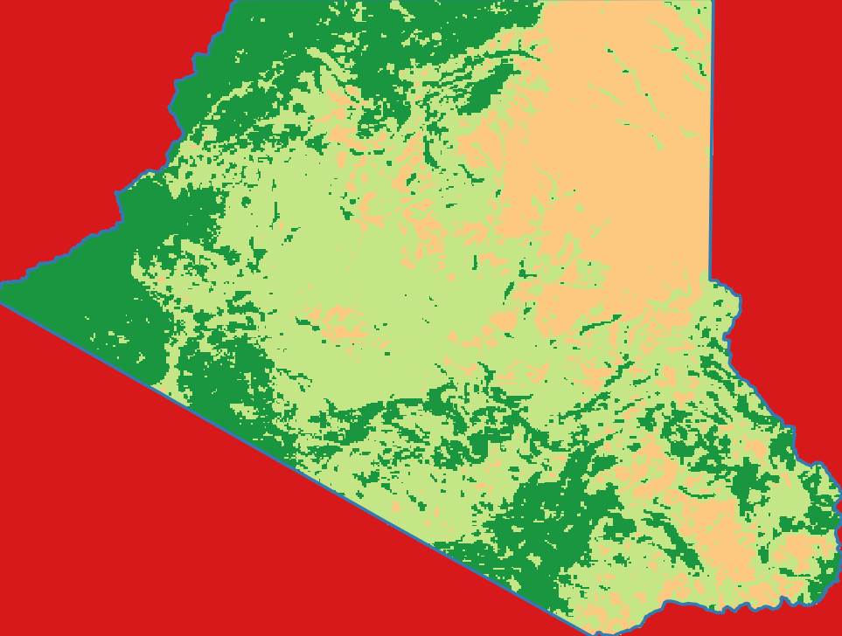

Convert these 2 TIFs to SHPs
- Use “Polygonize” for each of the 2 TIFs and save as SHPs: 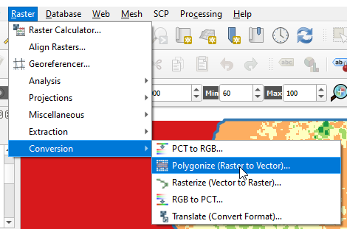
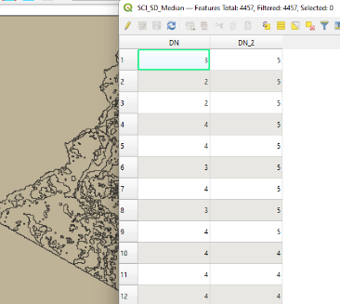
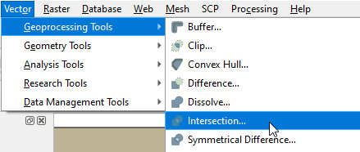
- Use the “Intersection” option to
combine both SHP-files into one
SHP-file (and check the Attribute Table):
Mak
[make sure it is a “Single-Part” SHP-file]

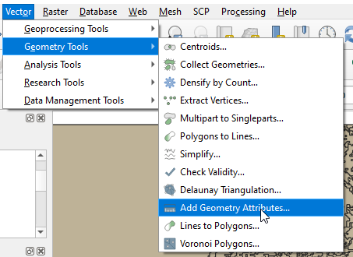
Add the required Geometry info the SHP-file
- Add the polygon areas to each polygon through:
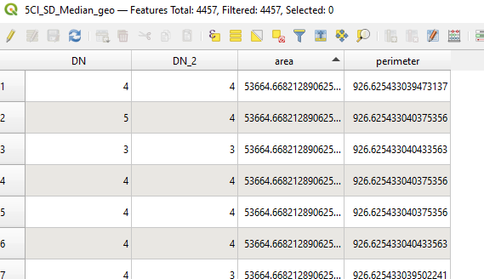
- And save the results in a new SHP file.

Select the larger Polygons
- Open the “Attribute Table” of the file with the GeoMetry, and select all polygons that are smaller than 1,000,000 m² (100 ha or about 16 pixels). Also remove the background along the AOI [put “Edit” on to delete polygons]. I am now left with 599 polygons.
- Create in the Table a new field and put there the result of: { 10*DN + DN_2 }.
- Create a nice coloured legend using that new field.
- I now got:
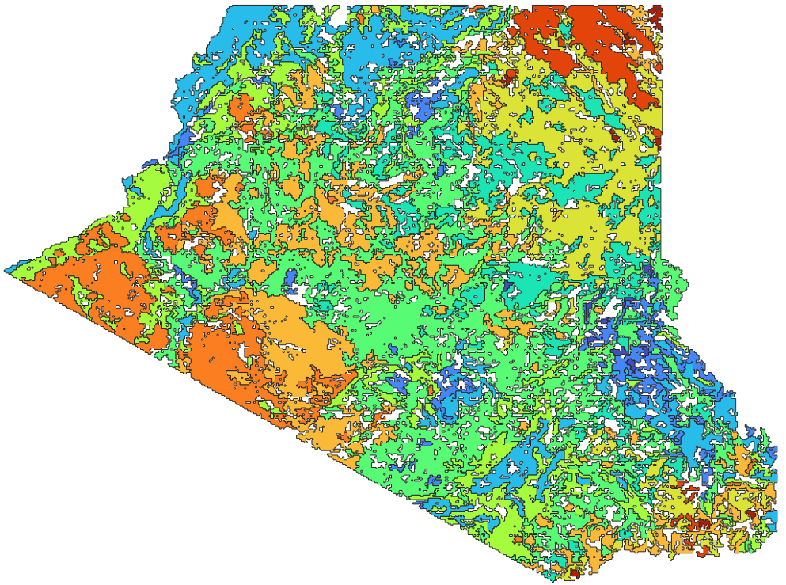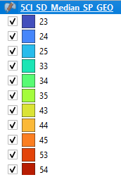

Next steps to do / Considerations / Discussion
- Add a road/paths layer and clip the above to about 1km distance to roads: these are the accessible areas to survey (unless you have an off-road permit from the park-management).
- Divide your available time by 11 (11 unique SD-Median combinations to sample equally!
- Sample each SD-Median combination multiple times either randomly within given polygons or representative after observing the contents of a polygon. The latter option is important when you have little time and must collect proper representative (observer defined!!) samples.
- Keep track that each combination is sampled and that you do cover the full range of variability.
Underlying assumption: The long-term SD and Median values of NDVI readings capture the actual variability in range-types (cover-types) in the study-area. Note: many of the above classes are NOT grasslands; thus classification must be more specific (it is now too generalized).
Our experience: YES that is correct at macro level, BUT locally (micro-level) terrain also creates lots of variability in range-types. Thus: combine the above with a Relative DEM (of 30m resolution). See the PPT.

