**Dynamic Monitoring of Coastline in Guangdong Province Based on Multi-Polarized Spaceborne Synthetic Aperture Radar**

**STUDY AREA**

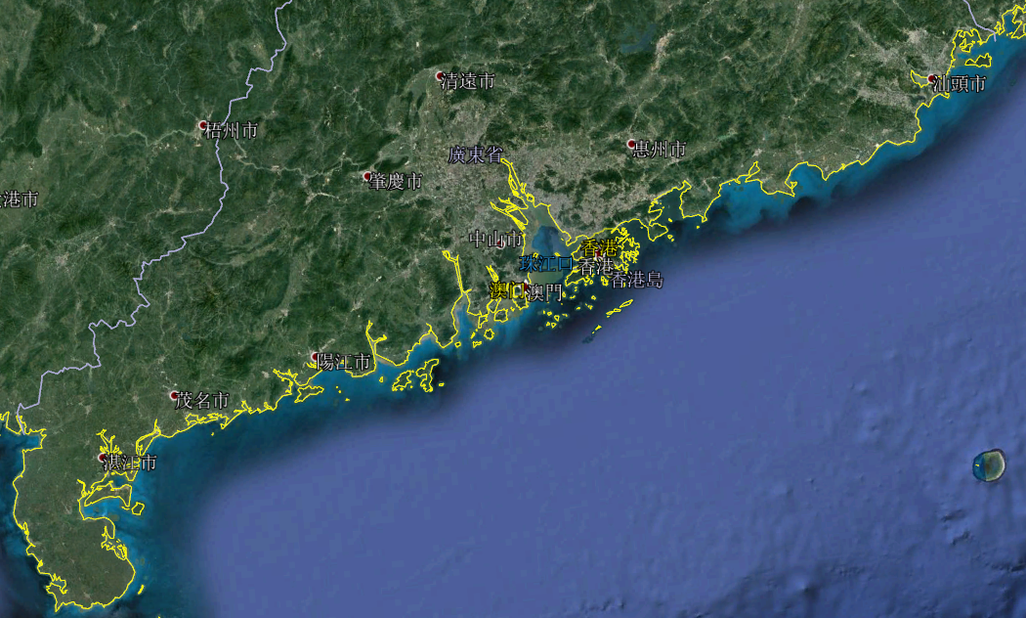

Guangdong coastline

**INTRODUCTION**

The current functional design of the project is divided into four parts: coastline extraction, coastal zone classification, marine oil spill detection, and marine disaster prediction.

Among them, the coastline extraction function is the premise basis of the other three functions. The project plans to algorithmize the Sentinel-1A satellite data of the ESA (ESA) website, ie the SAR image, to obtain the waterside line, and then correct it according to the tide level data to obtain a truly accurate coastline.

The coastal zone classification is based on the extraction of the coastline. Extend the extracted coastline to the inland direction for two kilometers and separate the portion of the coast that will be treated. After that, the classification of the coastal zone is carried out using a machine learning method.

Marine oil spill detection is based on the classification of coastal zones. Combined with the SAR image, it is compared with the previous oil spill image for oil spill detection.

Marine disaster prediction: Based on the coastline extraction and coastal classification, the system will analyze and predict marine disasters through SAR images combined with previous disaster cases.

**TEAM**

Sun Sheng(Associate Professor, School of Computer, Guangdong University of Technology)

Dong Xiaodong(Graduate student, School of Computer Science, Guangdong University of Technology)

Shui Wenze(Graduate student, School of Computer Science, Guangdong University of Technology)

Liu Yuping(Graduate student, School of Computer Science, Guangdong University of Technology)

**ABSTRACT**

Based on SAR data, this project extracts the coastline of Guangdong Province, then classifies the coastal zone, predicts marine disasters and monitors oil spills near the coastal zone.